**Seminar7**

1. For hard-switching Buck converter:

* Observe the switching waveform of power switch Q
* Plot loss curve



Fig.1 Hard-Switching Buck Converter

1. For ZVS QRC Buck converter:

* Observe the switching waveform of power switch Q
* Plot loss curve and compare with previous case



Fig.2 ZVS QRC Buck Converter

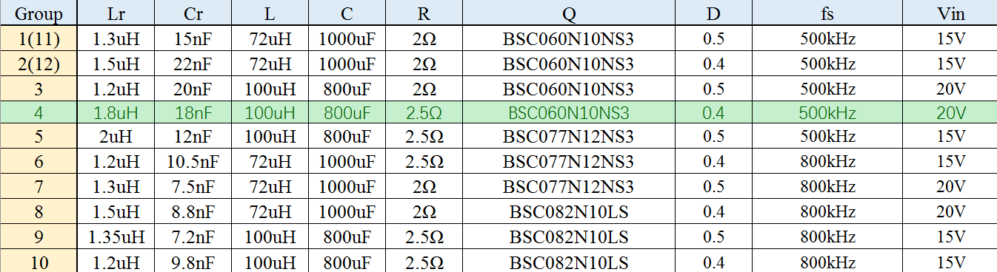

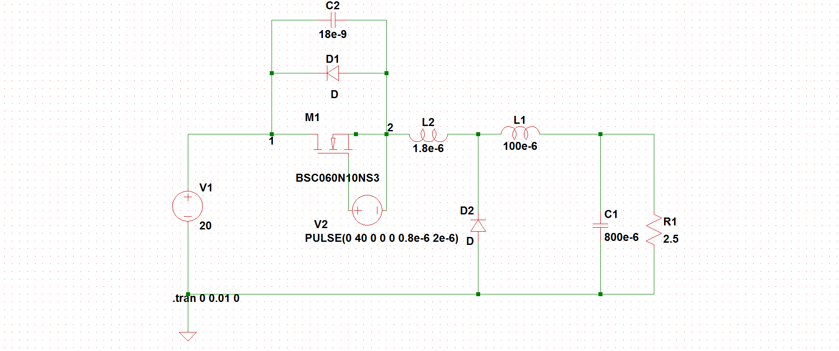

This is the circuit we use to simulate the ZVS function and in fact just put another inductor before the D2 which can make sure the order between the current zero point and the voltage zero point.

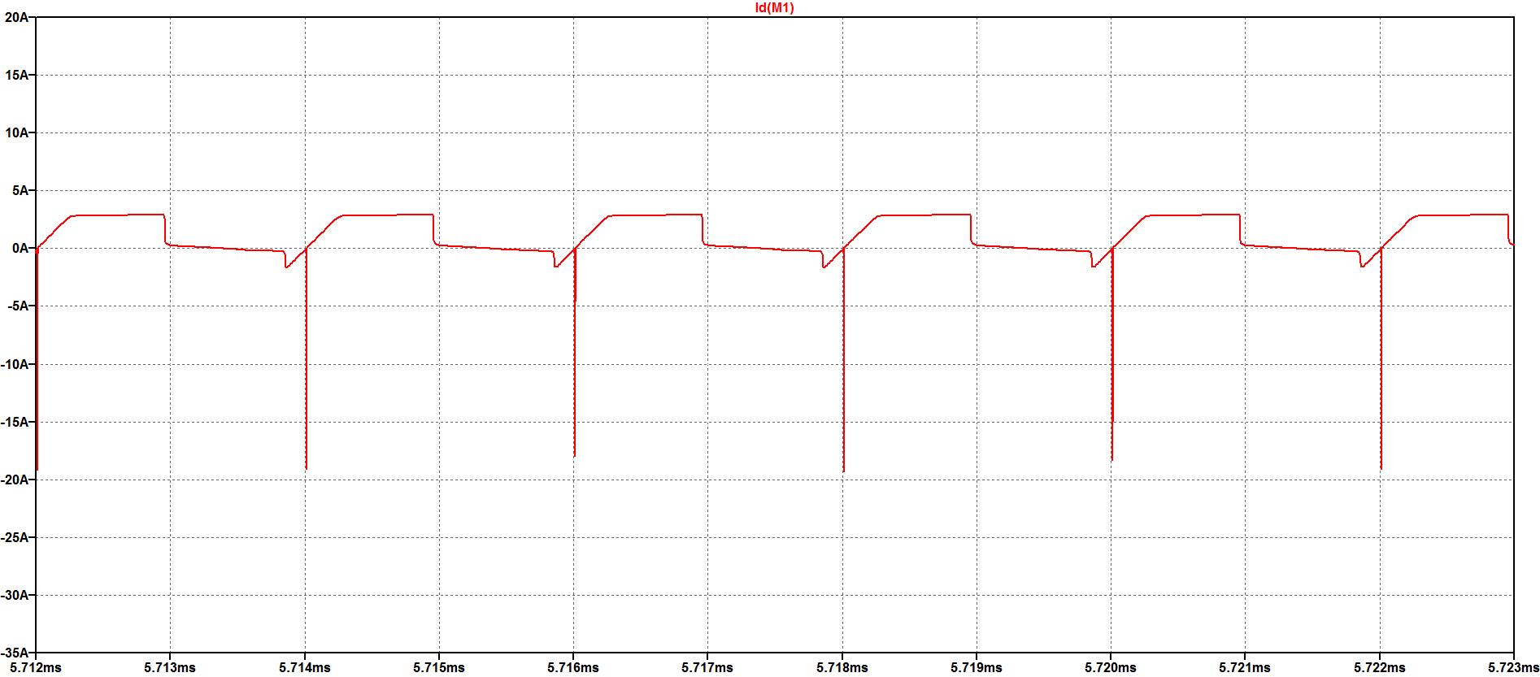

To simulate the waveform of the Id(M1) of the MOSFET, we get this graph.

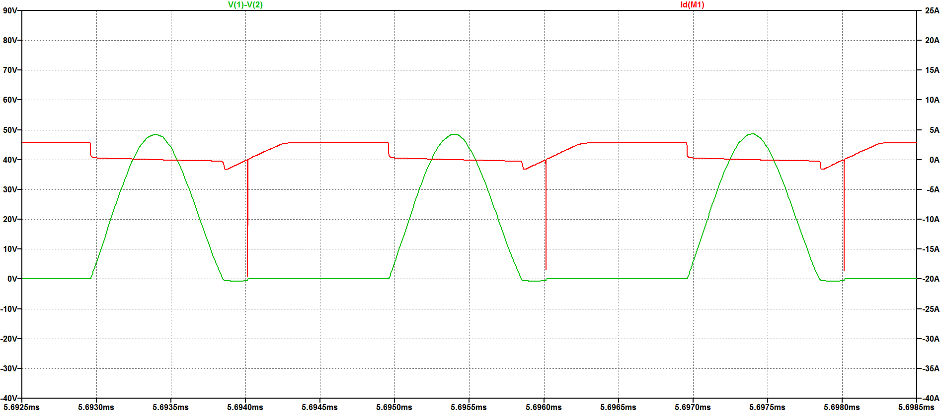

And when put the IS(M1) of the MOSFET and the voltage of the MOSFET together we can observe the phenomenon of the switching state. Which is exactly shown when the MOS turns on, voltage rising behind the current falling and when the MOS turns off, current rising behind the voltage falling.

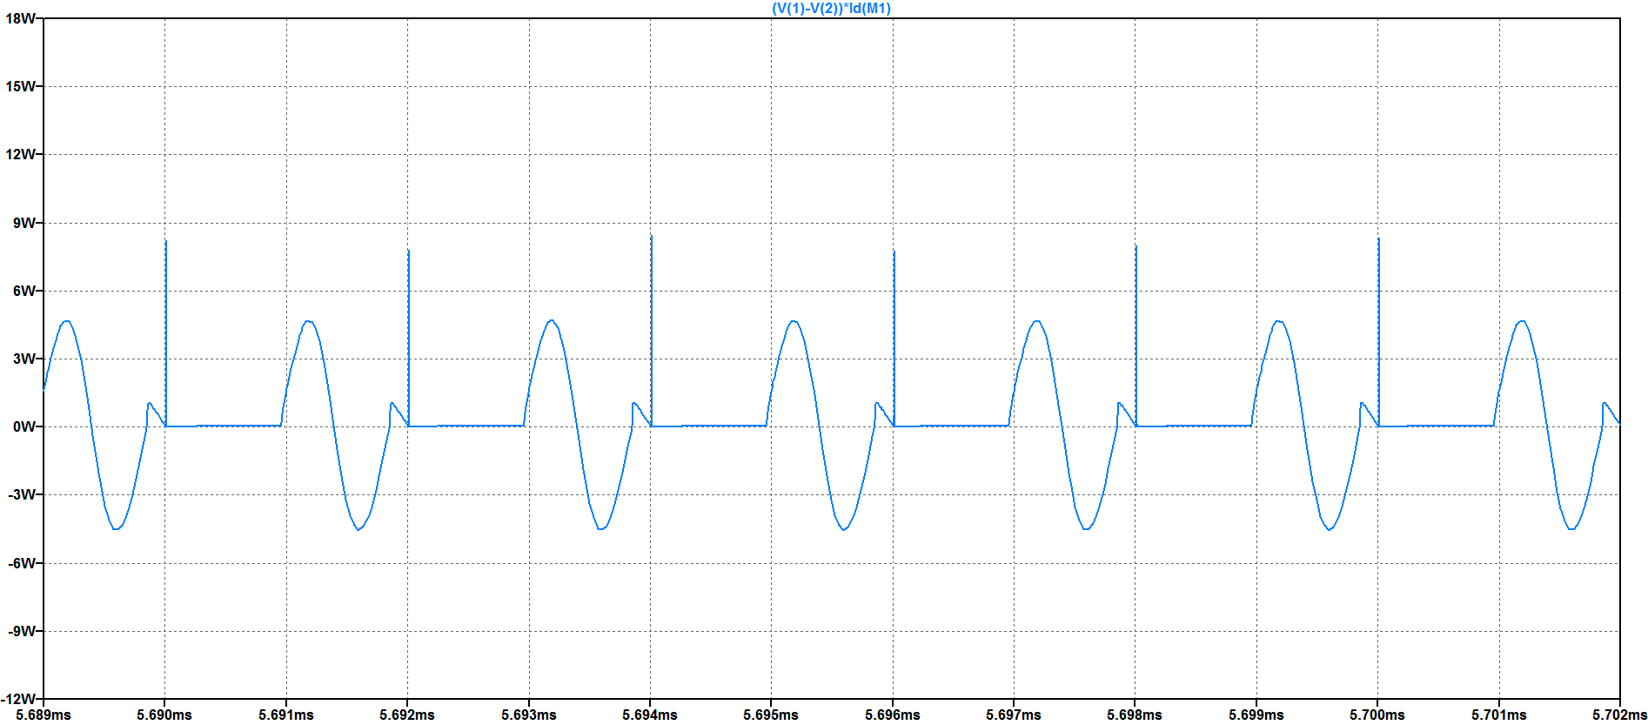

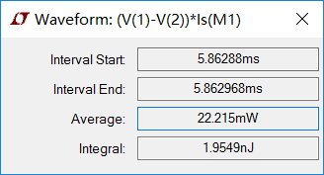 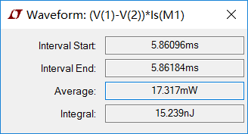

Turn-on loss On-state loss

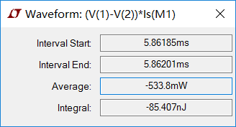 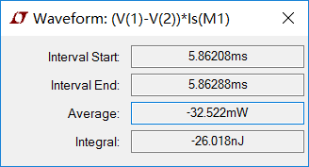

Turn-off loss Off state loss

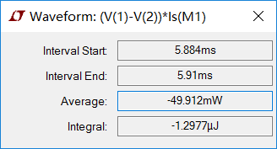

Total loss

The four losses data sum mostly equals to the total loss and we can see, in the whole process the turn off loss is the largest.

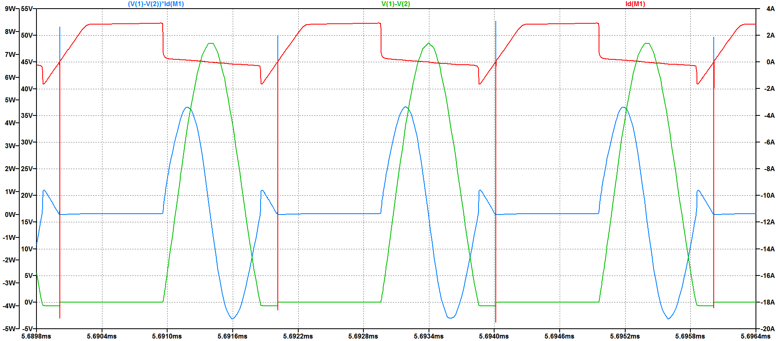

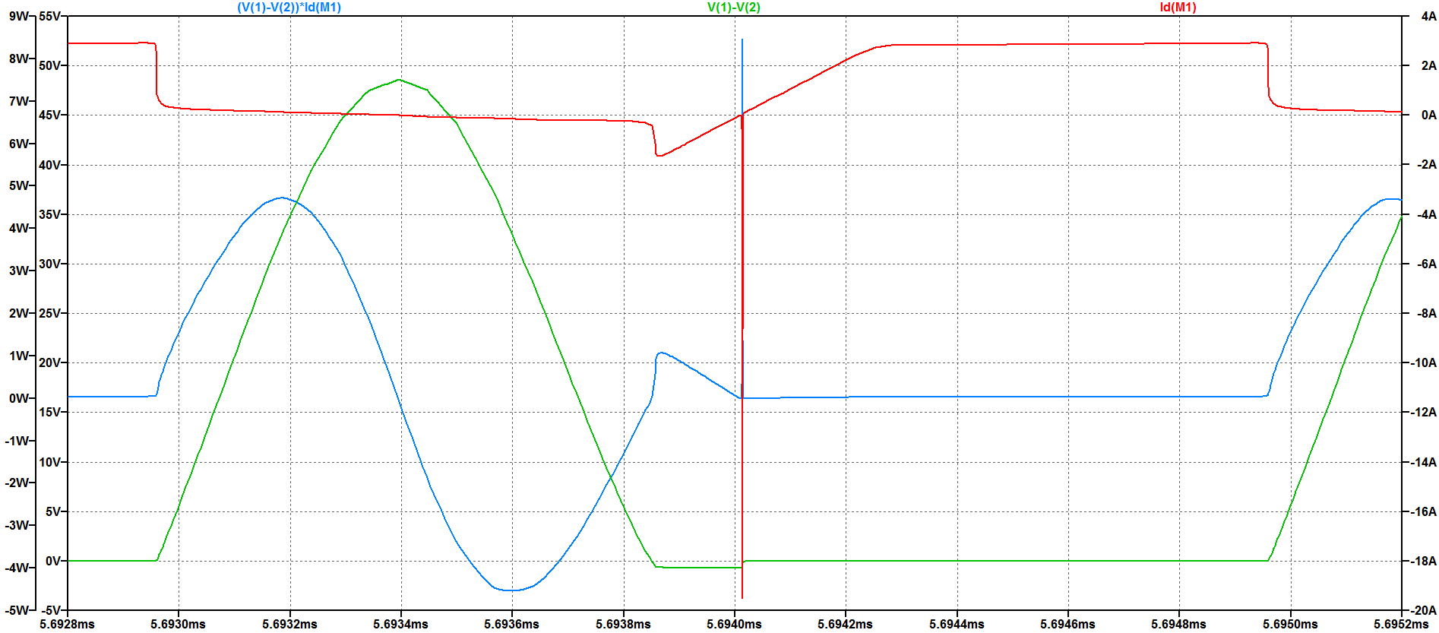

Through the calculation of the loss we can get the result that the soft switching technology can make the loss even more less and the current can be staggered with the voltage.

ZVS QRC makes the loss very small and be friendly to the industry.