**THE UNIVERSITY OF DODOMA**

**COLLEGE OF INFORMATICS AND VITUAL EDUCATION**



**DEPARTMENT OF COMPUTER SCIENCE AND ENGINEERING**

**GROUP ASSIGNMENT ONE**

**COURSE NAME**: OPEN SOURCE TECHNOLOGY

**COURSE CODE**: CP 222

**INSTRUCTOR:** MR MWACHA

**PARTICIPANTS**

|  |  |  |
| --- | --- | --- |
| NAME | REG NO | PROGRAM |
| **EMMANUEL MOSES** | T/UDOM/2020/09476 | BSc IN COMPUTER SCIENCE |
| **CONRAD KAMUGISHA** | T/UDOM/2020/00277 | BSc IN COMPUTER SCIENCE |
| **ELIBARIKI GERSON** | T/UDOM/2020/09473 | BSc IN COMPUTER SCIENCE |
| **RAPHAEL MWAISEMBA** | T/UDOM/2020/00300 | BSc IN COMPUTER SCIENCE |
| **FREDRICK BRIGHTON** | T/UDOM/2020/06791 | BSc IN COMPUTER SCIENCE |
| **EMMANUEL MUNISHI** | T/UDOM/2020/07070 | BSc IN COMPUTER SCIENCE |

**UBUNTU OPERATING SYSTEM**

**INTRODUCTION**

Ubuntu is a Linux distribution based on Debian and composed mostly of free and open-source software. Ubuntu is officially released in three editions: Desktop, Server, and Core for Internet of things devices and robots. All the editions can run on the computer alone, or in a virtual machine. Ubuntu is a popular operating system for cloud computing, with support for OpenStack. Ubuntu's default desktop has been GNOME since version 17.10.

Ubuntu is released every six months, with long-term support (LTS) releases every two years. As of 21 April 2022, the most recent long-term support release is 22.04 ("Jammy Jellyfish").

Ubuntu is developed by British company Canonical, and a community of other developers, under a meritocratic governance model. Canonical provides security updates and support for each Ubuntu release, starting from the release date and until the release reaches its designated end-of-life (EOL) date. Canonical generates revenue through the sale of premium services related to Ubuntu and donations from those who download the Ubuntu software.

**UBUNTU SOURCE CODE (DESKTOP VERSION)**

The kernel source for the Ubuntu kernel is based very closely on the upstream mainline kernel tree maintained by Linus. The Ubuntu-ness of this kernel is maintained as a git branch against the Linus tree. There are a number of different ways of getting the kernel sources. The two main ways are:

**Obtaining the kernel sources for an Ubuntu release using apt-get**

The literal source code which generated a specific binary package may be obtained using the apt-get source <package> command. For example, to obtain the source for the currently running kernel you can use the command below:

*apt-get source linux-image-unsigned-$(uname -r)*

or failing that:

*apt-get source linux-image-$(uname -r)*

**Obtaining the kernel sources for an Ubuntu release using git**

The source for each release is maintained in its own git repository on Launchpad. The git repository is listed in the Vcs-Git: header in the source package and is of the following form:

*git://git.launchpad.net/~ubuntu-kernel/ubuntu/+source/<source package>/+git/<series>*

For example, the standard Cosmic kernel is available at:

*git://git.launchpad.net/~ubuntu-kernel/ubuntu/+source/linux/+git/cosmic*

**SOURCE CODE FUNCTIONALITY**

The Linux kernel source code is divided into various categories based on their functionality. The source code downloaded from the ubuntu Linux kernel is of version of linux-5-15.0-27-generic. The following are categories of the Linux 5.15 source codes:

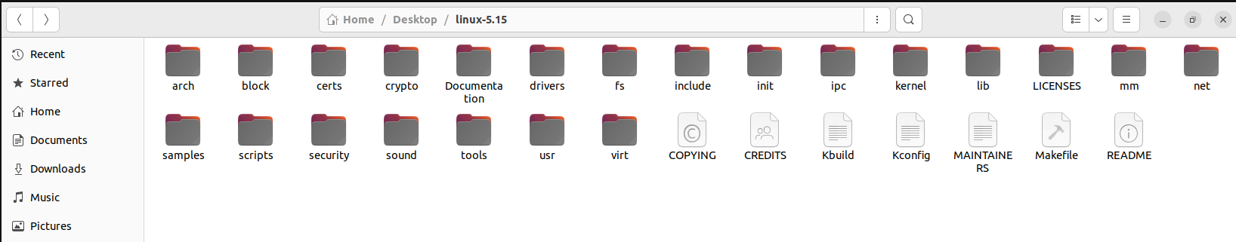

Source code for architecture of linux-5.15

The arch folder consists of source code which define the architecture of linux-5.15 operating system. It consists of different folder and file such riscv, x86, sparc, mips, powerpc, etc, which all define the architecture of the operating system.

The below is the example of the source for x86 architecure of linux-5.15 operating system.

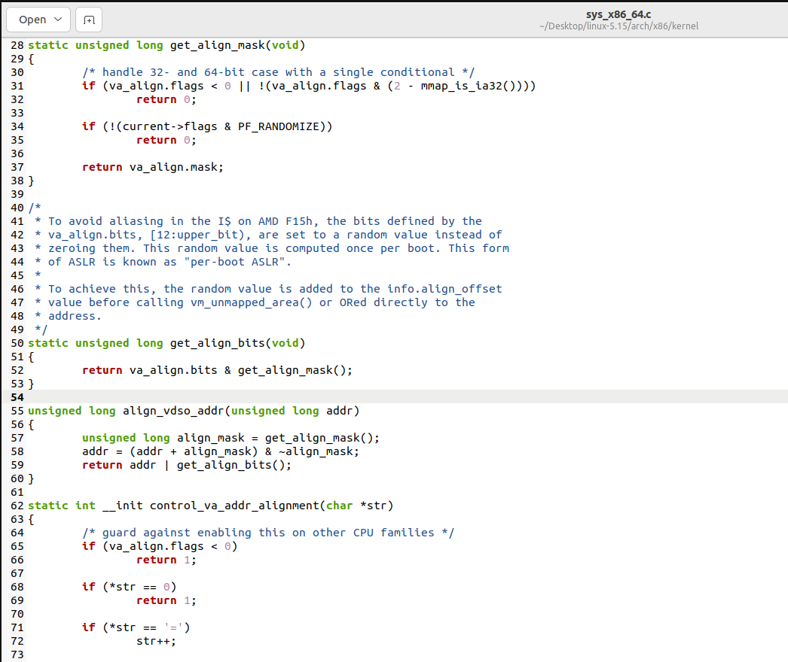

Source code for filesystem

The linux-5.15 consist of folder named as fs which consist of Linux filesystem source codes. Inside that folder consist of various folder which define source codes for all type of file system which linix-5.15 support. Examples are ext2, ext4, nfs, fat, etc.

Example below is the source code for filesystem file in general

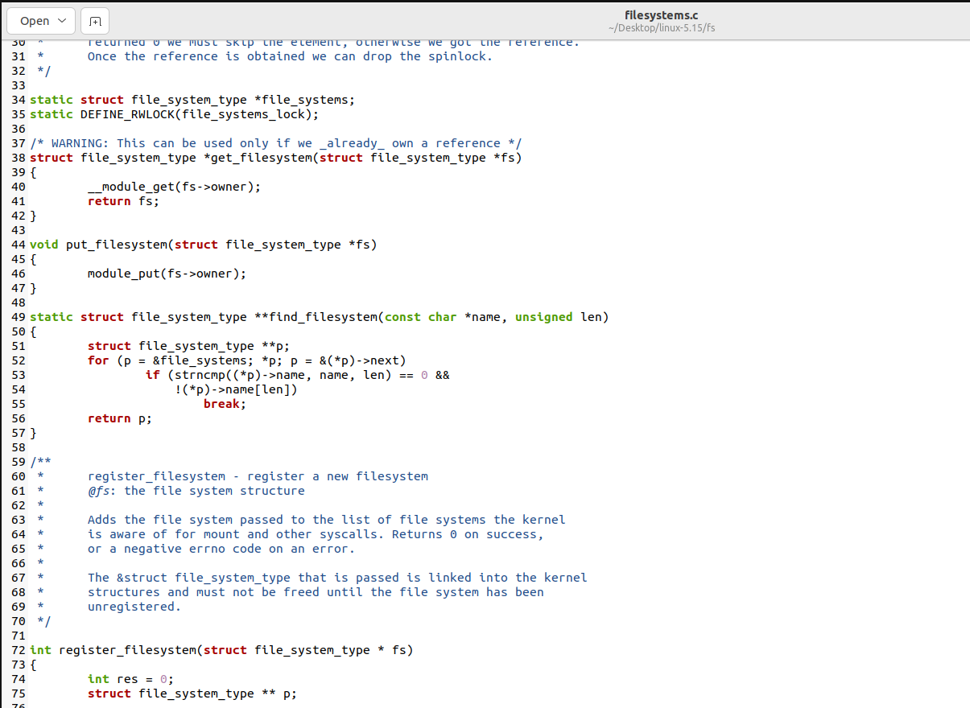

Source code for security

The linux-5.15. consist of source codes which maintain security for the Linux operating system. The source contains in a folder know as security, which inside it consists of different folders and files such as integrity, keys, safesetid.

Example below is the source code for inode file and security files.

Inode is used to allocate index node for every file and directory in the filesystem. It store metadata where you can find the storage blocks of each files data.

The security files consist of source code which implement the whole security in general from security of permission to inode files.

Example of source code for inode file

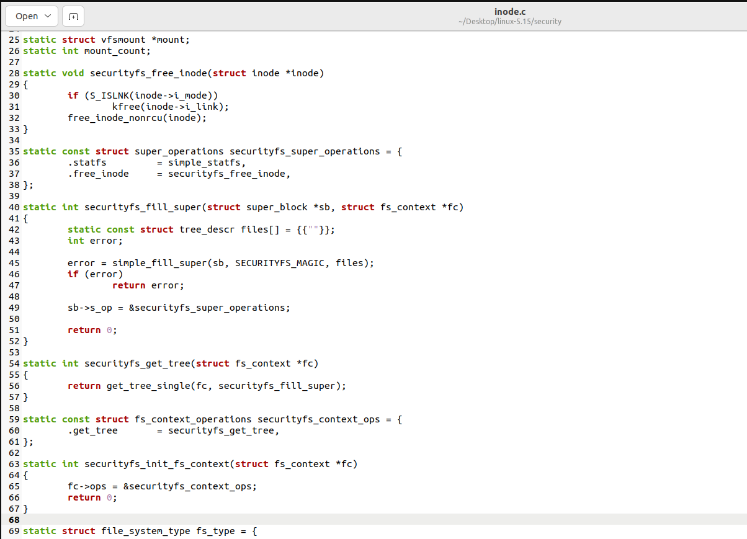

Example of source code for security file

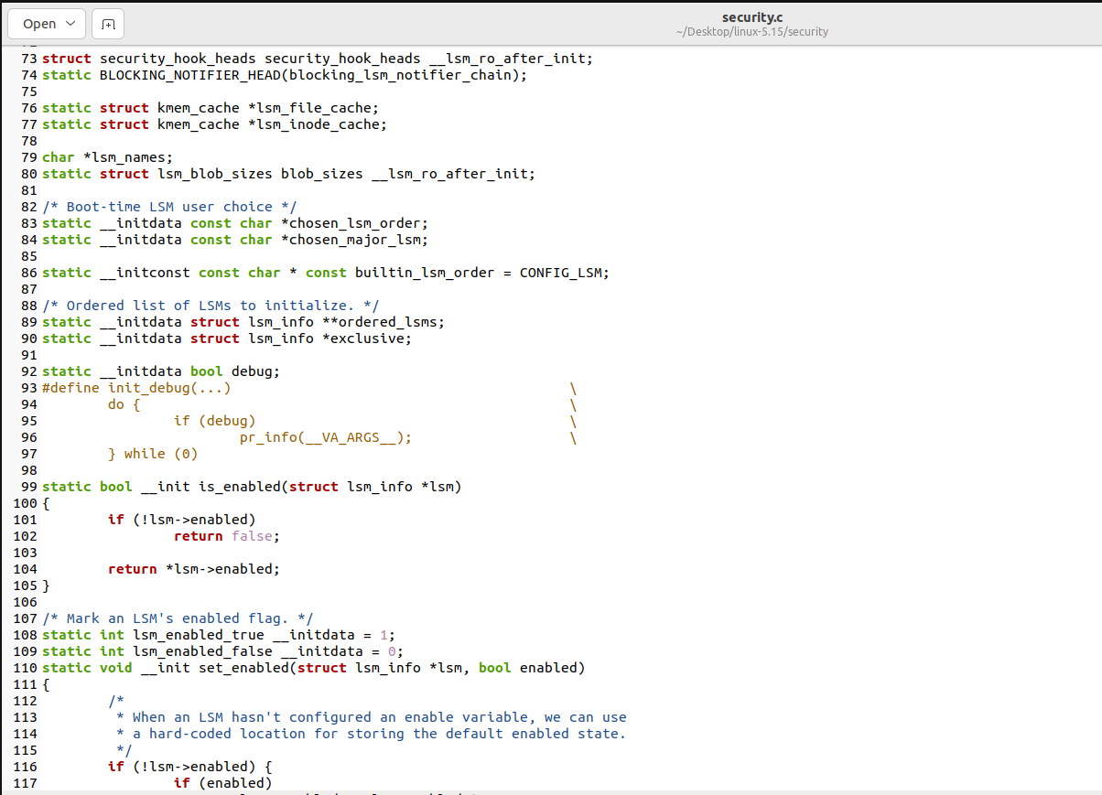

Source code for Linux kernel

The linux-5.15 consist of the source code which consist of define the linux kernel operating system. Its inside the folder known as kernel which inside it consists of different files and folders such as power, rcu, time, locking etc.

Example below is the source code for reboot file which used to reboot the operating system.

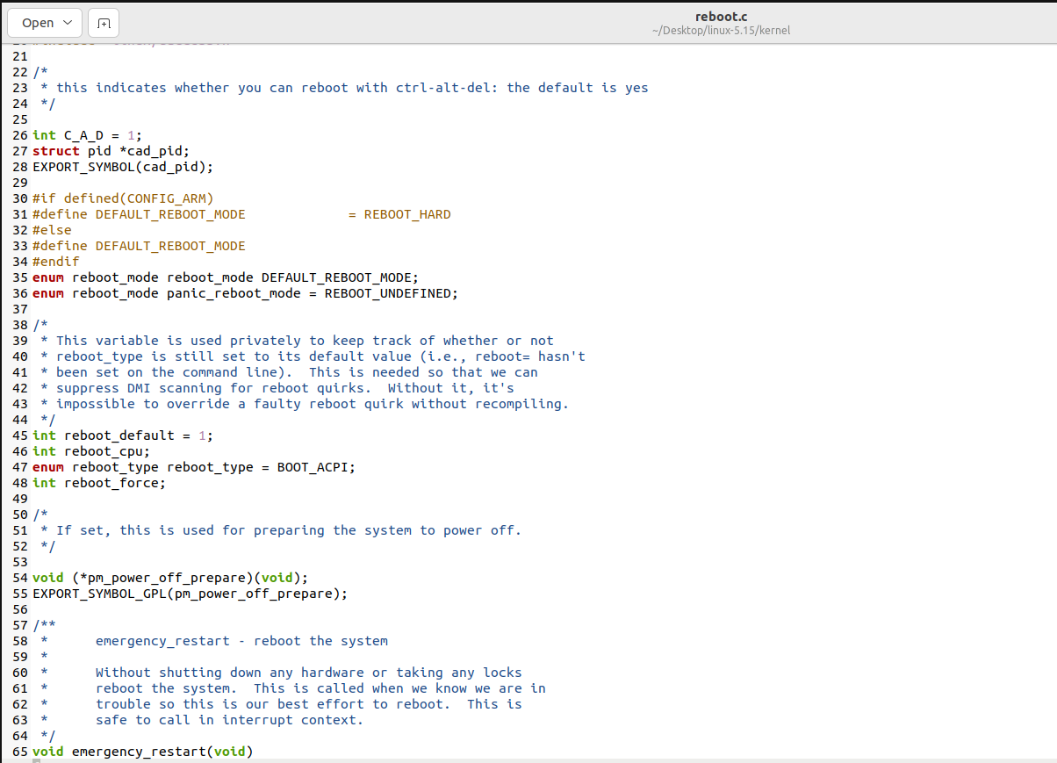

Example source code for pid which used to manage processes.

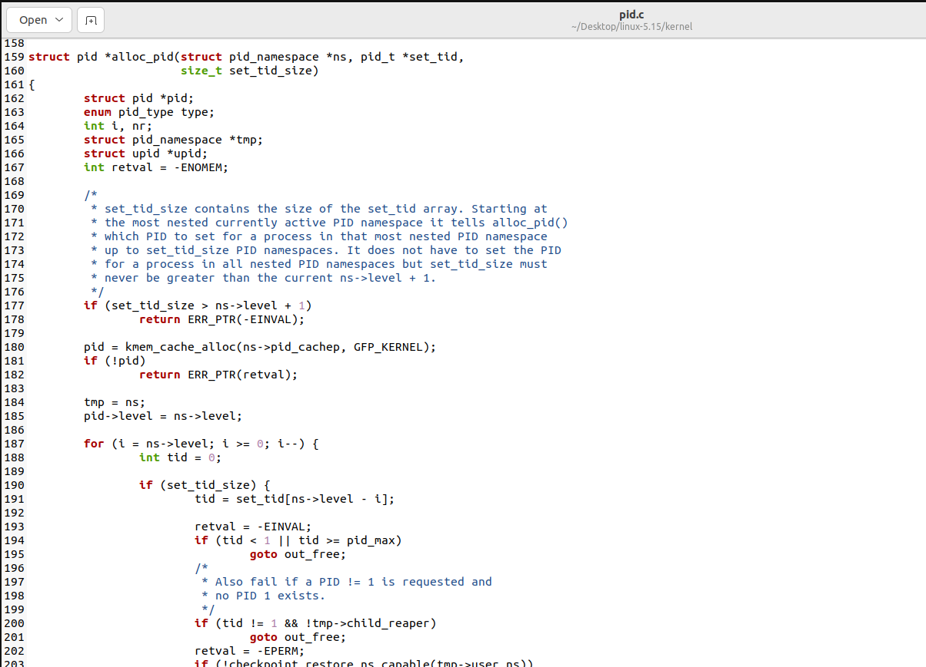

Source code for drivers

The linux-5.15 consist of source code which define various drivers for the Linux operating system. Inside the folder named as drivers consist of various files and folder each contain source code of particular drivers.

Example below is the source code for bluetooth card for connect Bluetooth service.

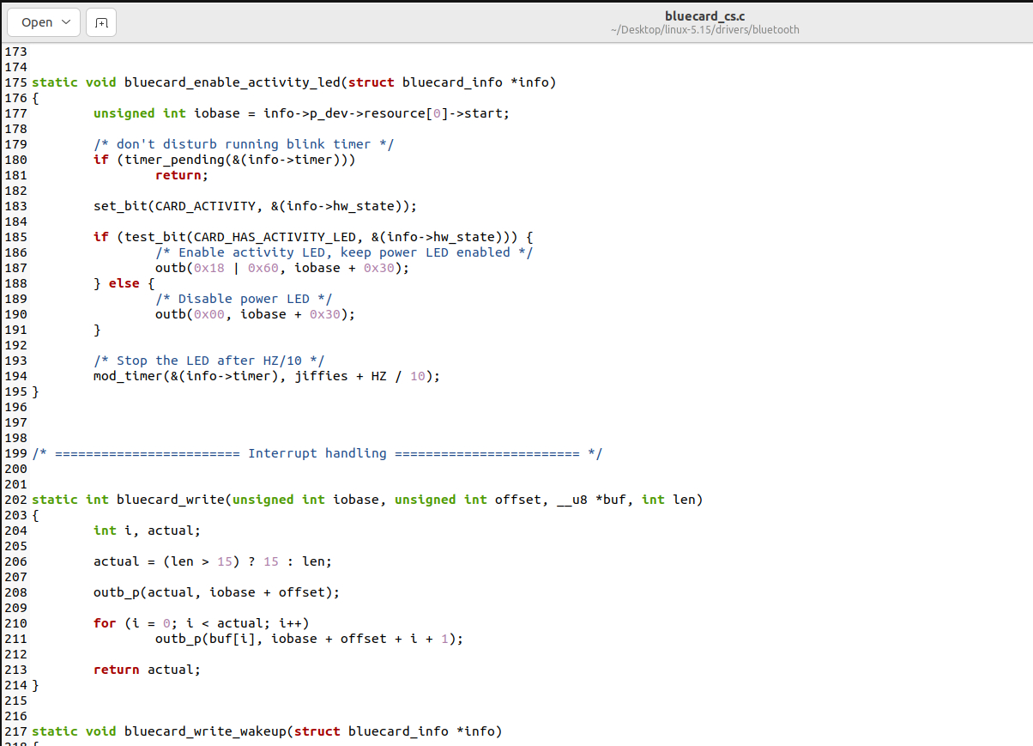

Example of source code for video driver used to set timing of display.

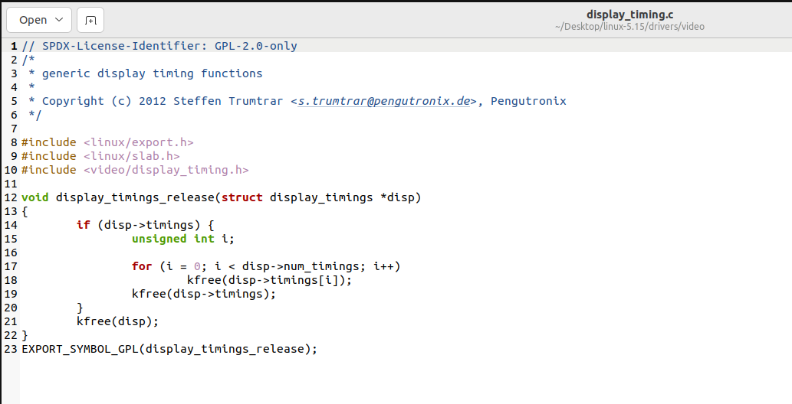

Source code for cryptography

The linux-5.15 consist of source code which maintain the cryptographic process of the operation system. It consists of different files and folders for enabling cryptographic process.

Example below is the source code for authentication process

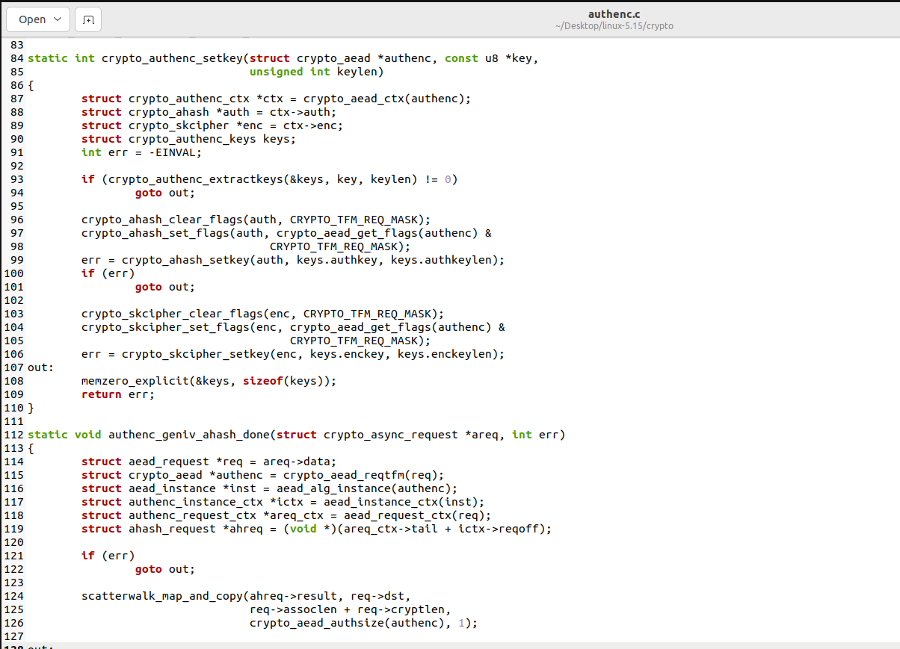

Example of source code for rsa process

