Brightcove Connector Documentation

## By 3|SHARE Corporation

## **Labels**

Labels can now be applied to videos within Adobe Experience Manager (AEM) and are synced with Brightcove Studio upon activation. The Brightcove Admin console also provides the ability to create new labels and filter assets by label.

|  |  |
| --- | --- |
|  |  |

To create a new label, use the dropdown in the filter header and select “+ Create New Label”. Labels are also visible in the metadata preview when you select an asset within the admin console. If you click on the label link, it will trigger a search for all assets with that label (similar behavior to tags).

**Note:**

1. New labels need to adhere to the conventions supported by Brightcove. For example, they must start with a “/” (forward slash).

## **Subfolders**

Subfolders created in Brightcove Studio are now created within AEM upon sync. AEM user permissions can be applied to these folders using the standard practices for AEM access control to limit who can see what videos within AEM.

**Notes:**

1. It is recommended that you delete and re-sync your video library to use this feature.
2. Folders created in AEM are not created within Brightcove Studio.
3. Applying permissions to videos or their folders does not exclude those videos from the admin console OR the video player since both UI elements make on-demand calls to Brightcove’s API.

## **Clips**

Clips (a type of video created from another video) are filterable on each page of search results within the admin console. They are also denoted with the “CLIP” marker within all search results.

Clips are also available via the video player and playlist components for playback on any AEM page.

## **Scheduled Activation**

Videos can utilize the out-of-the-box AEM functionality to schedule activation for a future date and time. This will then trigger replication only at the time specified in the dialog.

## **Playlist Creation**

Playlists can now be created within the AEM environment by selecting one or more videos and clicking “Create Playlist”.

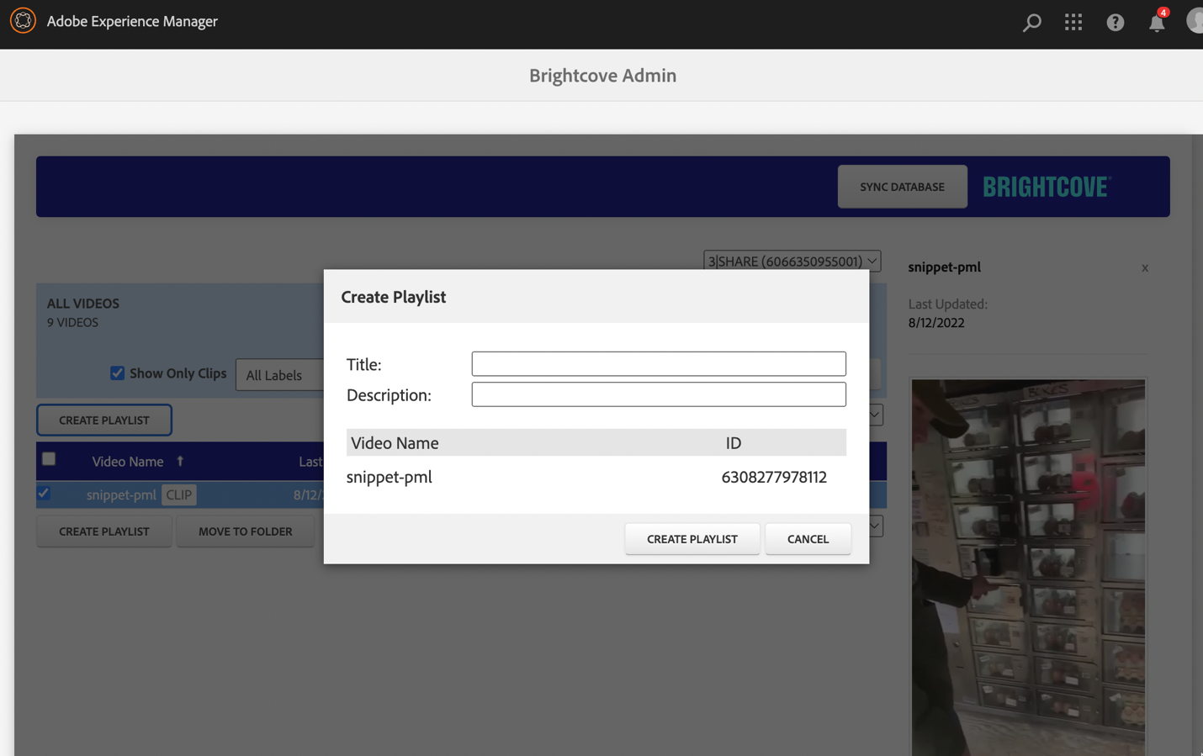

Playlists were previously editable (ability to add, sort, and delete videos) and that functionality has not changed.

## **Multilingual Metadata**

Multilingual metadata – or metadata variants – are now visible within the admin console when you select a video from the search results. Each variant link triggers a modal dialog that displays all metadata values as well as any custom fields that have been translated.

**Note:**

1. It is not currently possible to edit this metadata within AEM, but this is on our roadmap.