Magento eCommerce Install documentation

June 2020

**Table of Contents**

1. Purpose of Document 2

2. Installation Details 2

2.1. Installation Steps 2

2.2. Enable Extensions / Plugins 2

2.3. Configure Brightcove Module Credentials 2

2.4. Disable Extension 4

# Purpose of Document

Purpose of this document is to share the installation details of Brightcove Magento Extension.

# Installation Details

## Installation Steps

Extract Files & Folders and copy to the working folder:

1. Create a folder [Magento_Root]/app/code/Brightcove/Upload
2. Download the archive file (code files).
3. Unzip the files/folder
4. Drop/move contents of the unzipped files to the directory in step 1

**Note**: After pasting the code (as below) we need to run commands to enable the module using the CLI commands (instructed below).

## Enable Extensions / Plugins

* php bin/magento module:enable Brigtcove_Upload
* php bin/magento setup:upgrade
* php bin/magento cache:clean
* php bin/magento setup:static-content:deploy
* php bin/magento cache:flush

## Configure Brightcove Module Credentials

After Successfully installing Brightcove custom module/plug-in, we should be able to see the Configuration page (as in screen shot below) in the Magento portal

Navigate to:

* Store => Configuration => Brightcove (left tab) => Brightcove Video Configuration

At this point, the Brightcove configuration page should be visible in the list of options. The details of credentials on the page are as follows:

* Client ID: REST Client / User ID
* Client Secret: REST Client Secret / password.
* API Base URL: <[Link](https://oauth.brightcove.com/v4/access_token?grant_type=client_credentials)>
* ID: Brightcove Store ID
* Category Video Slot: To set the number of video slots to Category Column
* Master Video Slot: To set the number of video slots to Master Column
* Variant Video Slot: To set the number of video slots to Variant Column
* Email ID: To send email related to bulk upload status

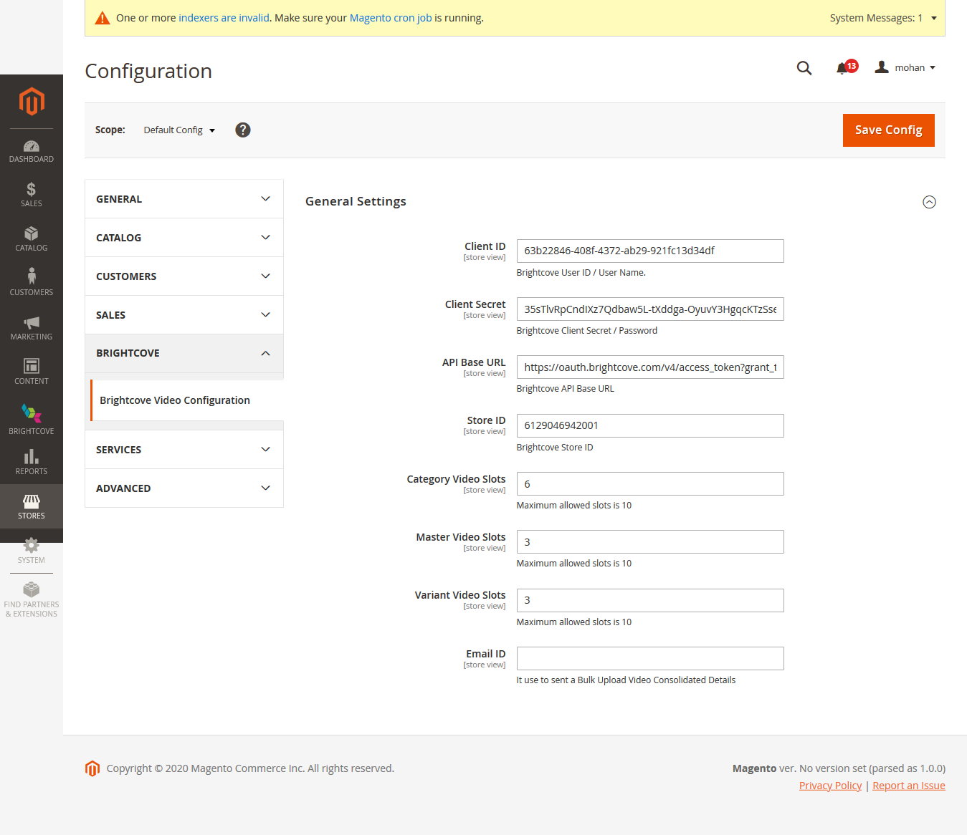

Figure 1 Configuration

Once all details are provided correctly, then Save the configuration page. Now user should be able to access the Brightcove custom module.

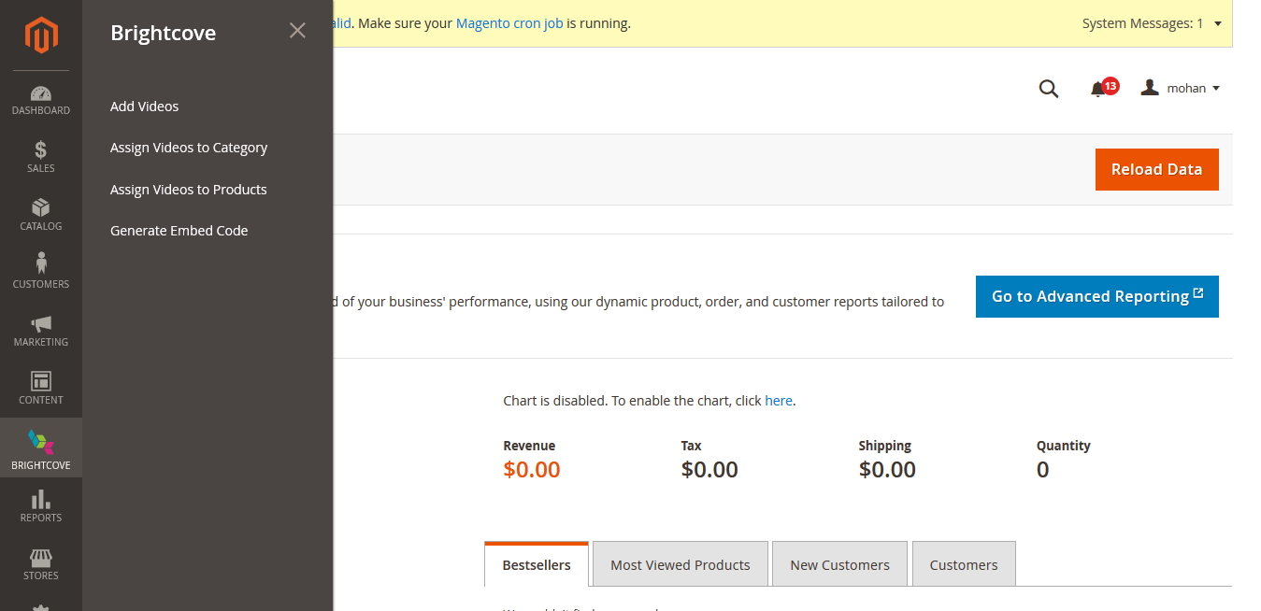

Figure 2 Successful Installation

## Disable Extension

To disable the custom plug-in, use following commands:

1. php bin/magento module:disable Brightcove_Upload
2. php bin/magento setup:upgrade
3. php bin/magento cache:clean
4. php bin/magento setup:static-content:deploy
5. php bin/magento cache:flush