Magento eCommerce User documentation

June 2020

**Table of Contents**

1. Purpose of Document 2

2. Screens 2

2.1. Magento Login Screen 2

2.2. Magento Dashboard with Brightcove Left Menu 3

2.3. Brightcove Menu – Content 4

2.4. Brightcove – “Add Video” Menu Page Content 4

2.5. Brightcove – “Assign Video to Category” Menu Page Content 6

2.6. Brightcove – “Assign Video to Product” Menu Page Content 7

2.7. Brightcove – “Generate Embed Code” Menu Page Content 8

2.8. Brightcove Video Assignment Page in Category 9

2.9. Brightcove Video Assignment Page in Products 11

2.10. Brightcove Configuration Page 12

2.11. Brightcove – Bulk Import Home Page 13

2.12. Brightcove – Bulk Upload Video to Brightcove Server Detail Page 14

2.13. Brightcove – Bulk Product Assignment Detail Page 15

2.14. Brightcove – Bulk Category Assignment Detail Page 16

# Purpose of Document

Purpose of this document is to share the functional details of Brightcove Magento Extension.

# Screens

## Magento Login Screen

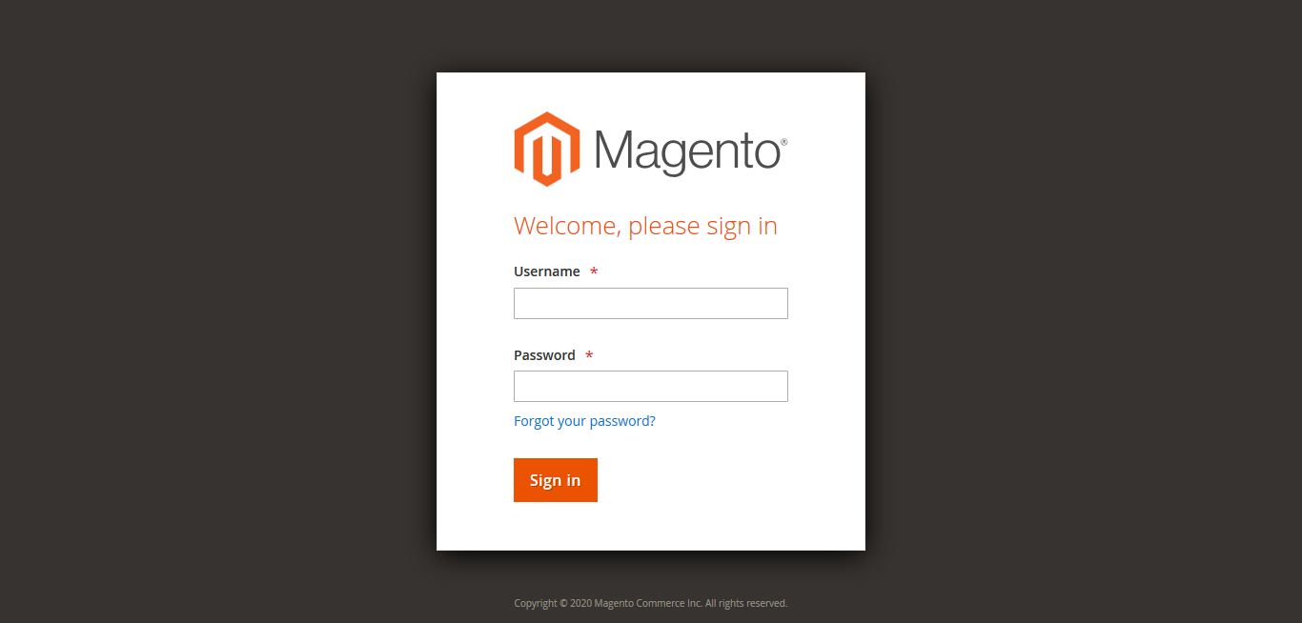

Figure 1 Magento Login Screen

## Magento Dashboard with Brightcove Left Menu

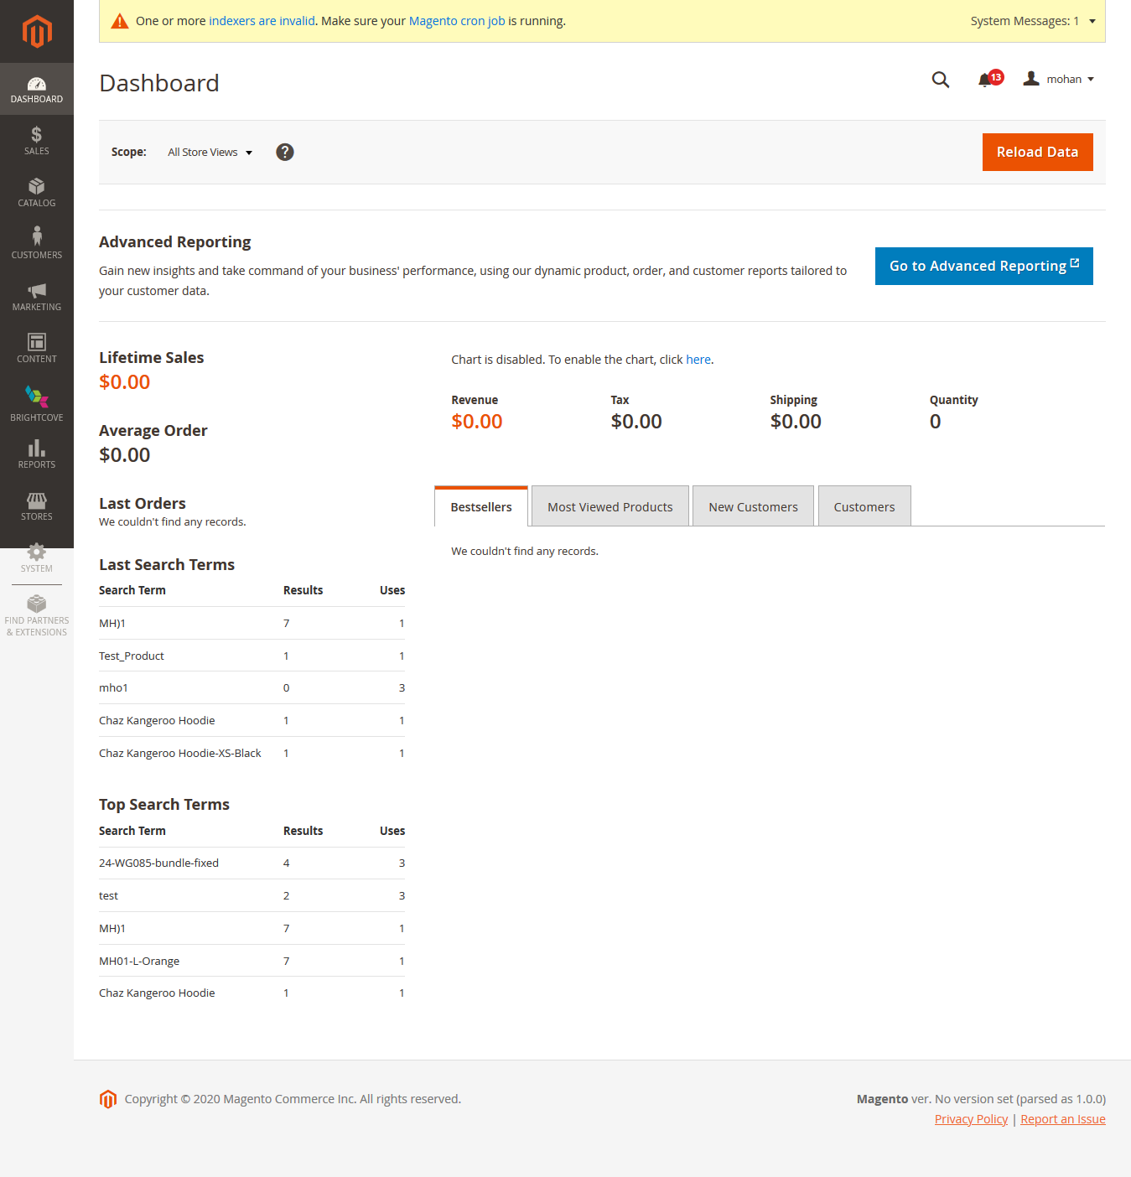

Figure 2 Magento Dashboard with Brightcove Left Menu

## Brightcove Menu – Content

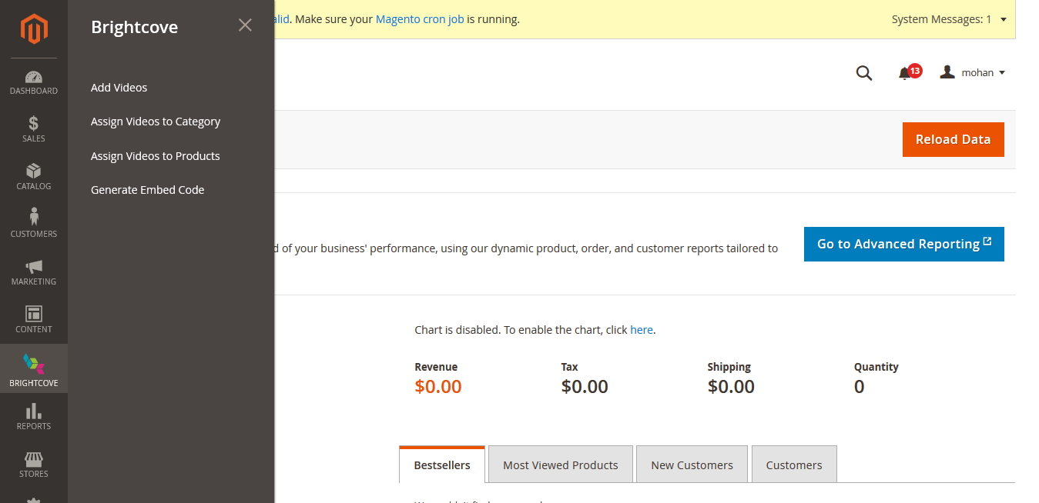

Figure 3 Brightcove Menu – Content

## Brightcove – “Add Video” Menu Page Content

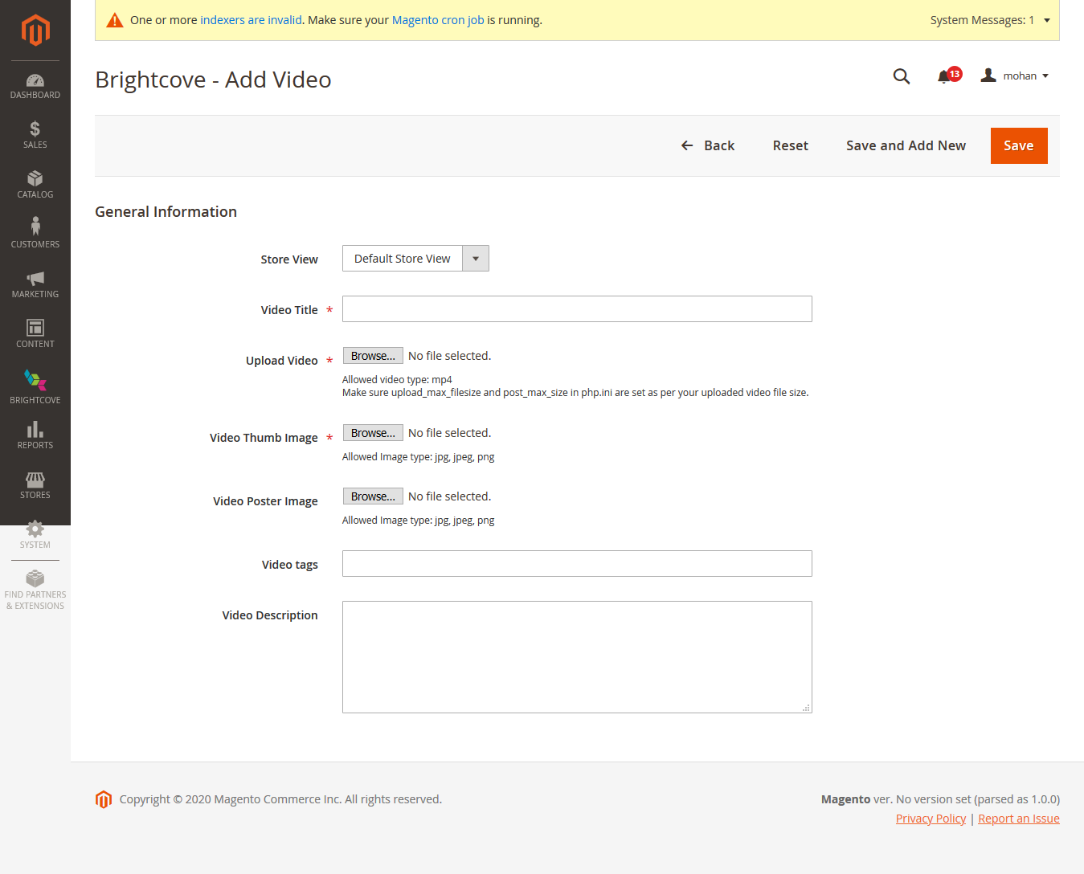

Figure 4 Brightcove – “Add Video” Menu Page Content

* **Functionality :**
  + User can upload the video and video metadata using this page.
* **Fields List:**
  + Store View
    - Shows the list of available Store View Website (Localization)
  + Video Title
    - Video Title is given in this text box.
  + Upload Video
    - Using Browse button, user can upload MP4 Video files.
  + Video Thumb Image
    - Using Browse button, user can upload images (jpg, jpeg, png)
  + Video Poster Image
    - Using Browse button, user can upload images (jpg, jpeg, png)
  + Video Tags
    - we can add video tags in this text box
  + Video Description
    - Video Description cane be added to this text area part

**Note :**

After successfully submitting this form. User concatenate the “store view” code into tags and push into Brightcove. Use this tag value for store filter for implementing Localization in assignment page.

## Brightcove – “Assign Video to Category” Menu Page Content

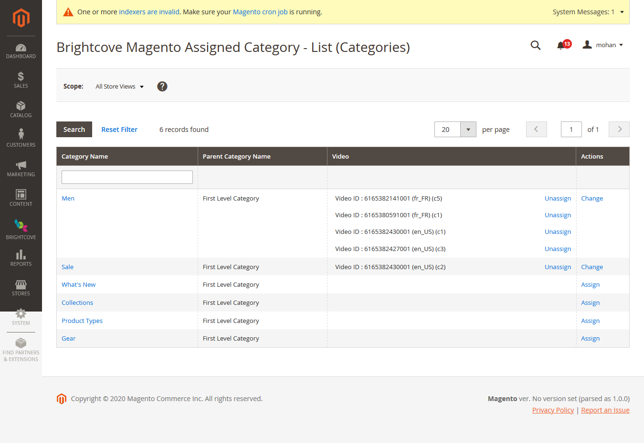

Figure 5 Brightcove – “Assign Video to Category” Menu Page Content

**Functionality:**

* In this page system shows list of main category names and shown, assigned video list and category parent name details.
* Apply Search Category Name Option to filter the records
* Unassign the video for existing
* Navigate sub-category use of category name link
* “Assign” & “Change” link to transfer control to Category Assignment page
* “Unassign” link to disconnect the assignment.
* Upon hovering the video ID Details, system shows the thumbnail image of that video
* Implement the localization filter in top of the content area “Scope - All Store Views”

## Brightcove – “Assign Video to Product” Menu Page Content

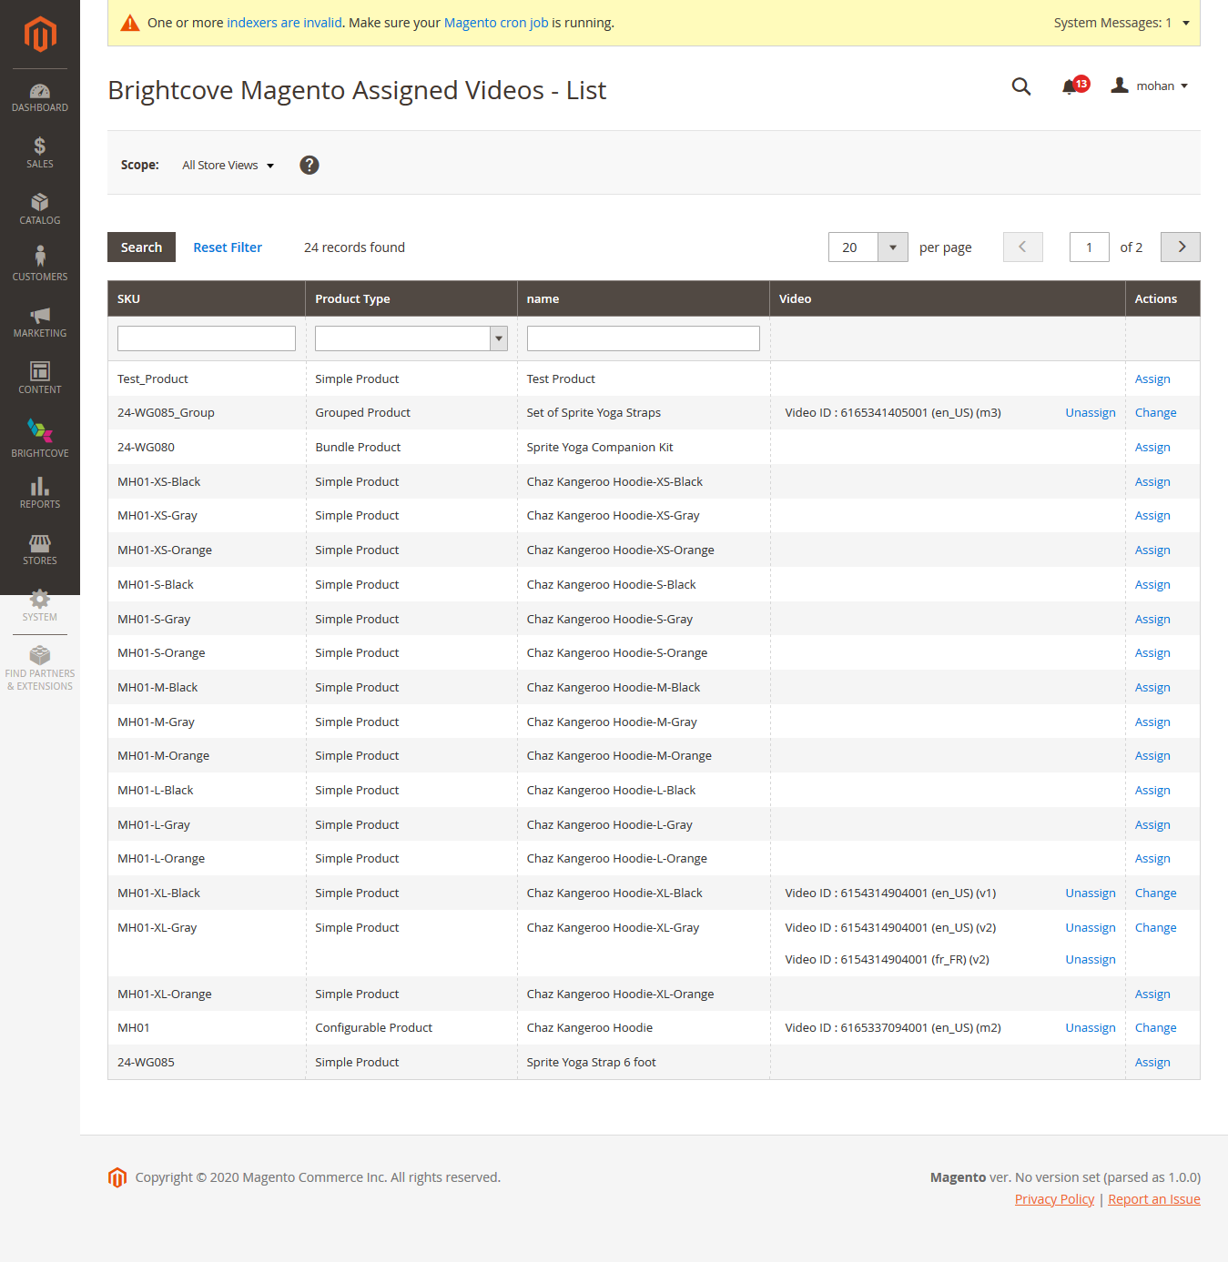

Figure 6 Brightcove – “Assign Video to Product” Menu Page Content

**Functionality:**

* Displays list of product names , assigned video list and product details like SKU, product type, name.
* Apply Search filter for name, SKU and product type (dropdown)
* Unassign the video for existing
* “Assign” & “Change” link to transfer control to Product Assignment page
* “Unassign” link to disconnect the assignment.
* Upon hovering the video ID Details, system shows the thumbnail image of that video
* Implement the localization filter in top of the content area “Scope - All Store Views”

## Brightcove – “Generate Embed Code” Menu Page Content

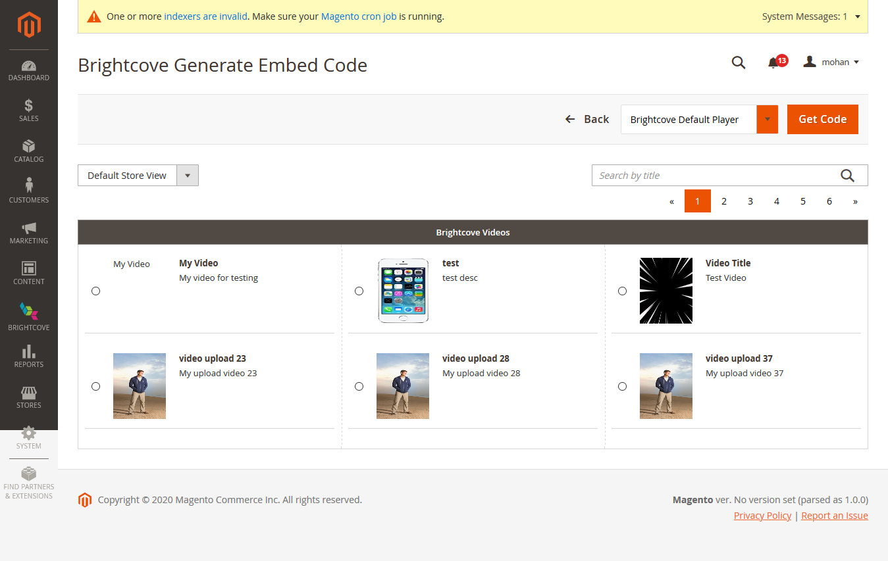

Figure 7Brightcove – “Generate Embed Code” Menu Page Content

**Functionality:**

* User can generate the embedded code for displaying the selected Brightcove video.
* Embedded code display in the popup is of two different types standard and dynamic (responsive) sizes
* It also shows iframe and advanced embedded code

## Brightcove Video Assignment Page in Category

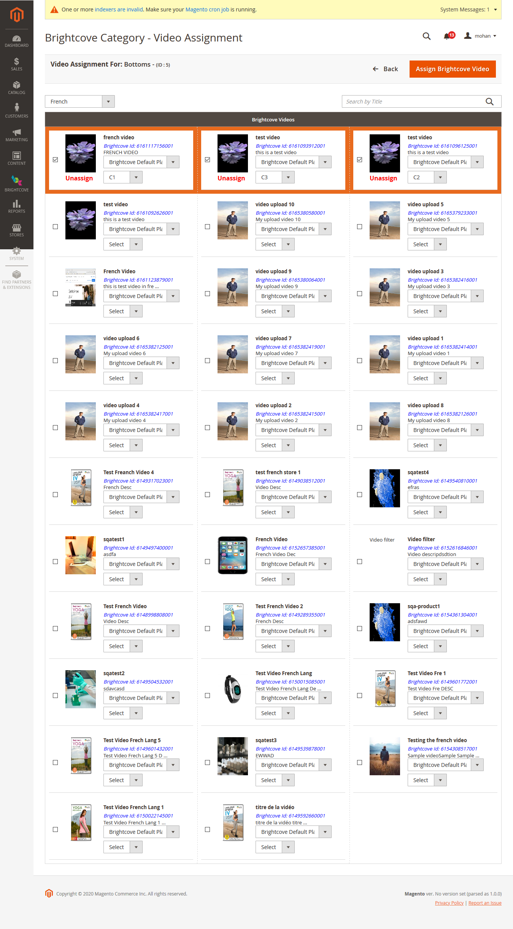

Figure 8 Brightcove Video Assignment Page in Category

**Functionality:**

* Implement the Search “Video Title” in top right text box
* Implement the Localization in top left dropdown
* Brightcove video player
  + In Video column select the player for the selected video
* Slot
  + In Video column using Select dropdown we chose the video slot
* If video is already assigned to this category, it will show the column border orange color and it show “Unassign” Option.

**Note**: No of Slot value is dynamically generated using configuration values

## Brightcove Video Assignment Page in Products

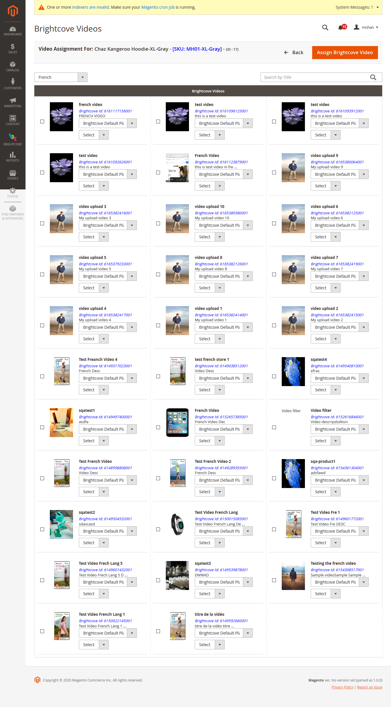

Figure 9 Brightcove Video Assignment Page in Products

**Functionality:**

* Implement the Search “Video Title” in top right text box
* Implement the Localization in top left dropdown
* Brightcove video player
  + In Video column select the player for the selected video
* Slot
  + In Video column using Select dropdown we chose the video slot
* If video is already assigned to this category, it will show the column border orange color and it show “Unassign” Option.

**Note**: No of Slot value is dynamically generated using configuration values

## Brightcove Configuration Page

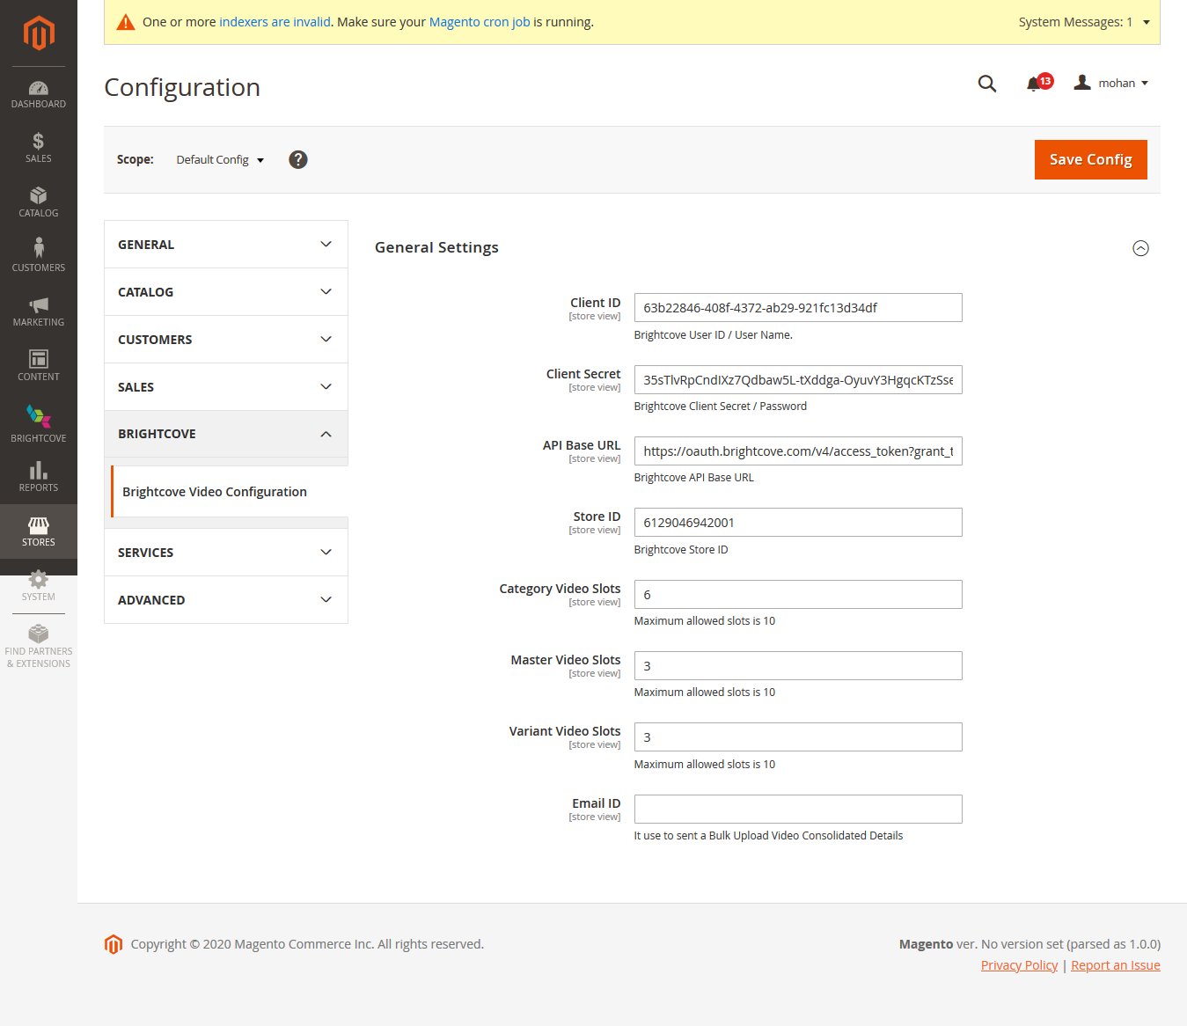

Figure 10 Brightcove Configuration Page

Need to follow the below steps from home page to reach this configuration page.

* Stores -> configuration (Popup In Menu) -> Brightcove (left Side Menu tab)

**Functionality :**

* Client ID: Fill “Brightcove Client ID”
* Client Secret : Fill “Brightcove Secret Key”
* Store ID: Fill “Brightcove Store ID”
* Category Video Slot: Assign the no of video slot below 10
* Variant Product Slot: Assign the no of video slot below 10
* Master Product Slot: Assign the no of video slot below 10
* Email ID: Bulk upload in add new video option. Assign multiple email id with comma separation

## Brightcove – Bulk Import Home Page

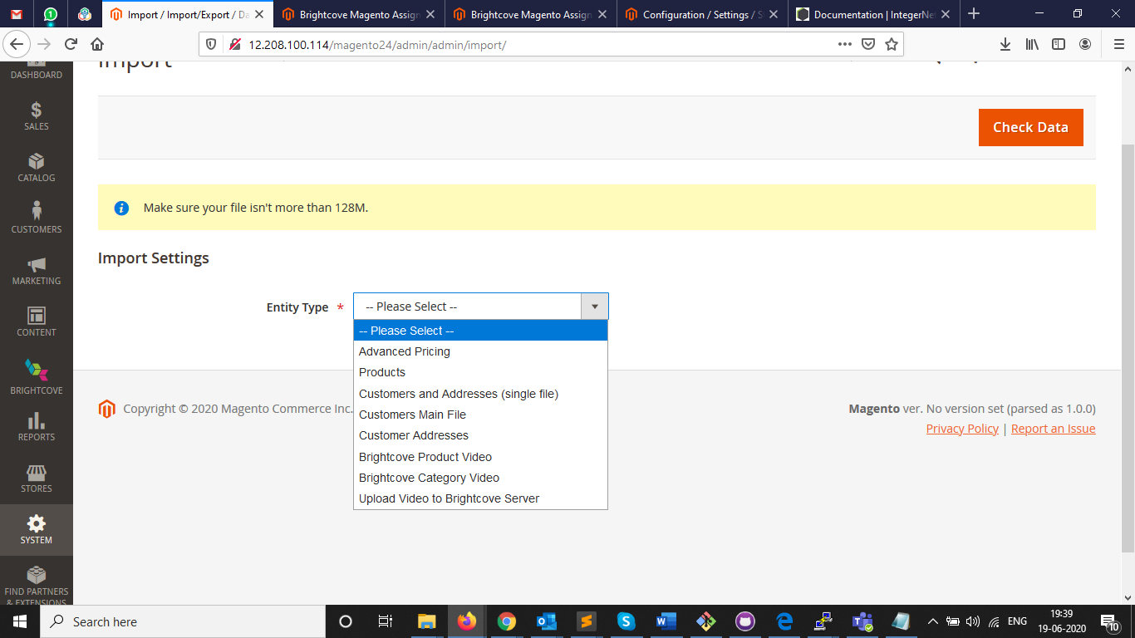

Figure 11 Brightcove – Bulk Import Home Page

Need to follow the below steps from home page to reach this configuration page

* System -> Import

Steps to follow import the files,

* Step 1 : Select the Entity Type (chose our bright options)
* Step 2 : If you don’t have the sample csv file, you can download using sample download link
* Step 3 : Select Import Behavior options
  + Add / Update
    - Add and replace the existing records
  + Replace
    - Replace the records
  + Delete
    - Delete the records
* Step 4 : Using “Browse” button, select the csv file
* Step 5 : After selecting the file, click “Check Data” button in top right
* Step 6 : It uploads CSV file and validate the values and gives the result and “import” button option
* Step 7 : If CSV file doesn’t contain any valid records, it doesn’t show the import option (errors need to be fixed)
* Step 8 : Once Import button click our CSV file upload successfully and give success message

## Brightcove – Bulk Upload Video to Brightcove Server Detail Page

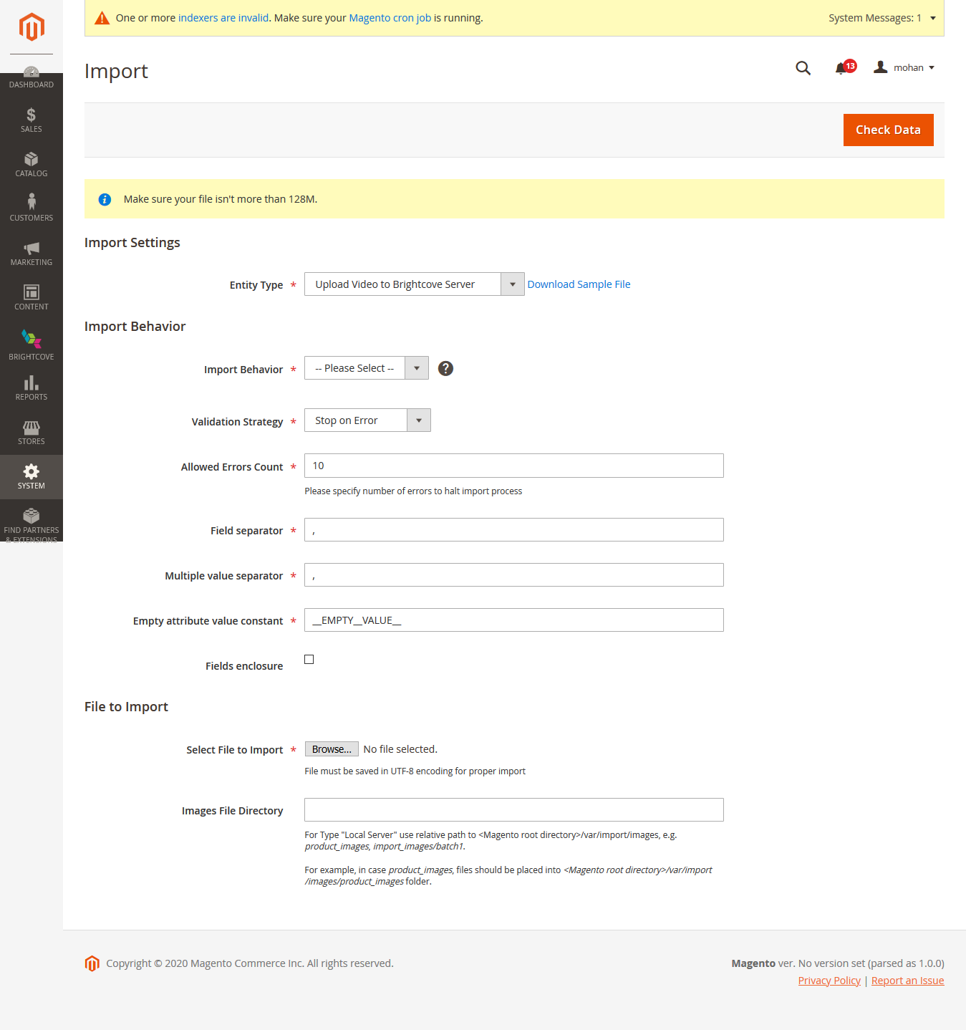

Figure 12 4.13. Brightcove – Bulk Upload Video to Brightcove Server Detail Page

Download the sample csv file using link near to “Entity Type” dropdown

## Brightcove – Bulk Product Assignment Detail Page

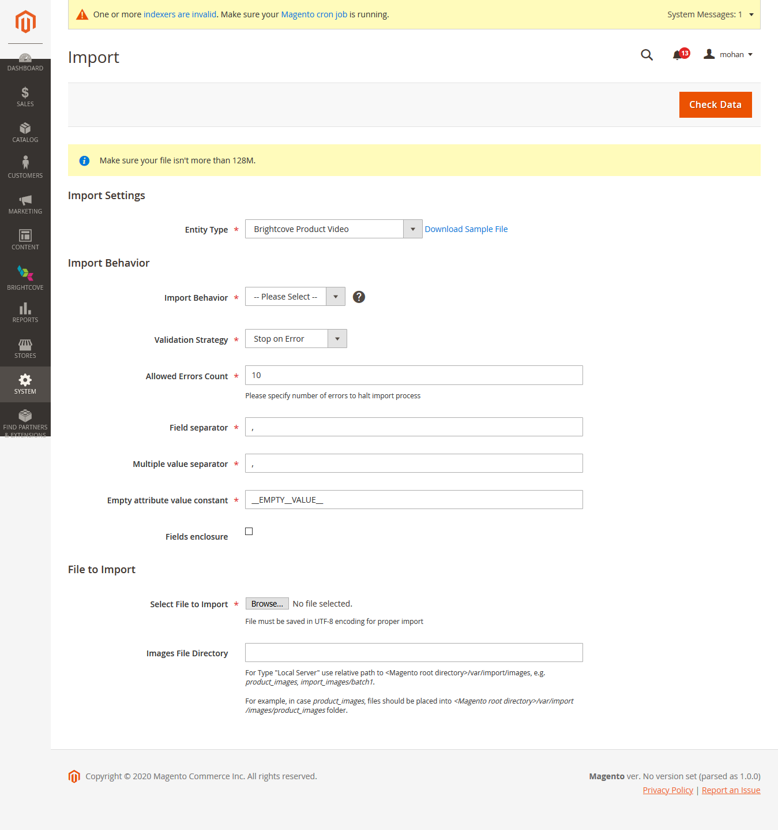

Figure 13 Brightcove – Bulk Product Assignment Detail Page

Download the sample csv file using link near to “Entity Type” dropdown

## Brightcove – Bulk Category Assignment Detail Page

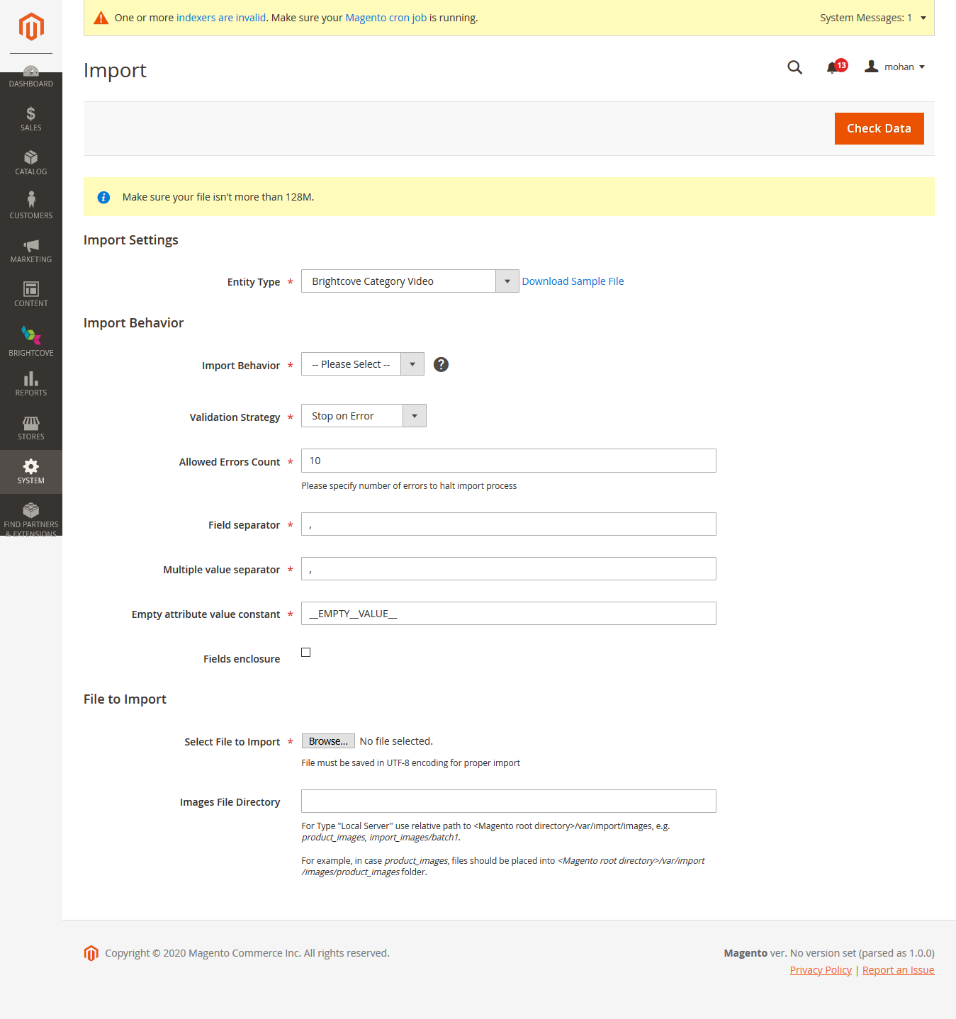

Figure 14 Brightcove – Bulk Category Assignment Detail Page

Download the sample csv file using link near to “Entity Type” Dropdown