Royal Cyber Inc.

Installation Guide

Brightcove custom cartridge for Salesforce Commerce Cloud

Contents

Overview 2

Functional Overview 2

Compatibility 2

Limitations 2

Installation Steps 3

Upload Cartridges: 3

Configure Salesforce Commerce Cloud Business Manager 4

Import System Object Extensions Files 8

Import Services File 10

Import Job File 12

Add Brightcove Features Under Roles & Permissions 14

Configure Custom Site Preferences 15

Include Brightcove Video Rendering in ISML Files 17

SFRA Cartridge – app_brightcove 17

SiteGenesis Cartridge – int_brightcove 18

# Overview

This document provides technical instructions for installing Brightcove custom cartridge, as well as setting up SFCC Business Manager, for integrating Brightcove Video Cloud with Salesforce Commerce Cloud (SFCC).

## Functional Overview

This custom cartridge is developed based on specifications provided by Brightcove. It enables Salesforce Commerce Cloud business users, to upload videos files to the Brightcove Cloud server through SFCC Business Manager, and publish these files on the storefront (product details page, category landing page, product listing page, etc.).

## Compatibility

The custom cartridge is designed for Salesforce Commerce Cloud API with controllers for extended functionality. Custom cartridges are available for SFRA and Site Genesis architecture. Clients should install version according to their Salesforce Commerce Cloud architecture.

## Limitations

As mentioned above, Brightcove SFCC custom Cartridge is designed to meet Brightcove’s specific requirements to integrate video files residing on Brightcove cloud server with SFCC. To make use of this cartridge, one must contact Brightcove and signup.

# Installation Steps

## Upload Cartridges:

1. Extract the zip file.
2. Upload cartridges (bm_brightcove, int_brightcove and app_brightcove) to the Salesforce Commerce Cloud instance.
3. Activate the code version with the uploaded cartridges.

## Configure Salesforce Commerce Cloud Business Manager

1. Login to Business Manager.
2. Navigate to ***Administration -> Manage Sites***
3. Select the site from the list.
4. Select ***Settings*** tab.
5. Add ***app_brightcove*** in the cartridge path for SFRA site as show below in the screenshot.

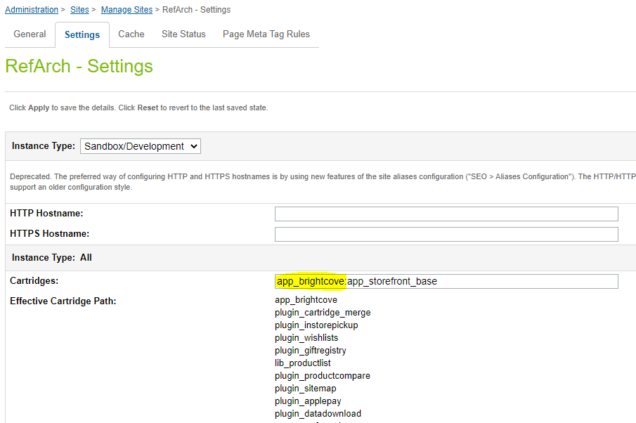

1. Apply changes.
2. Add ***int_brightcove*** in the cartridge path for SiteGenesis architecture site as show below in the screenshot.

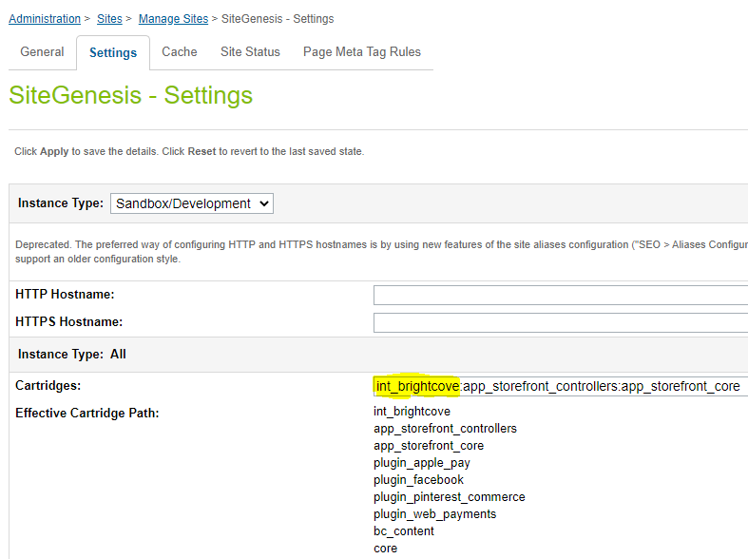

1. Apply changes.
2. Navigate to ***Administration -> Manage Sites***
3. Select ***Business Manager*** as show below in the screenshot below

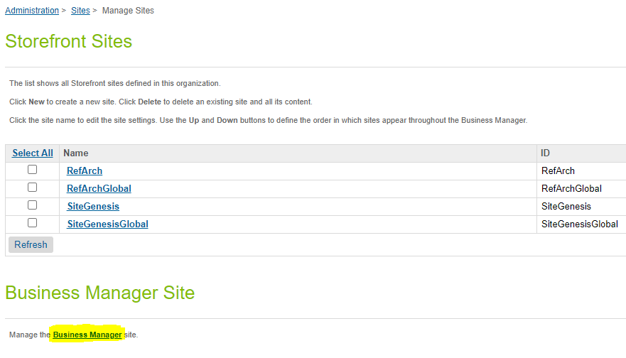

1. Add ***bm_brightcove*** in the cartridge path for Business Manager as show below in the screenshot.

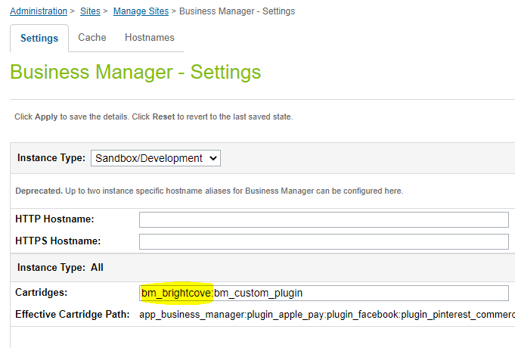

1. Apply changes.

## Import System Object Extensions Files

1. Navigate to Administration -> Site Development -> Import & Export.
2. Select ***Upload*** option under ***Import & Export Files*** section as shown in the screenshot below.

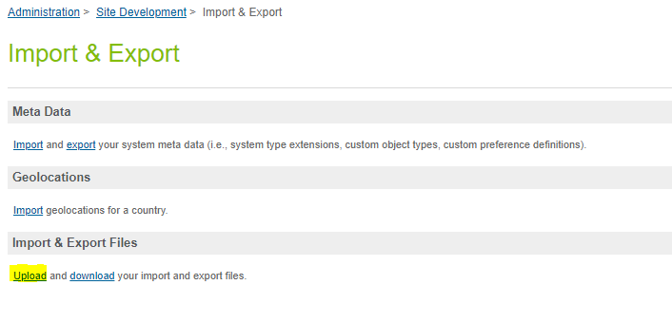

1. Upload ***brightcove-objecttype-extensions.xml*** from the ***meta*** directory of the zip file.
2. Navigate to Administration -> Site Development -> Import & Export.
3. Select ***Import*** option under ***Meta Data*** section as shown in the screenshot below.

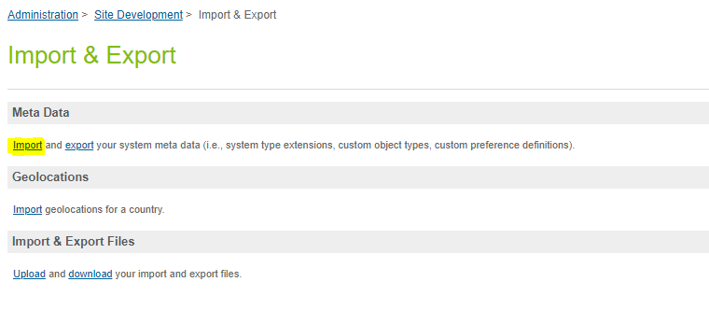

1. Import ***brightcove-objecttype-extensions.xml*** file.

## Import Services File

***Note: Clean Brightcove Folder job should be scheduled to execute after every 24 hours to clean up the files under static directory in ‘Brightcove_Folder’***.

1. Navigate to Administration -> Operations -> Import & Export.
2. Select ***Upload*** option under ***Import & Export Files*** section as shown in the screenshot below.

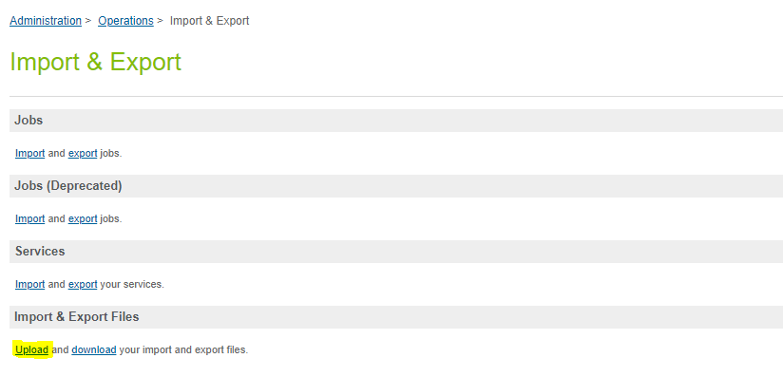

1. Upload ***brightcove_services.xml*** from the ***meta*** directory of the zip file.
2. Navigate to Administration -> Operations -> Import & Export.
3. Select ***Import*** option under ***Services*** section as shown in the screenshot below.

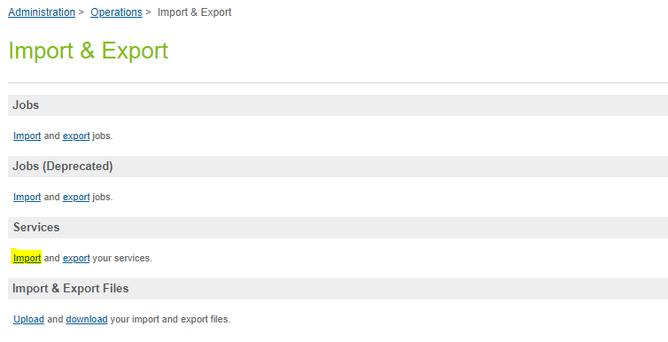

1. Import ***brightcove_services.xml*** file.

## Import Job File

1. Navigate to Administration -> Operations -> Import & Export.
2. Select ***Upload*** option under ***Import & Export Files*** section as shown in the screenshot below.



1. Upload ***brightcove_jobs.xml*** from the ***meta*** directory of the zip file.
2. Navigate to Administration -> Operations -> Import & Export.
3. Select ***Import*** option under ***Jobs*** section as shown in the screenshot below.

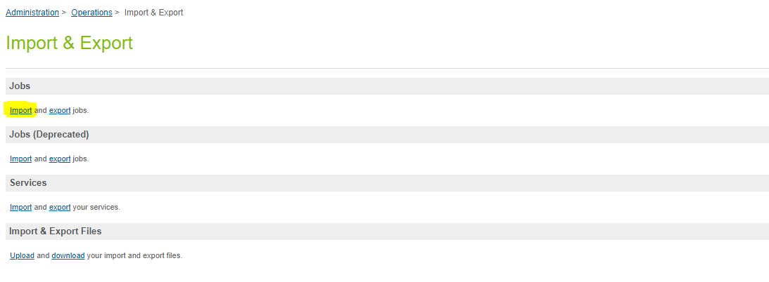

1. Import ***brightcove_jobs.xml*** file.
2. Select site context for the jobs listed below:
   1. Brightcove-BulkAssign.
   2. Brightcove-BulkUpload.
3. Create jobs manually:
   1. Navigate to ***Administration -> Jobs***.
   2. Create New Job.
   3. Select ***Job Steps***.
   4. Enter step ID.
   5. Select scope
4. Jobs to be created:
   1. Bulk Assign
   2. Bulk Upload
   3. Clean Brightcove Folder
5. Steps:
   1. custom.bulkAssign (Specific-site)
   2. custom.bulkUpload (Specific-site)
   3. custom.CleanFolderBrightcove (Organization)

## Add Brightcove Features Under Roles & Permissions

1. Navigate to ***Administration -> Organization -> Roles & Permissions***.
2. Select role from the list to grant access to Brightcove features.
3. Select ***Business Manager Modules***.
4. Select ***Site Context*** as shown in the screenshot below.

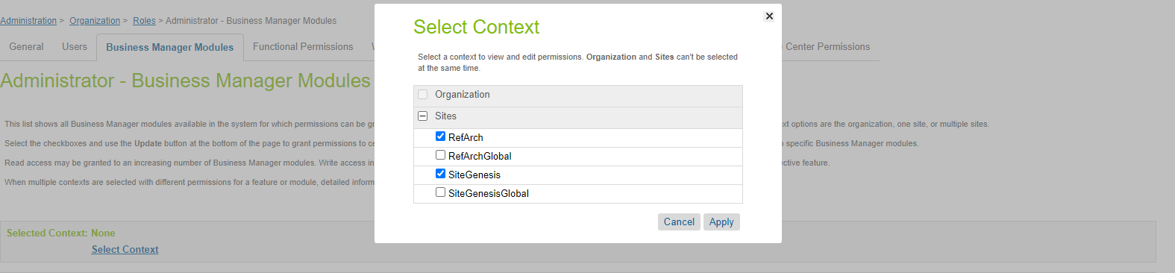

1. Apply context.
2. Scroll down to the ***Brightcove*** section.
3. Select all the features and click ***Update*** as shown is the screenshot below.

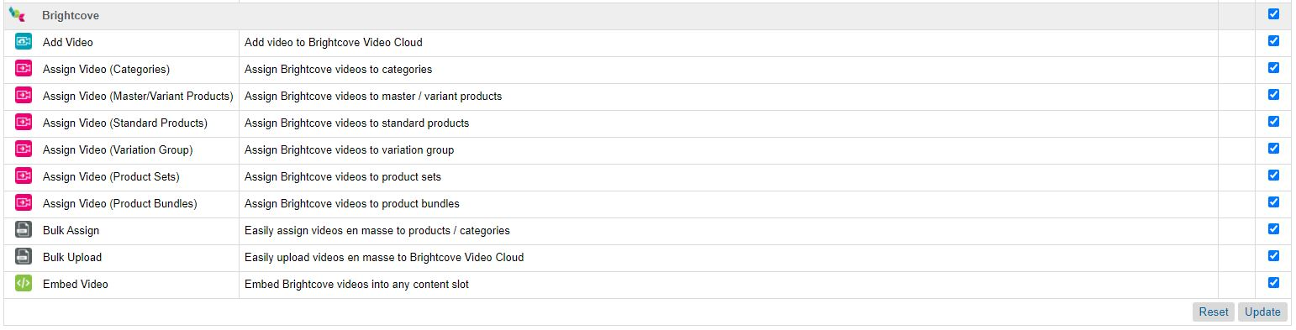

## Configure Custom Site Preferences

1. Select a Site from the dropdown as shown in the screenshot below.

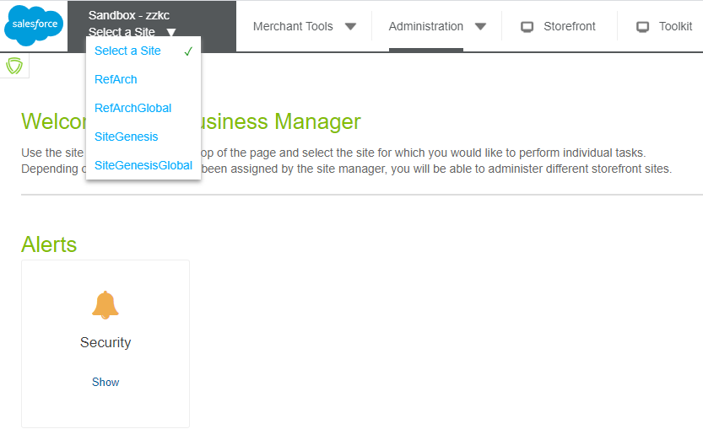

1. Navigate to ***Merchant Tools -> Site Preferences -> Custom Preferences***
2. Select ***Brightcove***.
3. Add the following values:
   1. Brightcove Account ID
   2. Brightcove ClientID
   3. Brightcove Client Secret

as shown in the screen below.

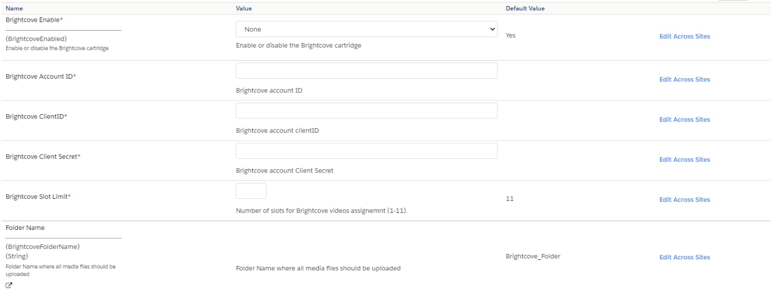

1. Add Brightcove Slot Limit between ***1 to 11***. The default value is ***11***.
   1. Slots for Master Products (***master*** and ***m1-m10***)
   2. Slots for Variant Products (***v1-v11***)
   3. Slots for Standard Products (***v1-v11***)
   4. Slots for Product Sets (***ps1-ps11***)
   5. Slots for Product Bundles (***pb1-pb11***)
   6. Slots for Variation Groups (***vg1-vg11***)
   7. Slots for Categories (***c1-c11***)
2. Slot limit ***5*** will provide below slots for configurations
   1. Master products (***master*** and ***m1-m4***)
   2. Variant and Standard products (***v1-v5***)
   3. Product Sets (***ps1-ps5***)
   4. Product Bundles (***pb1-pb5***)
   5. Variation Groups (***vg1-vg5***)
   6. Categories (***c1-c5***)

# Include Brightcove Video Rendering in ISML Files

## SFRA Cartridge – app_brightcove

1. Video rendering is supported for the below ISML files:
   1. productDetails.isml
   2. catLanding.isml
   3. searchResultsNoDecorator.isml
   4. bundleDetails.isml
   5. setDetails.isml
2. Include modules.isml

<isinclude template=*"modules"*>

1. Include the tags from modules.isml file to render video
   1. Master Product Video <isM1>, this will render the video assigned to the ***m1*** slot
   2. Variant Product Video <isV1>, this will render the video assigned to the ***v1*** slot
   3. Standard Product Video <isV1>, this will render the video assigned to the ***v1*** slot
   4. Product Set Video <isPS1>, this will render the video assigned to the ***ps1*** slot
   5. Product Bundle Video <isPB1>, this will render the video assigned to the ***pb1*** slot
   6. Variation Group Video <isVG1>, this will render the video assigned to the ***vg1*** slot
   7. Category Video <isC1>, this will render the video assigned to the ***c1*** slot

## SiteGenesis Cartridge – int_brightcove

1. Video rendering is supported for the below ISML files:
   1. productcontent.isml
   2. producttopcontent.isml
   3. producttopcontentPS.isml
   4. categoryproducthits.isml
   5. catlanding.isml
2. Include modules.isml

<isinclude template=*"modules"*>

1. Include the tags from modules.isml file to render video
   1. Master Product Video <isM1>, this will render the video assigned to the ***m1*** slot
   2. Variant Product Video <isV1>, this will render the video assigned to the ***v1*** slot
   3. Standard Product Video <isV1>, this will render the video assigned to the ***v1*** slot
   4. Product Set Video <isPS1>, this will render the video assigned to the ***ps1*** slot
   5. Product Bundle Video <isPB1>, this will render the video assigned to the ***pb1*** slot
   6. Variation Group Video <isVG1>, this will render the video assigned to the ***vg1*** slot
   7. Category Video <isC1>, this will render the video assigned to the ***c1*** slot