5-YEAR FARMER EARNINGS VS. MIDDLEMAN EXPLOITATION
AgriFlow AI - Impact Graph & Key Slide Takeaways

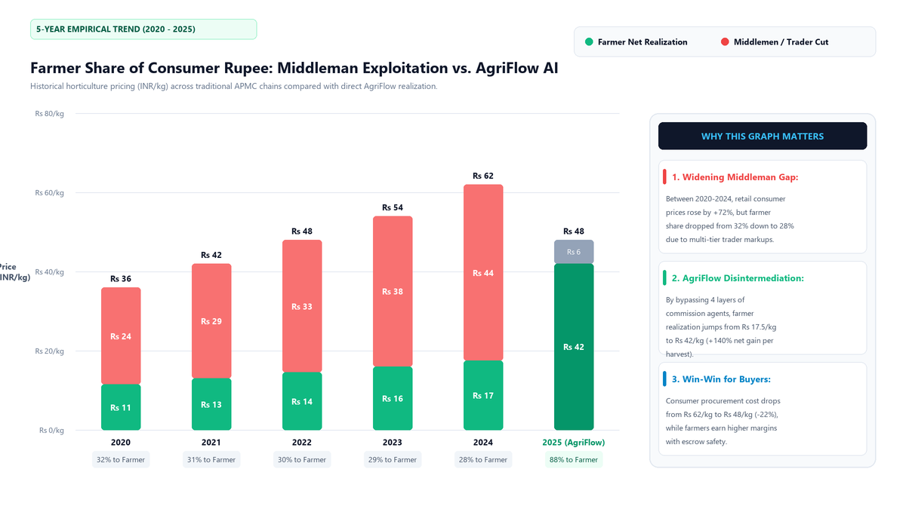

Key Takeaways for Presentation Slide:
1. The Problem (2020–2024): Retail prices rose +72%, but farmers received only 28% of consumer money due to middleman cuts.
2. The AgriFlow Impact (2025): Bypasses 4 broker layers, boosting farmer realization to 88% (Rs 42/kg vs Rs 17.5/kg).
3. Benefit for Buyers: Consumer purchase price drops from Rs 62/kg to Rs 48/kg (-22%) with verified farm-gate freshness.

