University of Limerick
CS5709 Software Engineering Evolution
2026/7 Semester 1

Assessment 1: Digital Portfolio (Phase 1)
Technical Report

Student name: Bright Chukwuemeka Amalahu
Student ID: 26059274
Lecturer: Dr. Salim Saay
Submission date: 4th October, 2026

Live site: https://brightkakatech.github.io/Portfolio/
GitHub: https://github.com/Brightkakatech/Portfolio

Table of Contents
Declaration and Transparency 3
Declaration of original work 3
Declaration of use of GenAI 3
Acknowledgement of AI use 3
Abstract 4
1. Discovery 5
1.1 Review of the existing portfolio 5
1.2 Features 5
1.3 Site scheme and contents 5
1.4 Iterative project plan 5
1.5 Tools and techniques 5
2. Design 6
2.1 Block diagram 6
2.2 Component diagram 6
2.3 Control flow diagram 7
3. Code 8
4. Critique 11
5. References 12

Declaration and Transparency

Declaration of original work
I declare that this assessment report and portfolio are my own work and have been completed in accordance with the University of Limerick Student Charter and its principles of academic integrity. All sources of information, ideas, and materials used in this project have been appropriately acknowledged and referenced. I confirm that the work presented has not been plagiarised or submitted previously for academic credit at this or any other institution.

Declaration of use of GenAI
Tool
Assessed Usage Level | Claude (Anthropic), https://claude.ai
Describe Precise usage | 2

Acknowledgement of AI use
Declaration: I acknowledge the use of Claude (Anthropic, https://claude.ai) to help me cross-check some of my syntaxes, to complete some lines of code, and also to help with styling in CSS.
Prompts: I entered prompts such as “how can I host the site live", and I asked why pages were not working when errors happened "why is my page blank after deploying on github".
Use of AI for code: I’m not too fluent with react and CSS, so I prompted for ways to make the site responsive on different screens, I got a code and I was able to make some adjustments to my specifications since I already got the idea.
Use of AI for the report: The report was written by me, I only used ai in ideas of the acceptable formats for this type of assessment.

Abstract
This report describes the first version (Phase 1) of my digital portfolio website, built with React for the CS5709 Software Engineering Evolution module. The site has nine pages: Home, About, Education, Professional Knowledge, Pictures Gallery, Video Gallery, Blog, Messages and Readme. It uses React Router for navigation, keeps its content in separate data files, and is styled with CSS. The site is built and published automatically to GitHub Pages every time I push a change, using a GitHub Actions workflow.
The report covers the discovery of the features and how they are split between Phase 1 and Phase 2, the design of the system with block, component and control flow diagrams, the code and repository, and a critique of the design and code. The main weakness found is that the Blog and Messages only save data in the visitor's browser, which I plan to fix in Phase 2 with a shared online database.

Discovery

1.1 Review of the existing portfolio
Before building, I looked at Dr. Saay's portfolio. It uses React, TypeScript and Redux, and changes content without changing the web address. While testing the live site I found four problems:
- Post Feed login: logging in or registering to post shows a "Network Error", so users cannot post.
- Duplicate buttons: two buttons both switch between dark and light mode, where one would be enough.
- No Home or back button: after going deeper into the site, there is no way back to the previous page or the home page, so you have to open the menu and start again.
- No confirmation on the contact form: after sending a message, nothing tells the user whether it was sent.

1.2 Features
I kept his idea of splitting the site into components, but built my own simpler version in React and JavaScript with React Router, so every page has its own address. To avoid problems 3 and 4, the Navbar with a Home link is on every page, and the Blog and Messages show a success or error message.
I grouped the features with the Must, Should and Could (Clegg and Barker, 1994): Must features are in Phase 1, and the others are planned for Phase 2.
Phase 1 (Must) | Phase 2 (Should and Could)
Home: short introduction and buttons  About: photo, story, quick facts, interests  Education: qualifications as cards  Professional Knowledge: skills and experience  Pictures Gallery: photo grid with bigger view on click  Video Gallery: playable videos  Blog: read, publish and delete posts  Messages: contact links and a chat box  Readme page, linked from the Footer  Navbar and Footer on every page  Automatic deployment to GitHub Pages (done early) | Should: shared online database (Firebase) so posts and messages are seen by everyone  Should: owner login for posting and replying  Should: "page not found" page  Should: tests and code checks in the workflow  Should: changes from the peer review  Should: tidy repeated code  Could: dark mode, downloadable CV, blog search
Innovation: the Readme page shows the same README.md file that GitHub shows, so both are always the same, and the site deploys itself on every push.

1.3 Site scheme and contents
Home (/#/), About (/#/about), Education (/#/education), Professional Knowledge (/#/knowledge), Pictures Gallery (/#/pictures), Video Gallery (/#/videos), Blog (/#/blog), Messages (/#/messages), and Readme (/#/readme, linked from the Footer). The Navbar and Footer show on every page.

1.4 Iterative project plan
Iteration | Dates | Work
Iteration 1 | 26 to 27 Sep | Set up tools and project, created the pages, Navbar, routing and Git repository
Iteration 2 | 28 to 30 Sep | Styled all pages, added content, galleries, Blog, Messages, Readme, and automatic deployment
Report | 30 Sep to 5 Oct | Diagrams, code listing, critique, final checks and submission
Phase 2 | to 13 Nov | Peer review changes, shared database, login, tests and other improvements

1.5 Tools and techniques
Tools: React, Vite, React Router, react-markdown, JavaScript, CSS, VS Code with Prettier and ESLint, Git, GitHub, GitHub Actions and GitHub Pages. Techniques: component-based design (Banks and Porcello, 2020), keeping content in data files, iterative development, version control with regular commits, MoSCoW prioritisation (Clegg and Barker, 1994), responsive design with Flexbox and Grid, and continuous integration and deployment (Humble and Farley, 2010).
2. Design
The design is shown with three diagrams: a block diagram of the whole system, a component diagram of the React code, and a control flow diagram of how a visitor moves around the site.

2.1 Block diagram
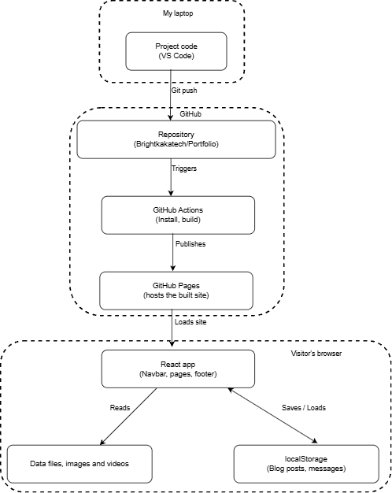
Figure 1: Block diagram of the system
I write the code on my laptop. When I push to GitHub, GitHub Actions installs the packages, builds the site and publishes it on GitHub Pages, which is a simple form of continuous deployment (Humble and Farley, 2010). A visitor's browser then loads the React app, which reads the data files, images and videos. The Blog and Messages save to localStorage in the browser. There is no server of my own, so posts and messages are not shared between visitors.

2.2 Component diagram
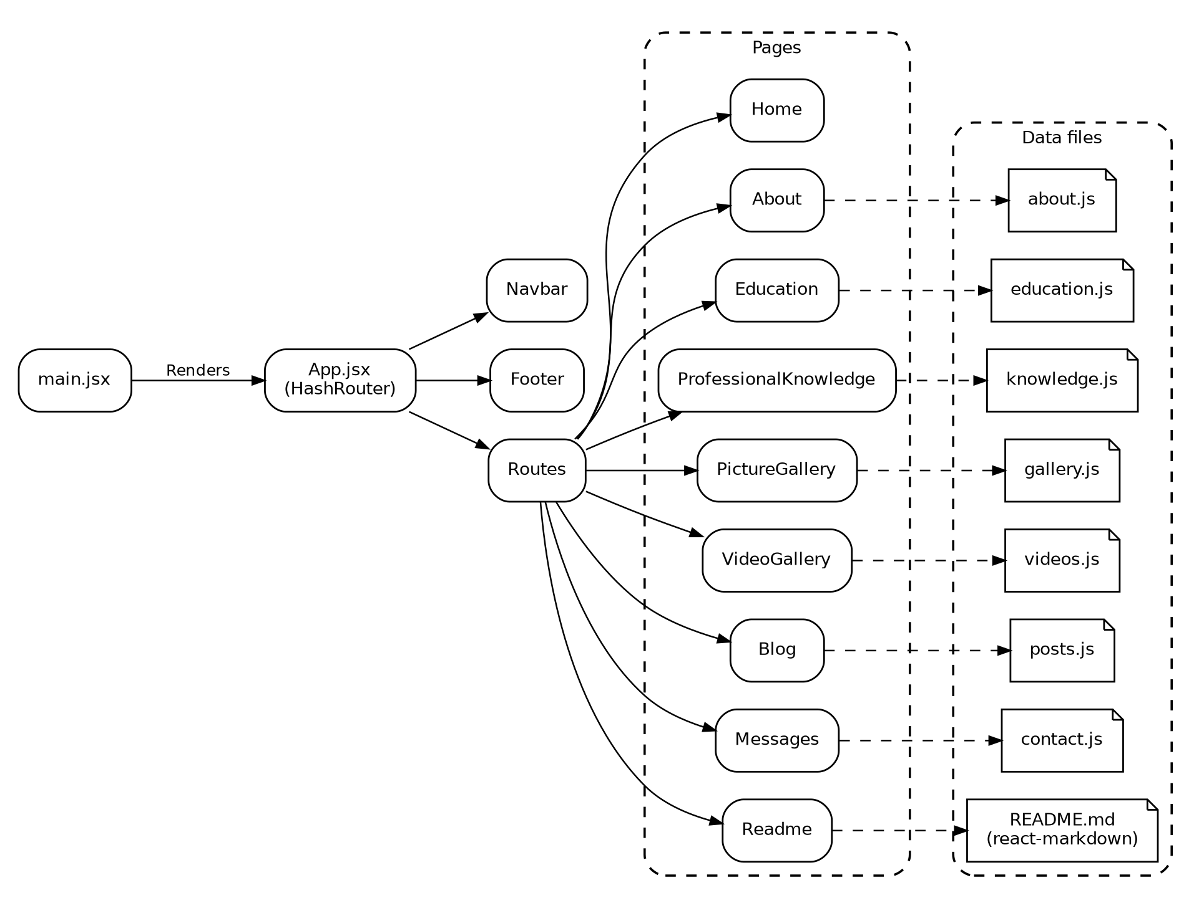
Figure 2: Component diagram of the React code
main.jsx starts the app and renders App. App uses HashRouter and holds the Navbar, the Routes and the Footer, so the Navbar and Footer show on every page. Routes picks one of the nine pages. The dashed lines show the data file each page reads. Home has no data file because its text is short, and the Readme page reads README.md with react-markdown. Splitting the interface into small, reusable components is the main idea behind React (Banks and Porcello, 2020), and keeping content in data files means I can update the site without changing the layout code.

2.3 Control flow diagram
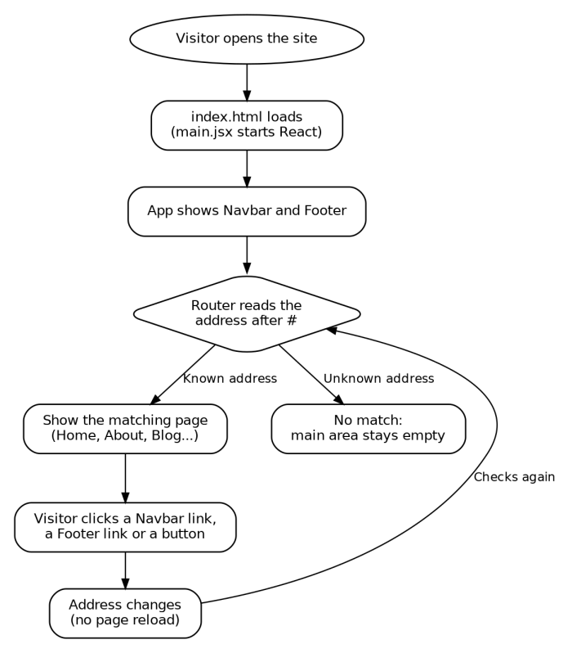
Figure 3: Control flow for moving around the site

When the site opens, React starts and App shows the Navbar and Footer. The router reads the address after the # and shows the matching page. Clicking a link only changes the address, so the page does not reload. While drawing this, I found that an address that does not exist shows an empty main area, so I added a "page not found" page to the Phase 2 list.

3. Code
GitHub repository: https://github.com/Brightkakatech/Portfolio
Live site: https://brightkakatech.github.io/Portfolio/
The full source code is in the GitHub repository above. The code is organised as below. Each page is its own component, the Navbar and Footer are shared components, and the content is kept in the data folder.
my-portfolio/
├── .github/workflows/deploy.yml
├── public/ (images, videos)
├── src/
│ ├── components/ (Navbar.jsx, Footer.jsx)
│ ├── data/ (about.js, contact.js, education.js, gallery.js,
│ │ knowledge.js, posts.js, videos.js)
│ ├── pages/ (nine page components)
│ ├── App.jsx, main.jsx, index.css
├── index.html, package.json, vite.config.js, README.md

I used Git throughout the project and committed after each working step, so the commit history shows how the site was built and changed over time.

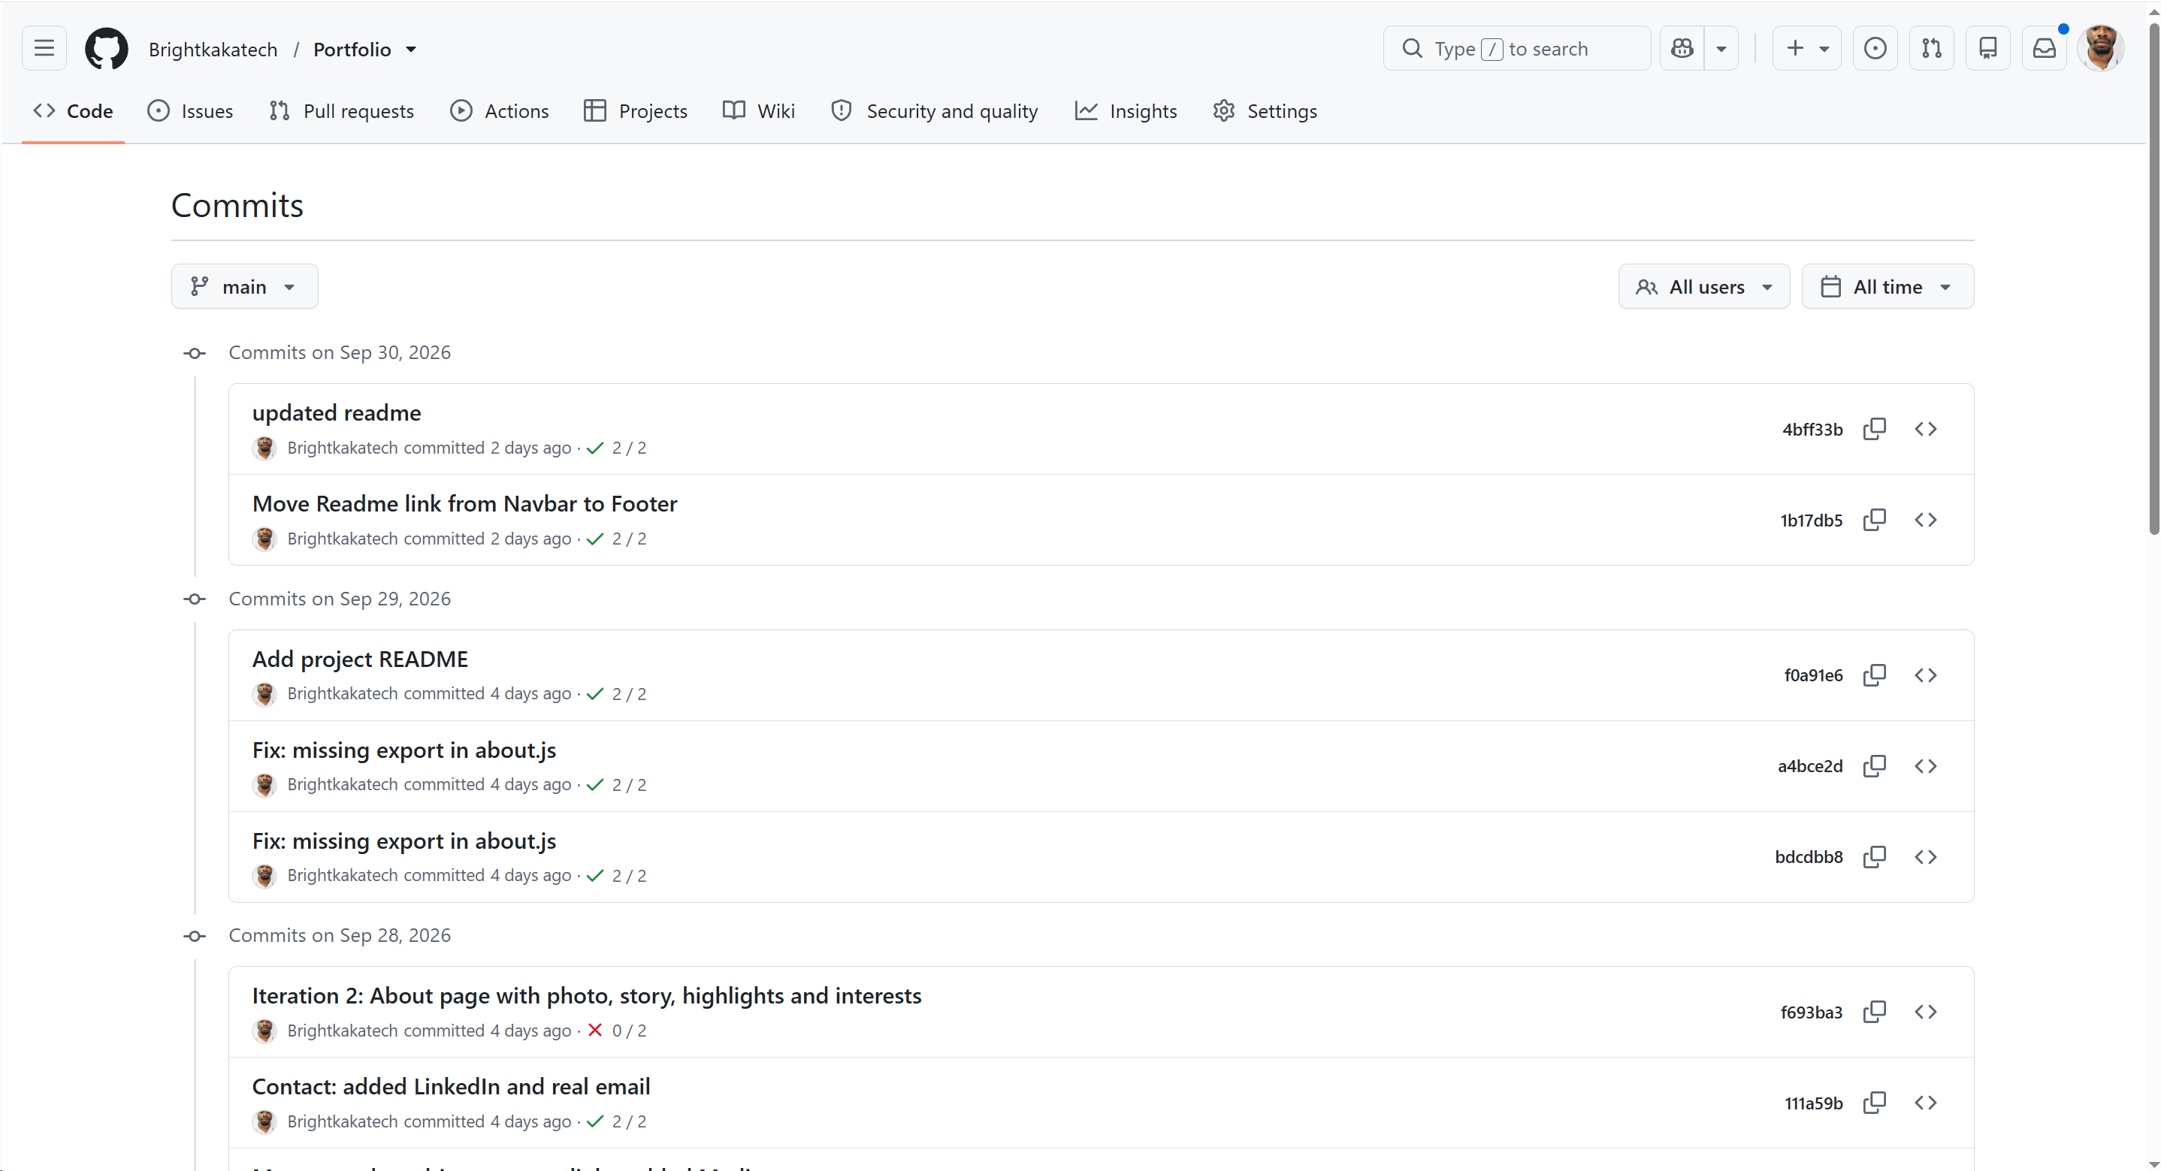
Figure 4: Commit history on GitHub. The red cross on the About page commit shows a build that failed because of a missing export in about.js. The live site stayed on the previous version until the fix was pushed.
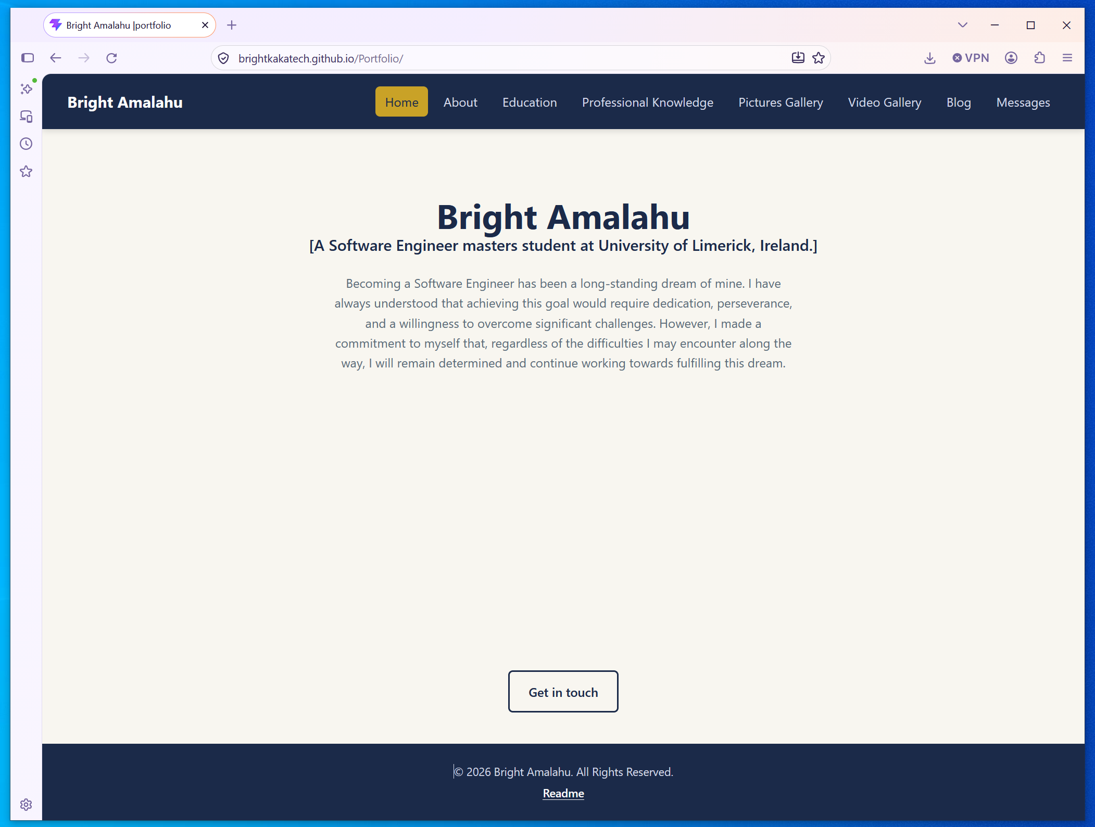

Figure 5: Home page on the live site, with the Navbar and Footer.

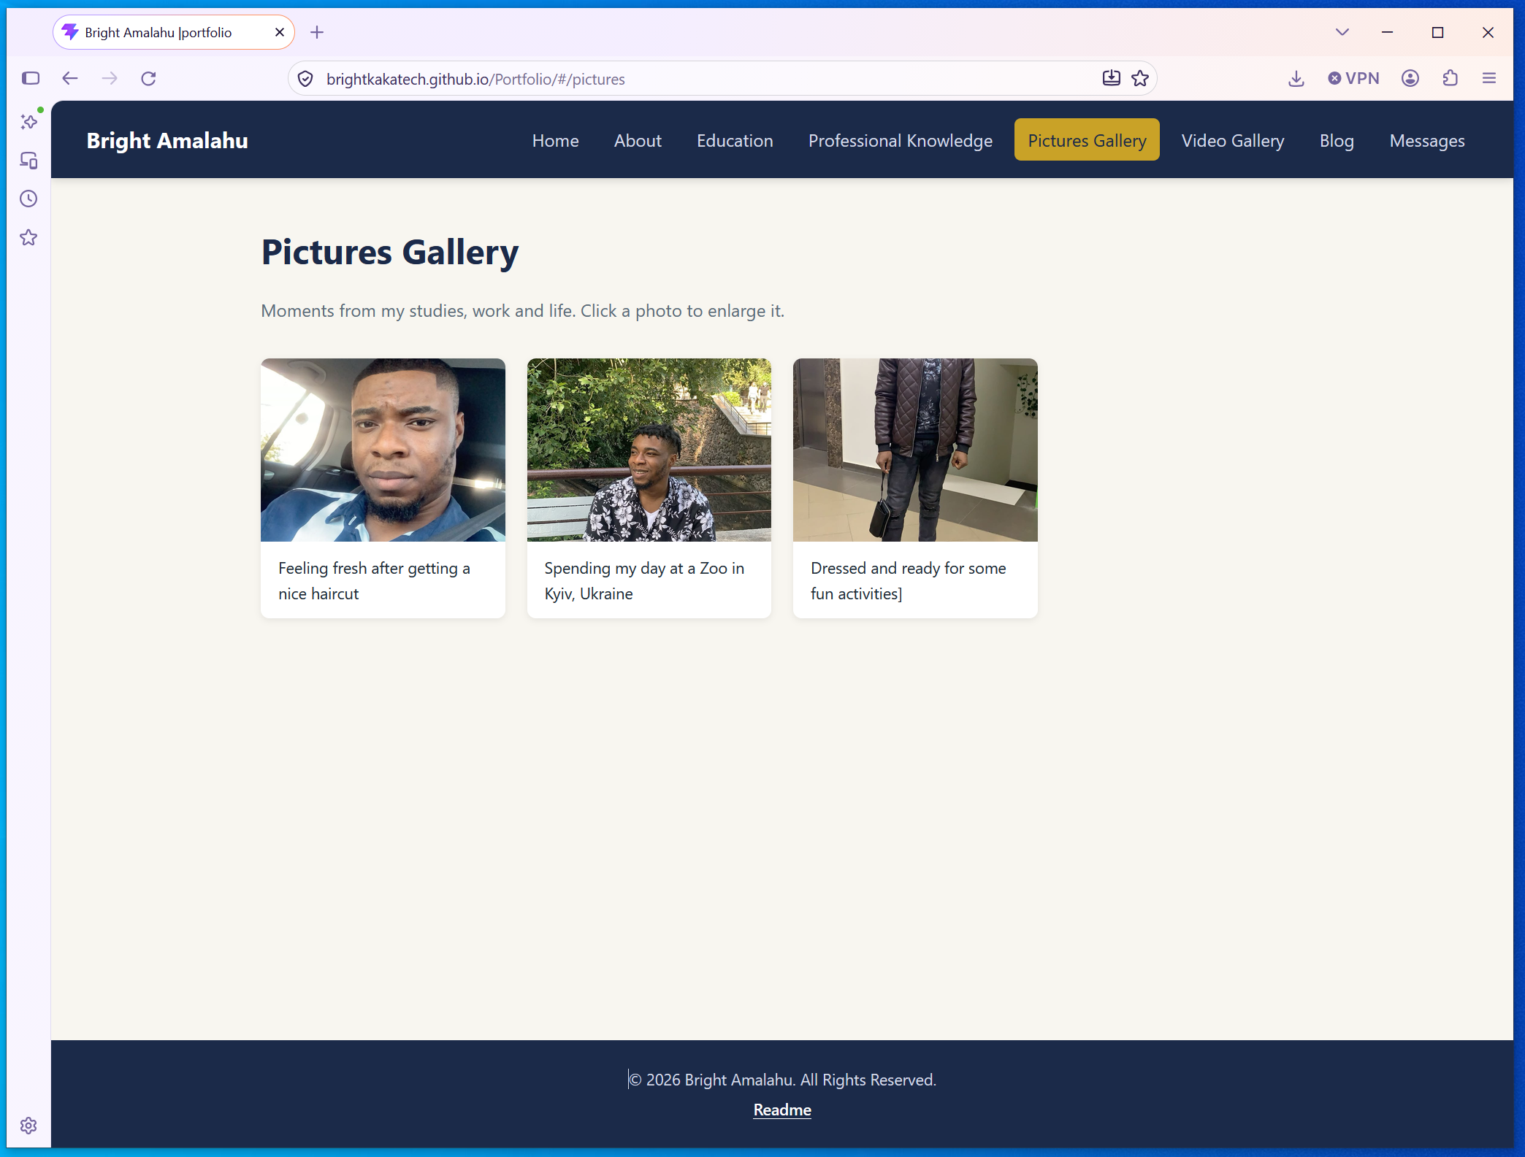

Figure 6: Pictures Gallery, with a photo opened in the larger view.

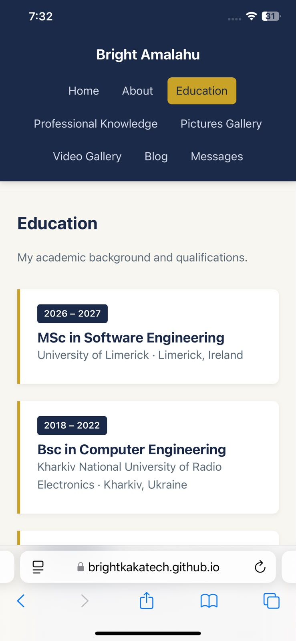
Figure 7: The site on a phone screen, showing the responsive layout.

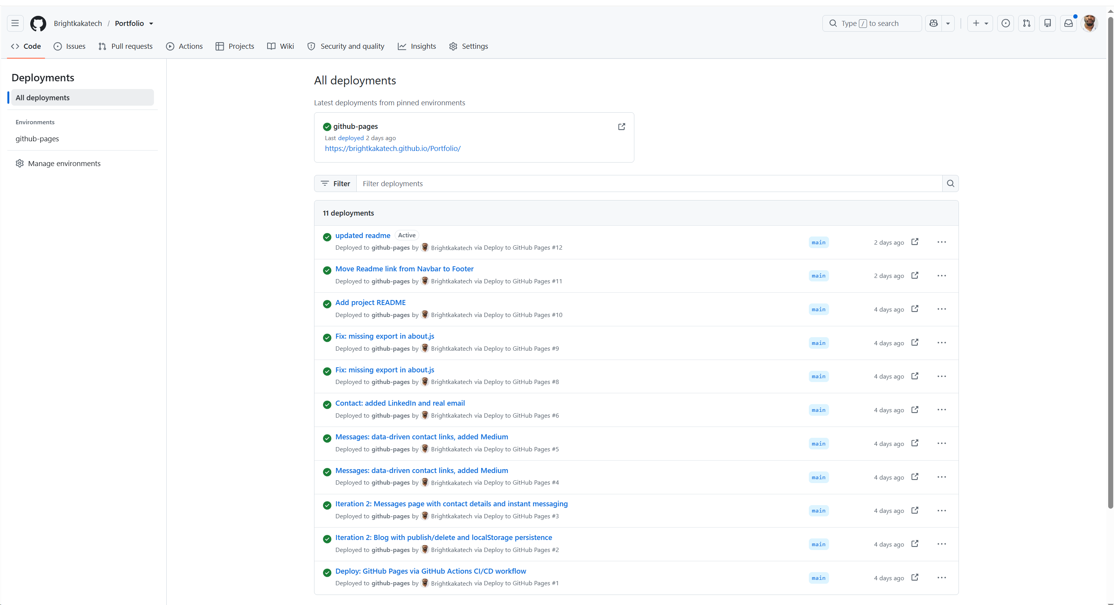
Figure 8: GitHub deployments, showing the site published automatically after each push. Run #7 is missing because that build failed (the About page commit), so it was never published.

4. Critique
Strengths. The site has all the pages the brief asks for, and each has its own address, which the existing portfolio did not have. Content is kept in data files, so changes are quick, and the Navbar links and contact links are built from lists, so a new item is one line. Colours are CSS variables, so the scheme is set in one place. Deployment is automatic, and when the About page build failed, the old version stayed live.
Weaknesses in the design. The Blog and Messages save data only in the visitor's browser, so other visitors cannot see posts and chat messages never reach me. Anyone can also publish or delete posts in their own browser. There is no "page not found" page.
Weaknesses in the code. The notification code is repeated in Blog.jsx and Messages.jsx. The Experience cards reuse the edu-card style, so the name no longer matches its use. Leftover template files such as App.css are unused. Testing was only manual, there are no automated tests, and the linter is not in the workflow. The photo view cannot be closed with the Escape key, and I have not tested the site with a screen reader.
Link to the module. My fixes fit the types of maintenance (Sommerville, 2016; Tripathy and Naik, 2014): fault repair (folder name capitals, double file extensions, the missing export), adaptation (the base path and HashRouter for GitHub Pages), adding functionality (Medium and LinkedIn links) and refactoring (Fowler, 2018), by turning the contact details into one list.
Lehman's Law of Continuing Change (Lehman et al., 1997) fits too, because the site already needs a shared database to meet users' expectations, and the repeated notification code shows the Law of Increasing Complexity starting to apply.
Enhancements for Phase 2:
- Shared database (Firebase) and an owner login for posts and messages
- A "page not found" page and closing the photo view with Escape
- Automated tests and linting in the GitHub Actions workflow
- One reusable Notice component, clearer class names and removing unused files
Reflection. I started this module not too good with React. The biggest lessons were how small naming mistakes, like capital letters or hidden file extensions, can break a site, and how reading the error message properly leads to the fix. Building in small steps and committing each working step made problems easy to find.

5. References
Banks, A. and Porcello, E. (2020) Learning React: Modern Patterns for Developing React Apps. 2nd edn. Sebastopol, CA: O'Reilly Media.
Clegg, D. and Barker, R. (1994) Case Method Fast-Track: A RAD Approach. Wokingham: Addison-Wesley.
Fowler, M. (2018) Refactoring: Improving the Design of Existing Code. 2nd edn. Boston, MA: Addison-Wesley.
Humble, J. and Farley, D. (2010) Continuous Delivery: Reliable Software Releases through Build, Test, and Deployment Automation. Upper Saddle River, NJ: Addison-Wesley.
Lehman, M.M., Ramil, J.F., Wernick, P.D., Perry, D.E. and Turski, W.M. (1997) 'Metrics and laws of software evolution: the nineties view', Proceedings of the 4th International Software Metrics Symposium (METRICS '97). Albuquerque, NM: IEEE, pp. 20–32.
Sommerville, I. (2016) Software Engineering. 10th edn. Harlow: Pearson.
Tripathy, P. and Naik, K. (2014) Software Evolution and Maintenance: A Practitioner's Approach. Hoboken, NJ: Wiley.

