🛠 Using Creator+ Tools in HTML Pages
Creator+ is a premium content authoring toolkit available in D2L Brightspace. It allows instructors to build dynamic, engaging, and interactive HTML pages using built-in design components without any coding knowledge.

📌 Why This Matters
✅ Boost Engagement – Add interactive elements like accordions, tabs, and flip cards.
✅ Improve Content Design – Use clean, modern layouts without advanced HTML.
✅ Save Time – Drag-and-drop design tools streamline page creation.
✅ Consistency – Use institution-branded templates and styles.

🛠 How to Use Creator+ Elements in an HTML Page
1. Go to your course and click 'Content'.
2. Select the module, then click 'Upload/Create' > 'Create a File'.
3. Enter a title and access the HTML editor.
4. Click the **Insert Elements** button (part of Creator+).
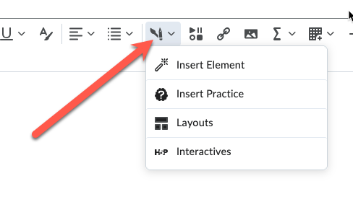
5. Choose a component to insert (e.g., Accordion, Tabs, Callout, Timeline, Flip Card).
6. Complete the configuration window with your content and style choices.
7. Click 'Insert' to add the element to the page.
8. Repeat to add multiple elements. Then click 'Save and Close'.

✨ Popular Creator+ Elements
📂 **Accordion** – Collapse/expand content to save space.
📑 **Tabs** – Organize content side-by-side under clickable headings.
💬 **Callouts** – Highlight important notes or warnings.
🕓 **Timeline** – Visualize sequences or progressions.
🔄 **Flip Cards** – Add interactive review items or definitions.

🛠 Example Scenarios
📘 Scenario 1: Weekly Overview
- Use Tabs to divide Objectives, Tasks, and Resources.
📗 Scenario 2: Glossary of Terms
- Use Flip Cards for definitions or concept checks.
📙 Scenario 3: Course Milestones
- Use Timeline to show key project dates or weekly progression.

💡 Additional Tips & Best Practices
✅ Don’t overuse visual effects—keep layout clean and focused.
✅ Preview elements to check formatting and responsiveness.
✅ Combine with accessible content practices: headings, contrast, alt text.
✅ Use Creator+ elements for clarity, not decoration.

