BUSINESS INFORMATION WAREHOUSE

A technical report for
CSc 564 Data Warehousing and Data Mining

Submitted by
Brihat Ratna Bajracharya
19/075

Submitted to
Mr. Bal Krishna Subedi

Central Department of Computer Science and Information Technology
29 November 2019
TABLE OF CONTENT
ABSTRACT 3
1. INTRODUCTION 4
1.1. Core Areas of BW 4
1.1.1. Data Warehousing 4
1.1.2. BI Platform 5
1.1.3. BI Suite Business Explorer 5
1.2. Development Techniques 5
1.3. SAP Business Suite 5
1.4. R/3 6
1.5. SAP ABAP 6
2. ARCHITECTURE 7
2.1. Presentation Layer 7
2.2. Application Layer 7
2.3. Database Layer 7
3. COMPONENTS OF SAP R/3 3-TIER ARCHIRECTURE 8
4. ADVANTAGES OF SAP BW 10
5. CONCLUSION 10
REFERENCES 11

ABSTRACT
The reporting, analysis, and interpretation of business data is of central importance to a company in guaranteeing its competitive edge, optimizing processes, and enabling it to react quickly and in line with the market. As a core component of SAP NetWeaver, the SAP Business Information Warehouse (SAP BW) provides data warehousing functionality, a business intelligence platform, and a suite of business intelligence tools that enable businesses to attain these goals.
Relevant business information from productive SAP applications and all external data sources can be integrated, transformed, and consolidated in SAP BW with the toolset provided.
SAP BW provides flexible reporting and analysis tools to support you in evaluating and interpreting data, as well as facilitating its distribution. Businesses are able to make well-founded decisions and determine target-orientated activities on the basis of this analysis. The several tools available with SAP BW allows a business to integrate data from several SAP modules, transform it into a more legible and easily understandable form, and consolidate data from various sources into one solid, concrete information that throws light on the intricacies of a business process

1. INTRODUCTION
Business Information Warehouse (BW) is a business intelligence software product from the German company SAP. It uses database resources to provide assistance with business intelligence analysis and decision making. It also provides different reporting tools and modeling applications for handling business data. Business Information Warehouse includes features for automated data extraction, a metadata repository, administrative tools and a Web dashboard. It is optimized for R/3 (described later), but is not limited to this design.

1.1. Core Areas of BW
Data Warehousing, BI Platform and BI Suite represent the core areas of SAP BW. The following graphic shows how subareas and their functions are integrated into the SAP BW architecture:
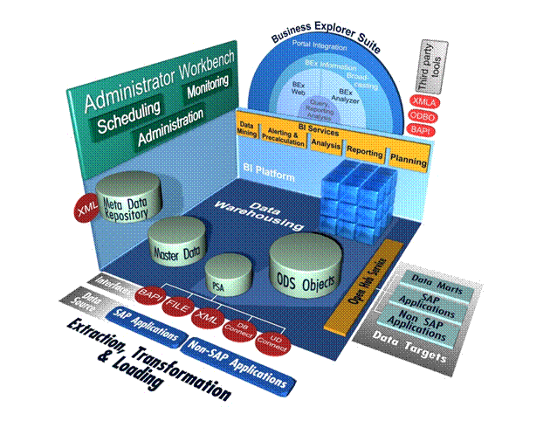

1.1.1. Data Warehousing
Data warehousing in SAP BW represents the integration, transformation, consolidation, cleanup, and storage of data. It also incorporates the extraction of data for analysis and interpretation. The data warehousing process includes data modeling, data extraction, and administration of the data warehouse management processes. The central tool for data warehousing tasks in SAP BW is the Administrator Workbench.

1.1.2. BI Platform
The Business Intelligence platform serves as the technological infrastructure and offers various analytical technologies and functions. These include the OLAP processor, the Metadata Repository, Business Planning and Simulation, special analysis processes such as Data Mining, and the Reporting Agent.

1.1.3. BI Suite Business Explorer
The SAP BW Business Intelligence Suite, the Business Explorer (BEx), provides flexible reporting and analysis tools for strategic analyses, operational reporting, and decision-making support within a business. These tools include query, reporting, and analysis functions. The Business Explorer allows a broad spectrum of users access to information in the SAP BW using the Enterprise Portal, the Intranet (Web application design) or mobile technologies.

1.2. Development Techniques
1.2.1. BI Java SDK
With the BI Java SDK we can create analytical applications with which you access both multidimensional (Online Analytical Processing or OLAP) and tabular (relational) data. We can also edit and display this data. BI Java Connectors, a group of four JCA-enabled (J2EE Connector Architecture) resource adapters, implement the BI Java SDK APIs and allow us to connect applications that you have created with the SDK to various data sources.

1.2.2. Open Analysis Interfaces
The Open Analysis Interfaces make various interfaces available for connecting front-end tools from third-party providers.

1.2.3. Web Design API
The Web design API and table interface allows you to realize highly individual scenarios and demanding applications with customer-defined interface elements.

1.3. SAP Business Suite
SAP Business Suite is a collection of applications including CRM, SCM and others, alongside the ECC component

1.4. R/3
With the advent of distributed client–server computing, SAP SE brought out a client–server version of the software called SAP R/3 (the "R" was for "Real-time data processing" and "3" was for "3-tier":
1) database,
2) application server, and
3) client (SAPgui).
This new architecture is compatible with multiple platforms and operating systems, such as Microsoft Windows or UNIX. SAP R/3 was officially launched on 6 July 1992.
A newer version of the software, with revised technical architecture, was released in 2004 renamed as SAP ERP Central Component (ECC). SAP ECC is the core component within the SAP's Business Suite. SAP ECC contains different, but integrated, functionality within its "modules" e.g. Finance module, HR module, Warehouse Management etc. all within the ECC). There is a newer version with improved system response timescalled the S/4 Simple Suite. The S/4 has a single tenant architecture and is being built upon SAP's in-memory database technology stack (HANA) and will be available in a choice of in-cloud and on-premises deployment. The classic three-tier and database-agnostic architecture of R/3 is replaced with a two-tier architecture.

1.5. SAP ABAP
It is one of the important programming module in SAP. It is a 4th generation programming language (ABAP/4) developed in 1980’s. SAP ABAP (Advanced Business Application Programming) is used to develop the SAP R/3 system where the application programs are written in the form ABAP language.

2. ARCHITECTURE
SAP R/3 is a 3 tier architecture consisting of 3 layers. They are Presentation, Application, and Database. In simple words, it’s a client server architecture. The R signifies Real-time system and 3 represents 3-tier architecture.

2.1. Presentation Layer
The Presentation Layer contains the software components that make up the SAPgui (graphical user interface). This layer is the interface between the R/3 System and its users. The R/3 System uses the SAPgui to provide an intuitive graphical user interface for entering and displaying data. The presentation layer sends the user's input to the application server, and receives data for display from it. While a SAPgui component is running, it remains linked to a user's terminal session in the R/3 System.

2.2. Application Layer
The Application Layer consists of one or more application servers and a message server. Each application server contains a set of services used to run the R/3 System. Though only one application server is enough to run an R/3 System, the services are distributed across more than one application server. The message server is responsible for communication between the application servers. It passes requests from one application server to another within the system. It also contains information about application server groups and the current load balancing within them. It uses this information to assign an appropriate server when a user logs onto the system.

2.3. Database Layer
The Database Layer consists of a central database system containing all of the data in the R/3 System. The database system has two components - the database management system (DBMS), and the database itself. SAP has manufactured its own database named Hana but is compatible with all major databases such as Oracle. It also contains the program code for your applications (and its program code, screen definitions, menus, function modules, and other components) in a special section of the database called the R/3 Repository, and are called repository objects. R/3 repository, objects are used in ABAP workbench.

3. COMPONENTS OF SAP R/3 3-TIER ARCHIRECTURE
The components of a SAP R/3 3-tier architecture is shown in the following figure
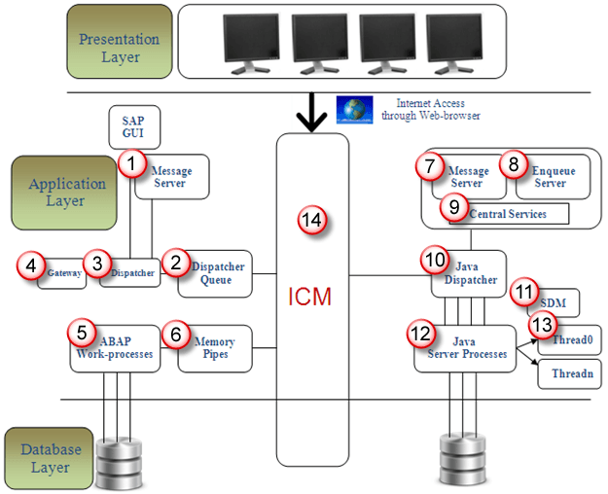
Index | Name | Function
1 | Message Server | It handles communication between distributed Dispatchers in ABAP system.
2 | Dispatcher Queue | Various work process types are stored in this queue.
3 | Dispatcher | It distributes requests to the work processes.
4 | Gateway | It enables communication between SAP system and between SAP system and external systems
5 | ABAP-Work processes | It separately executes dialog steps in R/3 applications. Steps are dialog, update, update2, background, spool, enqueue
6 | Memory-pipes | It enables communication between ICM and ABAP work processes.
7 | Message Server | It handles java dispatchers and server processes.It enables communication within java runtime environment.
8 | Enqueue Server | It handles logical locks that are set by the executed Java application program in a server process.
9 | Central Services | Java cluster requires a special instance of the central services for managing locks and transmitting messages and data. Java cluster is a set of processes that work together to build the reliable system. Instance is group of resources such as memory, work processes and so on.
10 | Java Dispatcher | It receives the client requests and forwards to the server process.
11 | SDM | Software Deployment Manager is used to install J2EE components.
12 | Java Server Processes | It can processes a large number of requests simultaneously.
13 | Threading | Multiple Processes executes separately in the background, this concept is called threading.
14 | ICM | It enables communication between SAP system and HTTP, HTTPS, SMTP protocol. It means by entering system URL in the browser you can access SAP from browser also.
15 | JCO | It handle communication between java dispatcher and ABAP dispatcher when system is configured as ABAP+Java.

4. ADVANTAGES OF SAP BW
- Every business seeks a competitive advantage, an “X-Factor” to give it a leg-up over the competition. SAP BW gives a business that advantage. This is because SAP BW does critical business functions, such as reporting, analysis and interpretation of business data.
- It helps a business to optimize its business processes and access the most important and most relevant data pertaining to the most crucial aspects of the business within seconds.
- The several tools available with SAP BW allows a business to integrate data from several SAP modules, transform it into a more legible and easily understandable form, and consolidate data from various sources into one solid, concrete information that throws light on the intricacies of a business process.
- The SAP BW provides a well thought out, high performance, well structured infrastructure that allows the end user to evaluate and interpret complex data, simplify it and to decipher its meaning. This allows the executives at the highest levels in an organization or managers looking after important departments or projects to make better decisions on crucial issues that affect the future of the corporation, identify specific business targets based on this information, and implement several business activities more efficiently by a better analysis of the data.

5. CONCLUSION
To conclude, SAP Business Information Warehouse integrates data from different sources, transforms and consolidates the data, does data cleansing, and storing of data as well. It also includes data modeling, administration and staging area. Also SAP Business Intelligence (BI) analyzes and reports data from different heterogeneous data sources and allows us to acquire data from multiple data sources, data staging, which can be further distributed to different BI systems. A SAP Business Intelligence system can work as a target system for data transfer or source system for distribution of data to different BI targets.

REFERENCES
- What is Business Information Warehouse (BW)? - Definition from Techopedia. (n.d.). Retrieved from https://www.techopedia.com/definition/13768/business-information-warehouse-bw
- SAP R/3 – Wikipedia. (22 October 2019). Retrieved from https://en.wikipedia.org/wiki/SAP_R/3
- SAP Business Information Warehouse (SAP Library). (n.d.). Retrieved from https://help.sap.com/doc/saphelp_scm41/4.1/en-US/b2/e50138fede083de10000009b38f8cf/content.htm?no_cache=true
- What is SAP BW (Business Warehouse) – SAP BW training. (n.d.). Retrieved from https://www.saponlinetutorials.com/what-is-sap-bw-business-warehouse/

