TRIBHUVAN UNIVERSITY
INSTITUTE OF SCIENCE AND TECHNOLOGY
Central Department of Computer Science and Information Technology
Kirtipur, Kathmandu



Classroom Assignment 1
Dataset Visualization, Linear and Logistic Regression and Perceptron Learning Algorithm

Submitted by:
Name: Brihat Ratna Bajracharya
Roll No.: 19/075

Submitted to:
Mr. Tej Bahadur Shahi
Central Department of Computer Science and Information Technology

Date of submission: 2076 Mangsir 29

Activities and Solutions
# Libraries imported
import pandas as pd

%matplotlib inline
import matplotlib.pyplot as plt
import seaborn as sns

import numpy as np
from sklearn.model_selection import train_test_split
from sklearn.metrics import mean_squared_error

1. Download the HousePrice.csv (https://www.kaggle.com/vikrishnan/boston-house-prices) and visualize it using Matplotlib or any other plotting library. Hint: Choose any one or two attribute with respect to price to visualize and further processing of data for easiness)
# reading csv
data = pd.read_csv('housing.csv', delim_whitespace=True)
data
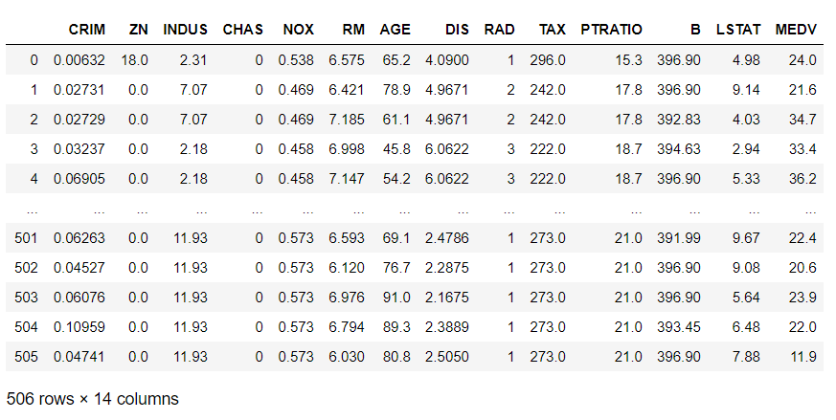Table 1: HousePrice Dataset
# obtain data from certain columns (taken most correlated columns with MEDV)
lstat = data['LSTAT']
room = data['RM']
pt_ratio = data['PTRATIO']
price = data['MEDV']

# lSTAT vs MEDV plot
plt.plot(lstat, price, 'g+')
plt.xlabel('% Lower Status of Population')
plt.ylabel('Price of house (in 1000s)')
plt.show()
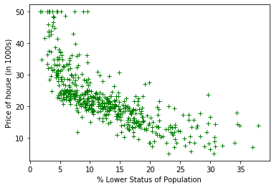Figure 1: LSTAT vs MEDV Plot

# RM vs MEDV plot
plt.plot(room, price, 'b+')
plt.xlabel('Avg number of rooms (per house)')
plt.ylabel('Price of house (in 1000s)')
plt.show()
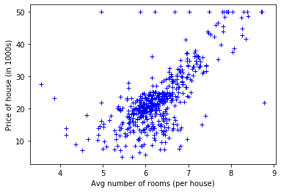Figure 2: RM vs MEDV Plot

# PTRATIO vs MEDV plot
plt.plot(pt_ratio, price, 'r+')
plt.xlabel('Pupil-Teacher Ratio')
plt.ylabel('Price od house (in 1000s)')
plt.show()

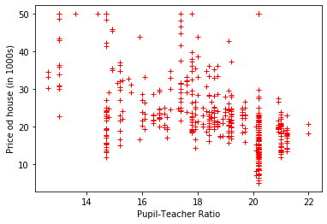Figure 3: PTRATIO vs MEDV Plot

2. Implement the linear regression Algorithm:
# train test split using sklearn
' get X and Y '
Y = data[list(data.columns)[-1]]
selected_columns = ['LSTAT']
X = data[selected_columns]
X_train_lstat, X_test_lstat, Y_train_lstat, Y_test_lstat = train_test_split(X, Y, test_size = 0.2)
X_train = X_train_room
X_test = X_test_room
Y_train = Y_train_room
Y_test = Y_test_room

# cost function
def costFunction(xVector, yVector, theta):
inner = np.power(((xVector * theta.T) - yVector), 2)
return np.sum(inner) / 2

# pre for linear regression
array_ones = np.ones(len(X_train))
xVector = np.column_stack((array_ones, X_train))
yVector = np.matrix(Y_train).T
theta = np.matrix(np.array([0.00, 0.00]))

# Linear Regression from scratch
learningRate = 0.0001
iterations = len(X_train)
costs = np.zeros(iterations)
m = np.size(theta,1)
newTheta = theta.T
for iter in range(iterations):
costs[iter] = costFunction(xVector, yVector, theta)
for i in range(len(xVector)):
currentError = yVector[i,0] - (xVector[i,:] * newTheta)
for j in range(m):
term = np.multiply(np.multiply(currentError, xVector[i,j]), learningRate)
newTheta[j,0] = newTheta[j,0] + term
# print(i, j, newTheta)
print(newTheta)

# linear regression on actual data (plot of regression line)
t0 = float(newTheta[0])
t1 = float(newTheta[1])

plt.plot(X_train, Y_train, 'g+')
axes = plt.gca()
x_vals = np.array(axes.get_xlim())
y_vals = t0 + t1 * x_vals
plt.plot(x_vals, y_vals, 'r--')
plt.show()
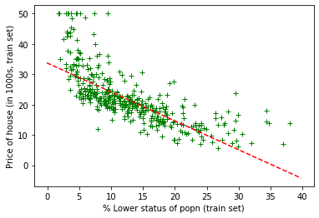Figure 4: Regression Line for LSTAT vs MDEV Plot

3. Try to normalize the data in between [0-1] using min-max normalization and use this normalized data in above algorithm and analyze the output.
# normalize function
def normalize(X):
mins = np.min(X, axis = 0)
maxs = np.max(X, axis = 0)
rng = maxs - mins
norm_X = 1 - ((maxs - X)/rng)
return norm_X

X_train_norm = normalize(X_train)
Y_train_norm = normalize(Y_train)
X_test_norm = normalize(X_test)
Y_test_norm = normalize(Y_test)
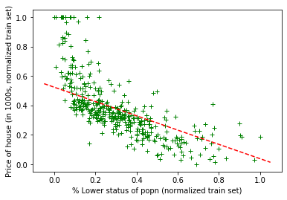Figure 5: Regression Line for LSTAT vs MDEV Plot (Normalized)

4. Implement the Logistic Regression and list the coefficient ϴ0, ϴ1 and ϴ2 for the dataset- LogisticDataset.csv.
# read csv
data = pd.read_csv('Logisticdataset.csv', delimiter=',')
data

X = data[data.columns[:-1]].to_numpy()
# print(X)
y = data[data.columns[-1]].to_numpy()
# print(y)

# adds 1 to beginning of X vector
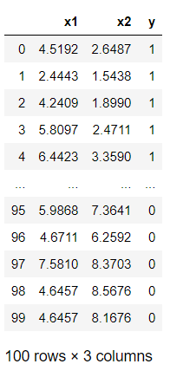Table 2: Logistic Dataset
def add_ones(X):
array_ones = np.ones((X.shape[0], 1))
return np.concatenate((array_ones, X), axis=1)

XX = add_ones(X)

# plotting x1, x2 vs y
plt.figure(figsize=(10, 6))

plt.scatter(X[y == 0][:, 0], X[y == 0][:, 1], color='b', label='0')
plt.scatter(X[y == 1][:, 0], X[y == 1][:, 1], color='r', label='1')

plt.xlabel('x1')
plt.ylabel('x2')
plt.legend();

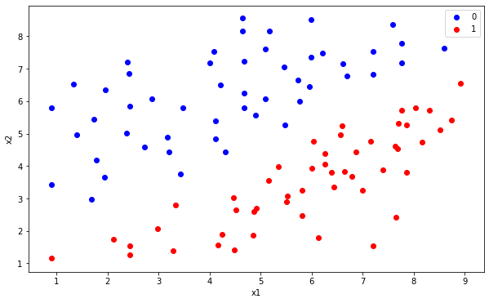Figure 6: Scatter Plot for Logistic Dataset

# sigmoid function
def sigmoid(x):
return 1 / (1 + np.exp(-x))

# loss function
def lossfunction(h, y):
return (-y * np.log(h) - (1 - y) * np.log(1 – h)).mean()

# function that calculates logistic regression conefficients
def myLogisticRegression(X, verbose=False):
theta = np.zeros(X.shape[1])
learning_rate = 0.1
iterations = len(X)

for i in range(iterations):
z = np.dot(X, theta)
h = sigmoid(z)
gradient = np.dot(X.T, (h - y)) / y.size
theta -= learning_rate * gradient

if(verbose==True and i % iterations == 0):
print(f'loss: {lossfunction(h, y)} \t')
print(theta)
return theta

# obtain theta coefficients from logistic regression
theta_calc = myLogisticRegression(XX, False)
theta_calc

Output:
array([ 0.20254295, 1.24114545, -1.4518324 ])

# Finally solution for Question No 4
print("Coefficients calculated from logistic regression")
print("\u03B80 =", theta_calc[0])
print("\u03B81 =", theta_calc[1])
print("\u03B82 =", theta_calc[2])

Output:
Coefficients calculated from logistic regression
θ0 = 0.20254294513724383
θ1 = 1.241145447686426
θ2 = -1.4518323972814373

# Plot logistic dataset in scatter plot with boundary
plt.figure(figsize=(10, 6))
plt.scatter(X[y == 0][:, 0], X[y == 0][:, 1], color='b', label='0')
plt.scatter(X[y == 1][:, 0], X[y == 1][:, 1], color='r', label='1')
plt.xlabel('x1')
plt.ylabel('x2')
plt.legend()

# for contour line (boundary line plot)
x1_min, x1_max = X[:,0].min(), X[:,0].max(),
x2_min, x2_max = X[:,1].min(), X[:,1].max(),

xx1, xx2 = np.meshgrid(np.linspace(x1_min, x1_max), np.linspace(x2_min, x2_max))
grid = np.c_[xx1.ravel(), xx2.ravel()]
grid = add_ones(grid)
pro = sigmoid(np.dot(grid, theta_calc))
probs = pro.reshape(xx1.shape)
plt.contour(xx1, xx2, probs, [0.5], linewidths=2, colors='black');

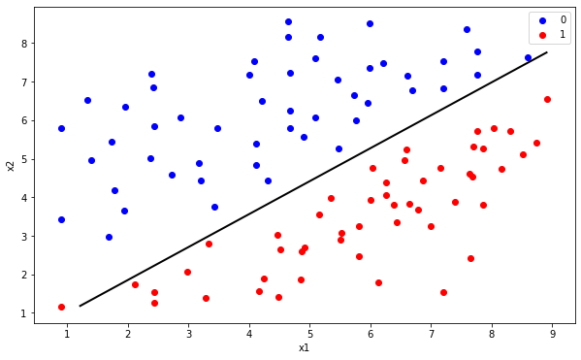Figure 7: Scatter Plot with boundary for Logistic Dataset

5. Modify the code for question 4 so that it could behave as perceptron learning algorithm. Predict the value of y for X = (5.8097, 2.4711).
# function that pre-processes input X for predicting Y using Perceptron learning algorithm (used by predict function)
def preprocess(X):
X.insert(0,1) # insert 1 at beginning
# print(X)
return np.array(X)

# prediction using perceptron learning algorithm
def threshold_function(z):
return z > 0

# for question 5
input_X = [5.8097,2.4711]
res = predict(input_X, theta_calc)
print('Value of Y for', input_X, 'is:', res)

Output:
Value of Y for [1, 5.8097, 2.4711] is: 1

Source Code
Programmed in Jupyter Notebook
GitHub link:

