Name: Brian Palm
Module 1.2 Assignment

Repository Link
https://github.com/BriiBo/csd-325

Screenshot of GitHub Repository
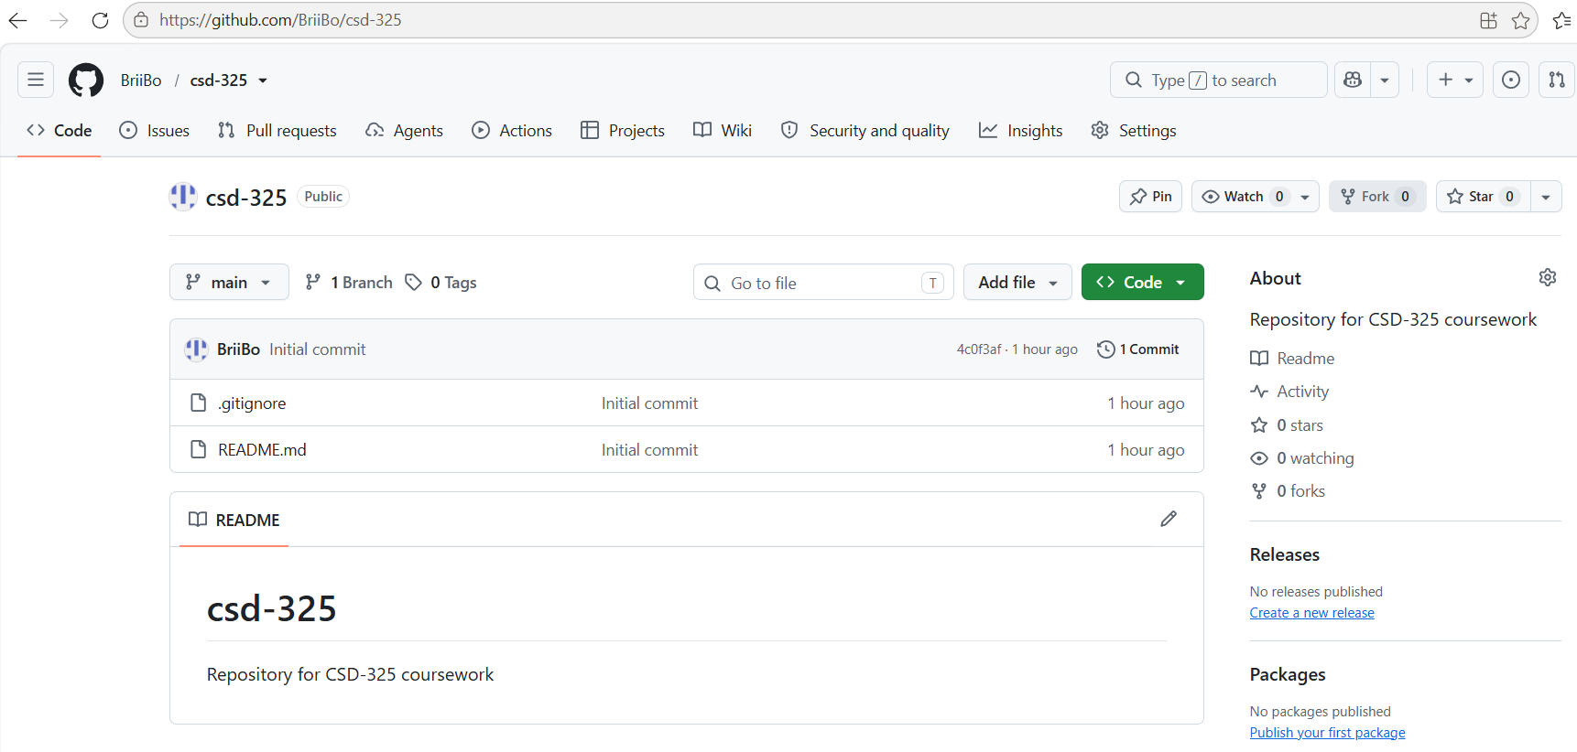

Screenshot of Local Directory
