Name: Brian Palm
Module 7.2 Assignment
Test Cases

city_functions.py - Initial City/Country Results
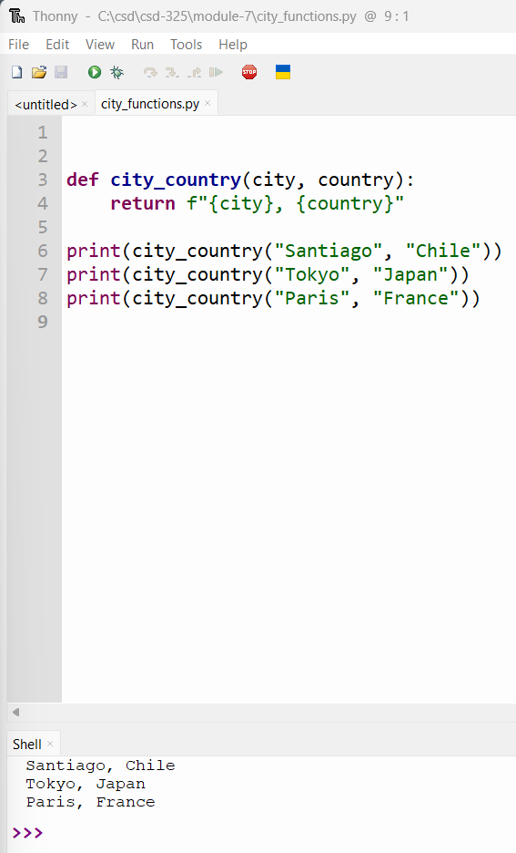

test_cities.py - Initial Passing Test
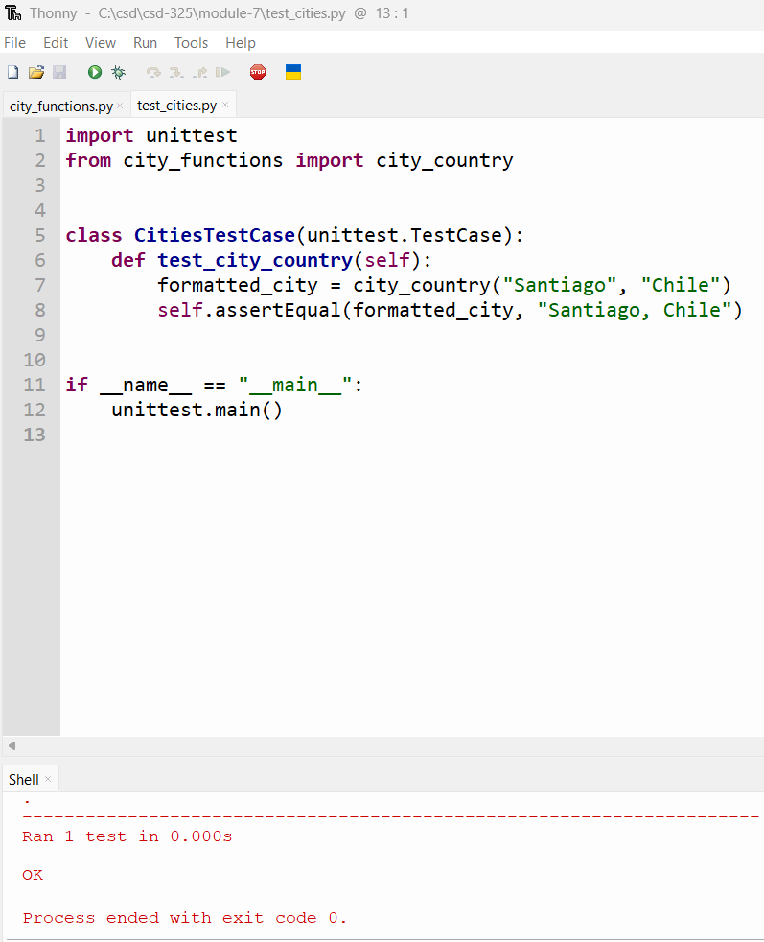

test_cities.py - Failed Test After Requiring Population
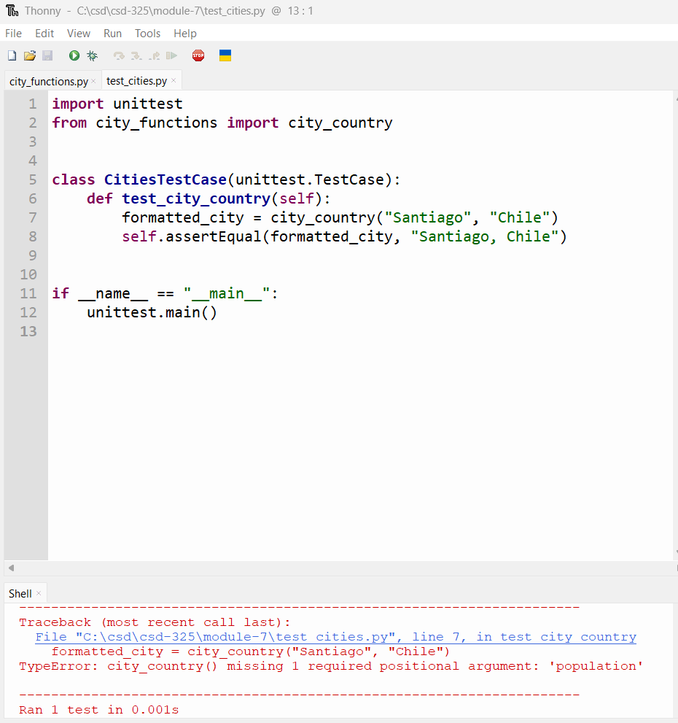

test_cities.py - Passing Test with Optional Population
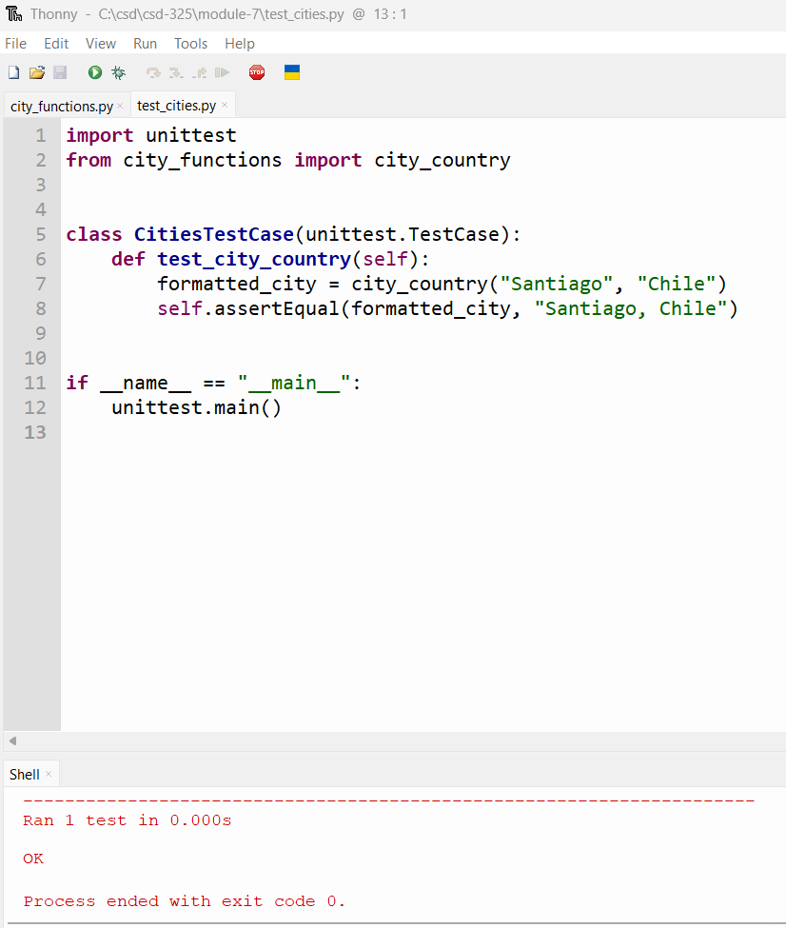

test_cities.py - Failed Test After Requiring Language
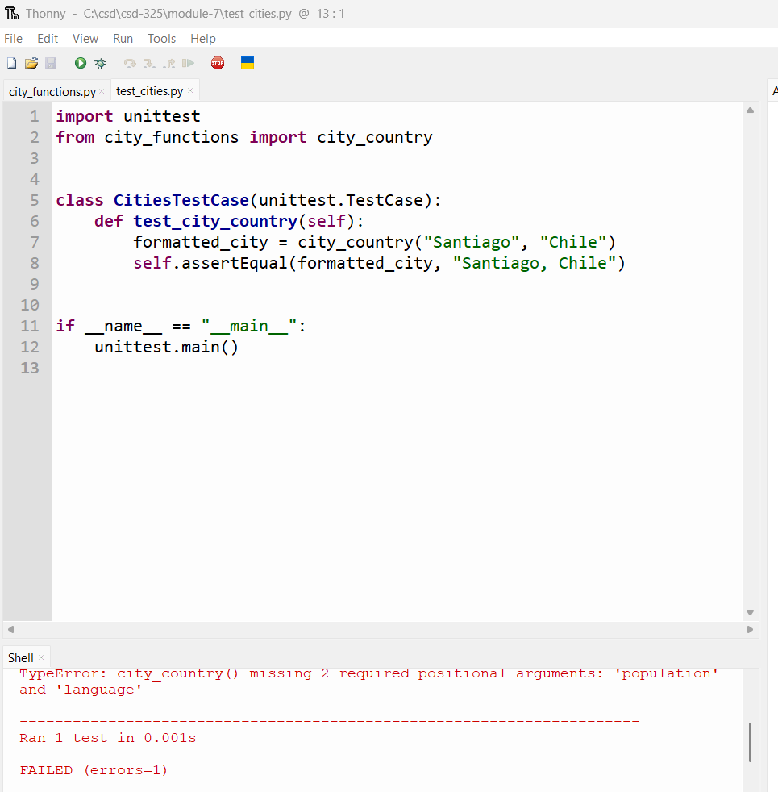

test_cities.py - Passing Test with Optional Language
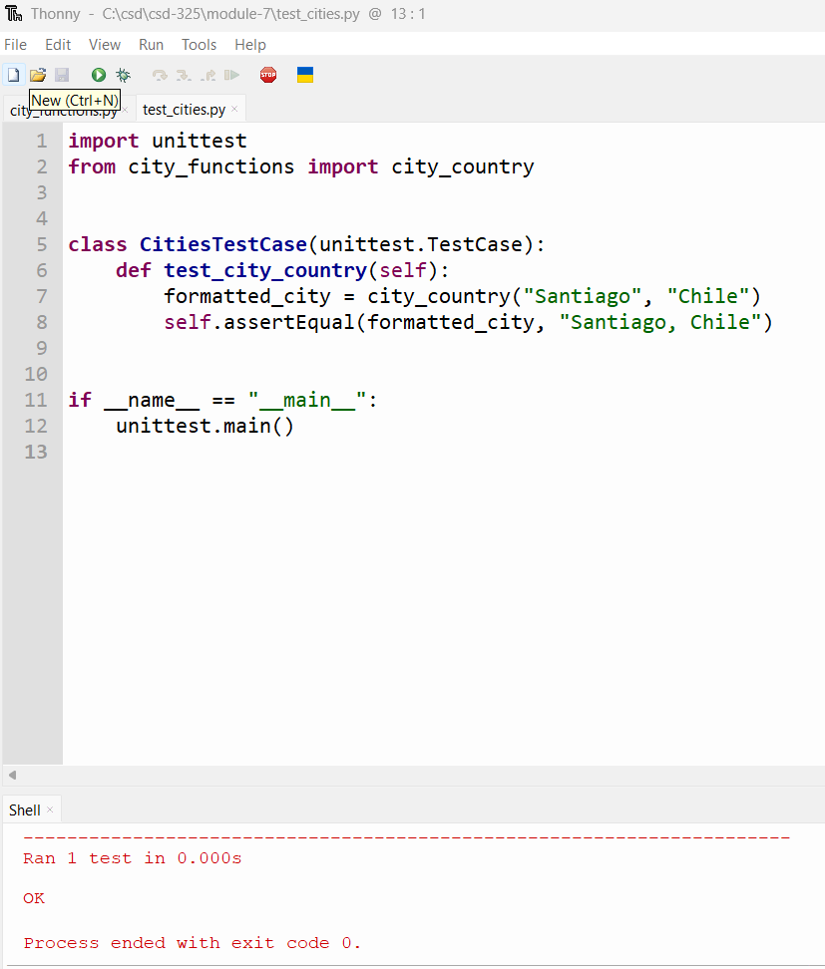

city_functions.py - Final Results with Optional Population and Language
