Name: Brian Palm
Module 2.2 Assignment

Screenshot 1: Breakpoint set before the countdown() function is called.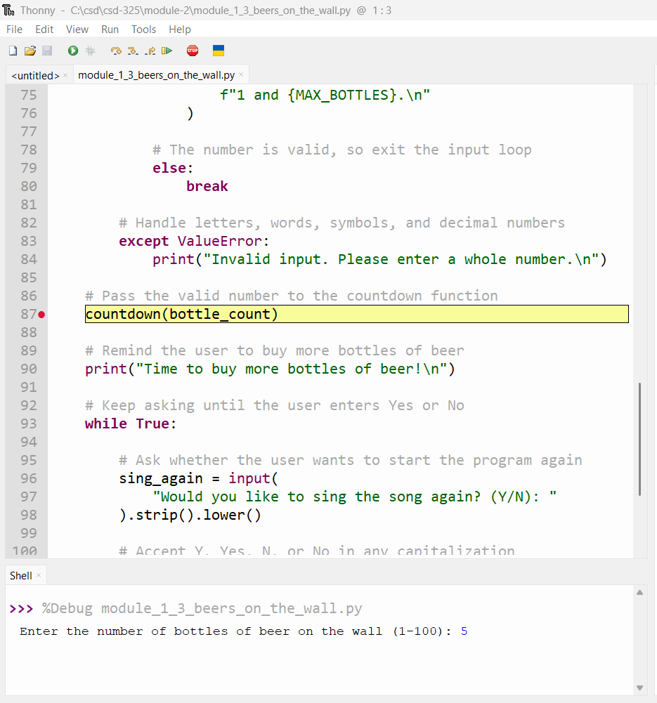

Screenshot 2:
Continued stepping through the program to examine the value being passed to the function.
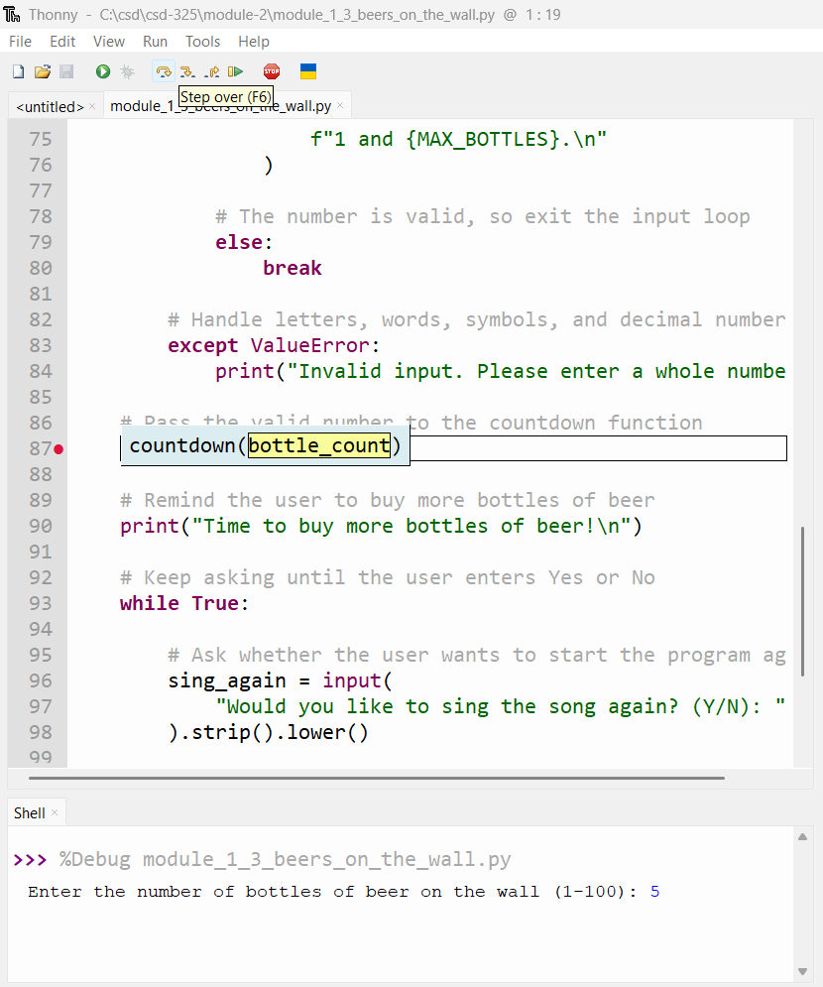

Screenshot 3:
Continued stepping through the program to examine the value being passed to the function.