# Brian Powell 012362894

# EE381 - Chaw-Long Chu

#

# Homework_3

#

# Question_1

# Please Use:

#

# (1) One order equation (y=ax+b) and

# (2) Third order equation (y=ax^3+bx^2+cx+d) and

# (3) Second order equation (y=a+bx+cx^2) using spread sheet to manually # calculate the coefficients of (a,b, and c) to fit the follow data # set: x=(0,1,2,3,4,5,6,7,8) and y=(0,0.8,0.9,0.1,-0.8,-1,-1.2,-1.6,-# 1.9) and plot the original data and 2 fitting results (1st order # and 3rd order) on same graph.

# (4) Finally compare the two least square fitting results of (1) and (2)

#

# The (1) and (2) using Python or Matlab to get results the (3) finished # by manually calculation

import numpy as np

import matplotlib.pyplot as plt

from scipy.integrate import *

x_data = np.array([0,1,2,3,4,5,6,7,8])

y_data = np.array([0,0.8,0.9,0.1,-0.8,-1,-1.2,-1.6,-1.9])

xx = np.linspace(-2,10,1000)

#3 Order Fit

p3 = np.polyfit(x_data, y_data, 3)

yy = np.polyval(p3, xx)

plt.plot(xx, yy, '_',label='3rd Order Fit')

plt.xlabel('X')

plt.ylabel('Y')

plt.legend(loc='best')

#1 Order Fit

p1 = np.polyfit(x_data, y_data, 1)

yy = np.polyval(p1, xx)

# plt.plot(x_data, y_data,'O', label = 'Data Set')

plt.plot(xx, yy, ':', label='1st Order Fit')

plt.xlabel('X')

plt.ylabel('Y')

plt.legend(loc='best')

# Print (1) and (2)

plt.show()

print('Coefficients of P3 Fitting:', p3)

print('Coefficients of P1 Fitting:', p1)

OUTPUT:

Coefficients of P3 Fitting:

[ 0.02306397 -0.30393218 0.71723184 0.17676768]

Coefficients of P1 Fitting:

[-0.335 0.81777778]

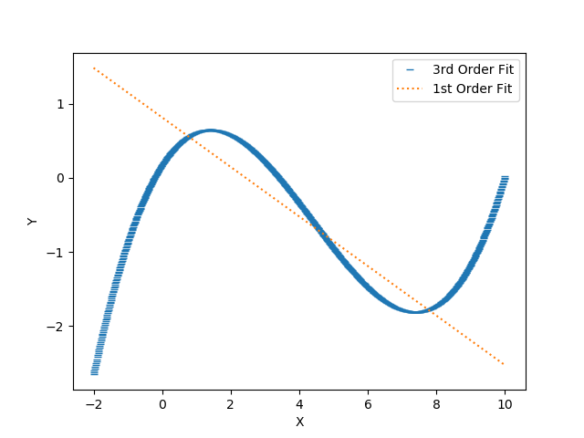

################## End of Part 1 & 2 ##################

# Brian Powell 012362894

# EE381 - Chaw-Long Chu

#

# Homework_3

#

# Question_1

# Please Use:

#

# (1) One order equation (y=ax+b) and

# (2) Third order equation (y=ax^3+bx^2+cx+d) and

# (3) Second order equation (y=a+bx+cx^2) using spread sheet to manually # calculate the coefficients of (a,b, and c) to fit the follow data # set: x=(0,1,2,3,4,5,6,7,8) and y=(0,0.8,0.9,0.1,-0.8,-1,-1.2,-1.6,-# 1.9) and plot the original data and 2 fitting results (1st order # and 3rd order) on same graph.

# (4) Finally compare the two least square fitting results of (1) and (2)

#

# The (1) and (2) using Python or Matlab to get results the (3) finished # by manually calculation

|  |  |  |  |
| --- | --- | --- | --- |
| **X** | **Y** |  | **Y = a+bx+cx^2** |
| 0 | 0 |  | 0.5642 |
| 1 | 0.8 |  | 0.4193 |
| 2 | 0.9 |  | 0.22 |
| 3 | 0.1 |  | -0.0337 |
| 4 | -0.8 |  | -0.3418 |
| 5 | -1 |  | -0.7043 |
| 6 | -1.2 |  | -1.1212 |
| 7 | -1.6 |  | -1.5925 |
| 8 | -1.9 |  | -2.1182 |

y = -0.0272x2 - 0.1177x + 0.5642

################## End of Part 3 ##################

# Brian Powell 012362894

# EE381 - Chaw-Long Chu

#

# Homework_3

#

# Question_1

# Please Use:

#

# (1) First order equation (y=ax+b) and

# (2) Third order equation (y=ax^3+bx^2+cx+d) and

# (3) Second order equation (y=a+bx+cx^2) using spread sheet to manually # calculate the coefficients of (a,b, and c) to fit the follow data # set: x=(0,1,2,3,4,5,6,7,8) and y=(0,0.8,0.9,0.1,-0.8,-1,-1.2,-1.6,-# 1.9) and plot the original data and 2 fitting results (1st order # and 3rd order) on same graph.

# (4) Finally compare the two least square fitting results of (1) and (2)

#

# The (1) and (2) using Python or Matlab to get results the (3) finished # by manually calculation

Least Square fitting result of Third Order Equation:

-0.30393218

Least Square Fitting Result of First Order Equation:

-0.335

-0.30393218 / -0.335 = 1.012900

(*100) = 101.2900

– 100 = 1.29%

First Order Fitting is 1.29% greater than the Third Order Fitting

################## End of Part 4 ##################