# Brian Powell 012362894

# EE381 - Chaw-Long Chu

#

# Homework_4

#

# Question_1

# Using Binomial Distribution to calculate the probability of getting less than 3 times of "5" in 8 throws of a fair die?

#

import matplotlib

from scipy.stats import binom

print("Homework_4")

print("Question_1")

n = 8

p = 1/6

k = 3

y = binom.pmf(k,n,p)

print("Probability of getting less than 3 times of \"5\" in 8 throws of a fair die:")

print(y)

################## End of Question 1 ##################

OUTPUT:

Homework_4

Question_1

Probability of getting less than 3 times of "5" in 8 throws of a fair die:

0.10419048163389728

# Brian Powell 012362894

# EE381 - Chaw-Long Chu

#

# Homework_4

#

# Question_2

# Using random number to generate 2000 numbers from (-1 to 1) and find mean, standard deviation, variance of these 200 numbers, and plot histogram of these 2000 numbers

#

import random as rand

import matplotlib.pyplot as plt

import numpy as np

x = [rand.uniform(-1,1) for x in range (2000)]

print("Homework 4")

print("Question 2")

print("\nMean of generate random numbers:")

print(sum(x)/float(len(x)))

print("\nStandard Deviation of generated random numbers:")

print(np.std(x))

print("\nVariance of generated random numbers:")

print(np.var(x))

plt.hist(x,bins=20)

plt.title("Generated Random Numbers")

plt.xlabel("Value")

plt.ylabel("Frequency")

plt.show()

################## End of Question 2 ##################

OUTPUT:

Homework 4

Question 2

Mean of generate random numbers:

0.0005715962055417485

Standard Deviation of generated random numbers:

0.5723435234290656

Variance of generated random numbers:

0.3275771088111973

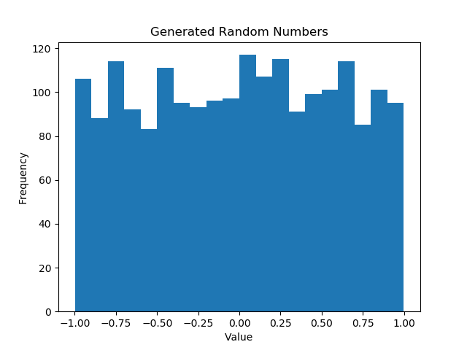

# Brian Powell 012362894

# EE381 - Chaw-Long Chu

#

# Homework_4

#

# Question_3

# A quality control unit inspects 400 poieces products every day. 35 of the products have defects, what is the highest number of defective products that will be found?

# And what is the probability?

#

import matplotlib

from scipy.stats import binom

print("Homework_4")

print("Question_1")

n = 400

p = .03

k = 12

y = binom.pmf(k,n,p)

print("\nHighest number of defective products found:")

print(k)

print("\nProbability of finding " + str(k) + " defective products:")

print(y)

OUTPUT:

Homework_4

Question_1

Highest number of defective products found:

12

Probability of finding 12 defective products:

0.11612227621437812