% Brian Powell 012362894

% EE381 - Chaw-Long Chu

%

% Homework_5

%

% Question_1

% X ranges from 0 to 50 and the interval on x-axis is 0.05, please plot pdf

% of Gamma Distribution for

% 1.(a=1,b=1) 2.(a=1,b=5) 3.(a=1,b=10) 4.(a=5,b=1) 5.(a=10,b=1)

% 6.(a=10,b=2)

%

clc

clear

z = (0:0.5:50);

%Gamma Distribution for each value

g1 = gampdf(z,1,1);

gg11 = g1/max(g1);

g2 = gampdf(z,1,5);

gg15 = g2/max(g2);

g3 = gampdf(z,1,10);

gg110 = g3/max(g3);

g4 = gampdf(z,5,1);

gg51 = g4/max(g4);

g5 = gampdf(z,10,1);

gg101 = g5/max(g5);

g6 = gampdf(z,10,2);

gg102 = g6/max(g6);

figure(1);

%Plotting 6 lines for each distribution

plot(z, gg11, 'r', 'LineWidth', 2);

hold on;

plot(z, gg15, 'g', 'LineWidth', 2);

hold on;

plot(z, gg110, 'k', 'LineWidth', 1);

hold on;

plot(z, gg51, 'b', 'LineWidth', 2);

hold on;

plot(z, gg101, 'y', 'LineWidth', 2);

hold on;

plot(z, gg102, 'p', 'LineWidth', 2);

title('Gamma Distribution');

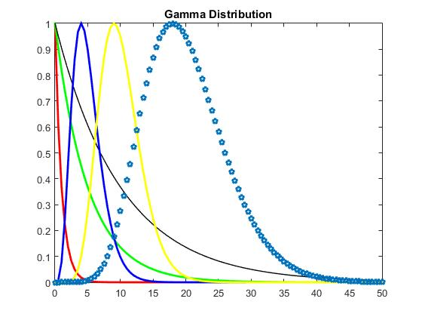

% Brian Powell 012362894

% EE381 - Chaw-Long Chu

%

% Homework_5

%

% Question_2

% Use Normal Distribution to generate Chi-sqquare distribution (graph

% results of 1 degree of freedom and 10 degree of freedom)

%

n = 10000;

% Random Values for 1 degree of Freedom to 10 degrees of Freedom.

n_1 = randn(1,n);

n_2 = randn(1,n);

n_3 = randn(1,n);

n_4 = randn(1,n);

n_5 = randn(1,n);

n_6 = randn(1,n);

n_7 = randn(1,n);

n_8 = randn(1,n);

n_9 = randn(1,n);

n_10 = randn(1,n);

sigma = 1;

% Chi Square for 1 degree of freedom

chisquare_1 = (sigma * n_1.^2);

% Plotting and labeling first result

figure(1);

hist(chisquare_1, 500);

xlabel('Bins');

ylabel('Occurences');

title('Chi-Square Distribution Composed of 1 Normal Distribution');

% Chi Square for 10 degrees of freedom

chisquare_2 = (sigma * n_1.^2) + (sigma * n_2.^2) + (sigma * n_3.^2) + (sigma * n_4.^2) + (sigma * n_5.^2) + (sigma * n_6.^2) + (sigma * n_7.^2) + (sigma * n_8.^2) + (sigma * n_9.^2) + (sigma * n_10.^2);

% Plotting and labeling second result

figure(2);

hist(chisquare_2, 500);

xlabel('Bins');

ylabel('Occurences');

title('Chi-Square Distribution Composed of 10 Normal Distributions');

