**CPSC 535 Project 2 Documentation**

This documentation contains 5 parts:

1 Group member info

2 Group info screenshot

3 Code execution screenshot

4 Instruction of execution

1. Your names, CSUF-supplied email address(es), and an indication that the submission is for project 2.

Brijesh Prajapati brijesh.prajapati@csu.fullerton.edu

Charles Babbage charlesbab@csu.fullerton.edu

Ming Chen mingalexchen@csu.fullerton.edu

1. A full-screen screenshot with your group member names shown clearly. One way to make your names appear in Atom is to simply open your README.md.

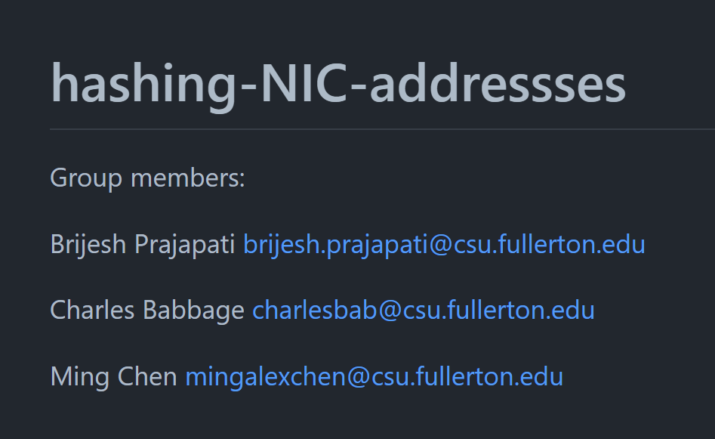

1. A full-screen snapshot of the code execution that follows the output given as example

output

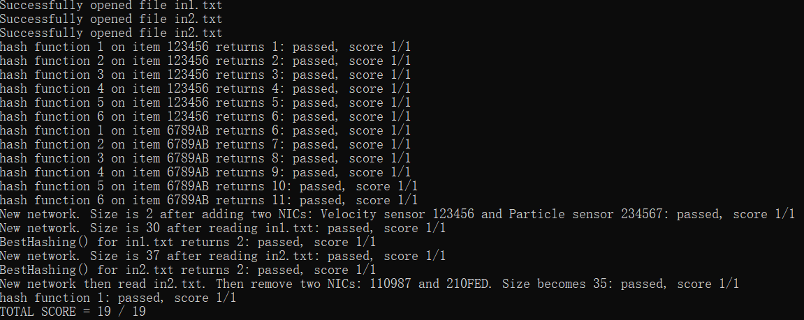

Input files

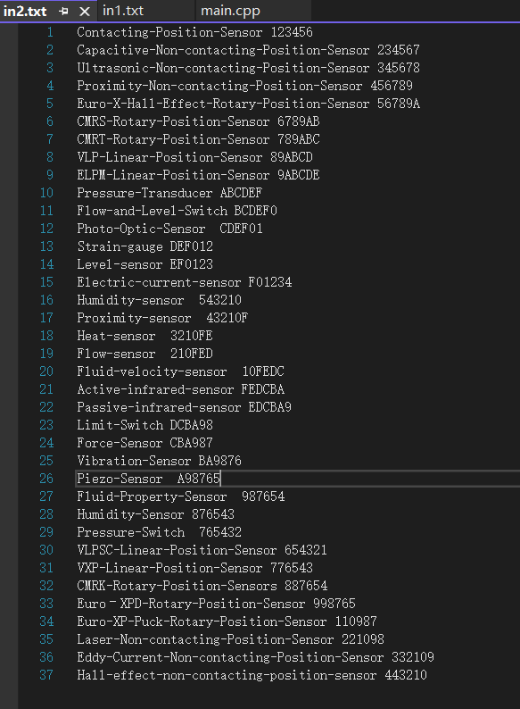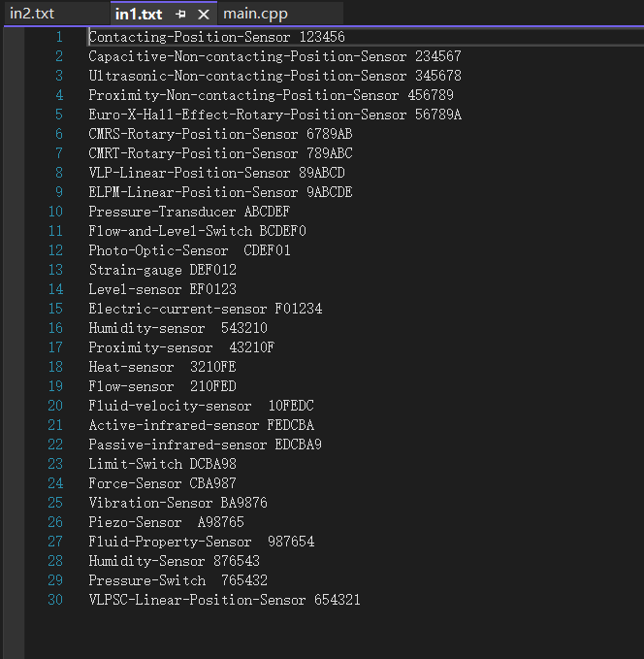

1. A brief description on how to run the code and how to change the code to accept other input files.

We did not add any extra dependency or change the way to read input files. Hence using the provided way to compile should work, and changing the value in input files would work for accepting other inputs.