The Buying Brain : E-commerce Intelligence Project

Business Problem Statement
The business needs a clear view of marketplace performance across customers, orders, products, sellers, payments,delivery, and reviews. The goal of this project is to combine raw e-commerce datasets into an analytical view that helps identify revenue drivers, customer behavior patterns, operational bottlenecks, and satisfaction risks. These insights can support decisions around category focus, seller management, customer retention, payment strategy, and delivery improvement.

Dataset Description
The project uses multiple relational e-commerce datasets stored in the dataset/ folder:
- orders.csv: 99,441 orders with order status and purchase, approval, shipping, delivery, and estimated delivery timestamps.
- order_item.csv: 112,650 order-item records with product, seller, price, freight value, and shipping limit details.
- payments.csv: 103,886 payment records with payment type, installments, and payment value.
- reviews.csv: 104,719 review records with review score, comments, and review timestamps.
- products.csv: 32,951 product records with category, description, photo, weight, and size attributes.
- customers.csv: 99,441 customer records with unique customer IDs and customer location details.
- sellers.csv: 3,095 seller records with seller city and state.
- location.csv: 1,000,163 geolocation records by zip-code prefix.
- category_translation.csv: 70 category translation records mapping original category names to English labels.

Methodology
- Loaded and inspected all source datasets to understand record counts, columns, data types, missing values, duplicates, and key relationships.
- Cleaned and prepared the data by converting timestamp columns to datetime format, validating numeric fields, removing duplicate records where needed, and standardizing analysis-ready fields.
- Integrated the datasets using common keys such as order_id, customer_id, product_id, seller_id, and product_category_name.
- Engineered business features including total order value, item count, delivery days, late delivery flag, purchase month, customer repeat status, customer value, category revenue, seller revenue, and dissatisfaction indicators.
- Performed exploratory data analysis across customer behavior, revenue trends, product categories, seller contribution, payment preferences, delivery performance, and review scores.
- Summarized findings into business recommendations focused on growth, retention, logistics, and customer satisfaction.

Key Findings
- The marketplace processed 99,441 total orders, of which 96,478 were delivered.
- Total item-plus-freight revenue was 15,843,553.24, with an average order value of 159.33.
- Repeat customer share was only 3.1%, indicating a large opportunity to improve retention and loyalty.
- Average review score was 4.09, showing generally positive customer satisfaction, but dissatisfaction is highly connected to delivery performance.
- Average delivery time was 12.6 days, and 7.9% of orders were delivered after the estimated delivery date.
- Late delivery is a major satisfaction risk: dissatisfied reviews, defined as review scores of 1 or 2, occurred in 52.9% of late deliveries compared with 11.3% of on-time or early deliveries.
- The highest revenue categories were health and beauty, watches and gifts, bed bath table, sports leisure, and computers accessories.
- The highest item-volume categories were bed bath table, health and beauty, sports leisure, furniture decor, and computers accessories.
- Customer demand was geographically concentrated, with the largest unique-customer states being SP, RJ, MG, RS, and PR.
- Credit card was the dominant payment method at 73.9% of payment records, followed by boleto at 19.0%.
- Revenue was distributed across many sellers: the top 10 sellers contributed 12.8% of total seller revenue, suggesting the marketplace is not overly dependent on a small seller group.

Business Insights
- Delivery reliability is one of the strongest controllable drivers of customer satisfaction. Late orders show a much higher low-rating rate than on-time or early orders.
- The platform has strong acquisition but weak repeat behavior. Most customers purchase once, so retention programs can create meaningful incremental revenue.
- Revenue and demand are concentrated in a few leading product categories, making category-level merchandising and inventory planning important for growth.
- Demand is geographically concentrated in major states, especially SP, RJ, and MG, which can guide regional logistics planning and marketing allocation.
- Seller revenue is broad-based rather than dominated by only a few sellers, so marketplace health depends on improving the performance of a wide seller base.
- Credit card usage dominates payments, but boleto remains large enough to keep as a priority payment option for customer accessibility.

Recommendations
- Prioritize delivery reliability by monitoring late-delivery rates, carrier performance, and seller shipping-limit compliance.
- Create retention campaigns for first-time customers, especially in high-demand states and top product categories.
- Invest in inventory, merchandising, and promotions for high-performing categories such as health and beauty, watches and gifts, and bed bath tables.
- Build seller scorecards that combine revenue, fulfillment speed, late delivery, review score, and cancellation behavior.
- Improve customer communication for orders at risk of delay to reduce dissatisfaction and protect review scores.
- Maintain credit-card optimization while continuing to support boleto customers, since both represent meaningful payment behavior.

Visual Outputs
The following visuals were generated from the project notebook and summarize the major analytical outputs used to support the findings and recommendations.

Figure 1: New vs Repeat Customers
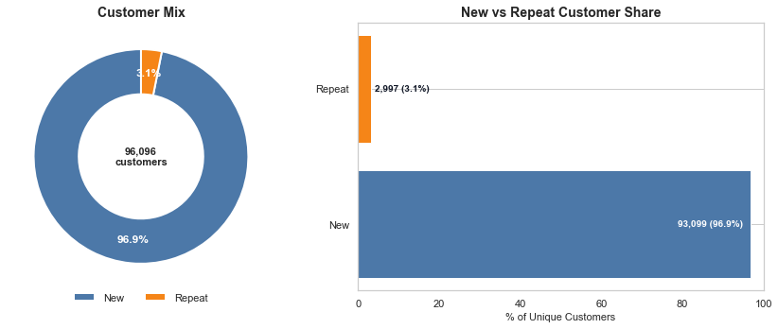
This visual shows that the marketplace is heavily driven by one-time buyers, with repeat customers forming only a small share of the unique customer base. It highlights a clear retention opportunity through loyalty campaigns, remarketing, and post-purchase engagement.
Figure 2: Customer Value Segments
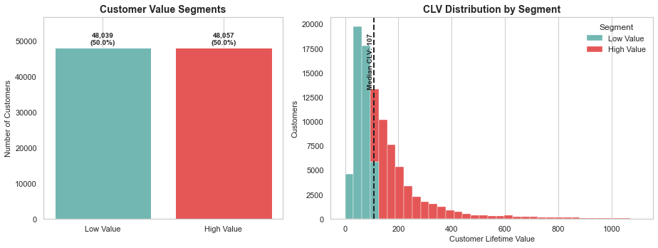
This chart splits customers into low-value and high-value segments using customer lifetime value. The distribution helps prioritize retention and upsell efforts toward higher-value customers while identifying room to lift spend among lower-value customers.

Figure 3: Geographic Distribution of Customers
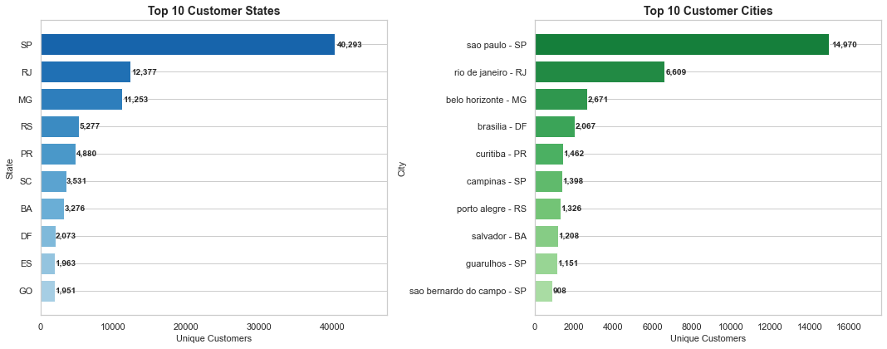
The customer base is concentrated in a small set of states and cities, especially major demand regions. These locations should guide marketing allocation, regional logistics planning, and delivery-capacity decisions.
Figure 4: Monthly Revenue Trend
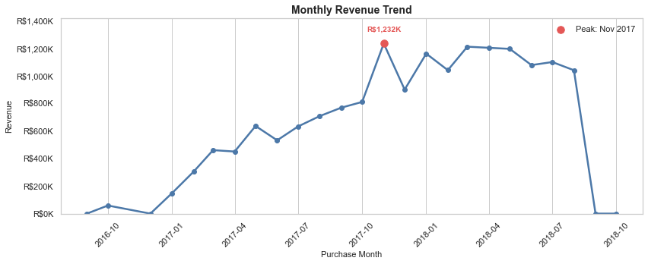
The revenue trend shows how sales value changes over time and marks the peak revenue month. This supports seasonal planning, promotion timing, and monitoring of marketplace growth momentum.

Figure 5: Monthly Order Volume Trend
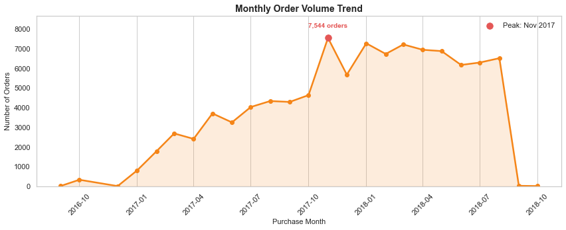
The order-volume trend tracks demand by month and identifies the highest order period. Comparing this with revenue helps separate true demand growth from changes in average order value.
Figure 6: Peak Sales Periods
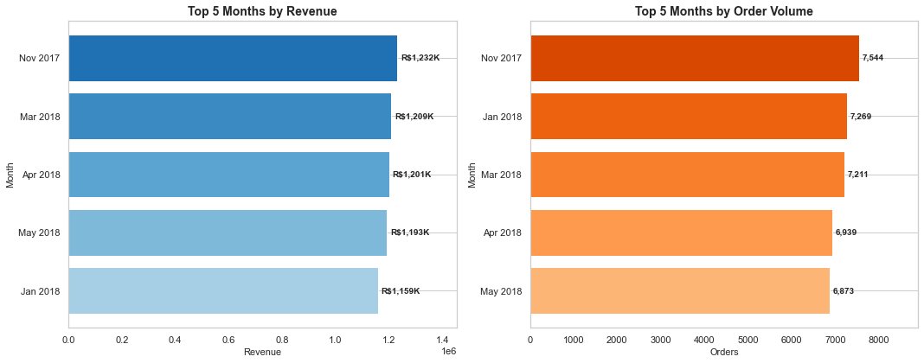
This visual ranks the top months by revenue and order count. It helps identify the strongest commercial periods where inventory, seller readiness, and marketing spend should be planned in advance.

Figure 7: Top Product Categories by Items Sold
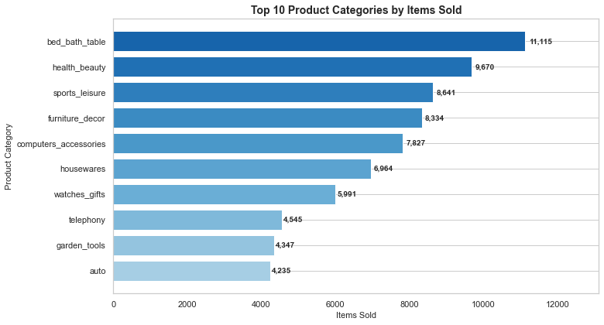
This chart identifies the categories with the highest unit demand. These categories are important for assortment planning, stock availability, and campaign placement because they represent the largest purchase volumes.
Figure 8: Top Product Categories by Revenue
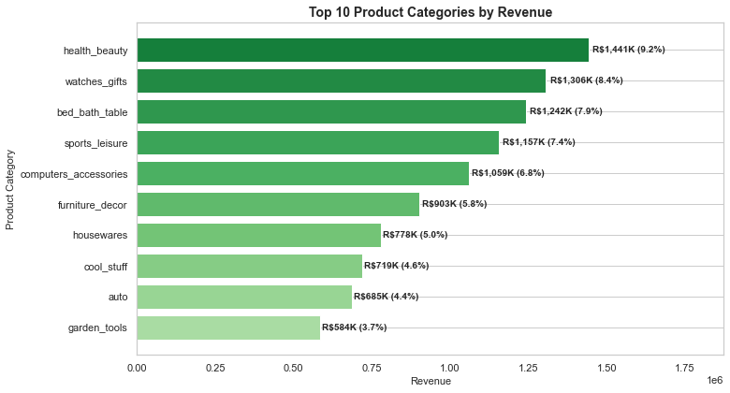
This revenue ranking shows which categories contribute the most monetary value. High-revenue categories deserve focused merchandising, seller quality checks, and pricing optimization.

Figure 9: Product Demand Distribution
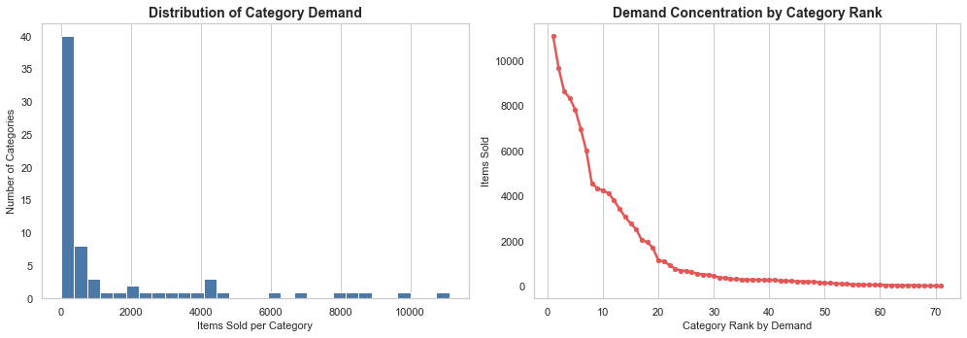
The demand distribution and rank curve show that product demand is uneven across categories. A small group of categories captures much of the demand, while many categories operate at lower volume.
Figure 10: Top Sellers by Revenue
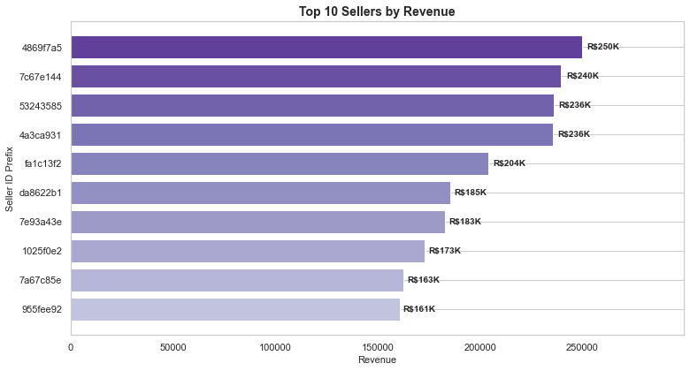
This chart highlights the sellers generating the highest revenue. These sellers can be monitored closely for fulfillment reliability and used as benchmarks for broader seller-performance programs.

Figure 11: Seller Revenue Contribution
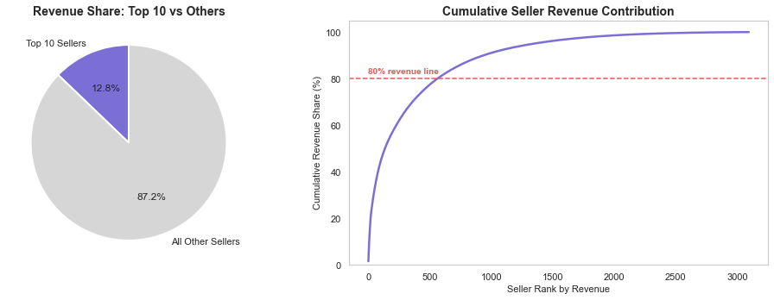
The seller contribution visual compares the top 10 sellers with the rest and shows cumulative revenue share by seller rank. It indicates whether marketplace revenue is concentrated or distributed across many sellers.

Figure 12: Seller Distribution by State
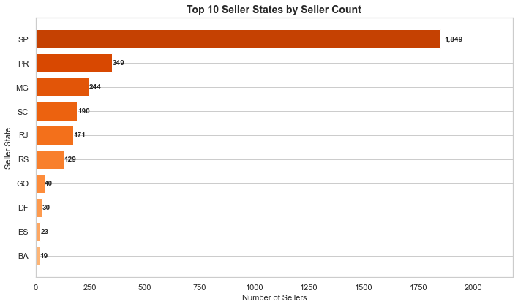
This chart shows where sellers are concentrated geographically. It can support regional seller acquisition, logistics coordination, and marketplace coverage planning.

Figure 13: Review Score Distribution
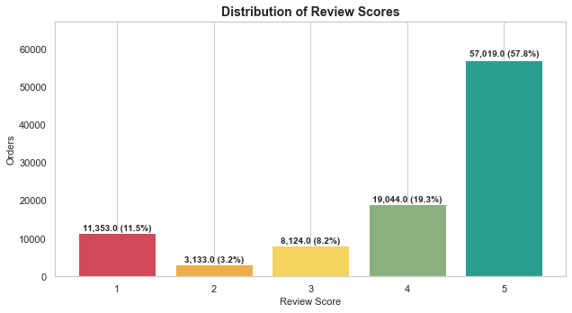
The review-score distribution shows that most customers leave positive ratings, but the lower-score segment remains important because it signals operational pain points and dissatisfaction drivers.
Figure 14: Delivery Time and Ratings
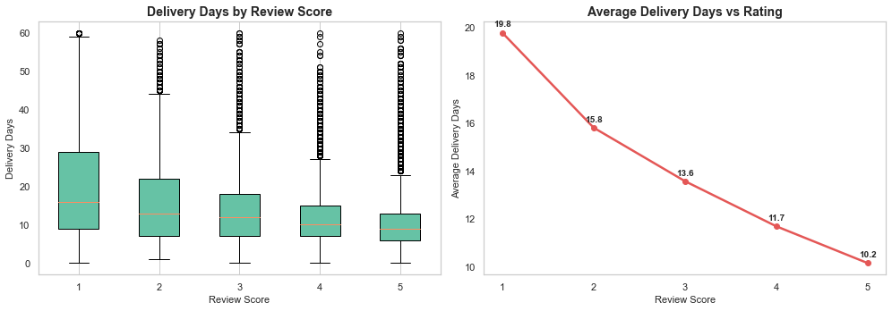
This visual connects delivery duration with review scores. It shows that longer delivery times tend to be associated with weaker ratings, reinforcing delivery speed as a satisfaction lever.

Figure 15: Dissatisfaction Patterns
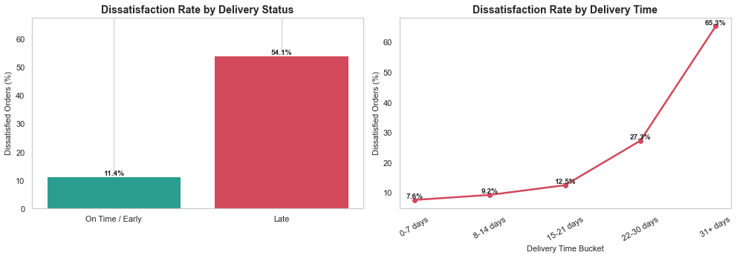
The dissatisfaction visual compares late versus on-time deliveries and delivery-time buckets. It shows that late and slower deliveries have much higher dissatisfaction rates, making logistics reliability a priority.
Figure 16: Correlation Heatmap
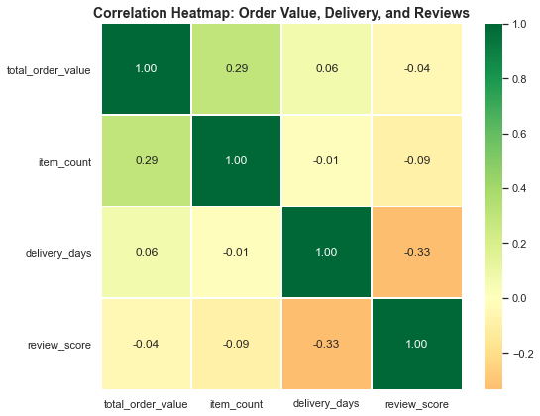
The heatmap summarizes relationships among order value, item count, delivery days, and review score. It provides a compact view of how commercial and operational metrics move together.

