**Automation User Guide:**

Application : Sweety  
 Organization : Codetheory.io  
 Author : Brijendra Singh

Document Version: v.1

1. **Framework Structure**

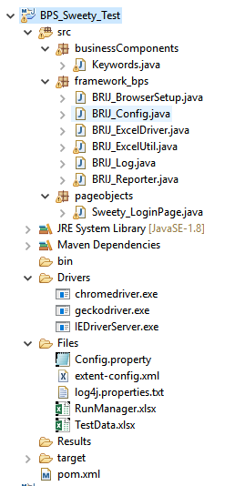

1. **Initiate Test Case and Test Data**
   1. **RunManger.xlsx** : Module setup and Test Case Setup
   2. **TestData.xlsx** : Test Data setup

RunManager.xlsx  
**-Setup Module:**  
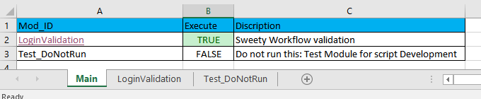

**-Setup Test Case:**  
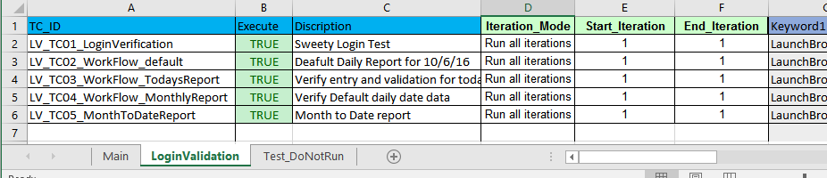

**-Test Case Keywords setup:**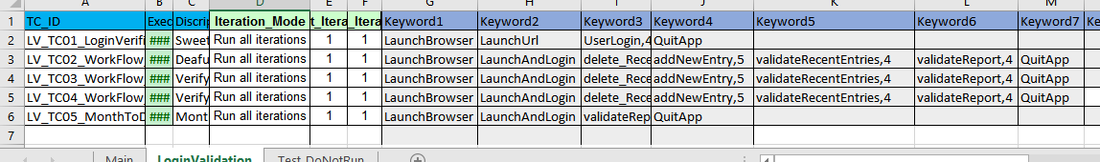

**-Iteration Setup:**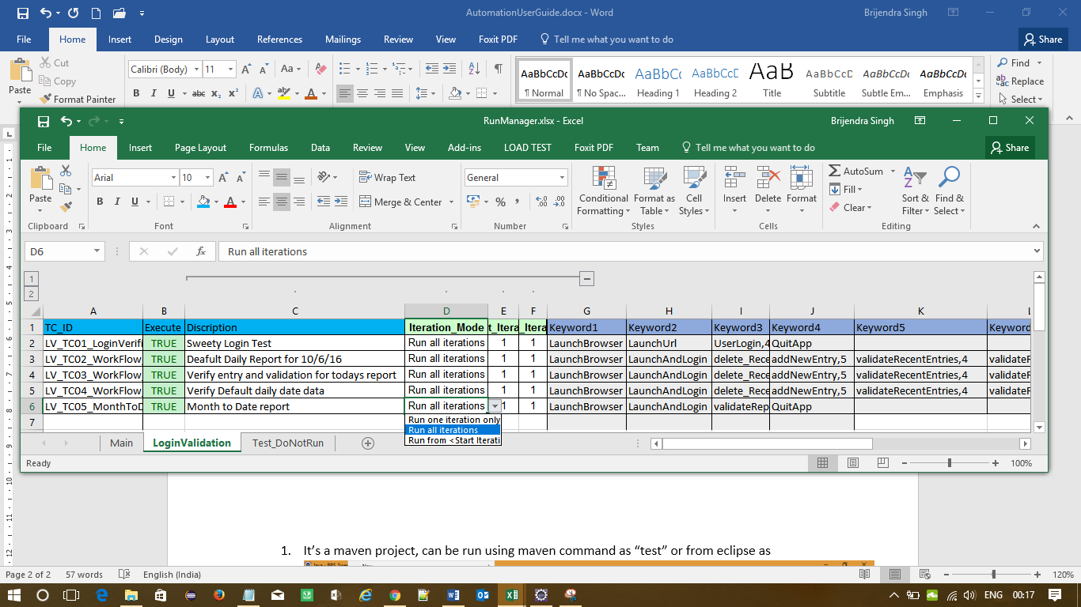

1. Run one Iteration
2. Run all iteration
3. Run <start> to <End> Iteration
4. Sub iteration: Keyword level Iteration and Group Keyword Iteration

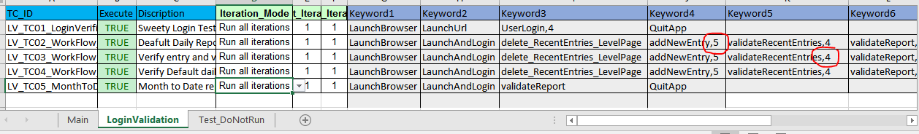

**TestData.xlsx**

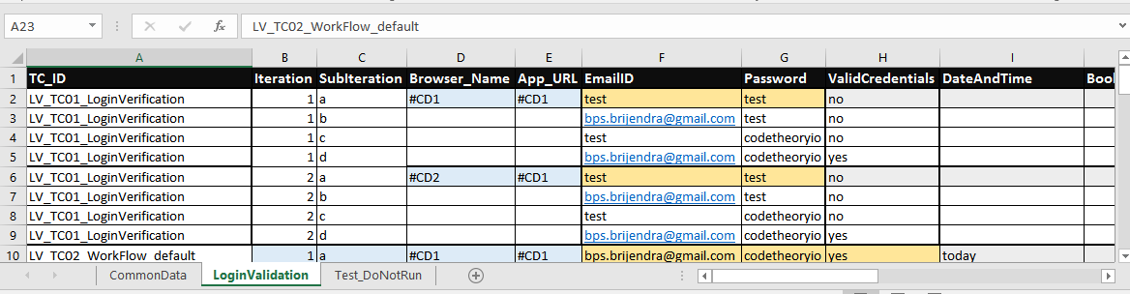

Common test data  
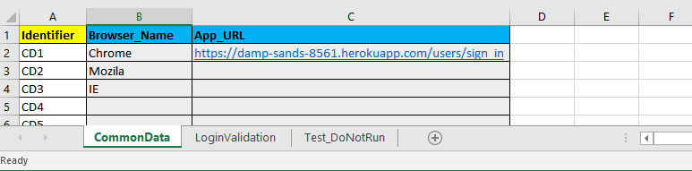

1. **Test Results**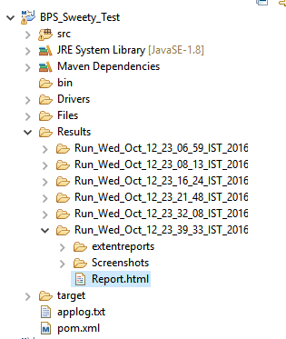

Go to the result directory and open the report.html file or It will be automatically open once execution ends.

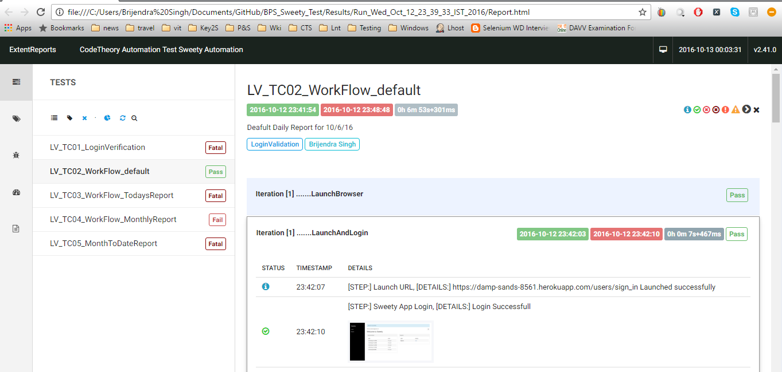

1. **Run Regression Suit**

-It’s a Maven project and can be build, clean, install and test

-All dependencies are managed by Maven POM file

Simplest way to run this project is as below  
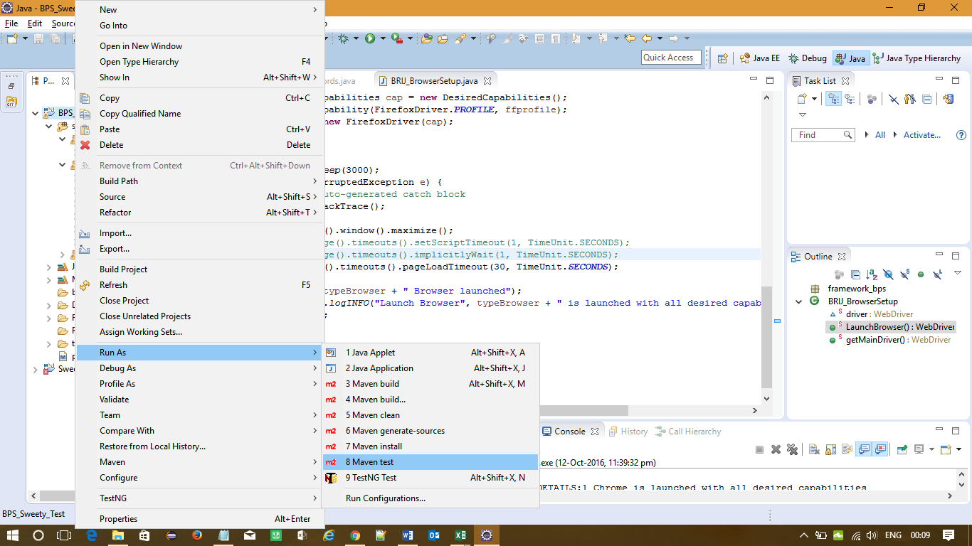

Or

Run from the main class as highlighted in the given screen-print:  
