Lab 4: Create 3D-Model using Three.js and A-Frame framework.
Sol:
Concept need for LAB:
  - Three.js is a powerful, open-source JavaScript library that simplifies the process of creating and displaying 3D graphics and animations in web browsers using WebGL. https://threejs.org/

  - "A-Frame" refers to a web framework, written in JavaScript, that simplifies the creation of 3D and WebXR scenes, including AR experiences, using a HTML. https://aframe.io/docs/1.7.0/introduction/

  - <a-scene> is the main container where all 3D objects are placed. It initializes the A-Frame environment.

  - <a-entity position="0 1.6 4">: Creates an entity to hold the camera. The position attribute sets the initial position of the camera (0 meters on the X-axis, 1.6 meters on the Y-axis (eye level), and 4 meters back on the Z-axis).
  - <a-camera></a-camera>: This tag defines the camera in the scene, through which the user views the VR environment. Since it's nested within the a-entity, it inherits the entity's position.
  - Directional Light simulates a light source (like the sun) coming from (x=1, y=1, z=1).
  - Ambient Light provides a general soft lighting across the scene.
  - cube at (x=0, y=1, z=-3), rotated 45° around the Y-axis.
  - Animation: Rotates from 0 45 0 to 0 90 0 every second (dur: 1000ms) and loops infinitely. As code.
A-Frame lifecycle methods

- init()
Called once when the component is attached to an entity; used for initial setup, variables, and event listeners.

- update(oldData)
Called after init() and whenever component data changes; used to react to property or state updates.

- play()
Called when the component or scene starts or resumes; used to activate behaviors.

- tick(time, timeDelta)
Called on every frame; used for animations, movement, or continuous updates.

- pause()
Called when the scene or component is paused; used to temporarily stop actions.

- remove()
Called when the component or entity is removed; used for cleanup like removing listeners or objects.

Steps
1: Check node, npm and express is installed
node -v
npm -v
npm list express

2: Create server.js by code
const express = require('express');
const path = require('path');
const app = express();
// Serve static files from the "public" directory
app.use(express.static(path.join(__dirname, 'public')));
// Start the server
const PORT = process.env.PORT || 3000;
app.listen(PORT, () => {
console.log(`Server is running on http://localhost:${PORT}`);
});

3. create folder public & download Aframe min.js Production version keep it in public folder
4: Lab4.html in public folder
<html>
<head>
<script src="aframe.min.js"></script>
</head>
<body>
<a-scene>
<!-- Camera and lighting -->
<a-entity position="0 1.6 4">
<a-camera></a-camera>
</a-entity>
<a-light type="directional" position="1 1 1" intensity="0.8"></a-light>
<a-light type="ambient" intensity="0.5"></a-light>
<!-- 3D Cube -->
<a-box position="0 1 -3" rotation="0 45 0" color="red" animation="property: rotation; to: 0 90 0; loop: true; dur: 1000"></a-box>
<a-box position="2 1 -3" rotation="0 0 45" color="green" animation="property: rotation; to: 0 90 0; loop: true; dur: 2000"></a-box>
<!-- Ground -->
<a-plane position="0 0 -4" rotation="-90 0 0" width="10" height="10" color="#7BC8A4"></a-plane>
</a-scene>
</body>
</html>

5. Type Server.js
Output:
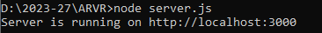
Type : http://localhost:3000 in browser
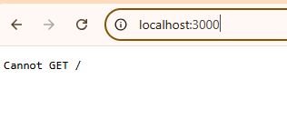
Type: /lab4.html after 3000
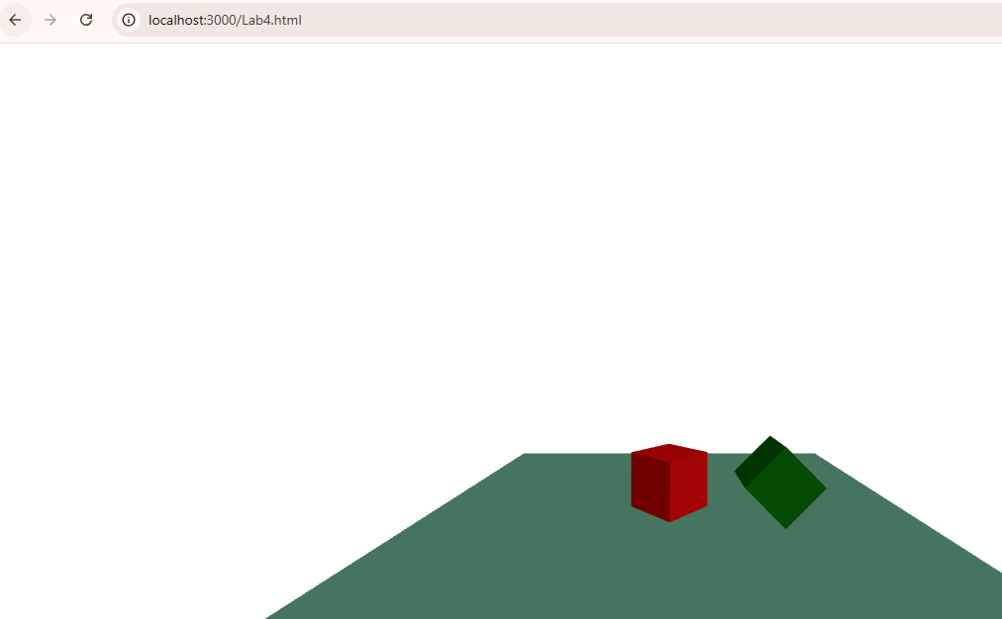

Lab 5: Develop a 3D model using Three.js and the A-Frame framework for interactive user experiences
Step 1: Create Lab5.html
<!DOCTYPE html>
<html>
<head>
<meta charset="utf-8">
<title>A-Frame Hover & Click Reset</title>

<!-- A-Frame (production) -->
<script src="aframe.min.js"></script>

<script>
// Hover color component (auto reset)
AFRAME.registerComponent('hover-color', {
init: function () {
const el = this.el;
const originalColor = el.getAttribute('material').color;

el.addEventListener('mouseenter', () => {
el.setAttribute('material', 'color', '#0000FF'); // blue
});

el.addEventListener('mouseleave', () => {
el.setAttribute('material', 'color', originalColor);
});
}
});

// Click scale toggle component (reset on next click)
AFRAME.registerComponent('click-scale-toggle', {
init: function () {
const el = this.el;
let scaled = false;

el.addEventListener('click', () => {
if (!scaled) {
el.setAttribute('scale', '1.5 1.5 1.5');
} else {
el.setAttribute('scale', '1 1 1');
}
scaled = !scaled;
});
}
});
</script>
</head>

<body>
<a-scene>

<!-- Camera -->
<a-camera position="0 1.6 4"
cursor="rayOrigin: mouse"
raycaster="objects: .interactive">
</a-camera>

<!-- Lights -->
<a-light type="directional" position="1 2 1" intensity="0.9"></a-light>
<a-light type="ambient" intensity="0.6"></a-light>

<!-- Cube: click to scale and reset -->
<a-box class="interactive"
position="-1.8 1 -3"
material="color: #FF0000"
click-scale-toggle>
</a-box>

<!-- Cylinder: hover color change and reset -->
<a-cylinder class="interactive"
position="0 1 -3"
radius="0.5"
height="1.5"
material="color: #00FF00"
hover-color>
</a-cylinder>

<!-- Torus: rotating -->
<a-torus position="1.8 1.2 -3"
radius="0.7"
radius-tubular="0.25"
material="color: #FFD700"
animation="property: rotation;
to: 0 360 0;
loop: true;
dur: 2000">
</a-torus>

<!-- Ground -->
<a-plane position="0 0 -4"
rotation="-90 0 0"
width="10"
height="10"
material="color: #7BC8A4">
</a-plane>

</a-scene>
</body>
</html>

Step 2: run in local server
Note:
AFRAME.registerComponent('hover-color', {
Registers a custom A-Frame component

'hover-color' is the component name

This component can be attached to any A-Frame entity as an HTML attribute

<a-cylinder hover-color></a-cylinder>

init: function () {

- init() is a lifecycle method in A-Frame
- It runs once when the component is attached to an entity
- Used to initialize variables and event listeners

this.el refers to the A-Frame entity to which the component is attached, allowing interaction and property modification.
- this → refers to the current component instance
- this.el → refers to the HTML element (entity) on which the component is applied
- el is a shortcut reference to the 3D object

Output:
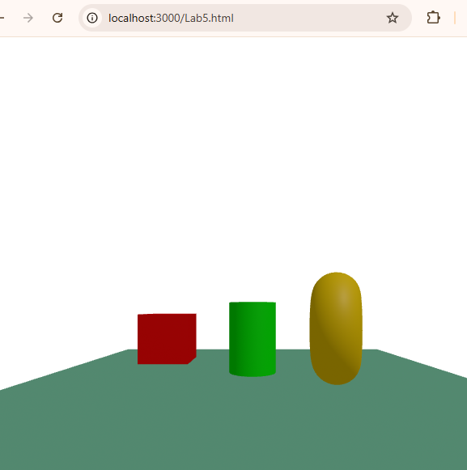
After Interaction
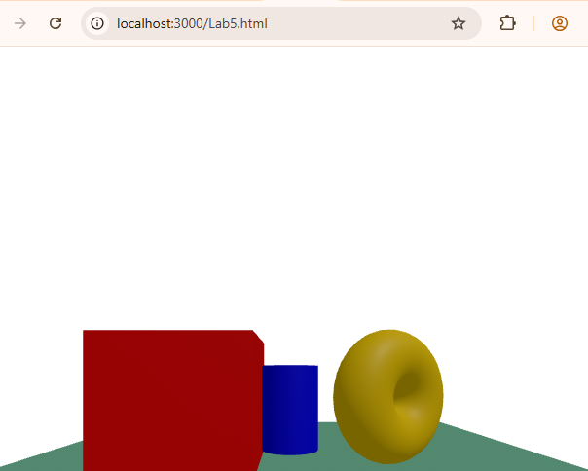
Lab 6: Develop an A-Frame-based 360° image gallery with local images, interactive hotspots, and gyroscope functionality.
Step 1: create folder images and download 360 or high quality image name it as required
Step 2 : create Lab6.html

<!DOCTYPE html>
<html>
<head>
<title>360 Image Galery</title>

<!-- LOCAL A-Frame -->
<script src="aframe.min.js"></script>

<script>
// Component to change 360 image on hotspot click
AFRAME.registerComponent('change-scene', {
schema: { target: {type: 'string'} },
init: function () {
this.el.addEventListener('click', () => {
document.querySelector('#sky').setAttribute('src', this.data.target);
});
}
});
</script>
</head>

<body style="margin:0; overflow:hidden;">

<a-scene>

<!-- Load LOCAL images -->
<a-assets>
<img id="img1" src="images/img1.jpg">
<img id="img2" src="images/img2.jpg">
<img id="img3" src="images/img3.jpg">
</a-assets>

<!-- Camera with gyroscope and mouse support -->
<a-camera position="0 1.6 0" look-controls cursor="rayOrigin: mouse" raycaster="objects: .clickable">
</a-camera>

<!-- 360 Sky -->
<a-sky id="sky" src="#img1" rotation="0 -90 0"></a-sky>

<!-- Hotspot 1 -->
<a-circle class="clickable"
position="-2 1.5 -3"
radius="0.3"
material="color: red"
change-scene="target: #img1">
</a-circle>
<!-- Label for Hotspot 1 -->
<a-text value="Living Room"
position="-2 2.1 -3"
color="white"
align="center"
width="3">
</a-text>

<!-- Hotspot 2 -->
<a-circle class="clickable"
position="0 1.5 -3"
radius="0.3"
material="color: blue"
change-scene="target: #img2">
</a-circle>
<!-- Label for Hotspot 2 -->
<a-text value="Kitchen"
position="0 2.1 -3"
color="white"
align="center"
width="3">
</a-text>

<!-- Hotspot 3 -->
<a-circle class="clickable"
position="2 1.5 -3"
radius="0.3"
material="color: green"
change-scene="target: #img3">
</a-circle>
<!-- Label for Hotspot 3 -->
<a-text value="Bedroom"
position="2 2.1 -3"
color="white"
align="center"
width="3">
</a-text>

</a-scene>

</body>
</html>

Output: In VR head set or in Mobile by hosting in GitHub
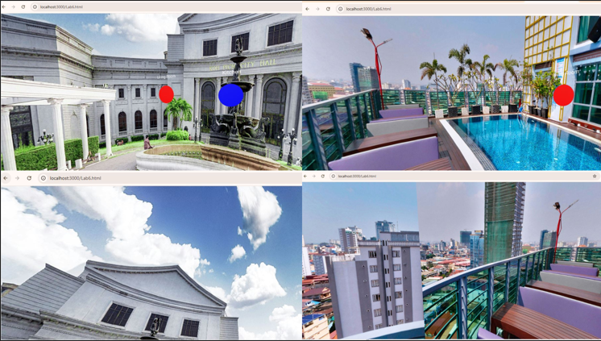
https://chirpy2710.github.io/imagegaalary/

Lab 7: Create a location-based pop-up object using geolocation data.
Step 1: find out two-three geo location latitude and longitude
Step 2: create Lab7.html
<!doctype html>
<html>
<head>
<title>A-Frame Geolocation</title>

<script src="/aframe.min.js"></script>
<script>
document.addEventListener('DOMContentLoaded', function() {
function showShapes(position)
{
var currentLatitude = position.coords.latitude;
var currentLongitude = position.coords.longitude;
console.log("Latitude: " + currentLatitude);
console.log("Longitude: " + currentLongitude);

var locations = [
{ id: "box", lat:12.9564672,lon:77.6208384, threshold: 0.005 },
{ id: "cylinder", lat: 12.90509057, lon: 77.55971556, threshold: 0.005 },
{ id: "sphere", lat: 12.9564672,lon: 77.594624,threshold: 0.005}
];
locations.forEach(location => {
var shape = document.querySelector(`#${location.id}`);
if (shape && Math.abs(currentLatitude - location.lat) < location.threshold &&
Math.abs(currentLongitude - location.lon) < location.threshold) {
shape.setAttribute('visible', true);
}
});
}
function locationError(error) {
console.error("Error getting location: ", error);
document.getElementById('currentLocation').innerHTML =
`Error getting location: ${error.message}`;
}
function getLocation() {
if (navigator.geolocation) {
navigator.geolocation.getCurrentPosition(showShapes, locationError, { enableHighAccuracy: true, timeout: 10000, maximumAge: 0 });
} else {
document.getElementById('currentLocation').innerHTML =
"Geolocation is not supported by this browser.";
}
}
getLocation();
});</script>
</head>
<body><h3 id="currentLocation">Fetching location...</h3>
<a-scene><a-box id="box" position="0 0.5 -3" rotation="0 45 0" color="red" visible="false"></a-box>
<a-cylinder id="cylinder" position="2 0.5 -3" radius="0.5" height="1.5" color="blue" visible="false"></a-cylinder>
<a-sphere id="sphere" position="-2 0.75 -3" radius="0.75" color="green" visible="false"></a-sphere>
<a-camera gps-camera rotation-reader></a-camera>
</a-scene>
</body>
</html>

Output:
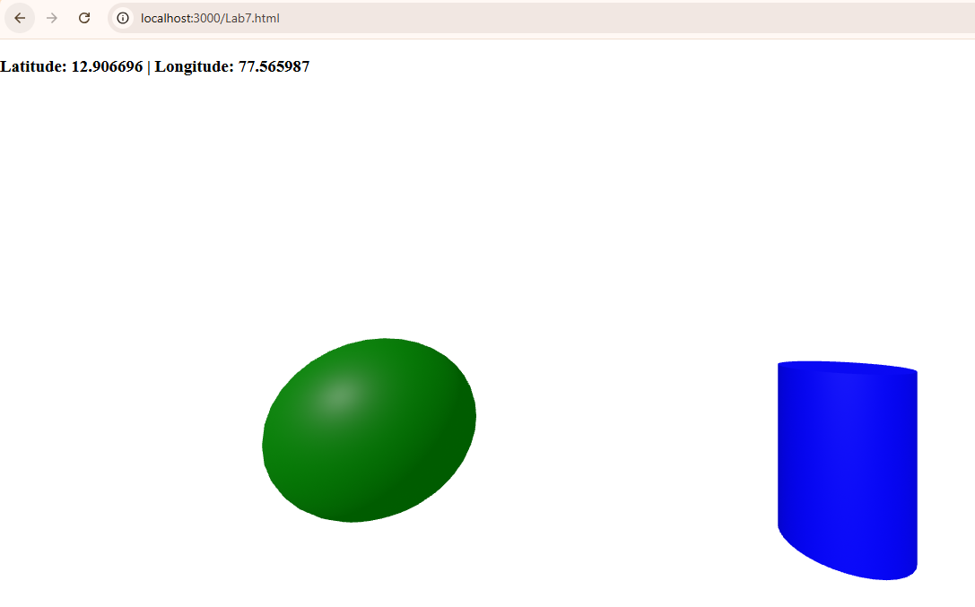
Lab 8: Design and implement Pattern-Based AR application using markers.
Step 1: Download Aframe-AR.js
https://github.com/jeromeetienne/AR.js/blob/master/aframe/build/aframe-ar.min.js
step 2: Download Pattern file RAW in .patt and image file for same
https://github.com/jeromeetienne/AR.js/blob/master/three.js/examples/marker-training/examples/pattern-files/pattern-letterA.patt
https://github.com/jeromeetienne/AR.js/blob/master/three.js/examples/marker-training/examples/pattern-images/pattern-letterA.png
Step 3: Create Lab 8.html
<!DOCTYPE html>
<html>
<head>
<title>A-Frame AR Marker</title>

<!-- Local A-Frame -->
<script src="aframe.min.js"></script>

<!-- Local AR.js for A-Frame -->
<script src="aframe-ar.js"></script>
</head>

<body style="margin: 0; overflow: hidden;">
<a-scene embedded arjs="sourceType: webcam; debugUIEnabled: false;">

<!-- Marker -->
<a-marker type="pattern" url="pattern-letterA.patt">
<a-box position="0 0.5 0" material="color: red; opacity: 0.5"></a-box>
<a-cylinder color="green" height="1" radius="0.3" position="1 0.5 0"></a-cylinder>
</a-marker>

<!-- Camera -->
<a-entity camera></a-entity>

</a-scene>
</body>
</html>

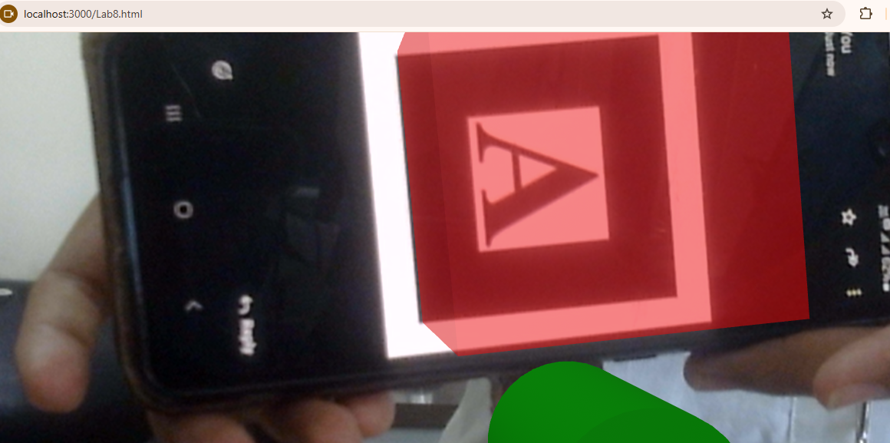

LAB 9: Create a Marker based AR Application for Image Traget.
Steps1: Download or create mindar-image-aframe.prod.js
Step 2: Create .mind file while helps in image processing
https://hiukim.github.io/mind-ar-js-doc/tools/compile/
Step 3: create Lab9.html
<!DOCTYPE html>
<html>
<head>
<meta charset="utf-8">
<title> Marker Based</title>

<script src="aframe.min.js"></script>
<script src="mindar-image-aframe.prod.js"></script>

<style>
body { margin: 0; overflow: hidden; }
</style>
</head>

<body>

<a-scene
mindar-image="imageTargetSrc: targets.mind;"
vr-mode-ui="false"
device-orientation-permission-ui="false">

<a-camera position="0 0 0" look-controls="false"></a-camera>

<a-entity mindar-image-target="targetIndex: 0">
<a-torus
radius="0.3"
radius-tubular="0.05"
color="#ff4081"
animation="property: rotation; to: 0 360 0; loop: true; dur: 3000">
</a-torus>
</a-entity>

</a-scene>

</body>
</html>

Step 4: Runs on local server
node server.js
localhost: 3000/Lab9.html
Output:

- When no image target found AR script searching for image Target Image.
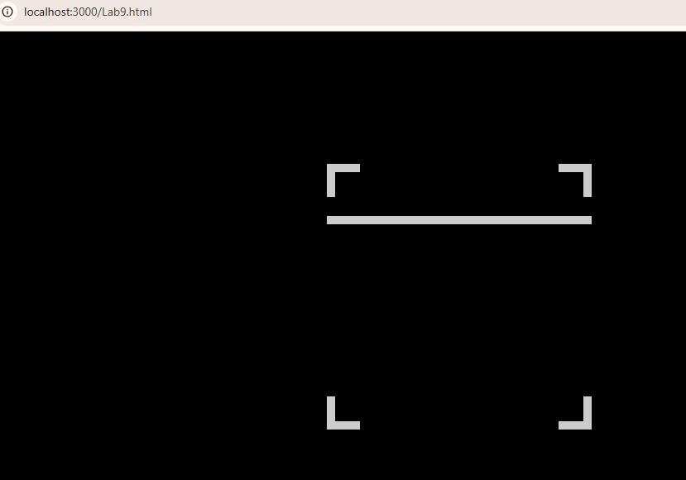
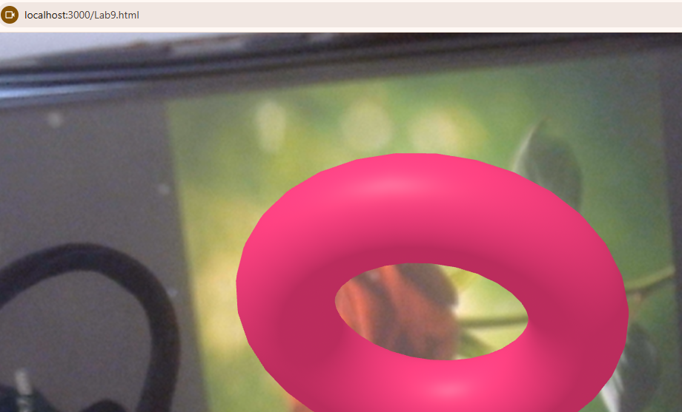

LAB-10: Create application to display 3D model in GLTF /Glb Format in web-based application
Sol:
Concept:
glTF (Graphics Library Transmission Format or GL Transmission Format and formerly known as WebGL Transmissions Format or WebGL TF) is a standard file format for three-dimensional scenes and models.
GLB is a file format for 3D models that includes textures, materials, and animations. It's a binary version of the GL Transmission Format (glTF) file.
- Download GLTF model from website
- Create Lab10.html
- Run using Localhost
<!DOCTYPE html>
<html lang="en">
<head>
<meta charset="UTF-8">
<meta name="viewport" content="width=device-width, initial-scale=1.0">
<title>Simple A-Frame Scene</title>
<script src="aframe.min.js"></script>
<style>
/* Ensure the body takes full height */
body, html {
margin: 0;
padding: 0;
height: 100%;
}

/* Style the button to make it visible and positioned correctly */
button {
position: absolute;
top: 20px;
left: 50%;
transform: translateX(-50%);
padding: 10px 20px;
font-size: 16px;
background-color: #4CC3D9;
border: none;
color: white;
border-radius: 5px;
cursor: pointer;
z-index: 10; /* Ensure it's above the scene */
}

/* Add hover effect for the button */
button:hover {
background-color: #3a9ca1;
}
</style>
</head>
<body>
<a-scene>
<a-assets>
<a-asset-item id="value" src="model/model.glb"></a-asset-item>
</a-assets>

<a-entity position="0 1.6 0">
<a-camera></a-camera>
</a-entity>

<a-entity id="model" gltf-model="#value" position="0 0 -5" rotation="0 45 0" scale="1 1 1"></a-entity>
</a-scene>

<!-- Button to trigger rotation -->
<button onclick="rotateModel()">Rotate Model 45°</button>

<script>
// Function to rotate the model by 45 degrees each time
function rotateModel() {
const model = document.querySelector('#model');

// Get the current rotation
let currentRotation = model.getAttribute('rotation');

// Increment the Y rotation by 45 degrees
currentRotation.y += 45;

// Apply the updated rotation
model.setAttribute('rotation', currentRotation);
}
</script>
</body>
</html>

Output
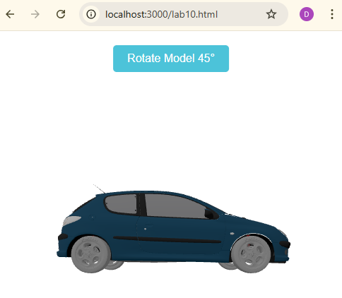
//After click rotation
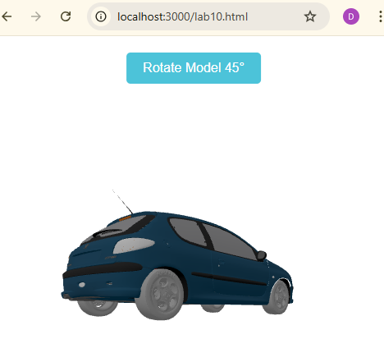
-------------------------------------END-------------------------------------

