Sugar Labs Website Refresh: Content Document
Last edited: 27 Nov 2011
Last author: Christian Marc Schmidt

Design
The link below contains a click-through slideshow of pages belonging to the new website. The content shown here is placeholder; the pages are there mainly to showcase the new design but should also serve as a point of reference for filling in content.
http://www.christianmarcschmidt.com/projects/sugarlabs/index.html

Introduction
The purpose of this document is to gather content for the new Sugar Labs website. The visual design represented here should be considered final, pending any feedback from the community and refinements that result from the content gathered here.

The general layout of these pages is based on a modular system, although there are also “static” pages. Modular page layouts are determined from sets of content that can change and should be maintained to keep the site fresh. An example is the set of case studies shown in 2.1: Education below. Unlike modular page, static pages consist of mainly text and supporting images. An example is 2.4: About the Software.

This document should be used as a template to fill in all of the content for a first launch of the website. Content should be entered in the tables below, organized by page. All the content shown below is placeholder—please feel free to change it.

Most importantly remember that this site is intended for a general audience, in order to introduce them to Sugar and Sugar Labs. We need to aim for making the content as accessible as possible.

Guidelines for content entry:

- Tables with rows labeled “module” (e.g. “Module 1 content”) should be thought of as extensible. This means that as many modules can be added (or subtracted) as necessary, based on the content needs for the page.
- Lightboxes appear as overlays on the page after the user clicks on a link or a page element. They can have 1 or more pages. Video overlays should only have 1 page, while slideshows (e.g. for case studies) can have as many pages as needed. Pages are treated as tables within tables below. Make sure to denote what element on a page invokes a lightbox!
- Text should be formatted using bold and italics in the way that it should be shown on the website.
- Links should be entered as actual links, pointing to the page in the wiki or an external reference, and
- Images should be referenced as links to the highest possible resolution of the image, in the corresponding position in the document. Use html syntax (<img src=””>) to specify that the link is for an image.
- Notes should be indicated in square brackets, eg. [Note].

For a general sitemap please see the Appendix at the bottom of this document. Please direct any questions about the use of this document or the content to John (jtis4stx@gmail.com) and Christian (christianmarc@gmail.com).

1. Home
(Slides 1-3 on website)

This is the homepage for the new website. It is a modular page and should change occasionally to reflect changes to the software or the organization. Most importantly, it provides entry points into the key areas of the site (Education proposition, Activities, Getting involved).

Content modules shouldn’t point to the wiki, they should drive people into the site first, where the right-pane module “Links” will provide links into the wiki.

Modules are varying sizes, based on the content needs. Try to keep the text as concise as possible—the homepage should be primarily visual to capture visitor engagement.

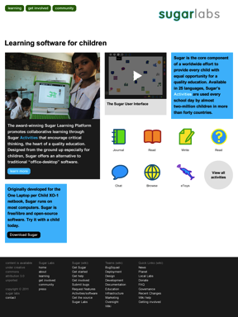
Homepage

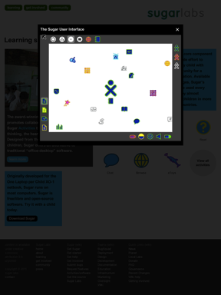
Video lightbox

Page Title | Learning software for children
Module 1 content | [Insert image]  The award-winning Sugar Learning Platform promotes collaborative learning through Sugar Activities that encourage critical thinking, the heart of a quality education. Designed from the ground up especially for children, Sugar offers an alternative to traditional “office-desktop” software.  Learn more
Module 2 content | [Insert image]  The Sugar User Interface  [Opens Lightbox A]
Module 3 content | Sugar is the core component of a worldwide effort to provide every child with equal opportunity for a quality education. Available in 25 languages, Sugar’s Activities are used every school day by almost two-million children in more than forty countries.
Module 4 content | [This module contains activity icons for the most popular/fundamental Sugar activities. These icons will link to the corresponding page in the activities portal. There is a “more” link to view all activities that leads to the the “Activities” page.]  [Activity icon] Journal  [Activity icon] Read  [Activity icon] Write  [Activity icon] Help  [Activity icon] Chat  [Activity icon] Browse  [Activity icon] eToys  View all activities
Module 5 content | Originally developed for the One Laptop per Child XO-1 netbook, Sugar runs on most computers. Sugar is free/libre and open-source software. Try it with a child today.  Download Sugar
Module N content
Lightbox A | The Sugar User Interface
  Slide 1 | [Insert image]  [Insert caption]
  Slide N | [Insert image]  [Insert caption]
Lightbox N | [Insert lightbox title]
  Slide 1 | [Insert image]  [Insert caption]
  Slide N | [Insert image]  [Insert caption]

2.1 Learning / Education
(Slide 4 on website)

This page shows a set of quotes as well as case studies. Quotes are short and don’t link anywhere. Case studies link to in-depth slideshows about specific learnings from the field, and can include as many slides as needed. These should eventually be updated whenever there is a new case study. The larger goal is to represent how Sugar is being effectively employed in the classroom, and how it is helping students learn.

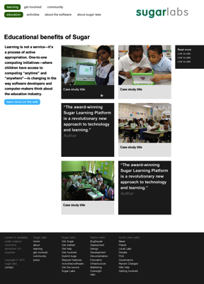
Educational benefits landing page

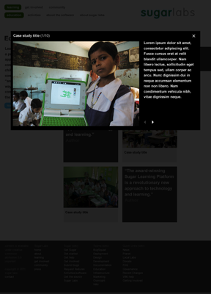
Case study slideshow

Page Title | Educational benefits of Sugar
Page Intro | Learning is not a service—it’s a process of active appropriation. One-to-one computation initiatives—where children have access to computing “anytime” and “anywhere”—is changing in the way software developers and computer-makers think about the education industry.  Learn more on the wiki
Links to the wiki | [Insert link 1]  [Insert link 2]  [Insert link 3]  [Insert link N]
Module 1 content | [Insert thumbnail]  [Insert case study title]  [Links to Lightbox A]
Module 2 content | [Insert thumbnail]  [Insert case study title]  [Links to Lightbox B]
Module 3 content | [Insert quote]  [Insert author name]
Module 4 content | [Insert thumbnail]  [Insert case study title]  [Links to Lightbox C]
Module 5 content | [Insert thumbnail]  [Insert case study title]  [Links to Lightbox D]
Module 6 content | [Insert quote]  [Insert author name]
Module N content
Lightbox A | [Insert case study title]
  Slide 1 | [Insert image]  [Insert caption]
  Slide 2 | [Insert image]  [Insert caption]
  Slide 3 | [Insert image]  [Insert caption]

2.2 Learning / Activities
(Slide 6 on website)

This page has a list of Sugar activities, ordered by importance. All activity icons link directly to the corresponding page in the activities portal.

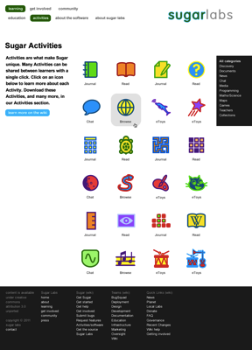

Page Title | Sugar Activities
Page Intro | Activities are what make Sugar unique. Many Activities can be shared between learners with a single click. Click on an icon below to learn more about each Activity. Download these Activities, and many more, in our Activities section.  Learn more on the wiki
Links to the activities portal | All categories:  Discovery  Documents  News  Chat  Media  Programming  Maths/Science  Maps  Games  Teachers  Collections
Activities | [Activity icon] Journal  [Activity icon] Read  [Activity icon] Write  [Activity icon] Help  [Activity icon] Chat  [Activity icon] Browse  [Activity icon] Distance  [Activity icon] eToys  [Activity icon] Calculate  [Activity icon] Turtle Art  [Activity icon] Maze  [Activity icon] Memorize  [Activity icon] Moon  [Activity icon] Pippy  [Activity icon] Paint  [Activity icon] Scratch  [Activity icon] Ruler  [Activity icon] Record  [Activity icon] Implode  [Activity icon] WikiBrowse English  [Activity icon] TamTam SynthLab  [Activity icon] TamTam Edit  [Activity icon] TamTam Mini  [Activity icon] TamTam Jam  [Activity icon] Measure  [Activity icon] Terminal  [Activity icon] Analyze  [Activity icon] Log

2.3 Learning / About the Software / Tutorials
(Slide 7 on website)

This page aggregates video tutorials that show how to use Sugar in all aspects, from basic UI to specific activities. We have six existing video tutorials, but should continue to extend this set.

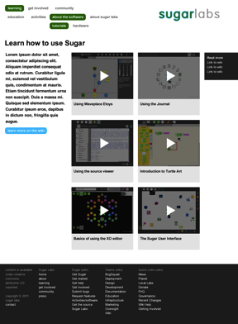

Page Title | Learn how to use Sugar
Page Intro | [Insert intro]
Links to the wiki | [Insert link 1]  [Insert link 2]  [Insert link 3]  [Insert link N]
Module 1 content | [Insert thumbnail]  Using Waveplace Etoys  [Opens Lightbox A]
Module 2 content | [Thumbnail: Link to Lightbox B]  Using the Journal  [Opens Lightbox B]
Module 3 content | [Insert thumbnail]  Using the source viewer  [Opens Lightbox C]
Module 4 content | [Insert thumbnail]  Introduction to Turtle Art  [Opens Lightbox D]
Module 5 content | [Insert thumbnail]  Basics of using the XO editor  [Opens Lightbox E]
Module 6 content | [Insert thumbnail]  The Sugar User Interface
Lightbox A | Using Waveplace Etoys  [Insert video]  [Insert caption]
Lightbox B | Using the Journal  [Insert video]  [Insert caption]
Lightbox C | Using the source viewer  [Insert video]  [Insert caption]
Lightbox D | Introduction to Turtle Art  [Insert video]  [Insert caption]
Lightbox E | Basics of using the XO editor  [Insert video]  [Insert caption]
Lightbox F | The Sugar User Interface  [Insert video]  [Insert caption]

2.4 Learning / About the Software / Hardware
(Slide 8 on website)

Static page describing the hardware requirements for Sugar, and that it runs on many platforms.
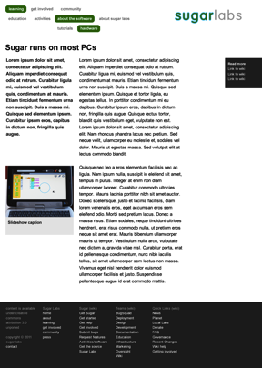

Page Title | Sugar runs on Most PCs
Page Intro | [Insert intro paragraph]
Links to the wiki | [Insert link 1]  [Insert link 2]  [Insert link 3]  [Insert link N]
Page Body
   | [Insert paragraph]
  [Insert optional image] | [Insert paragraph]
  [Insert optional image] | [Insert paragraph]
  etc.

2.5 Learning / About Sugar Labs / Mission
(Slide 9 on website)

Static page describing the Sugar Labs mission.
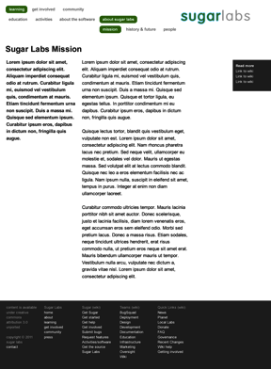

Page Title | Sugar Labs Mission
Page Intro | [Insert intro paragraph]
Links to the wiki | [Insert link 1]  [Insert link 2]  [Insert link 3]  [Insert link N]
Page Body
   | [Insert paragraph]
  [Insert optional image] | [Insert paragraph]
  [Insert optional image] | [Insert paragraph]
  etc.

2.6 Learning / About Sugar Labs / History & Future
(Slide 10 on website)

Static page describing the history or Sugar Labs and OLPC, as well as what the future holds.
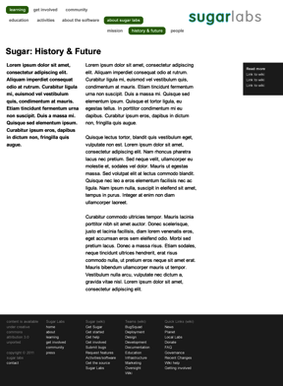

Page Title | History & Future
Page Intro | [Insert intro paragraph]
Links to the wiki | [Insert link 1]  [Insert link 2]  [Insert link 3]  [Insert link N]
Page Body
   | [Insert paragraph]
  [Insert optional image] | [Insert paragraph]
  [Insert optional image] | [Insert paragraph]
  etc.

2.7 Learning / About Sugar Labs / People
(Slide 11 on website)

This is a module page showing a set of contributors at Sugar Labs. Each person has a thumbnail and a name, and links to a unique URL (personal website or profile on Planet Sugar).
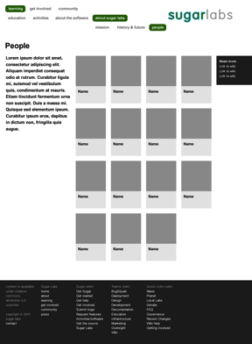

Page Title | People
Page Intro | [Insert intro paragraph]
Links to the wiki | [Insert link 1]  [Insert link 2]  [Insert link 3]  [Insert link N]
People
  [Insert thumbnail] | [Insert name]
  [Insert thumbnail] | [Insert name]
  [Insert thumbnail] | [Insert name]
  [Insert thumbnail] | [Insert name]
  etc.

3.1 Get Involved / Donations
(Slide 12 on website)

Static page describing how and where to donate to Sugar Labs. (We may need a PayPal account, unless this already exists?)
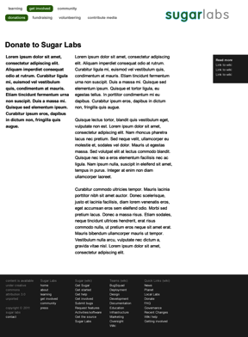

Page Title | Donate to Sugar Labs
Page Intro | [Insert intro paragraph]
Links to the wiki | [Insert link 1]  [Insert link 2]  [Insert link 3]  [Insert link N]
Page Body
   | [Insert paragraph]
  [Insert optional image] | [Insert paragraph]
  [Insert optional image] | [Insert paragraph]
  etc.

3.2 Get Involved / Help with fundraising
(Slide 13 on website)

Static page describing how to volunteer to help with fundraising.
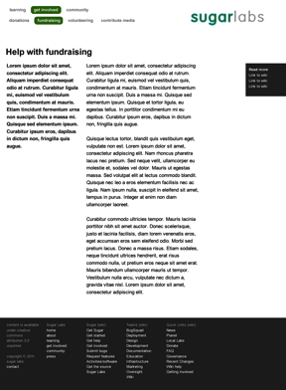

Page Title | Help with fundraising
Page Intro | [Insert intro paragraph]
Links to the wiki | [Insert link 1]  [Insert link 2]  [Insert link 3]  [Insert link N]
Page Body
   | [Insert paragraph]
  [Insert optional image] | [Insert paragraph]
  [Insert optional image] | [Insert paragraph]
  etc.

3.3 Get Involved / Volunteering
(Slide 14 on website)

Static page describing how to join Sugar as a volunteer, as well as the various teams.
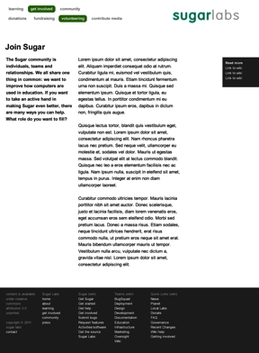

Page Title | Join Sugar
Page Intro | [Insert intro paragraph]
Links to the wiki | [Insert link 1]  [Insert link 2]  [Insert link 3]  [Insert link N]
Page Body
   | [Insert paragraph]
  [Insert optional image] | [Insert paragraph]
  [Insert optional image] | [Insert paragraph]
  etc.

3.4 Get Involved / Contribute Media
(Slide 15 on website)

Static page describing how to contribute media (photos, videos, case studies, articles, etc.) to Sugar Labs.

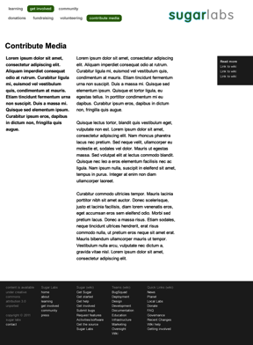

Page Title | Contribute Media
Page Intro | [Insert intro paragraph]
Links to the wiki | [Insert link 1]  [Insert link 2]  [Insert link 3]  [Insert link N]
Page Body
   | [Insert paragraph]
  [Insert optional image] | [Insert paragraph]
  [Insert optional image] | [Insert paragraph]
  etc.

3.5 Get Involved / Deployments
(Slide 16 on website)

Static page showing a Google map of Sugar Labs deployments.
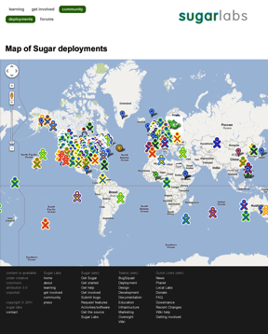

Page Title | Map of Sugar deployments

3.6 Get Involved / Contribute Media
(Slide 17 on website)

Static page describing how to participate in Sugar Labs forums and where to go to participate.
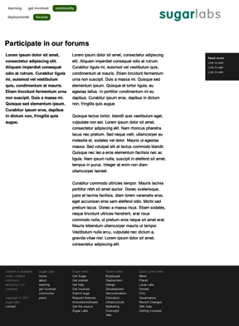

Page Title | Participate in our forums
Page Intro | [Insert intro paragraph]
Links to the wiki | [Insert link 1]  [Insert link 2]  [Insert link 3]  [Insert link N]
Page Body
   | [Insert paragraph]
  [Insert optional image] | [Insert paragraph]
  [Insert optional image] | [Insert paragraph]
  etc.

