3GPP TS 29.509 V16.2.0 (2019-12)
Technical Specification
3rd Generation Partnership Project;
Technical Specification Group Core Network and Terminals;
5G System; Authentication Server Services;
Stage 3
(Release 16)


The present document has been developed within the 3rd Generation Partnership Project (3GPP TM) and may be further elaborated for the purposes of 3GPP..
The present document has not been subject to any approval process by the 3GPP Organizational Partners and shall not be implemented.
This Specification is provided for future development work within 3GPP only. The Organizational Partners accept no liability for any use of this Specification.
Specifications and Reports for implementation of the 3GPP TM system should be obtained via the 3GPP Organizational Partners' Publications Offices.

Keywords
3GPP, 5G System
3GPP
Postal address

3GPP support office address
650 Route des Lucioles - Sophia Antipolis
Valbonne - FRANCE
Tel.: +33 4 92 94 42 00 Fax: +33 4 93 65 47 16
Internet
http://www.3gpp.org
Copyright Notification
No part may be reproduced except as authorized by written permission.
The copyright and the foregoing restriction extend to reproduction in all media.

© 2019, 3GPP Organizational Partners (ARIB, ATIS, CCSA, ETSI, TSDSI, TTA, TTC).
All rights reserved.

UMTS™ is a Trade Mark of ETSI registered for the benefit of its members
3GPP™ is a Trade Mark of ETSI registered for the benefit of its Members and of the 3GPP Organizational Partners
LTE™ is a Trade Mark of ETSI registered for the benefit of its Members and of the 3GPP Organizational Partners
GSM® and the GSM logo are registered and owned by the GSM Association
Contents
Foreword 7
1 Scope 8
2 References 8
3 Definitions and abbreviations 9
3.1 Definitions 9
3.2 Abbreviations 9
4 Overview 9
4.1 Introduction 9
5 Services offered by the AUSF 10
5.1 Introduction 10
5.2 Nausf_UEAuthentication Service 10
5.2.1 Service Description 10
5.2.2 Service Operations 11
5.2.2.1 Introduction 11
5.2.2.2 Authenticate 11
5.2.2.2.1 General 11
5.2.2.2.2 5G AKA 11
5.2.2.2.3 EAP-based authentication method 12
5.2.2.2.3.1 General 12
5.2.2.2.3.2 EAP method: EAP-AKA' 13
5.2.2.2.3.3 EAP method: EAP-TLS 14
5.2.2.2.4 Authentication for FN-RG 14
5.3 Nausf_SoRProtection Service 14
5.3.1 Service Description 14
5.3.2 Service Operations 15
5.3.2.1 Introduction 15
5.3.2.2 Protect 15
5.3.2.2.1 General 15
5.4 Nausf_UPUProtection Service 16
5.4.1 Service Description 16
5.4.2 Service Operations 16
5.4.2.1 Introduction 16
5.4.2.2 Protect 16
5.4.2.2.1 General 16
6 API Definitions 17
6.1 Nausf_UEAuthentication Service API 17
6.1.1 API URI 17
6.1.2 Usage of HTTP 17
6.1.2.1 General 17
6.1.2.2 HTTP standard headers 17
6.1.2.2.1 General 17
6.1.2.2.2 Content type 17
6.1.2.3 HTTP custom headers 17
6.1.2.3.1 General 17
6.1.3 Resources 17
6.1.3.1 Overview 17
6.1.3.2 Resource: List of ue-authentications 18
6.1.3.2.1 Description 18
6.1.3.2.2 Resource Definition 19
6.1.3.2.3 Resource Standard Methods 19
6.1.3.2.3.1 POST 19
6.1.3.2.4 Resource Custom Operations 20
6.1.3.2.4.1 Overview 20
6.1.3.3 Resource: 5g-aka-confirmation (Document) 20
6.1.3.3.1 Description 20
6.1.3.3.2 Resource Definition 20
6.1.3.3.3 Resource Standard Methods 21
6.1.3.3.3.1 PUT 21
6.1.3.4 Resource: eap-session (Document) 21
6.1.3.4.1 Description 21
6.1.3.4.2 Resource Definition 21
6.1.3.4.3 Resource Standard Methods 22
6.1.3.4.3.1 POST 22
6.1.3.5 Resource: List of rg-authentications 22
6.1.3.5.1 Description 22
6.1.3.5.2 Resource Definition 22
6.1.3.5.3 Resource Standard Methods 23
6.1.3.5.3.1 POST 23
6.1.4 Custom Operations without associated resources 23
6.1.4.1 Overview 23
6.1.5 Notifications 24
6.1.5.1 General 24
6.1.6 Data Model 24
6.1.6.1 General 24
6.1.6.2 Structured data types 24
6.1.6.2.1 Introduction 24
6.1.6.2.2 Type: AuthenticationInfo 25
6.1.6.2.3 Type: UEAuthenticationCtx 25
6.1.6.2.4 Type: 5gAuthData 25
6.1.6.2.5 Type: Av5gAka 25
6.1.6.2.6 Type: ConfirmationData 26
6.1.6.2.7 Type: EapSession 26
6.1.6.2.8 Type: ConfirmationDataResponse 26
6.1.6.2.9 Type: RgAuthenticationInfo 26
6.1.6.2.10 Type: RgAuthCtx 27
6.1.6.3 Simple data types and enumerations 27
6.1.6.3.1 Introduction 27
6.1.6.3.2 Simple data types 27
6.1.6.3.3 Enumeration: AuthType 27
6.1.6.3.4 Enumeration: AuthResult 27
6.1.6.3.5 Relation Types 28
6.1.6.3.5.1 General 28
6.1.6.3.5.2 The "5g-aka" Link relation 28
6.1.6.3.5.3 The "eap-session" Link relation 28
6.1.6.4 Binary data 28
6.1.6.4.1 Introduction 28
6.1.7 Error Handling 28
6.1.7.1 General 28
6.1.7.2 Protocol Errors 28
6.1.7.3 Application Errors 28
6.1.8 Security 29
6.2 Nausf_SoRProtection Service API 30
6.2.1 API URI 30
6.2.2 Usage of HTTP 30
6.2.2.1 General 30
6.2.2.2 HTTP standard headers 30
6.2.2.2.1 General 30
6.2.2.2.2 Content type 30
6.2.2.3 HTTP custom headers 30
6.2.2.3.1 General 30
6.2.3 Resources 30
6.2.3.1 Overview 30
6.2.3.2 Resource: ue-sor 31
6.2.3.2.1 Description 31
6.2.3.2.2 Resource Definition 31
6.2.3.2.3 Resource Standard Methods 31
6.2.3.2.4 Resource Custom Operations 32
6.2.3.2.4.1 Overview 32
6.2.3.2.4.2 Operation: generate-sor-data 32
6.2.3.2.4.2.1 Description 32
6.2.3.2.4.2.2 Operation Definition 32
6.2.4 Custom Operations without associated resources 32
6.2.4.1 Overview 32
6.2.5 Notifications 33
6.2.5.1 General 33
6.2.6 Data Model 33
6.2.6.1 General 33
6.2.6.2 Structured data types 33
6.2.6.2.1 Introduction 33
6.2.6.2.2 Type: SorInfo 34
6.2.6.2.3 Type: SorSecurityInfo 34
6.2.6.2.4 Type: SteeringInfo 34
6.2.6.2.5 Type: SteeringContainer 34
6.2.6.3 Simple data types and enumerations 35
6.2.6.3.1 Introduction 35
6.2.6.3.2 Simple data types 35
6.2.6.3.3 Enumeration: AccessTech 35
6.2.7 Error Handling 35
6.2.7.1 General 35
6.2.7.2 Protocol Errors 35
6.2.7.3 Application Errors 35
6.2.8 Security 36
6.3 Nausf_UPUProtection Service API 36
6.3.1 API URI 36
6.3.2 Usage of HTTP 36
6.3.2.1 General 36
6.3.2.2 HTTP standard headers 36
6.3.2.2.1 General 36
6.3.2.2.2 Content type 36
6.3.2.3 HTTP custom headers 37
6.3.2.3.1 General 37
6.3.3 Resources 37
6.3.3.1 Overview 37
6.3.3.2 Resource: ue-upu 37
6.3.3.2.1 Description 37
6.3.3.2.2 Resource Definition 37
6.3.3.2.3 Resource Standard Methods 38
6.3.3.2.4 Resource Custom Operations 38
6.3.3.2.4.1 Overview 38
6.3.3.2.4.2 Operation: generate-upu-data 38
6.3.3.2.4.2.1 Description 38
6.3.3.2.4.2.2 Operation Definition 38
6.3.4 Custom Operations without associated resources 39
6.3.4.1 Overview 39
6.3.5 Notifications 39
6.3.5.1 General 39
6.3.6 Data Model 39
6.3.6.1 General 39
6.3.6.2 Structured data types 39
6.3.6.2.1 Introduction 39
6.3.6.2.2 Type: UpuInfo 40
6.3.6.2.3 Type: UpuSecurityInfo 40
6.3.6.2.4 Type: UpuData 40
6.3.6.3 Simple data types and enumerations 40
6.3.6.3.1 Introduction 40
6.3.6.3.2 Simple data types 40
6.3.6.3.3 Enumeration: UpuDataType 41
6.3.7 Error Handling 41
6.3.7.1 General 41
6.3.7.2 Protocol Errors 41
6.3.7.3 Application Errors 41
6.3.8 Security 41
Annex A (normative): OpenAPI specification 42
A.1 General 42
A.2 Nausf_UEAuthentication API 42
A.3 Nausf_SoRProtection API 47
A.4 Nausf_UPUProtection API 49
Annex B (Informative): Use of EAP-TLS 50
B.1 General 50
B.2 EAP method: EAP-TLS 50
Annex C (informative): Withdrawn API versions 52
C.1 General 52
C.2 Nausf_SoRProtection API 52
Annex D (informative): Change history 53

Foreword
This Technical Specification has been produced by the 3rd Generation Partnership Project (3GPP).
The contents of the present document are subject to continuing work within the TSG and may change following formal TSG approval. Should the TSG modify the contents of the present document, it will be re-released by the TSG with an identifying change of release date and an increase in version number as follows:
Version x.y.z
where:
x the first digit:
1 presented to TSG for information;
2 presented to TSG for approval;
3 or greater indicates TSG approved document under change control.
y the second digit is incremented for all changes of substance, i.e. technical enhancements, corrections, updates, etc.
z the third digit is incremented when editorial only changes have been incorporated in the document.

1 Scope
The present document specifies the stage 3 protocol and data model for the Nausf Service Based Interface. It provides stage 3 protocol definitions and message flows, and specifies the API for each service offered by the AUSF.
The 5G System stage 2 architecture and procedures are specified in 3GPP TS 23.501 [2], 3GPP TS 23.502 [3] and 3GPP TS 33.501 [8].
The Technical Realization of the Service Based Architecture and the Principles and Guidelines for Services Definition are specified in 3GPP TS 29.500 [4] and 3GPP TS 29.501 [5].

2 References
The following documents contain provisions which, through reference in this text, constitute provisions of the present document.
- References are either specific (identified by date of publication, edition number, version number, etc.) or non-specific.
- For a specific reference, subsequent revisions do not apply.
- For a non-specific reference, the latest version applies. In the case of a reference to a 3GPP document (including a GSM document), a non-specific reference implicitly refers to the latest version of that document in the same Release as the present document.
[1] 3GPP TR 21.905: "Vocabulary for 3GPP Specifications".
[2] 3GPP TS 23.501: "System Architecture for the 5G System; Stage 2".
[3] 3GPP TS 23.502: "Procedures for the 5G System; Stage 2".
[4] 3GPP TS 29.500: "5G System; Technical Realization of Service Based Architecture; Stage 3".
[5] 3GPP TS 29.501: "5G System; Principles and Guidelines for Services Definition; Stage 3".
[6] IETF RFC 7540: "Hypertext Transfer Protocol Version 2 (HTTP/2)".
[7] IETF RFC 8259: "The JavaScript Object Notation (JSON) Data Interchange Format".
[8] 3GPP TS 33.501: "Security Architecture and Procedures for 5G System".
[9] IETF RFC 5448: "Improved Extensible Authentication Protocol Method for 3rd Generation Authentication and Key Agreement (EAP-AKA')".
Editor's Note: This reference may be removed and references to it updated when the IETF publishes the corresponding update version.
[10] 3GPP TS 29.571: "5G System; Common Data Types for Service Based Interfaces; Stage 3".
[11] IETF RFC 7807: "Problem Details for HTTP APIs".
[12] 3GPP TS 29.503: "5G System; Unified Data Management Services; Stage 3".
[13] IETF RFC 6749: "The OAuth 2.0 Authorization Framework".
[14] 3GPP TS 29.510: "Network Function Repository Services; Stage 3".
[15] 3GPP TS 31.102: "Characteristics of the Universal Subscriber Identity Module (USIM) application".
[16] IETF RFC 5216: "The EAP-TLS Authentication Protocol".
[17] Internet draft draft-ietf-emu-rfc5448bis: "Improved Extensible Authentication Protocol Method for 3rd Generation Authentication and Key Agreement (EAP-AKA')".
[18] IETF RFC 3748: "Extensible Authentication Protocol (EAP)".
[19] IETF RFC 4648: "The Base16, Base32 and Base64 Data Encodings".
[20] 3GPP TS 24.501: "Non-Access-Stratum (NAS) protocol for 5G System (5GS); Stage 3".
[21] 3GPP TR 21.900: "Technical Specification Group working methods".
[22] 3GPP TS 29.544: "5G System; OTAF Services; Stage 3".
[23] 3GPP TS 23.316: " Wireless and wireline convergence access support for the 5G System (5GS); Release 16".
[24] 3GPP TS 29.524: "5G System; Cause codes mapping between 5GC interfaces; Stage 3".

3 Definitions and abbreviations

3.1 Definitions
For the purposes of the present document, the terms and definitions given in 3GPP TR 21.905 [1] and the following apply. A term defined in the present document takes precedence over the definition of the same term, if any, in 3GPP TR 21.905 [1].

3.2 Abbreviations
For the purposes of the present document, the abbreviations given in 3GPP TR 21.905 [1] and the following apply. An abbreviation defined in the present document takes precedence over the definition of the same abbreviation, if any, in 3GPP TR 21.905 [1].
AMF Access and Mobility Management Function
API Application Programming Interface
AUSF Authentication Server Function
FN-RG Fixed Network RG
MAC Message Authentication Code
NF Network Function
RG Residential Gateway
SEAF SEcurity Anchor Function
SoR Steering of Roaming
URI Uniform Resource Identifier
UPU UE Parameters Update
W-AGF Wireline Access Gateway Function

4 Overview

4.1 Introduction
The Network Function (NF) Authentication Server Function (AUSF) is the network entity in the 5G Core Network (5GC) supporting the following functionalities:
- Authenticate the UE for the requester NF,
- Provide keying material to the requester NF,
- Protect the Steering Information List for the requester NF.
- Protect the UE Parameter Update Data for the requester NF.
Figure 4-1 shows the reference architecture for the AUSF:

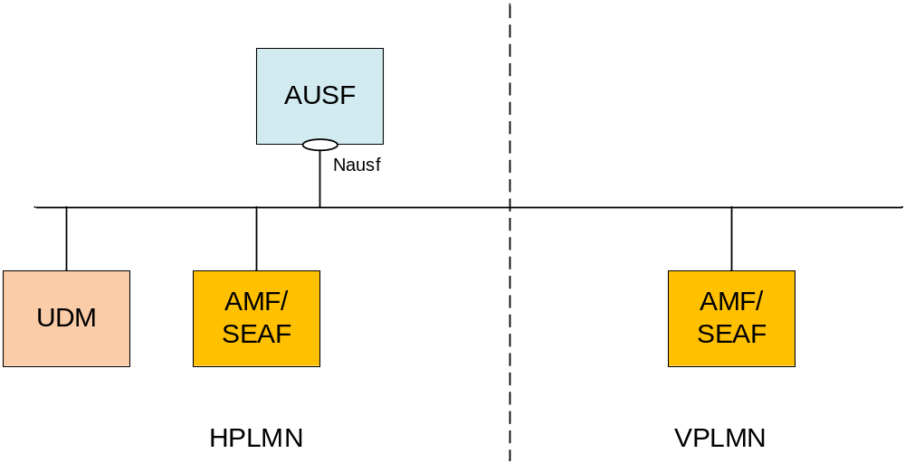
Figure 4-1: AUSF in 5G System architecture
This figure represents the AUSF architecture in the Service-based Architecture model. In the reference point model, the interface between the AMF and the AUSF is named N12. In this release, the SEAF function is collocated with the AMF. The AUSF may provide the service to the UDM.

5 Services offered by the AUSF

5.1 Introduction
The AUSF offers to NF Service Consumers (e.g. AMF) the following services:
- Nausf_UEAuthentication
- Nausf_SoRProtection
- Nausf_UPUProtection

5.2 Nausf_UEAuthentication Service

5.2.1 Service Description
The AUSF is acting as NF Service Producer. It provides UE authentication service to the requester NF. The NF Service Consumer is the AMF.
For this service, the following service operations are defined:
- Authenticate
This service permits to authenticate the UE and to provide one or more master keys which are used by the AMF to derived subsequent keys.

5.2.2 Service Operations

5.2.2.1 Introduction
The service operation defined for the Nausf_UEAuthentication is as follows:
- Authenticate: It allows the AMF to authenticate the UE.

5.2.2.2 Authenticate

5.2.2.2.1 General
The service operation "Authenticate" permits the requester NF to initiate the Authentication of the UE by providing the following information to the AUSF:
- UE id (e.g. SUPI)
- Serving Network Name
The AUSF retrieves the UE's subscribed authentication method from the UDM and depending on the information provided by the UDM, the AUSF enters in one of the following procedures:
- 5G-AKA
- EAP-based authentication'
For those two different procedures a new resource is generated by the AUSF. The content of the resource will depend on the procedure and will be returned to the AMF.
This service operation "Authenticate" also permits the requester NF to initiate the Authentication of the FN-RG registration via W-AGF by providing the following information to the AUSF:
- UE id (e.g. SUCI)
- Indication that the W-AGF has authenticated the FN-RG
The AUSF retrieves the UE's SUPI, indication that authentication is not required for the FN-RG from the UDM, and AUSF shall not perform the authentication.

5.2.2.2.2 5G AKA
In this procedure, the NF Service Consumer (AMF) requests the authentication of the UE by providing UE related information and the serving network name and the 5G AKA is selected. The NF Service Consumer (AMF) shall then return to the AUSF the result received from the UE:

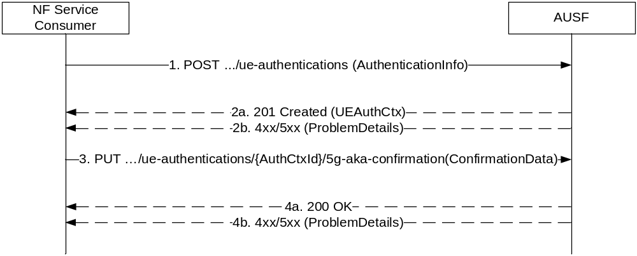
Figure 5.2.2.2.2-1: 5G AKA
1. The NF Service Consumer (AMF) shall send a POST request to the AUSF. The payload of the body shall contain at least the UE Id and the Serving Network Name.
2a. On success, "201 Created" shall be returned. The payload body shall contain the representation of the resource created and the "Location" header shall contain the URI of the created resource (e.g. .../v1/ue_authentications/{authCtxId}). The AUSF generates a sub-resource "5g-aka-confirmation". The AUSF shall provide an hypermedia link towards this sub-resource in the payload to indicate to the AMF where it shall send a PUT for the confirmation.
2b. On failure, one of the HTTP status code listed in table 6.1.7.3-1 shall be returned with the message body containing a ProblemDetails structure with the "cause" attribute set to one of the application error listed in Table 6.1.7.3-1. If the serving network is not authorized, the AUSF shall use the SERVING_NETWORK_NOT_AUTHORIZED "cause".
3. Based on the relation type, the NF Service Consumer (AMF) deduces that it shall send a PUT containing the "RES*" provided by the UE to the URI provided by the AUSF or derived by itself. The NF Service Consumer (AMF) shall also send a PUT containing null value in the RES* to indicate the failure to the AUSF for the following cases:
- if the UE is not reached, and the RES* is never received by the NF Service Consumer (AMF);
- the comparation of the HRES* and HXRES* is unsuccessful in the NF Service Consumer (AMF);
- the authentication failure is received from the UE, e.g. synchronization failure or MAC failure;
4a. On success, "200 OK" shall be returned. If the UE is not authenticated, e.g. the verification of the RES* was not successful in the AUSF, the AUSF shall set the value of AuthResult to AUTHENTICATION_FAILURE.
4b. On failure, one of the HTTP status code listed in table 6.1.7.3-1 shall be returned with the message body containing a ProblemDetails structure with the "cause" attribute set to one of the application error listed in Table 6.1.7.3-1.

5.2.2.2.3 EAP-based authentication method

5.2.2.2.3.1 General
In this procedure, the NF Service Consumer requests the authentication of the UE by providing UE related information and the serving network and the EAP-based authentication is selected (see IETF RFC 3748 [18]). EAP messages are exchanged between a UE acting as EAP peer, an NF Service Consumer (AMF/SEAF) acting as a pass-through authenticator and the AUSF acting as the EAP server.

5.2.2.2.3.2 EAP method: EAP-AKA'
EAP-AKA' is the EAP method used in this procedure

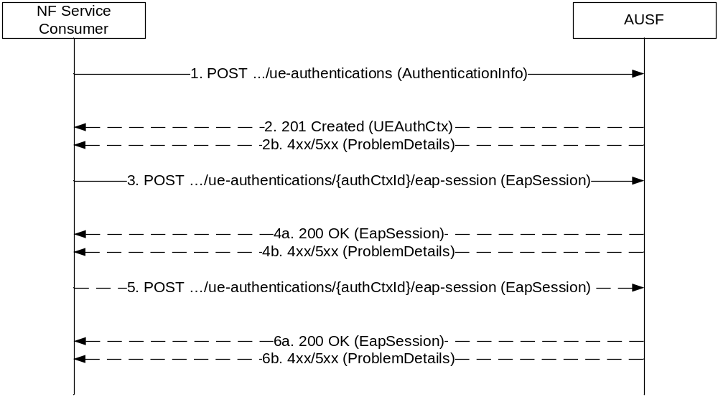
Figure 5.2.2.2.3-1: EAP-based authentication with EAP-AKA' method
1. The NF Service Consumer (AMF) shall send a POST request to the AUSF. The payload of the body shall contain at least the UE Id, Serving Network Name.
2a. On success, "201 Created" shall be returned. The payload body shall contain the representation of the resource generated and the "Location" header shall contain the URI of the generated resource (e.g. .../v1/ue_authentications/{authCtxId}/eap-session). The AUSF generates a sub-resource "eap-session". The AUSF shall provide an hypermedia link towards this sub-resource in the payload to indicate to the AMF where it shall send a POST containing the EAP packet response. The body payload shall also contain the EAP packet EAP-Request/AKA'-Challenge.
2b. On failure, one of the HTTP status code listed in table 6.1.7.3-1 shall be returned with the message body containing a ProblemDetails structure with the "cause" attribute set to one of the application error listed in Table 6.1.7.3-1. In particular, if the serving network is not authorized, the AUSF shall use the "Cause" SERVING_NETWORK_NOT_AUTHORIZED.
3. Based on the relation type, the NF Service Consumer (AMF) shall send a POST request including the EAP-Response/AKA' Challenge received from the UE. The POST request is sent to the URI provided by the AUSF or derived by the NF Service Consumer (AMF).
4a. On success, and if the AUSF and the UE have indicated the use of protected successful result indications as in IETF RFC 5448 [9] (to be superseded by draft-ietf-emu-rfc5448bis [17]), the AUSF shall reply with a "200 OK" HTTP message containing the EAP Request/AKA' Notification and an hypermedia link towards the sub-resource "eap-session".
4b. On failure, one of the HTTP status code listed in table 6.1.7.3-1 shall be returned with the message body containing a ProblemDetails structure with the "cause" attribute set to one of the application error listed in Table 6.1.7.3-1.
NOTE: Steps 4 to 5 are optional.
5. The NF Service Consumer (AMF) shall send a POST request including the EAP Response/AKA' Notification received from the UE. The POST request is sent to the URI provided by the AUSF or derived by the NF Service Consumser (AMF).
6a. If the EAP authentication exchange is successfully completed (with or without the optional Notification Request/Response messages exchange), "200 OK" shall be returned to the NF Service Consumer (AMF). The payload shall contain the result of the authentication, an EAP success/failure and the Kseaf if the authentication is successful. If the UE is not authenticated, the AUSF shall set the authResult to AUTHENTICATION_FAILURE.
6b. On failure, one of the HTTP status code listed in table 6.1.7.3-1 shall be returned with the message body containing a ProblemDetails structure with the "cause" attribute set to one of the application error listed in Table 6.1.7.3-1.

5.2.2.2.3.3 EAP method: EAP-TLS
The EAP-TLS method can be used in private networks as an EAP method (see 3GPP TS 33.501 [8] Annex B.1). The corresponding stage 3 implementation is described in Annex B.

5.2.2.2.4 Authentication for FN-RG
In this procedure, the NF Service Consumer (AMF) requests the authentication of the FN-RG registration via W-AGF by providing the the SUCI of the FN-RG and the authenticated indication.

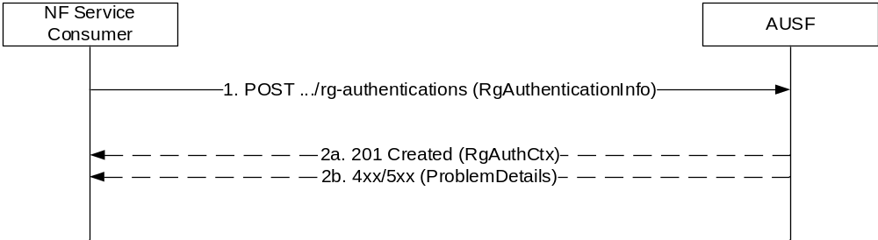
Figure 5.2.2.2.4-1: Authentication for FN-RG
1. The NF Service Consumer (AMF) shall send a POST request to the AUSF. The payload of the body shall contain at least the UE Id and the authenticated indication.
2a. On success, "201 Created" shall be returned. The payload body shall contain the representation of the resource created and the "Location" header shall contain the URI of the created resource (e.g. .../v1/rg-authentications/{authCtxId}).
2b. On failure, one of the HTTP status code listed in table 6.1.7.3-1 shall be returned with the message body containing a ProblemDetails structure with the "cause" attribute set to one of the application error listed in Table 6.1.7.3-1.

5.3 Nausf_SoRProtection Service

5.3.1 Service Description
The AUSF is acting as NF Service Producer. It provides SoRProtection service to the NF Service Consumer.
This service permits to provide the NF Service Consumer (e.g. UDM) with the SoR-MAC-IAUSF and CounterSoR to protect the the Steering Information List from being tampered with or removed by the VPLMN.
NOTE: If the Steering Information List is not available or HPLMN determines that no steering of the UE is required, a SOR transparent container information element with an HPLMN indication that 'no change of the "Operator Controlled PLMN Selector with Access Technology" list stored in the UE' protected by SoR-MAC-IAUSF and CounterSoR is still sent to the UE during registration. The Steering Information List In such a case, the NF Service Consumer shall send an empty list to the AUSF when consuming the Nausf_SoRProtection Service.
In option this service also allows to provide the NF Service Consumer (e.g. UDM) with the SoR-XMAC-IUE that allows the NF Service Consumer (e.g. UDM) to verify that the UE received the Steering Information List.

5.3.2 Service Operations

5.3.2.1 Introduction
The service operation defined for the Nausf_SoRProtection is as follows:
- Protect

5.3.2.2 Protect

5.3.2.2.1 General
The Protect service operation is used in the following procedures:
- Procedure for steering of UE in VPLMN during registration (see clause 6.14.2.1 of 3GPP TS 33.501 [8]);
- Procedure for steering of UE in VPLMN after registration (see clause 6.14.2.2 of 3GPP TS 33.501 [8]).
The NF Service Consumer (e.g. UDM) uses this service operation to request the AUSF to compute the SoR-MAC-IAUSF and the CounterSoR by providing Steering Information List. The NF Service Consumer (e.g. UDM) may also request the AUSF to compute the SoR-XMAC-IUE by providing the indication that an acknowledgement is requested from the UE.

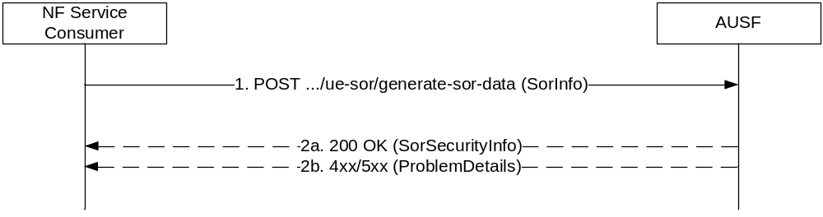
Figure 5.3.2.2.1-1: Steering of UE in VPLMN
1. The NF Service Consumer (e.g. UDM) shall send a POST request to the AUSF that was used to authenticate the UE. The payload of the body shall contain the Steering Information List and the acknowledge indication.
2a. On success, "200 OK" shall be returned. The payload body shall contain the requested security material necessary to protect the Steering of Roaming procedure.
2b. On failure, one of the HTTP status code listed in table 6.2.7.3-1 shall be returned with the message body containing a ProblemDetails structure with the "cause" attribute set to one of the application error listed in Table 6.2.7.3-1. If the Counter_{SoR} associated with the K_{AUSF} of the UE, is about to wrap around, the AUSF shall use the "COUNTER-WRAP" cause.

5.4 Nausf_UPUProtection Service

5.4.1 Service Description
The AUSF is acting as NF Service Producer. It provides UPUProtection service to the NF Service Consumer.
This service permits to provide the NF Service Consumer (e.g. UDM) with the UPU-MAC-I_{AUSF} and Counter_{UPU} to protect the UE Parameters Update Data from being tampered with or removed by the VPLMN.
In option this service also allows to provide the NF Service Consumer (e.g. UDM) with the UPU-XMAC-I_{UE} that allows the NF Service Consumer (e.g. UDM) to verify that the UE received UE Parameters Update Data correctly.

5.4.2 Service Operations

5.4.2.1 Introduction
The service operation defined for the Nausf_UPUProtection is as follows:
- Protect

5.4.2.2 Protect

5.4.2.2.1 General
The Protect service operation is used in the following procedures:
- Procedure for UE Parameters Update (see clause 6.15.2.1 of 3GPP TS 33.501 [8]).
The NF Service Consumer (e.g. UDM) uses this service operation to request the AUSF to compute the UPU-MAC-I_{AUSF} and Counter_{UPU} by providing the UE Parameters Update Data (UPU Data). The NF Service Consumer (e.g. UDM) may also request the AUSF to compute the UPU-XMAC-I_{UE} by providing the indication that an acknowledgement is requested from the UE.

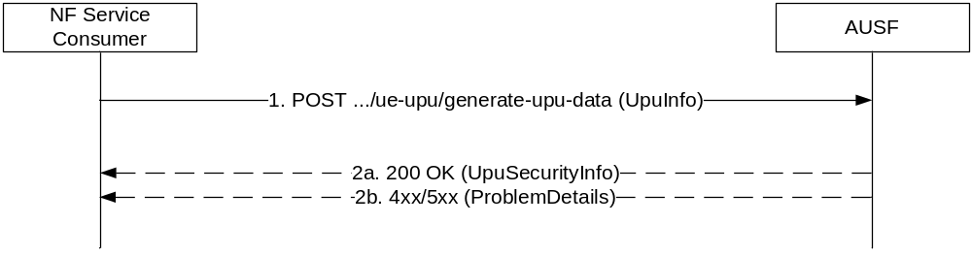
Figure 5.4.2.2-1: UE Parameters Update in VPLMN
1. The NF Service Consumer (e.g. UDM) shall send a POST request to the AUSF that was used to authenticate the UE. The payload of the body shall contain the UE Parameters Update Data (UPU Data) and the acknowledge indication.
2a. On success, "200 OK" shall be returned. The payload body shall contain the requested security material necessary to protect the UE Parameters Update procedure.
2b. On failure, one of the HTTP status code listed in table 6.4.7.3-1 shall be returned with the message body containing a ProblemDetails structure with the "cause" attribute set to one of the application error listed in Table 6.4.7.3-1. If the Counter_{UPU} associated with the K_{AUSF} of the UE, is about to wrap around, the AUSF shall use the "COUNTER-WRAP" cause.

6 API Definitions

6.1 Nausf_UEAuthentication Service API

6.1.1 API URI
URIs of this API shall have the following root:
{apiRoot}/{apiName}/{apiVersion}/
where "apiRoot" is defined in clause 4.4.1 of 3GPP TS 29.501 [5], the "apiName" shall be set to "nausf-auth" and the "apiVersion" shall be set to "v1" for the current version of this specification.

6.1.2 Usage of HTTP

6.1.2.1 General
HTTP/2, as defined in IETF RFC 7540 [6], shall be used as specified in clause 5 of 3GPP TS 29.500 [4].

6.1.2.2 HTTP standard headers

6.1.2.2.1 General
The usage of HTTP standard headers is specified in clause 5.2.2 of 3GPP TS 29.500 [4].

6.1.2.2.2 Content type
The following content types shall be supported:
- JSON, as defined in IETF RFC 8259 [7], shall be used as content type of the HTTP bodies specified in the present specification as indicated in clause 5.4 of 3GPP TS 29.500 [4].
- The Problem Details JSON Object (IETF RFC 7807 [11]. The use of the Problem Details JSON object in a HTTP response body shall be signalled by the content type "application/problem+json"
- The 3GPP hypermedia format as defined in 3GPP TS 29.501 [5]. The use of the 3GPP hypermedia format in a HTTP response body shall be signalled by the content type "application/3gppHal+json"

6.1.2.3 HTTP custom headers

6.1.2.3.1 General
The usage of HTTP custom headers shall be supported as specified in clause 5.2.3 of 3GPP TS 29.500 [4].

6.1.3 Resources

6.1.3.1 Overview
The structure of the Resource URIs of the "Authenticate" service is shown in Figure 6.1.3.1-1

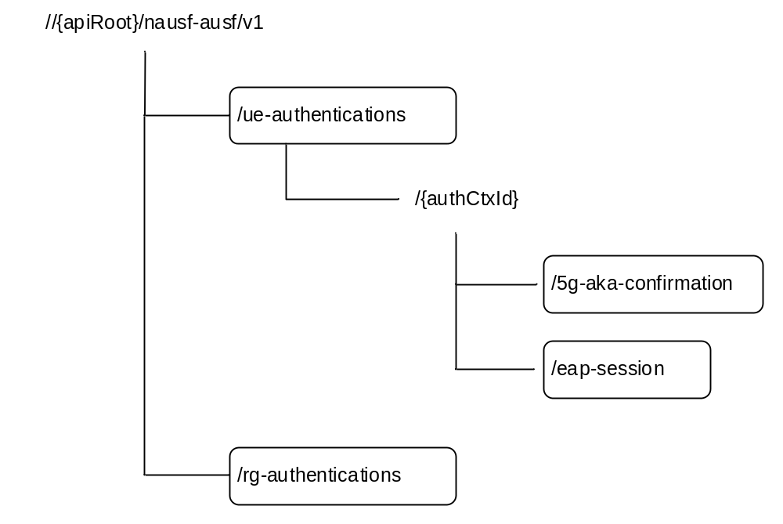
Figure 6.1.3.1-1: Resource URI structure of the AUSF API
Table 6.1.3.1-1 provides an overview of the resources and applicable HTTP methods.
Table 6.1.3.1-1: Resources and methods overview
Resource name | Resource URI | HTTP method or custom operation | Description
ue-authentications  (Collection) | {apiRoot}/nausf-auth/v1/ue-authentications | POST | Initiate the authentication process by providing inputs related to the UE
5g-aka-confirmation  (Document) | {apiRoot}/nausf-auth/v1/ue-authentications/{authCtxId}/5g-aka-confirmation | PUT | Put the UE response from the 5G-AKA process.
eap-session  (Document) | {apiRoot}/nausf-auth/v1/ue-authentications/{authCtxId}/eap-session | POST | Post the EAP response from the UE.  See NOTE.
rg-authentications  (Collection) | {apiRoot}/nausf-auth/v1/rg-authentications | POST | Initiate the authentication process by providing inputs related to the FN-RG
NOTE: This POST is used to provide EAP response to the AUSF in a sub-resource (Document) generated by the first POST operation. As this operation is not idempotent (it triggers subsequent EAP operations), a PUT was not adequate.

6.1.3.2 Resource: List of ue-authentications

6.1.3.2.1 Description
This resource represents a collection of the ue-authentication resources generated by the AUSF.

6.1.3.2.2 Resource Definition
Resource URI: {apiRoot}/nausf-auth/v1/ue-authentications
This resource shall support the resource URI variables defined in table 6.1.3.2.2-1.
Table 6.1.3.2.2-1: Resource URI variables for this resource
Name | Definition
apiRoot | See clause 6.1.1

6.1.3.2.3 Resource Standard Methods

6.1.3.2.3.1 POST
This method shall support the URI query parameters specified in table 6.1.3.2.3.1-1.
Table 6.1.3.2.3.1-1: URI query parameters supported by the POST method on this resource
Name | Data type | P | Cardinality | Description
n/a

This method shall support the request data structures specified in table 6.1.3.2.3.1-2 and the response data structures and response codes specified in table 6.1.3.2.3.1-3.
Table 6.1.3.2.3.1-2: Data structures supported by the POST Request Body on this resource
Data type | P | Cardinality | Description
AuthenticationInfo | M | 1 | Contains the UE id (i.e. SUCI or SUPI as specified in 3GPP TS 33.501 [8]) and the serving network name.  It may also contain Trace Data as specified in 3GPP TS 23.501 [2].

Table 6.1.3.2.3.1-3: Data structures supported by the POST Response Body on this resource
Data type | P | Cardinality | Response  Codes | Description
UEAuthenticationCtx | M | 1 | 201 Created | Upon success, if 5G AKA is selected, the response body will contain one AV and "link" for the AMF to PUT the confirmation.  If an EAP-based method is selected, the response body will contain the EAP method selected, the corresponding EAP packet request and a "link" for the AMF to POST the EAP response.  The HTTP response shall include a "Location" header that contains the resource URI of the created resource.
ProblemDetails | M | 1 | 400 Bad Request | This case represents the failure to start authentication service because of input parameter error.
ProblemDetails | M | 1 | 403 Forbidden | This case represents when the UE is not allowed to be authenticated.  The "cause" attribute can be set to one of the following application errors:  - AUTHENTICATION_REJECTED  - SERVING_NETWORK_NOT_AUTHORIZED  - INVALID_HN_PUBLIC_KEY_IDENTIFIER  - INVALID_SCHEME_OUTPUT
ProblemDetails | M | 1 | 404 Not Found | The "cause" attribute can be set to the following application error:  - USER_NOT_FOUND
ProblemDetails | M | 1 | 500 Internal Server Error | This case represents the failure in starting the authentication service because of a server internal error.  If the error is due to a problem with UDM not able to generate the requested AV, the AUSF shall indicate the following application error: "AV_GENERATION_PROBLEM"
ProblemDetails | M | 1 | 501 Not Implemented | The "cause" attribute can be set to the following application error:  - UNSUPPORTED_PROTECTION_SCHEME  This response shall not be cached.
NOTE: The mandatory HTTP error status codes for the POST method listed in Table 5.2.7.1-1 of 3GPP TS 29.500 [4] other than those specified in the table above also apply, with a ProblemDetails data type (see clause 5.2.7 of 3GPP TS 29.500 [4].

6.1.3.2.4 Resource Custom Operations

6.1.3.2.4.1 Overview
There is no Resource Custom Operations in the current version of this API.

6.1.3.3 Resource: 5g-aka-confirmation (Document)

6.1.3.3.1 Description
The subresource "5g-aka-confirmation" is generated by the AUSF. This subresource should not persist after the AUSF has read its content.

6.1.3.3.2 Resource Definition
Resource URI: {apiRoot}/nausf-auth/v1/ue-authentications/{authCtxId}/5g-aka-confirmation
This resource shall support the resource URI variables defined in table 6.1.3.2.2-1.
Table 6.1.3.3.2-1: Resource URI variables for this resource
Name | Definition
apiRoot | See clause 6.1.1
authCtxId | Represents a specific ue-authentication

6.1.3.3.3 Resource Standard Methods

6.1.3.3.3.1 PUT
This method shall support the URI query parameters specified in table 6.1.3.2.3.1-1.
Table 6.1.3.2.3.1-1: URI query parameters supported by the PUT method on this resource
Name | Data type | P | Cardinality | Description
n/a

This method shall support the request data structures specified in table 6.1.3.2.3.1-2 and the response data structures and response codes specified in table 6.1.3.2.3.1-3.
Table 6.1.3.3.3.1-2: Data structures supported by the PUT Request Body on this resource
Data type | P | Cardinality | Description
ConfirmationData | M | 1 | Contains the "RES*" generated by the UE and provided to the AMF.

Table 6.1.3.3.3.1-3: Data structures supported by the PUT Response Body on this resource
Data type | P | Cardinality | Response  Codes | Description
ConfirmationDataResponse | M | 1 | 200 OK | This case indicates that the AUSF has performed the verification of the 5G AKA confirmation. The response body shall contain the result of the authentication and the Kseaf if the authentication is successful.
ProblemDetails | M | 1 | 400 Bad Request | This case represents a 5G AKA confirmation failure because of input parameter error. This indicates that the AUSF was not able to confirm the authentication.
ProblemDetails | M | 1 | 500 Internal Server Error | This case represents a 5G AKA confirmation failure because of a server internal error.
NOTE: The mandatory HTTP error status codes for the PUT method listed in Table 5.2.7.1-1 of 3GPP TS 29.500 [4] other than those specified in the table above also apply, with a ProblemDetails data type (see clause 5.2.7 of 3GPP TS 29.500 [4].

6.1.3.4 Resource: eap-session (Document)

6.1.3.4.1 Description
The "eap-session" is generated by the AUSF if an EAP-based authentication method is selected. This resource is used to handle the EAP session. This subresource should not persist after the EAP exchanges.

6.1.3.4.2 Resource Definition
Resource URI: {apiRoot}/nausf-auth/v1/ue-authentications/{authCtxId}/eap-session
This resource shall support the resource URI variables defined in table 6.1.3.4.2-1.
Table 6.1.3.4.2-1: Resource URI variables for this resource
Name | Definition
apiRoot | See clause 6.1.1
authCtxId | Represents a specifc ue-authentication

6.1.3.4.3 Resource Standard Methods

6.1.3.4.3.1 POST
This method shall support the URI query parameters specified in table 6.1.3.4.3.1-1.
Table 6.1.3.4.3.1-1: URI query parameters supported by the POST method on this resource
Name | Data type | P | Cardinality | Description
n/a

This method shall support the request data structures specified in table 6.1.3.4.3.1-2 and the response data structures and response codes specified in table 6.1.3.4.3.1-3.
Table 6.1.3.4.3.1-2: Data structures supported by the POST Request Body on this resource
Data type | P | Cardinality | Description
EapSession | M | 1 | Contains the EAP packet response (see IETF RFC 3748 [18]) from the UE and transferred by the AMF

Table 6.1.3.4.3.1-3: Data structures supported by the POST Response Body on this resource
Data type | P | Cardinality | Response  Codes | Description
EapSession | M | 1 | 200 OK | During an EAP session, the body response shall contain the EAP packet Response and an hypermedia link.  At the end of the EAP session, the body response shall contain the EAP packet Success or Failure (see IETF RFC 3748 [18]) and the Kseaf if the authentication is successful
ProblemDetails | M | 1 | 400 Bad Request | This case represents an EAP session failure because of input parameter error. This indicates that the AUSF was not able to continue the EAP session.
ProblemDetails | M | 1 | 500 Internal Server Error | This case represents an EAP session failure failure because of a server internal error.
NOTE: The mandatory HTTP error status codes for the POST method listed in Table 5.2.7.1-1 of 3GPP TS 29.500 [4] other than those specified in the table above also apply, with a ProblemDetails data type (see clause 5.2.7 of 3GPP TS 29.500 [4].

6.1.3.5 Resource: List of rg-authentications

6.1.3.5.1 Description
This resource represents a collection of the rg-authentication resources generated by the AUSF.

6.1.3.5.2 Resource Definition
Resource URI: {apiRoot}/nausf-auth/v1/rg-authentications
This resource shall support the resource URI variables defined in table 6.1.3.5.2-1.
Table 6.1.3.5.2-1: Resource URI variables for this resource
Name | Definition
apiRoot | See clause 6.1.1

6.1.3.5.3 Resource Standard Methods

6.1.3.5.3.1 POST
This method shall support the URI query parameters specified in table 6.1.3.5.3.1-1.
Table 6.1.3.5.3.1-1: URI query parameters supported by the POST method on this resource
Name | Data type | P | Cardinality | Description
n/a

This method shall support the request data structures specified in table 6.1.3.5.3.1-2 and the response data structures and response codes specified in table 6.1.3.5.3.1-3.
Table 6.1.3.5.3.1-2: Data structures supported by the POST Request Body on this resource
Data type | P | Cardinality | Description
RgAuthenticationInfo | M | 1 | Contains the UE id (i.e. SUCI as specified in 3GPP TS 23.316 [23] or 3GPP TS 33.501 [8]) and the authenticated indication.

Table 6.1.3.5.3.1-3: Data structures supported by the POST Response Body on this resource
Data type | P | Cardinality | Response  codes | Description
RgAuthCtx | M | 1 | 201 Created | Upon success, the response body will contain the SUPI of the UE and the authentication indication.  The HTTP response shall include a "Location" header that contains the resource URI of the created resource.
ProblemDetails | O | 0..1 | 400 Bad Request | This case represents the failure to start authentication service because of input parameter error.
ProblemDetails | O | 0..1 | 403 Forbidden | This case represents when the UE is not allowed to be authenticated.  The "cause" attribute may be used to indicate one of the following application errors:  - AUTHENTICATION_REJECTED  - INVALID_SCHEME_OUTPUT
ProblemDetails | O | 0..1 | 404 Not Found | The "cause" attribute may be used to indicate the following application error:  - USER_NOT_FOUND
NOTE: The mandatory HTTP error status codes for the POST method listed in Table 5.2.7.1-1 of 3GPP TS 29.500 [4] other than those specified in the table above also apply, with a ProblemDetails data type (see clause 5.2.7 of 3GPP TS 29.500 [4].

6.1.4 Custom Operations without associated resources

6.1.4.1 Overview
There is no Custom Operation in the current version of this API.

6.1.5 Notifications

6.1.5.1 General
There is no use of notification in the current version of this API.

6.1.6 Data Model

6.1.6.1 General
This clause specifies the application data model supported by the API.
Table 6.1.6.1-1 specifies the data types defined for the Nausf service based interface protocol.
Table 6.1.6.1-1: Nausf specific Data Types
Data type | Clause defined | Description
AuthenticationInfo | 6.1.6.2.2 | Contains the UE id (i.e. SUCI or SUPI) and the Serving Network Name.
UEAuthenticationCtx | 6.1.6.2.3 | Contains the information related to the resource generated to handle the UE authentication. It contains at least the UE id, Serving Network, the Authentication Method and related EAP information or related 5G-AKA information.
5gAuthData | 6.1.6.2.4 | Contains 5G authentication related information.
AV5gAka | 6.1.6.2.5 | Contains Authentication Vector for method 5G AKA.
ConfirmationData | 6.1.6.2.7 | Contains the "RES*" generated by the UE.
EapSession | 6.1.6.2.8 | Contains information related to the EAP session.
RgAuthenticationInfo | 6.1.6.2.9 | Contains the UE id (i.e. SUCI) and the authenticated indication.
RgAuthCtx | 6.1.6.2.10 | Contains the UE id (i.e. SUPI) and the authentication indication.

Table 6.1.6.1-2 specifies data types re-used by the Nausf service based interface protocol from other specifications, including a reference to their respective specifications and when needed, a short description of their use within the Nausf service based interface.
Table 6.1.6.1-2: Nausf re-used Data Types
Data type | Reference | Comments
LinksValueSchema | 3GPP TS 29.571 [10] | 3GPP Hypermedia link
ProblemDetails | 3GPP TS 29.571 [10] | Common Data Type used in response bodies
Supi | 3GPP TS 29.571 [10]
Uri | 3GPP TS 29.571 [10]
ResynchronizationInfo | 3GPP TS 29.503 [12]
SupiOrSuci | 3GPP TS 29.503 [12]
ServingNetworkName | 3GPP TS 29.503 [12]
Autn | 3GPP TS 29.503 [12]
Pei | 3GPP TS 29.571 [10]
TraceData | 3GPP TS 29.571 [10]
NfGroupId | 3GPP TS 29.571 [10]

6.1.6.2 Structured data types

6.1.6.2.1 Introduction
The following clause defines the structures to be used in resource representations.

6.1.6.2.2 Type: AuthenticationInfo
Table 6.1.6.2.2-1: Definition of type AuthenticationInfo
Attribute name | Data type | P | Cardinality | Description
supiOrSuci | SupiOrSuci | M | 1 | Contains the SUPI or SUCI of the UE.
servingNetworkName | ServingNetworkName | M | 1 | Contains the Serving Network Name.
resynchronizationInfo | ResynchronizationInfo | O | 0..1 | Contains RAND and AUTS; see 3GPP 33.501 [8] clause 9.4.
pei | Pei | O | 0..1 | Permanent Equipment Identifier
traceData | TraceData | O | 0..1 | Contains TraceData provided by the UDM to the AMF
udmGroupId | NfGroupId | O | 0..1 | Identity of the UDM group serving the SUPI
routingIndicator | String | O | 0..1 | When present, it shall indicate the Routing Indicator of the UE.  Pattern: '^[0-9]{1,4}$'

6.1.6.2.3 Type: UEAuthenticationCtx
Table 6.1.6.2.3-1: Definition of type UEAuthenticationCtx
Attribute name | Data type | P | Cardinality | Description
authType | AuthType | M | 1 | Indicates the authentication method used for this UE ie. "5G-AKA-Confirmation", "EAP-AKA'" or "EAP-TLS". See clause 6.1.6.3.3
_links | map(LinksValueSchema) | M | 1..N | If 5G-AKA has been selected, this IE shall contain a member whose name is set to "5g-aka" and the URI to perform the confirmation.  If an EAP-based method has been selected, this IE shall contain a member whose name is set to "eap-session" and the URI to perform the EAP session.  See NOTE
5gAuthData | 5GAuthData | M | 1 | Contains either 5G-AKA or EAP related information.
servingNetworkName | ServingNetworkName | O | 0..1 | Contains the Serving Network Name.
NOTE: In the current version of this API, only one hypermedia link is provided

6.1.6.2.4 Type: 5gAuthData

Table 6.1.6.2.4-1: Definition of type 5gAuthData as a list of mutually exclusive alternatives
Data type | Cardinality | Description
Av5gAka | 1 | Contains the 5G AV if 5G-AKA has been selected.
EapPayload | 1 | Contains the EAP packet request.

6.1.6.2.5 Type: Av5gAka
Table 6.1.6.2.5-1: Definition of type Av5gAka
Attribute name | Data type | P | Cardinality | Description
rand | Rand | M | 1
autn | Autn | M | 1
hxresStar | HxresStar | M | 1

6.1.6.2.6 Type: ConfirmationData
Table 6.1.6.2.6-1: Definition of type ConfirmationData
Attribute name | Data type | P | Cardinality | Description
resStar | ResStar | M | 1 | Contains the "RES*" provided by the UE to the AMF.  If no RES* has been provided by the UE the null value is conveyed to the AUSF.

6.1.6.2.7 Type: EapSession
Table 6.1.6.2.7-1: Definition of type EapSession
Attribute name | Data type | P | Cardinality | Description
eapPayload | EapPayload | M | 1 | Contains the EAP packet (see IETF RFC 3748 [18]).  If no EAP packet has been provided by the UE the null value is conveyed to the AUSF.
kSeaf | Kseaf | C | 0..1 | If the authentication is successful, the Kseaf shall be included
_links | map(LinksValueSchema) | C | 1..N | If the EAP session requires another exchange e.g. for EAP-AKA' notification, this IE shall contain a member whose name is "eap-session" and the URI to continue the EAP session.  See NOTE.
authResult | AuthResult | C | 0..1 | Indicates the result of the authentication.
supi | Supi | C | 0..1 | If the authentication is successful and if the AMF had provided a SUCI, this IE shall contain the SUPI of the UE.
NOTE: In the current version of this API, only 0 or 1 hypermedia link is provided.

6.1.6.2.8 Type: ConfirmationDataResponse
Table 6.1.6.2.8-1: Definition of type ConfirmationDataResponse
Attribute name | Data type | P | Cardinality | Description
authResult | AuthResult | M | 1 | Indicates the result of the authentication
supi | Supi | C | 0..1 | If the authentication is successful and if the AMF had provided a SUCI, this IE shall contain the SUPI of the UE
kseaf | Kseaf | C | 0..1 | Contains the Kseaf if authentication is successful.

6.1.6.2.9 Type: RgAuthenticationInfo
Table 6.1.6.2.9-1: Definition of type RgAuthenticationInfo
Attribute name | Data type | P | Cardinality | Description
suci | Suci | M | 1 | Contains the SUCI of the FN-RG.
authenticatedInd | Boolean | M | 1 | This IE shall be set as follows:  - true: authenticated by the W-AGF;  - false (default): unauthenticated by the W-AGF.

6.1.6.2.10 Type: RgAuthCtx
Table 6.1.6.2.10-1: Definition of type RgAuthCtx
Attribute name | Data type | P | Cardinality | Description
authResult | AuthResult | M | 1 | Indicates the result of the authentication
supi | Supi | C | 0..1 | If the authentication is successful and if the AMF had provided a SUCI, this IE shall contain the SUPI of the UE.
authInd | Boolean | C | 0..1 | When present, this IE shall be set as follows:  - true: authentication is not required;  - false (default): authentication is required.

6.1.6.3 Simple data types and enumerations

6.1.6.3.1 Introduction
This clause defines simple data types and enumerations that can be referenced from data structures defined in the previous clauses.

6.1.6.3.2 Simple data types
Table 6.1.6.3.2-1: Simple data types
Type Name | Type Definition | Description
EapPayload | String | The EAP packet is encoded using base64 (see IETF RFC 4648 [19]) and represented as a String.
ResStar | String | pattern: "[A-Fa-f0-9]{32}"; nullable
Kseaf | String | pattern: "[A-Fa-f0-9]{64}"
HxresStar | String | pattern: "[A-Fa-f0-9]{32}"
Suci | string | String containing a SUCI.  Pattern: "^(suci-(0-[0-9]{3}-[0-9]{2,3}|[1-7]-.+)-[0-9]{1,4}-(0-0-.+|[a-fA-F1-9]-([1-9]|[1-9][0-9]|1[0-9]{2}|2[0-4][0-9]|25[0-5])-[a-fA-F0-9]+)|.+)$"

6.1.6.3.3 Enumeration: AuthType
Table 6.1.6.3.3-1: Enumeration AuthType
Enumeration value | Description
5G_AKA | 5G AKA
EAP_AKA_PRIME | EAP-AKA'
EAP_TLS | EAP-TLS is only used in the case where the Annex B is supported.

6.1.6.3.4 Enumeration: AuthResult
Table 6.1.6.3.4-1: Enumeration AuthResult
Enumeration value | Description
AUTHENTICATION_SUCCESS | This value is used to indicate that the AUSF successfully authenticate the UE
AUTHENTICATION_FAILURE | This value is used to indicate that the AUSF fails to authenticate the UE.
AUTHENTICATION_ONGOING | This value is used during an EAP Session to indicate that the EAP session is still ongoing.

6.1.6.3.5 Relation Types

6.1.6.3.5.1 General
This clause describes the possible relation types defined within AUSF API.
Table 6.1.6.3.5-1: supported registered relation types
Relation Name
5g-aka
eap-session

6.1.6.3.5.2 The "5g-aka" Link relation
The value "5g-aka" specifies that the value of the href attribute is the URI where NF Service Consumer shall send a PUT containing the result "RES*" received from the UE.

6.1.6.3.5.3 The "eap-session" Link relation
The value "eap-session" specifies that the value of the href attribute is the URI that will be used by the NF Service Consumer to provide EAP packet response during an EAP exchange. The NF Service Consumer shall use a POST to provide the EAP Packet Response to the AUSF to the corresponding URI.

6.1.6.4 Binary data

6.1.6.4.1 Introduction
There is no binary data in the current version of this API.

6.1.7 Error Handling

6.1.7.1 General
HTTP error handling shall be supported as specified in clause 5.2.4 of 3GPP TS 29.500 [4].
The Cause codes mapping performed by AMF between the following HTTP responses returned by the AUSF services to the AMF and the 5GMM related values is specified in clause 4.2.2 of 3GPP TS 29.524 [24].

6.1.7.2 Protocol Errors
Protocol errors shall be supported as specified in clause 5.2.7 of 3GPP TS 29.500 [4].

6.1.7.3 Application Errors
The common application errors defined in the Table 5.2.7.2-1 in 3GPP TS 29.500 [4] may also be used for the Nausf_UEauthentication service. The following application errors listed in Table 6.1.7.3-1 are specific for the Nausf_Ueauthentication service.
Table 6.1.7.3-1: Application errors
Application Error | HTTP status code | Description
SERVING_NETWORK_NOT_AUTHORIZED | 403 Forbidden | The serving network is not authorized, e.g. serving PLMN.
AUTHENTICATION_REJECTED | 403 Forbidden | The user cannot be authenticated with this authentication method e.g. only SIM data available
INVALID_HN_PUBLIC_KEY_IDENTIFIER | 403 Forbidden | Invalid HN public key identifier received
INVALID_SCHEME_OUTPUT | 403 Forbidden | SUCI cannot be decrypted with received data
CONTEXT_NOT_FOUND | 404 Not Found | The AUSF cannot found the resource corresponding to the URI provided by the NF Service Consumer.
USER_NOT_FOUND | 404 Not Found | The user does not exist in the HPLMN
UPSTREAM_SERVER_ERROR | 504 Gateway Timeout | No response is received from a remote peer, e.g. from the UDM
NETWORK_FAILURE | 504 Gateway Timeout | The request is rejected due to a network problem.
AV_GENERATION_PROBLEM | 500 Internal Server Error | The UDM has indicated that it was not able to generate AV.
UNSUPPORTED_PROTECTION_SCHEME | 501 Not implemented | The received protection scheme is not supported by HPLMN

6.1.8 Security
As indicated in 3GPP TS 33.501 [8], the access to the Nausf_UEAuthentication Service API may be authorized by means of the Oauth2 protocol (see IETF RFC 6749 [13]), using the "Client Credentials" authorization grant, where the NRF (see 3GPP TS 29.510 [14]) plays the role of the authorization server.
If OAuth2 is used, an NF Service Consumer, prior to consuming service offered by the Nausf_UEAuthentication Service API, shall obtain a "token" from the authorization server, by invoking the Access Token Request service, as described in 3GPP TS 29.510 [14], clause 5.4.2.2.
NOTE: When multiple NRFs are deployed in a network, the NRF used as authorization server is the same NRF that the NF Service Consumer used for discovering the Nausf_UEAuthentication service.
The Nausf_UEAuthentication Service API does not define any scopes for Oauth2 authorization as specified in 3GPP TS 33.501 [8]; it defines a single scope consisting on the name of the service (i.e., "nausf-auth"), and it does not define any additional scopes at resource or operation level.

6.2 Nausf_SoRProtection Service API

6.2.1 API URI
URIs of this API shall have the following root:
{apiRoot}/{apiName}/{apiVersion}/
where "apiRoot" is defined in clause 4.4.1 of 3GPP TS 29.501 [5], the "apiName" shall be set to "nausf-sorprotection" and the "apiVersion" shall be set to "v1" for the current version of this specification.

6.2.2 Usage of HTTP

6.2.2.1 General
HTTP/2, as defined in IETF RFC 7540 [6], shall be used as specified in clause 5 of 3GPP TS 29.500 [4].

6.2.2.2 HTTP standard headers

6.2.2.2.1 General
The usage of HTTP standard headers is specified in clause 5.2.2 of 3GPP TS 29.500 [4].

6.2.2.2.2 Content type
The following content types shall be supported:
- JSON, as defined in IETF RFC 8259 [7], shall be used as content type of the HTTP bodies specified in the present specification as indicated in clause 5.4 of 3GPP TS 29.500 [4].
- The Problem Details JSON Object (IETF RFC 7807 [11]. The use of the Problem Details JSON object in a HTTP response body shall be signalled by the content type "application/problem+json"

6.2.2.3 HTTP custom headers

6.2.2.3.1 General
In this version of the API, no specific custom headers are defined for the "Nausf_SoRProtection" service.
For 3GPP specific HTTP custom headers used across all service based interfaces, see clause 5.2.3 of 3GPP TS 29.500 [4].

6.2.3 Resources

6.2.3.1 Overview
The structure of the Resource URIs of the SoRProtection service is shown in Figure 6.2.3.1-1

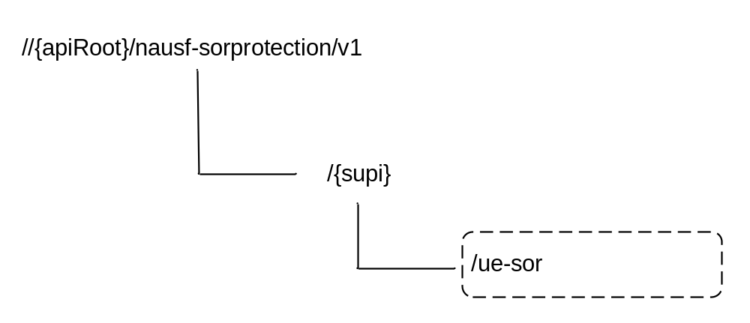
Figure 6.x.3.1-1: Resource URI structure of the SoRProtection API
Table 6.2.3.1-1 provides an overview of the resources and applicable HTTP methods.
Table 6.2.3.1-1: Resources and methods overview
Resource name | Resource URI | HTTP method or custom operation | Description
ue-sor  (Custom operation) | {apiRoot}/nausf-sorprotection/v1/{supi}/ue-sor/generate-sor-data | generate-sor-data (POST) | Resource for SoR security material computation

6.2.3.2 Resource: ue-sor

6.2.3.2.1 Description
It is the resource to which the custom operation used to generate the SoR security material is associated with.

6.2.3.2.2 Resource Definition
Resource URI: {apiRoot}/nausf-sorprotection/v1/supi/ue-sor
This resource shall support the resource URI variables defined in table 6.2.3.2.2-1.
Table 6.2.3.2.2-1: Resource URI variables for this resource
Name | Definition
apiRoot | See clause 6.2.1
supi | Represents the Subscription Permanent Identifier (see 3GPP TS 23.501 [2] clause 5.9.2)  pattern: '^(imsi-[0-9]{5,15}|nai-.+|.+)$'

6.2.3.2.3 Resource Standard Methods
No Standard Methods are supported for this resource.

6.2.3.2.4 Resource Custom Operations

6.2.3.2.4.1 Overview
Table 6.2.3.2.4.1-1: Custom operations
Custom operation URI | Mapped HTTP method | Description
/generate-sor-data | POST | The AUSF calculates the SoR-MAC-IAUSF and the CounterSoR to protect the Steering Information List provided. It may also calculate the SoR-XMAC-IUE to verify that the UE received the Steering Information List if the indication that an acknowledgement is requested from the UE.

6.2.3.2.4.2 Operation: generate-sor-data

6.2.3.2.4.2.1 Description
This custom operation is used by the NF service consumer (e.g. UDM) to request the AUSF to compute the security material (SoR-MAC-IAUSF, CounterSoR and SoR-XMAC-IUE) needed to ensure the protection of the SoR procedure (see 3GPP TS 33.501 [8]).

6.2.3.2.4.2.2 Operation Definition
This method shall support the request data structures specified in table 6.2.3.2.4.2.2-1 and the response data structures and response codes specified in table 6.2.3.2.4.2.2-2.
Table 6.2.3.2.4.2.2-1: Data structures supported by the POST Request Body on this resource
Data type | P | Cardinality | Description
SorInfo | M | 1 | Contains the Steering Information List and may contain the indication that an acknowledgement is requested from the UE (as specified in 3GPP TS 33.501 [8]).

Table 6.2.3.2.4.2.2-2: Data structures supported by the POST Response Body on this resource
Data type | P | Cardinality | Response  codes | Description
SorSecurityInfo | M | 1 | 200 OK | Upon success, the response body will contain SoR-MAC-IAUSF and CounterSoR and may contain the SoR-XMAC-IUE.
ProblemDetails | M | 1 | 503 Service Unavailable | The "cause" attribute shall be set to one of the following application error:  - COUNTER_WRAP  See table 6.2.7.3-1 for the description of these errors.
NOTE: The mandatory HTTP error status codes for the POST method listed in Table 5.2.7.1-1 of 3GPP TS 29.500 [4] other than those specified in the table above also apply, with a ProblemDetails data type (see clause 5.2.7 of 3GPP TS 29.500 [4].

6.2.4 Custom Operations without associated resources

6.2.4.1 Overview
There is no Custom Operation in the current version of this API.

6.2.5 Notifications

6.2.5.1 General
There is no use of notification in the current version of this API.

6.2.6 Data Model

6.2.6.1 General
This clause specifies the application data model supported by the API.
Table 6.2.6.1-1 specifies the data types defined for the Nausf-SORProtection service based interface protocol.
Table 6.x.6.1-1: Nausf specific Data Types
Data type | Clause defined | Description
SorInfo | 6.2.6.2.2 | Contains the Steering Information
SorSecurityInfo | 6.2.6.2.3 | Contains the material generated for securing of SoR. It contains at least the SoR-MAC-IAUSF and CounterSoR.
SteeringInfo | 6.2.6.2.4 | Contains a combination of one PLMN identity and zero or more access technologies.
SorMac | 6.2.6.3.2 | MAC value for protecting SOR procedure (SoR-MAC-IAUSF and SoR-XMAC-IUE)
Countersor | 6.2.6.3.2 | CounterSoR
AckInd | 6.2.6.3.2 | Contains indication whether the acknowledgement from UE is needed
AccessTech | 6.2.6.3.3 | Access Technology

Table 6.2.6.1-2 specifies data types re-used by the Nausf-SORProtection service based interface protocol from other specifications, including a reference to their respective specifications and when needed, a short description of their use within the Nausf service based interface.
Table 6.2.6.1-2: Nausf re-used Data Types
Data type | Reference | Comments
PlmnId | 3GPP TS 29.571 [10] | PLMN ID

6.2.6.2 Structured data types

6.2.6.2.1 Introduction
The following clauses define the structures to be used in resource representations.

6.2.6.2.2 Type: SorInfo
Table 6.2.6.2.2-1: Definition of type SorInfo
Attribute name | Data type | P | Cardinality | Description
ackInd | AckInd | M | 1 | Contains the indication whether the acknowledgement from UE is needed.
steeringContainer | SteeringContainer | C | 1 | When present, this information contains the information needed to update the "Operator Controlled PLMN Selector with Access Technology" list stored in the USIM.  It may contain an array of preferred PLMN/AccessTechnologies combinations in priority order. The first entry in the array indicates the highest priority and the last entry indicates the lowest.  Or it may contain a secured packet.  If no change of the "Operator Controlled PLMN Selector with Access Technology" list stored in the USIM is needed then this attribute shall be absent.

6.2.6.2.3 Type: SorSecurityInfo
Table 6..6.2.3-1: Definition of type SorSecurityInfo
Attribute name | Data type | P | Cardinality | Description
sorMacIausf | SorMac | M | 1 | Contains the SoR-MAC-IAUSF.
countersor | CounterSor | M | 1 | Contains the Counter_{SoR}.
sorXmacIue | SorMac | O | 0..1 | When present, contains the SoR-XMAC-I_{UE}. It shall be included, if the UDM requests the acknowledgement from the UE.

6.2.6.2.4 Type: SteeringInfo
Table 6..6.2.4-1: Definition of type SteeringInfo
Attribute name | Data type | P | Cardinality | Description
plmnId | PlmnId | M | 1 | Contains a preferred PLMN identity.
accessTechList | Array(AccessTech) | C | 1..N | When present it contains the 34referred access technologies as listed in clause 4.2.5 of 3GPP TS 31.102 [15]. If absent it means that all access technologies are equivalently preferred in this PLMN.

6.2.6.2.5 Type: SteeringContainer
Table 6.2.6.2.5.-1: Definition of type SteeringContainer as a list of alternatives
Data type | Cardinality | Description
array(SteeringInfo) | 1..N | List of PLMN/AccessTechnologies combinations.
SecuredPacket | 1 | A secured packet containing one or more APDUs commands dedicated to Remote File Management.

6.2.6.3 Simple data types and enumerations

6.2.6.3.1 Introduction
This clause defines simple data types and enumerations that can be referenced from data structures defined in the previous clauses.

6.2.6.3.2 Simple data types
Table 6.2.6.3.2-1: Simple data types
Type Name | Type Definition | Description
SorMac | string | pattern: "^[A-Fa-f0-9]{32}$"
CounterSor | string | pattern: "^[A-Fa-f0-9]{4}$"
AckInd | boolean | true indicates that the SoR-XMAC-I_{UE} shall be computed and returned in the response
SecuredPacket | string | Contains a secure packet as specified in 3GPP TS 24.501 [20]. It is encoded using base64 and represented as a String.

6.2.6.3.3 Enumeration: AccessTech
Table 6.2.6.3.3-1: Enumeration AccessTech
Enumeration value | Description
"NR"
"EUTRAN_IN_WBS1_MODE_AND_NBS1_MODE"
"EUTRAN_IN_NBS1_MODE_ONLY"
"EUTRAN_IN_WBS1_MODE_ONLY"
"UTRAN"
"GSM_AND_ECGSM_IoT"
"GSM_WITHOUT_ECGSM_IoT"
"ECGSM_IoT_ONLY"
"CDMA_1xRTT"
"CDMA_HRPD"
"GSM_COMPACT"

6.2.7 Error Handling

6.2.7.1 General
HTTP error handling shall be supported as specified in clause 5.2.4 of 3GPP TS 29.500 [4].

6.2.7.2 Protocol Errors
Protocol Error Handling shall be supported as specified in clause 5.2.7.2 of 3GPP TS 29.500 [4].

6.2.7.3 Application Errors
The common application errors defined in the Table 5.2.7.2-1 in 3GPP TS 29.500 [4] may also be used for the Nausf_SoRProtection service. The following application errors listed in Table 6..7.3-1 are specific for the Nausf_SoRProtection service.
Table 6.2.7.3-1: Application errors
Application Error | HTTP status code | Description
COUNTER_WRAP | 503 Service Unavailable | The Counter_{SoR} associated with the KAUSF of the UE is about to wrap around. The AUSF suspends the SoR protection service for the UE until a new KAUSF is generated.

6.2.8 Security
As indicated in 3GPP TS 33.501 [8], the access to the Nausf_SoRProtection API may be authorized by means of the OAuth2 protocol (see IETF RFC 6749 [13]), using the "Client Credentials" authorization grant, where the NRF (see 3GPP TS 29.510 [14]) plays the role of the authorization server.
If OAuth2 is used, an NF Service Consumer, prior to consuming services offered by the Nausf_SoRProtection API, shall obtain a "token" from the authorization server, by invoking the Access Token Request service, as described in 3GPP TS 29.510 [14], clause 5.4.2.2.
NOTE: When multiple NRFs are deployed in a network, the NRF used as authorization server is the same NRF that the NF Service Consumer used for discovering the Nausf_SoRProtection service.
The Nausf_SoRProtection Service API does not define any scopes for OAuth2 authorization as specified in 3GPP TS 33.501 [8]; it defines a single scope consisting on the name of the service (i.e., "nausf-sorprotection"), and it does not define any additional scopes at resource or operation level.

6.3 Nausf_UPUProtection Service API

6.3.1 API URI
URIs of this API shall have the following root:
{apiRoot}/{apiName}/{apiVersion}/
where "apiRoot" is defined in clause 4.4.1 of 3GPP TS 29.501 [5], the "apiName" shall be set to "nausf-upuprotection" and the "apiVersion" shall be set to "v1" for the current version of this specification.

6.3.2 Usage of HTTP

6.3.2.1 General
HTTP/2, as defined in IETF RFC 7540 [6], shall be used as specified in clause 5 of 3GPP TS 29.500 [4].

6.3.2.2 HTTP standard headers

6.3.2.2.1 General
The usage of HTTP standard headers is specified in clause 5.2.2 of 3GPP TS 29.500 [4].

6.3.2.2.2 Content type
The following content types shall be supported:
- JSON, as defined in IETF RFC 8259 [7], shall be used as content type of the HTTP bodies specified in the present specification as indicated in clause 5.4 of 3GPP TS 29.500 [4].
- The Problem Details JSON Object (IETF RFC 7807 [11]. The use of the Problem Details JSON object in a HTTP response body shall be signalled by the content type "application/problem+json"

6.3.2.3 HTTP custom headers

6.3.2.3.1 General
In this version of the API, no specific custom headers are defined for the "Nausf_UPUProtection" service.
For 3GPP specific HTTP custom headers used across all service based interfaces, see clause 5.2.3 of 3GPP TS 29.500 [4].

6.3.3 Resources

6.3.3.1 Overview
The structure of the Resource URIs of the UPUProtection service is shown in Figure 6.3.3.1-1
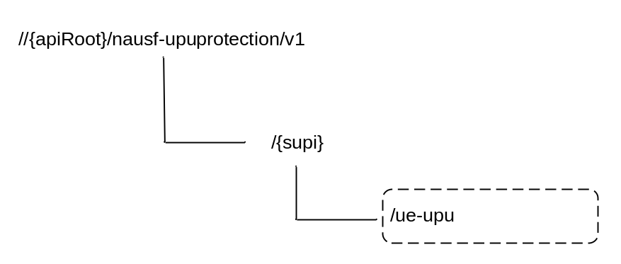
Figure 6.3.3.1-1: Resource URI structure of the UPUProtection API
Table 6.3.3.1-1 provides an overview of the resources and applicable HTTP methods.
Table 6.3.3.1-1: Resources and methods overview
Resource name | Resource URI | HTTP method or custom operation | Description
ue-upu  (Custom operation) | {apiRoot}/nausf-upuprotection/v1/{supi}/ue-upu/generate-upu-data | generate-upu-data (POST) | Resource for UPU security material computation

6.3.3.2 Resource: ue-upu

6.3.3.2.1 Description
It is the resource to which the custom operation used to generate the UPU security material is associated with.

6.3.3.2.2 Resource Definition
Resource URI: {apiRoot}/nausf-upuprotection/v1/supi/ue-upu
This resource shall support the resource URI variables defined in table 6.3.3.2.2-1.
Table 6.3.3.2.2-1: Resource URI variables for this resource
Name | Definition
apiRoot | See clause 6.3.1
supi | Represents the Subscription Permanent Identifier (see 3GPP TS 23.501 [2] clause 5.9.2)  pattern: '^(imsi-[0-9]{5,15}|nai-.+|.+)$'

6.3.3.2.3 Resource Standard Methods
No Standard Methods are supported for this resource.

6.3.3.2.4 Resource Custom Operations

6.3.3.2.4.1 Overview
Table 6.3.3.2.4.1-1: Custom operations
Custom operation URI | Mapped HTTP method | Description
/generate-upu-data | POST | The AUSF calculates the UPU-MAC-I_{AUSF} and the Counter_{UPU} to protect the UE Parameters Update Data provided. It may also calculate the UPU-XMAC-I_{UE} to verify that the UE received the UE Parameters Update Data if the indication that an acknowledgement is requested from the UE is provided.

6.3.3.2.4.2 Operation: generate-upu-data

6.3.3.2.4.2.1 Description
This custom operation is used by the NF service consumer (e.g. UDM) to request the AUSF to compute the security material (UPU-MAC-I_{AUSF}, Counter_{UPU} and UPU-XMAC-I_{UE}) needed to ensure the protection of the UPU procedure (see 3GPP TS 33.501 [8]).

6.3.3.2.4.2.2 Operation Definition
This method shall support the request data structures specified in table 6.3.3.2.4.2.2-1 and the response data structures and response codes specified in table 6.3.3.2.4.2.2-2.
Table 6.3.3.2.4.2.2-1: Data structures supported by the POST Request Body on this resource
Data type | P | Cardinality | Description
UpuInfo | M | 1 | Contains the UE Parameters Update Data and may contain the indication that an acknowledgement is requested from the UE (as specified in 3GPP TS 33.501 [8]).

Table 6.3.3.2.4.2.2-2: Data structures supported by the POST Response Body on this resource
Data type | P | Cardinality | Response  codes | Description
UpuSecurityInfo | M | 1 | 200 OK | Upon success, the response body will contain UPU-MAC-I_{AUSF} and Counter_{UPU} and may contain the UPU-XMAC-I_{UE.}
ProblemDetails | M | 1 | 503 Service Unavailable | The "cause" attribute shall be set to one of the following application error:  - COUNTER_WRAP  See table 6.3.7.3-1 for the description of these errors.

6.3.4 Custom Operations without associated resources

6.3.4.1 Overview
There is no Custom Operation in the current version of this API.

6.3.5 Notifications

6.3.5.1 General
There is no use of notification in the current version of this API.

6.3.6 Data Model

6.3.6.1 General
This clause specifies the application data model supported by the API.
Table 6.3.6.1-1 specifies the data types defined for the Nausf-UPUProtection service based interface protocol.
Table 6.3.6.1-1: Nausf specific Data Types
Data type | Clause defined | Description
UpuInfo | 6.3.6.2.2 | Contains the UE parameters update Information
UpuSecurityInfo | 6.3.6.2.3 | Contains the material generated for securing of UPU. It contains at least the UPU-MAC-I_{AUSF} and Counter_{UPU}.
UpuData | 6.3.6.2.4 | Contains UE parameters update data set (e.g., the updated Routing ID Data or the Default configured NSSAI).
UpuMac | 6.3.6.3.2 | MAC value for protecting UPU procedure (UPU-MAC-I_{AUSF} and UPU-MAC-I_{UE})
CounterUpu | 6.3.6.3.2 | Counter_{UPU}
AckInd | 6.3.6.3.2 | Contains the indication of whether the acknowledgement from UE is needed

Table 6.3.6.1-2 specifies data types re-used by the Nausf-UPUProtection service based interface protocol from other specifications, including a reference to their respective specifications and when needed, a short description of their use within the Nausf service based interface.
Table 6.3.6.1-2: Nausf re-used Data Types
Data type | Reference | Comments
Snssai | 3GPP TS 29.571 [10] | Default configured NSSAI

6.3.6.2 Structured data types

6.3.6.2.1 Introduction
The following clauses define the structures to be used in resource representations.

6.3.6.2.2 Type: UpuInfo
Table 6.3.6.2.2-1: Definition of type UpuInfo
Attribute name | Data type | P | Cardinality | Description
upuDataList | array(UpuData) | M | 1..N | This information defines the UE Parameters Update (UPU). A secured packed with the Routing indicator update data and/or the Default configured NSSAI update data are included. See clause 6.3.6.2.4.
upuAckInd | UpuAckInd | M | 1 | Contains the indication of whether the acknowledgement from UE is needed.

6.3.6.2.3 Type: UpuSecurityInfo
Table 6.3.6.2.3-1: Definition of type UpuSecurityInfo
Attribute name | Data type | P | Cardinality | Description
upuMacIausf | UpuMac | M | 1 | Contains the UPU-MAC-I_{AUSF}.
counterUpu | CounterUpu | M | 1 | Contains the Counter_{UPU}.
upuXmacIue | UpuMac | O | 0..1 | When present, contains the UPU-XMAC-I_{UE}. It shall be included, if the UDM requests the acknowledgement from the UE.

6.3.6.2.4 Type: UpuData
Table 6.3.6.2.4-1: Definition of type UpuData
Attribute name | Data type | P | Cardinality | Description
secPacket | SecuredPacket | C | 0..1 | Presents if the Routing indicator update data is required to be updated, and contains a secured packet with the Routing indicator to be updated.
defaultConfNssai | array(Snssai) | C | 0..N | Presents if the Default configured NSSAI is required to be updated, and contains the Default configured NSSAI to be updated.
RoutingId | RoutingId | C | 0..1 | May be present when sent from UDR to UDM. The UDM shall make use of Notaf services (see 3GPP TS 29.544 [22] to encapsulate the routing id in a secured packet which is then conveyed to the AUSF and AMF.

6.3.6.3 Simple data types and enumerations

6.3.6.3.1 Introduction
This clause defines simple data types and enumerations that can be referenced from data structures defined in the previous clauses.

6.3.6.3.2 Simple data types
Table 6.3.6.3.2-1: Simple data types
Type Name | Type Definition | Description
UpuMac | string | pattern: "^[A-Fa-f0-9]{32}$"
CounterUpu | string | pattern: "^[A-Fa-f0-9]{4}$"
UpuAckInd | boolean | true indicates that the UPU-XMAC-I_{UE} shall be computed and returned in the response

6.3.6.3.3 Enumeration: UpuDataType
Table 6.3.6.3.3-1: Enumeration UpuDataType
Enumeration value | Description
"ROUT_INDICATOR" | Routing indicator update data
"DEFAULT_CONF_NSSAI" | Default configured NSSAI update data

6.3.7 Error Handling

6.3.7.1 General
HTTP error handling shall be supported as specified in clause 5.2.4 of 3GPP TS 29.500 [4].

6.3.7.2 Protocol Errors
Protocol Error Handling shall be supported as specified in clause 5.2.7.2 of 3GPP TS 29.500 [4].

6.3.7.3 Application Errors
The common application errors defined in the Table 5.2.7.2-1 in 3GPP TS 29.500 [4] may also be used for the Nausf_UPUProtection service. The following application errors listed in Table 6..7.3-1 are specific for the Nausf_UPUProtection service.
Table 6.3.7.3-1: Application errors
Application Error | HTTP status code | Description
COUNTER_WRAP | 503 Service Unavailable | The Counter_{UPU} associated with the K_{AUSF} of the UE is about to wrap around. The AUSF suspends the UPU protection service for the UE until a new K_{AUSF} is generated.

6.3.8 Security
As indicated in 3GPP TS 33.501 [8], the access to the Nausf_UPUProtection API may be authorized by means of the OAuth2 protocol (see IETF RFC 6749 [13]), using the "Client Credentials" authorization grant, where the NRF (see 3GPP TS 29.510 [14]) plays the role of the authorization server.
If OAuth2 is used, an NF Service Consumer, prior to consuming services offered by the Nausf_UPUProtection API, shall obtain a "token" from the authorization server, by invoking the Access Token Request service, as described in 3GPP TS 29.510 [14], clause 5.4.2.2.
NOTE: When multiple NRFs are deployed in a network, the NRF used as authorization server is the same NRF that the NF Service Consumer used for discovering the Nausf_UPUProtection service.
The Nausf_UPUProtection Service API does not define any scopes for OAuth2 authorization as specified in 3GPP TS 33.501 [8]; it defines a single scope consisting on the name of the service (i.e., "nausf-upuprotection"), and it does not define any additional scopes at resource or operation level.

Annex A (normative):
OpenAPI specification

A.1 General
This Annex specifies the formal definition of the Nausf Service API(s). It consists of OpenAPI 3.0.0 specifications in YAML format.
NOTE 1: OpenAPI 3.0 does not support description of API using HATEOAS. Indeed, only relative paths can be used and as a consequence the URI provided in the "href" cannot be reused as it is.
This Annex takes precedence when being discrepant to other parts of the specification with respect to the encoding of information elements and methods within the API(s).
NOTE 2: The semantics and procedures, as well as conditions, e.g. for the applicability and allowed combinations of attributes or values, not expressed in the OpenAPI definitions but defined in other parts of the specification also apply.
Informative copies of the OpenAPI specification files contained in this 3GPP Technical Specification are available on the public 3GPP file server in the following locations (see clause 5B of the 3GPP TR 21.900 [21] for further information):
- https://www.3gpp.org/ftp/Specs/archive/OpenAPI/<Release>/, and
- https://www.3gpp.org/ftp/Specs/<Plenary>/<Release>/OpenAPI/.
NOTE 3: To fetch the OpenAPI specification file after CT#83 plenary meeting for Release 15 in the above links <Plenary> must be replaced with the date the CT Plenary occurs, in the form of year-month (yyyy-mm), e.g. for CT#83 meeting <Plenary> must be replaced with value "2019-03" and <Release> must be replaced with value "Rel-15".

A.2 Nausf_UEAuthentication API
openapi: 3.0.0
info:
version: 1.1.0.alpha-3
title: AUSF API
description: |
AUSF UE Authentication Service.
© 2019, 3GPP Organizational Partners (ARIB, ATIS, CCSA, ETSI, TSDSI, TTA, TTC).
All rights reserved.

externalDocs:
description: 3GPP TS 29.509 V16.2.0; 5G System; 3GPP TS Authentication Server services.
url: 'http://www.3gpp.org/ftp/Specs/archive/29_series/29.509'

servers:
- url: '{apiRoot}/nausf-auth/v1'
variables:
apiRoot:
default: https://example.com
description: apiRoot as defined in clause clause 4.4 of 3GPP TS 29.501.

security:
- {}
- oAuth2ClientCredentials:
- nausf-auth
paths:
/ue-authentications:
post:
requestBody:
content:
application/json:
schema:
$ref: '#/components/schemas/AuthenticationInfo'
required: true
responses:
'201':
description: UEAuthenticationCtx
content:
application/3gppHal+json:
schema:
$ref: '#/components/schemas/UEAuthenticationCtx'
headers:
Location:
description: 'Contains the URI of the newly created resource according to the structure: {apiRoot}/nausf-auth/v1/ue-authentications/{authCtxId}'
required: true
schema:
type: string

'400':
description: Bad Request from the AMF
content:
application/problem+json:
schema:
$ref: 'TS29571_CommonData.yaml#/components/schemas/ProblemDetails'
'403':
description: Forbidden due to serving network not authorized
content:
application/problem+json:
schema:
$ref: 'TS29571_CommonData.yaml#/components/schemas/ProblemDetails'
'404':
description: User does not exist in the HPLMN
content:
application/problem+json:
schema:
$ref: 'TS29571_CommonData.yaml#/components/schemas/ProblemDetails'
'500':
description: Internal Server Error
content:
application/problem+json:
schema:
$ref: 'TS29571_CommonData.yaml#/components/schemas/ProblemDetails'
'501':
description: Received protection scheme is not supported by HPLMN
content:
application/problem+json:
schema:
$ref: 'TS29571_CommonData.yaml#/components/schemas/ProblemDetails'
/ue-authentications/{authCtxId}/5g-aka-confirmation:
put:
parameters:
- name: authCtxId
in: path
required: true
schema:
type: string
requestBody:
content:
application/json:
schema:
$ref: '#/components/schemas/ConfirmationData'
responses:
'200':
description: Request processed (EAP success or Failure)
content:
application/json:
schema:
$ref: '#/components/schemas/ConfirmationDataResponse'

'400':
description: Bad Request
content:
application/problem+json:
schema:
$ref: 'TS29571_CommonData.yaml#/components/schemas/ProblemDetails'
'500':
description: Internal Server Error
content:
application/problem+json:
schema:
$ref: 'TS29571_CommonData.yaml#/components/schemas/ProblemDetails'
/ue-authentications/{authCtxId}/eap-session:
post:
operationId: EapAuthMethod
parameters:
- name: authCtxId
in: path
required: true
schema:
type: string
requestBody:
content:
application/json:
schema:
$ref: '#/components/schemas/EapSession'
responses:
'200':
description: Use to handle or close the EAP session
content:
application/json:
schema:
$ref: '#/components/schemas/EapSession'

application/3gppHal+json:
schema:
type: object
properties:
eapPayload:
$ref: '#/components/schemas/EapPayload'
_links:
type: object
description: 'URI : /{eapSessionUri}'
additionalProperties:
$ref: 'TS29571_CommonData.yaml#/components/schemas/LinksValueSchema'
minProperties: 1
required:
- eapPayload
- _links
'400':
description: Bad Request
content:
application/problem+json:
schema:
$ref: 'TS29571_CommonData.yaml#/components/schemas/ProblemDetails'
'500':
description: Internal Server Error
content:
application/problem+json:
schema:
$ref: 'TS29571_CommonData.yaml#/components/schemas/ProblemDetails'
/rg-authentications:
post:
requestBody:
content:
application/json:
schema:
$ref: '#/components/schemas/RgAuthenticationInfo'
required: true
responses:
'201':
description: RgAuthCtx
content:
application/json:
schema:
$ref: '#/components/schemas/RgAuthCtx'
headers:
Location:
description: 'Contains the URI of the newly created resource according to the structure: {apiRoot}/nausf-auth/v1/rg-authentications/{authCtxId}'
required: true
schema:
type: string
'403':
description: The UE is not allowed to be authenticated
content:
application/problem+json:
schema:
$ref: 'TS29571_CommonData.yaml#/components/schemas/ProblemDetails'
'400':
description: Bad Request from the AMF
content:
application/problem+json:
schema:
$ref: 'TS29571_CommonData.yaml#/components/schemas/ProblemDetails'
'404':
description: User does not exist in the HPLMN
content:
application/problem+json:
schema:
$ref: 'TS29571_CommonData.yaml#/components/schemas/ProblemDetails'

components:
securitySchemes:
oAuth2ClientCredentials:
type: oauth2
flows:
clientCredentials:
tokenUrl: '{nrfApiRoot}/oauth2/token'
scopes:
nausf-auth: Access to Nausf_UEAuthentication API
schemas:
AuthenticationInfo:
type: object
properties:
supiOrSuci:
$ref: 'TS29503_Nudm_UEAU.yaml#/components/schemas/SupiOrSuci'
servingNetworkName:
$ref: 'TS29503_Nudm_UEAU.yaml#/components/schemas/ServingNetworkName'
resynchronizationInfo:
$ref: 'TS29503_Nudm_UEAU.yaml#/components/schemas/ResynchronizationInfo'
pei:
$ref: 'TS29571_CommonData.yaml#/components/schemas/Pei'
traceData:
$ref: 'TS29571_CommonData.yaml#/components/schemas/TraceData'
udmGroupId:
$ref: 'TS29571_CommonData.yaml#/components/schemas/NfGroupId'
routingIndicator:
type: string
pattern: '^[0-9]{1,4}$'
required:
- supiOrSuci
- servingNetworkName
UEAuthenticationCtx:
type: object
properties:
authType:
$ref: '#/components/schemas/AuthType'
5gAuthData:
oneOf:
- $ref: '#/components/schemas/Av5gAka'
- $ref: '#/components/schemas/EapPayload'
_links:
type: object
additionalProperties:
$ref: 'TS29571_CommonData.yaml#/components/schemas/LinksValueSchema'
servingNetworkName:
$ref: 'TS29503_Nudm_UEAU.yaml#/components/schemas/ServingNetworkName'
required:
- authType
- 5gAuthData
- _links

Av5gAka:
type: object
required:
- rand
- hxresStar
- autn
properties:
rand:
$ref: 'TS29503_Nudm_UEAU.yaml#/components/schemas/Rand'
hxresStar:
$ref: '#/components/schemas/HxresStar'
autn:
$ref: 'TS29503_Nudm_UEAU.yaml#/components/schemas/Autn'
ConfirmationData:
type: object
required:
- resStar
properties:
resStar:
$ref: '#/components/schemas/ResStar'
ConfirmationDataResponse:
type: object
properties:
authResult:
$ref: '#/components/schemas/AuthResult'
supi:
$ref: 'TS29571_CommonData.yaml#/components/schemas/Supi'
kseaf:
$ref: '#/components/schemas/Kseaf'

required:
- authResult
EapSession:
type: object
properties:
eapPayload:
$ref: '#/components/schemas/EapPayload'
kSeaf:
$ref: '#/components/schemas/Kseaf'
_links:
type: object
additionalProperties:
$ref: 'TS29571_CommonData.yaml#/components/schemas/LinksValueSchema'
authResult:
$ref: '#/components/schemas/AuthResult'
supi:
$ref: 'TS29571_CommonData.yaml#/components/schemas/Supi'
required:
- eapPayload
RgAuthenticationInfo:
type: object
properties:
suci:
$ref: '#/components/schemas/Suci'
authenticatedInd:
type: boolean
default: false
required:
- suci
- authenticatedInd
RgAuthCtx:
type: object
properties:
authResult:
$ref: '#/components/schemas/AuthResult'
supi:
$ref: 'TS29571_CommonData.yaml#/components/schemas/Supi'
authInd:
type: boolean
default: false
required:
- authResult

AuthResult:
type: string
enum:
- AUTHENTICATION_SUCCESS
- AUTHENTICATION_FAILURE
- AUTHENTICATION_ONGOING
EapPayload:
type: string
format: base64
description: contains an EAP packet
nullable: true
Kseaf:
type: string
pattern: '[A-Fa-f0-9]{64}'
ResStar:
type: string
pattern: '[A-Fa-f0-9]{32}'
nullable: true
HxresStar:
type: string
pattern: "[A-Fa-f0-9]{32}"
Suci:
type: string
pattern: '^(suci-(0-[0-9]{3}-[0-9]{2,3}|[1-7]-.+)-[0-9]{1,4}-(0-0-.+|[a-fA-F1-9]-([1-9]|[1-9][0-9]|1[0-9]{2}|2[0-4][0-9]|25[0-5])-[a-fA-F0-9]+)|.+)$'
AuthType:
anyOf:
- type: string
enum:
- 5G_AKA
- EAP_AKA_PRIME
- EAP_TLS
- type: string

A.3 Nausf_SoRProtection API
openapi: 3.0.0
info:
version: 1.0.2
title: Nausf_SoRProtection Service
description: |
AUSF SoR Protection Service.
© 2019, 3GPP Organizational Partners (ARIB, ATIS, CCSA, ETSI, TSDSI, TTA, TTC).
All rights reserved.

externalDocs:
description: 3GPP TS 29.509 V16.2.0; 5G System; Authentication Server Services
url: 'http://www.3gpp.org/ftp/Specs/archive/29_series/29.509'

servers:
- url: '{apiRoot}/nausf-sorprotection/v1'
variables:
apiRoot:
default: https://example.com
description: apiRoot as defined in clause 4.4 of 3GPP TS 29.501
security:
- {}
- oAuth2ClientCredentials:
- nausf-sorprotection
paths:
/{supi}/ue-sor:
post:
parameters:
- name: supi
in: path
description: Identifier of the UE
required: true
schema:
$ref: 'TS29571_CommonData.yaml#/components/schemas/Supi'
requestBody:
content:
application/json:
schema:
$ref: '#/components/schemas/SorInfo'
required: true
responses:
'200':
description: SorSecurityInfo
content:
application/json:
schema:
$ref: '#/components/schemas/SorSecurityInfo'
'503':
description: Service Unavailable
content:
application/problem+json:
schema:
$ref: 'TS29571_CommonData.yaml#/components/schemas/ProblemDetails'
components:
securitySchemes:
oAuth2ClientCredentials:
type: oauth2
flows:
clientCredentials:
tokenUrl: '{nrfApiRoot}/oauth2/token'
scopes:
nausf-sorprotection: Access to the Nausf_SoRProtection API
schemas:
SorInfo:
type: object
properties:
steeringContainer:
$ref: '#/components/schemas/SteeringContainer'
ackInd:
$ref: '#/components/schemas/AckInd'
required:
- ackInd
SorSecurityInfo:
type: object
properties:
sorMacIausf:
$ref: '#/components/schemas/SorMac'
counterSor:
$ref: '#/components/schemas/CounterSor'
sorXmacIue:
$ref: '#/components/schemas/SorMac'
required:
- sorMacIausf
- counterSor
SteeringContainer:
oneOf:
- type: array
items:
$ref: 'TS29509_Nausf_SoRProtection.yaml#/components/schemas/SteeringInfo'
minItems: 1
- $ref: '#/components/schemas/SecuredPacket'
SteeringInfo:
type: object
properties:
plmnId:
$ref: 'TS29571_CommonData.yaml#/components/schemas/PlmnId'
accessTechList:
type: array
items:
$ref: '#/components/schemas/AccessTech'
minItems: 1
required:
- plmnId
SorMac:
type: string
pattern: '^[A-Fa-f0-9]{32}$'
CounterSor:
type: string
pattern: '^[A-Fa-f0-9]{4}$'
AckInd:
type: boolean
SecuredPacket:
type: string
format: base64
AccessTech:
anyOf:
- type: string
enum:
- NR
- EUTRAN_IN_WBS1_MODE_AND_NBS1_MODE
- EUTRAN_IN_NBS1_MODE_ONLY
- EUTRAN_IN_WBS1_MODE_ONLY
- UTRAN
- GSM_AND_ECGSM_IoT
- GSM_WITHOUT_ECGSM_IoT
- ECGSM_IoT_ONLY
- CDMA_1xRTT
- CDMA_HRPD
- GSM_COMPACT
- type: string

A.4 Nausf_UPUProtection API
openapi: 3.0.0
info:
version: 1.1.0.alpha-1
title: Nausf_UPUProtection Service
description: |
AUSF UPU Protection Service
© 2019, 3GPP Organizational Partners (ARIB, ATIS, CCSA, ETSI, TSDSI, TTA, TTC).
All rights reserved.

externalDocs:
description: 3GPP TS 29.509 V16.2.0; 5G System; Authentication Server Services
url: 'http://www.3gpp.org/ftp/Specs/archive/29_series/29.509'

servers:
- url: '{apiRoot}/nausf-upuprotection/v1'
variables:
apiRoot:
default: https://example.com
description: apiRoot as defined in clause 4.4 of 3GPP TS 29.501
security:
- {}
- oAuth2ClientCredentials:
- nausf-upuprotection
paths:
/{supi}/ue-upu:
post:
parameters:
- name: supi
in: path
description: Identifier of the UE
required: true
schema:
$ref: 'TS29571_CommonData.yaml#/components/schemas/Supi'
requestBody:
content:
application/json:
schema:
$ref: '#/components/schemas/UpuInfo'
required: true
responses:
'200':
description: UpuSecurityInfo
content:
application/json:
schema:
$ref: '#/components/schemas/UpuSecurityInfo'
'503':
description: Service Unavailable
content:
application/problem+json:
schema:
$ref: 'TS29571_CommonData.yaml#/components/schemas/ProblemDetails'

components:
securitySchemes:
oAuth2ClientCredentials:
type: oauth2
flows:
clientCredentials:
tokenUrl: '{nrfApiRoot}/oauth2/token'
scopes:
nausf-upuprotection: Access to the Nausf_UPUProtection API
schemas:
UpuInfo:
type: object
properties:
upuDataList:
type: array
items:
$ref: '#/components/schemas/UpuData'
minItems: 1
upuAckInd:
$ref: '#/components/schemas/UpuAckInd'
required:
- upuDataList
- upuAckInd
UpuSecurityInfo:
type: object
properties:
upuMacIausf:
$ref: '#/components/schemas/UpuMac'
counterUpu:
$ref: '#/components/schemas/CounterUpu'
upuXmacIue:
$ref: '#/components/schemas/UpuMac'
required:
- upuMacIausf
- counterUpu
UpuData:
type: object
properties:
secPacket:
$ref: 'TS29509_Nausf_SoRProtection.yaml#/components/schemas/SecuredPacket'
defaultConfNssai:
type: array
items:
$ref: 'TS29571_CommonData.yaml#/components/schemas/Snssai'
minItems: 1
routingId:
$ref: 'TS29544_Notaf_SecuredPacket.yaml#/components/schemas/RoutingId'
oneOf:
- required: [secPacket]
- required: [defaultConfNssai]
UpuMac:
type: string
pattern: '^[A-Fa-f0-9]{32}$'
CounterUpu:
type: string
pattern: '^[A-Fa-f0-9]{4}$'
UpuAckInd:
type: boolean

Annex B (Informative):
Use of EAP-TLS

B.1 General
The Annex B of 3GPP TS 33.501 [8] describes the use of EAP-TLS as an alternative authentication method in the case of private network. This annex describes corresponding stage 3.

B.2 EAP method: EAP-TLS
EAP-TLS as defined in IETF RFC 5216 [16] is the EAP method used in this procedure. This procedure is described in Annex B.2.1 of 3GPP TS 33.501 [8].
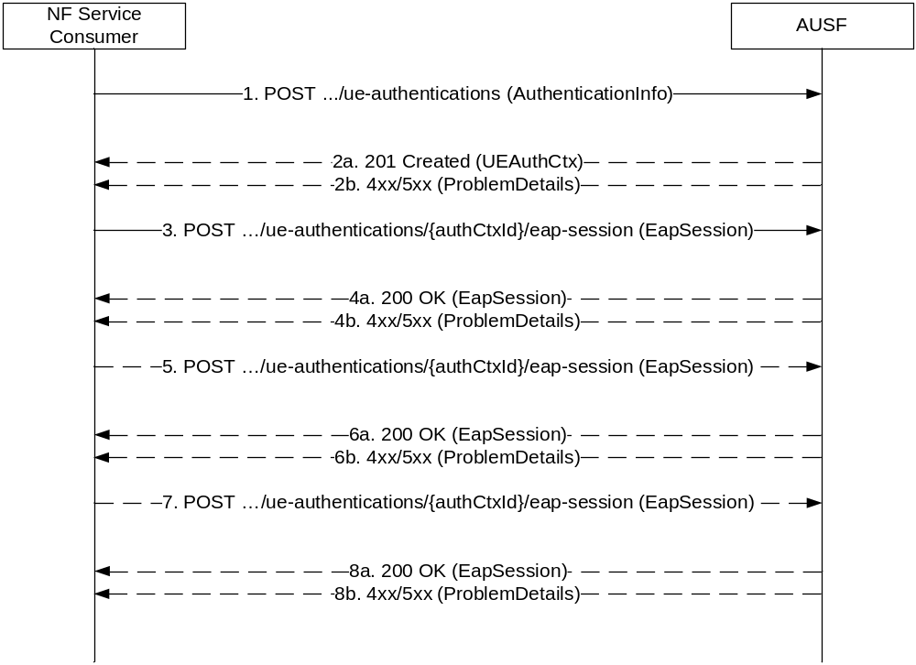

1 The NF Service Consumer (AMF) shall send a POST request to the AUSF. The payload of the body shall contain at least the UE Id and Serving Network Name.
2a. On success, "201 Created" shall be returned. The payload body shall contain the representation of the resource generated and the "Location" header shall contain the URI of the generated resource (e.g. .../v1/ue_authentications/{authCtxId}/eap-session). The AUSF generates a sub-resource "eap-session". The AUSF shall provide a hypermedia link towards this sub-resource in the payload to indicate to the AMF where it shall send a POST containing the EAP packet response. The body payload shall also contain the EAP packet EAP-Request/EAP-Type=EAP-TLS (TLS Start)
2b. On failure, one of the HTTP status code listed in table 6.1.7.3-1 shall be returned with the message body containing a ProblemDetails structure with the "cause" attribute set to one of the application error listed in Table 6.1.7.3-1. In particular, if the serving network is not authorized, the AUSF shall use the "Cause" SERVING_NETWORK_NOT_AUTHORIZED.
3. Based on the relation type, the NF Service Consumer (AMF) shall send a POST request including the EAP-Response/EAP-Type=EAP-TLS (TLS client_hello) received from the UE. The POST request is sent to the URI provided by the AUSF or derived by the NF Service Consumer (AMF).
4a. On success, the AUSF shall reply with a "200 OK" HTTP message containing the EAP Request as described in Annex B.2.1 of 3GPP TS 33.501 [8] and a hypermedia link towards the sub-resource "eap-session".
4b. On failure, one of the HTTP status code listed in table 6.1.7.3-1 shall be returned with the message body containing a ProblemDetails structure with the "cause" attribute set to one of the application error listed in Table 6.1.7.3-1.
5. The NF Service Consumer (AMF) shall send a POST request including the EAP Response received from the UE. The POST request is sent to the URI provided by the AUSF or derived by the NF Service Consumer (AMF).
6a. On success, the AUSF shall reply with a "200 OK" HTTP message containing the EAP Request as described in Annex B.2.1 of 3GPP TS 33.501 [8] and a hypermedia link towards the sub-resource "eap-session".
6b. On failure, one of the HTTP status code listed in table 6.1.7.3-1 shall be returned with the message body containing a ProblemDetails structure with the "cause" attribute set to one of the application error listed in Table 6.1.7.3-1.
7. The NF Service Consumer (AMF) shall send a POST request including the EAP Response received from the UE. The POST request is sent to the URI provided by the AUSF or derived by the NF Service Consumer (AMF).
8a. If the EAP authentication exchange is successfully completed (with or without the optional Notification Request/Response messages exchange), "200 OK" shall be returned to the NF Service Consumer (AMF). The payload shall contain the result of the authentication, an EAP success/failure and the Kseaf if the authentication is successful.
8b. On failure, one of the HTTP status code listed in table 6.1.7.3-1 shall be returned with the message body containing a ProblemDetails structure with the "cause" attribute set to one of the application error listed in Table 6.1.7.3-1.

Annex C (informative):
Withdrawn API versions

C.1 General
This Annex lists withdrawn API versions of the APIs defined in the present specification. 3GPP TS 29.501 [5] clause 4.3.1.6 describes the withdrawal of API versions.

C.2 Nausf_SoRProtection API
The API versions listed in table C.2-1 are withdrawn for the Nausf_SoRProtection API.
Table C.2-1: Withdrawn API versions of the Nausf_SoRProtection service
API version number | Reason for withdrawal
1.0.0 | The version 1.0.0 indicates that a 201 "Created" must be sent in response to the POST Custom Operations while it should be a "200 OK" as indicated in clause 6.2.3.2.4.2.2. The version 1.0.1 corrects this mistake. As a consequence, the version 1.0.0 is withdrawn in order to avoid interoperability problems with further version of the Nausf_SoRProtection service.

Annex D (informative):
Change history

Change history
Date | Meeting | TDoc | CR | Rev | Cat | Subject/Comment | New version
2017-10 | CT4#80 | C4-175268 |  |  |  | Initial Draft.(Agreed Skeleton) | 0.1.0
2017-10 | CT4#80 | C4-175394 |  |  |  | Inclusion of pCR agreeds during CT4#80: C4-175269 and C4-175270 | 0.2.0
2017-12 | CT4#81 | C4-176437 |  |  |  | Inclusion of pCR agreeds during CT4#81: C4-176267, C4-176269, C4-176426, C4-17427 | 0.3.0
2018-01 | CT4#82 | C4-181391 |  |  |  | Inclusion of pCR agreeds during CT4#82: C4-181341, C4-181342, C4-181343, C4-181344, C4-181345,C4-181346, C4-181347,C4-181155 | 0.4.0
2018-03 | CT4#83 | C4-182434 |  |  |  | Inclusion of pCRs agreeds during CT4#83: C4-182283 and C4-182279 | 0.5.0
2018-03 | CT#79 | CP-180031 |  |  |  | Presented for information | 1.0.0
2018-04 | CT4#84 | C4-183516 |  |  |  | Inclusion of pCRs agreed during CT4#84: C4-183309, C4-183313, C4-183346, C4-183347 and C4-183448 | 1.1.0
2018-05 | CT4#85 | C4-184623 |  |  |  | Inclusion of PCRs agreeds during CT4#83: C4-184219, C4-184220, C4-184224, C4-184227, C4-184227, C4-184362, C4-184363, C4-184367, C4-184368, C4-184370, C4-184376, C4-184380, C4-184584, C4-184624 | 1.2.0
2018-06 | CT#80 | CP-181104 |  |  |  | Presented for approval | 2.0.0
2018-06 | CT#80 |  |  |  |  | Approved in CT#80. | 15.0.0
2018-09 | CT#81 | CP-182059 | 0002 | 2 | F | Requester ID in Authentication Info | 15.1.0
2018-09 | CT#81 | CP-182059 | 0003 | 1 | F | HTTP method in figure 5.2.2.2.2-1 (Note: clause 6.1.3.1 is not included, already covered) | 15.1.0
2018-09 | CT#81 | CP-182059 | 0004 | 4 | F | SoRProtection service operation | 15.1.0
2018-09 | CT#81 | CP-182059 | 0010 | 1 | F | Adding TS 33.501 reference | 15.1.0
2018-09 | CT#81 | CP-182059 | 0011 | - | F | HTTP Custom Header | 15.1.0
2018-09 | CT#81 | CP-182059 | 0013 | 1 | F | SUPI sends to AMF | 15.1.0
2018-09 | CT#81 | CP-182068 | 0014 | 2 | B | 5G Trace for AUSF | 15.1.0
2018-09 | CT#81 | CP-182013 | 0015 | 2 | F | Making Oauth 2.0 optional in OAS description | 15.1.0
2018-09 | CT#81 | CP-182059 | 0016 | 1 | F | Editorial Corrections | 15.1.0
2018-09 | CT#81 | CP-182059 | 0017 | 1 | F | Error code correction | 15.1.0
2018-09 | CT#81 | CP-182059 | 0018 | 1 | F | Add support to EAP-TLS (Optional) | 15.1.0
2018-09 | CT#81 | CP-182059 | 0019 | - | F | Correcting Presentation of resources for AUSF API | 15.1.0
2018-09 | CT#81 | CP-182059 | 0020 | 1 | F | Correcting confirmation message | 15.1.0
2018-09 | CT#81 | CP-182059 | 0021 | - | F | API version number update | 15.1.0
2018-12 | CT#82 | C4-187253 | 0026 | - | F | Remove the "supiOrSuci" in Confirmation Data | 15.2.0
2018-12 | CT#82 | C4-187254 | 0027 | - | F | Correcting Resource URI structure of the SoRProtection Service | 15.2.0
2018-12 | CT#82 | C4-187359 | 0030 | - | F | Cardinality | 15.2.0
2018-12 | CT#82 | C4-187370 | 0031 | - | F | Add supi and authResult to EapSession in OpenAPI definitions | 15.2.0
2018-12 | CT#82 | C4-187478 | 0022 | - | F | Requester ID not needed in initial request from AMF | 15.2.0
2018-12 | CT#82 | C4-187479 | 0023 | - | F | Delaying transmission of Kseaf | 15.2.0
2018-12 | CT#82 | C4-187480 | 0024 | 1 | F | Correcting the reference to EAP-AKA' | 15.2.0
2018-12 | CT#82 | C4-187481 | 0025 | 1 | F | Adding a reference to the Annex in the Specification | 15.2.0
2018-12 | CT#82 | C4-187483 | 0028 | 1 | F | Error handling in AUSF | 15.2.0
2018-12 | CT#82 | C4-187485 | 0029 | 1 | F | Add a reference to the IETF RFC 3748 on EAP Framework | 15.2.0
2018-12 | CT#82 | C4-188060 | 0032 | - | F | Base64 reference | 15.2.0
2018-12 | CT#82 | C4-188109 | 0033 | - | F | APIRoot Clarification | 15.2.0
2018-12 | CT#82 | C4-188150 | 0034 | - | F | Reference correction | 15.2.0
2018-12 | CT#82 | C4-188251 | 0036 | - | F | OpenAPI version number for Nausf_UEAuthentication service | 15.2.0
2018-12 | CT#82 | C4-188494 | 0037 | 1 | F | OpenAPI version number for Nausf_SoRProtection | 15.2.0
2018-12 | CT#82 | C4-188495 | 0038 | 1 | F | Correct "externalDocs" for Nausf_UEAuthentication OAS | 15.2.0
2018-12 | CT#82 | C4-188497 | 0039 | 1 | F | Clarification on the 200 OK returned by AUSF in case of authentication failure | 15.2.0
2018-12 | CT#82 | C4-188547 | 0040 | - | F | Secured packet in SorInfo | 15.2.0
2018-12 | CT#82 | CP-183170 | 0035 | 2 |  | Location Header in OpenAPI | 15.2.0
2018-12 | CT#82 | CP-183172 | 0041 | - | F | Alignement for Oauth scopes - Nausf_UEAuthentication | 15.2.0
2018-12 | CT#82 | CP-183173 | 0042 | - | F | Alignement for Oauth scopes - Nausf_SoRProtection | 15.2.0
2018-12 | CT#82 | CP-183203 | 0043 | - | F | externalDocs for Nausf_SoRProtection OpenAPI Annex | 15.2.0
2019-03 | CT#83 | CP-190022 | 0047 | 1 | F | Mandatory HTTP status codes | 15.3.0
2019-03 | CT#83 | CP-190022 | 0049 | 1 | F | SoR Protection response code alignment | 15.3.0
2019-03 | CT#83 | CP-190022 | 0044 | 3 | F | Authentication Failure scenarios | 15.3.0
2019-03 | CT#83 | CP-190153 | 0046 | 7 | F | UE parameters update support (indicated as C4-190618 + C4-190618_rev7I) | 15.3.0
2019-03 | CT#83 | CP-19205 | 0050 | 1 | F | 3GPP TS 29.509 API version update | 15.3.0
2019-06 | CT#84 | CP-191033 | 0051 | - | F | Correct the expression of URI variables in 5g-aka-confirmation resource | 15.4.0
2019-06 | CT#84 | CP-191033 | 0053 | 2 | F | Storage of OpenAPI specification files | 15.4.0
2019-06 | CT#84 | CP-191033 | 0056 | - | F | AUSF Tracing Targeting a PEI | 15.4.0
2019-06 | CT#84 | CP-191033 | 0055 | 1 | F | Determination of the Authentication Method | 15.4.0
2019-06 | CT#84 | CP-191218 | 0059 | 4 | F | Add withdrawn API version Annex | 15.4.0
2019-06 | CT#84 | CP-191033 | 0058 | 1 | F | Essential correction to add Copyright on OpenAPI specifications | 15.4.0
2019-06 | CT#84 | CP-191057 | 0054 | 1 | F | Non cacheable 501 response | 16.0.0
2019-06 | CT#84 | CP-191057 | 0057 | 1 | B | UDM service discovery based on GroupID and/or RoutingID | 16.0.0
2019-06 | CT#84 | CP-191223 | 0060 | 2 | F | 3GPP TS 29.509 API version update | 16.0.0
2019-09 | CT#85 | CP-192106 | 0063 | 1 | F | Missing status codes | 16.1.0
2019-09 | CT#85 | CP-192120 | 0066 | - | F | API version and ExternalDocs update | 16.1.0
2019-10 |  |  |  |  |  | Corrupted references fixed | 16.1.1
2019-12 | CT#86 | CP-193063 | 0072 | - | F | Add UPU protection in AUSF functionality | 16.2.0
2019-12 | CT#86 | CP-193058 | 0067 | 1 | B | RoutingId | 16.2.0
2019-12 | CT#86 | CP-193134 | 0069 | 2 | B | Authentication Indication from W-AGF (tmp) | 16.2.0
2019-12 | CT#86 | CP-193241 | 0071 | 2 | F | Move ExternalDocs in OpenAPI specifications | 16.2.0
2019-12 | CT#86 | CP-193036 | 0068 | 1 | F | EAP Payload | 16.2.0
2019-12 | CT#86 | CP-193036 | 0070 | 1 | F | Add reference to TS 29.524 | 16.2.0
2019-12 | CT#86 | CP-193044 | 0074 | - | F | 3GPP TS 29.509 API version update | 16.2.0

