**What is Laravel 9.0 ?**

Laravel is a framework of php.

Laravel is most popular framework in php

Laravel provides its own structure i.e support MVC architecture.

Laravel is support oops.

Laravel is best framework to create dynamic website or web application.

Laravel is most used to create web apps | website | mobile apps api’s.

Laravel provides seo friendly website.

Laravel best for large or small scale of website or web apps.

**Advantage of Laravel**

1. Framework of php
2. Open source framework
3. Seo friendly provides website
4. Mvc support
5. Blade templating structure
6. Database migrations procedures
7. Large scale developed website
8. Secured website development
9. Laravel is used for frontend and backend

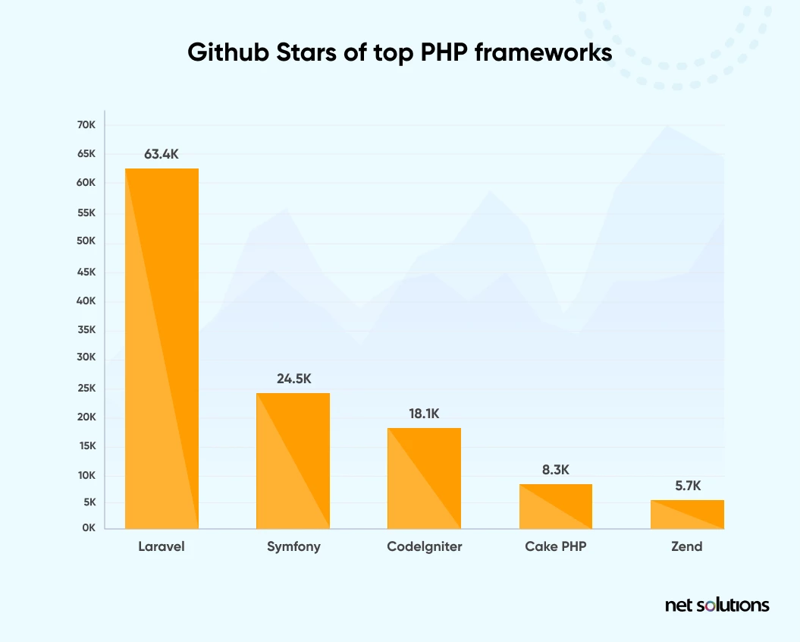

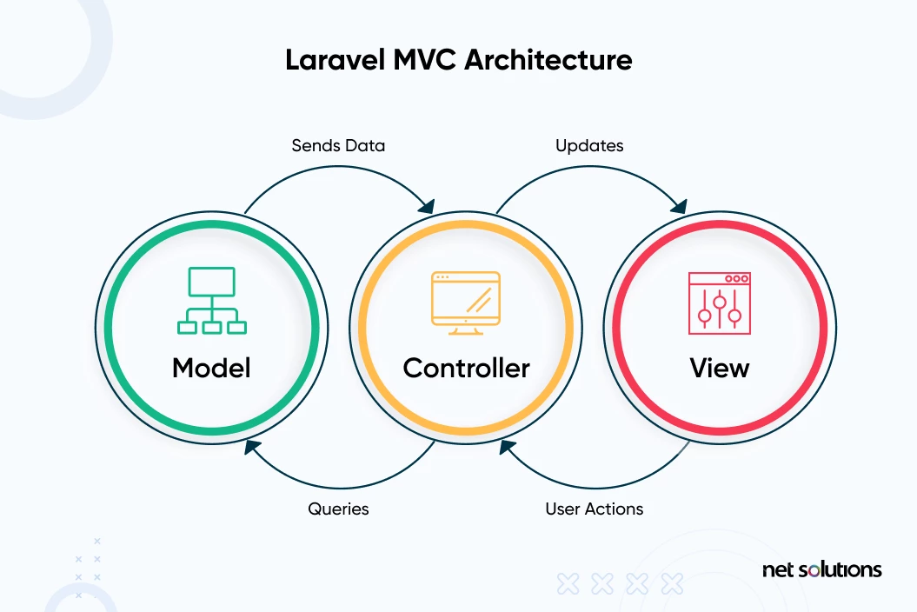

**Laravel installations:**

**Step 1: download and install composer**

**What is composer ?**

<https://getcomposer.org/download/>

composer is an dependency manager i.e used to install Laravel .

Composer in Laravel is used **to manage their dependencies**. Once Composer is installed, download the framework and extract its contents into a directory on your server. The primary task you should do after installing Laravel is to set your application key to a random string

How to check composer is install or not ?

Step 2: check composer install or not ?

Cmd: composer

C:\xampp\htdocs>composer

______

/ ____/___ ____ ___ ____ ____ ________ _____

/ / / __ \/ __ `__ \/ __ \/ __ \/ ___/ _ \/ ___/

/ /___/ /_/ / / / / / / /_/ / /_/ (__ ) __/ /

\____/\____/_/ /_/ /_/ .___/\____/____/\___/_/

/_/

Composer version 2.4.1 2022-08-20 11:44:50

**Step 3: install Laravel**

[**https://laravel.com/docs/9.x**](https://laravel.com/docs/9.x)

However, if you are not using Homestead, you will need to make sure your server meets the following requirements:

* PHP >= 7.2.5
* BCMath PHP Extension
* Ctype PHP Extension
* Fileinfo PHP extension
* JSON PHP Extension
* Mbstring PHP Extension
* OpenSSL PHP Extension
* PDO PHP Extension
* Tokenizer PHP Extension
* XML PHP Extension

composer create-project laravel/laravel example-app

Step 5: how to run projects

C:\xampp\htdocs\charmi-fashionshop-app>

C:\xampp\htdocs\charmi-fashionshop-app>php artisan serve

INFO Server running on [http://127.0.0.1:8000].

Press Ctrl+C to stop the server

Server running url of Laravel

<http://127.0.0.1:8000/>

**Laravel provides maintenance mode :**

C:\xampp\htdocs\charmi-fashionshop-app>php artisan down

INFO Application is now in maintenance mode.

C:\xampp\htdocs\charmi-fashionshop-app>

C:\xampp\htdocs\charmi-fashionshop-app>php artisan up

INFO Application is now in maintenance mode.

C:\xampp\htdocs\charmi-fashionshop-app>

**How to run Laravel on localhost :**

Public/index.php => paste in main directory

Change path of n

require __DIR__.'../vendor/autoload.php';

$app = require_once __DIR__.'../bootstrap/app.php';

<http://localhost/flipkart-app/>

**how to run Laravel on server development URL**

**cmd :** php artisan serve

<http://127.0.0.1:8000/>

**how to connect Laravel with database**

go in main director and change .env

DB_CONNECTION=mysql

DB_HOST=127.0.0.1

DB_PORT=3306

DB_DATABASE=flipkart_db

DB_USERNAME=root

DB_PASSWORD=

How to connect Laravel more than one database used

Config=>database.php

'mysql' => [

            'driver' => 'mysql',

            'url' => env('DATABASE_URL'),

            'host' => env('DB_HOST', '127.0.0.1'),

            'port' => env('DB_PORT', '3306'),

            'database' => env('DB_DATABASE', 'flipkart_db'),

            'username' => env('DB_USERNAME', 'root'),

            'password' => env('DB_PASSWORD', ''),

            'unix_socket' => env('DB_SOCKET', ''),

            'charset' => 'utf8mb4',

            'collation' => 'utf8mb4_unicode_ci',

            'prefix' => '',

Laravel migrations:

Laravel migrations is a default mechanism to create a database tables structure or its schema.

How to create a tables in Laravel using migrations

Cmd : php artisan make:migration create_customers_table

How to migrate tables inside of database :

Cmd : php artisan migrate

php artisan list

php artisan migrate

migrate:fresh Drop all tables and re-run all migrations

migrate:install Create the migration repository

migrate:refresh Reset and re-run all migrations

migrate:reset Rollback all database migrations

migrate:rollback Rollback the last database migration

migrate:status Show the status of each migration