**What is OOPS?**

Oops stands for object-oriented programming structured language.

Oops used in advanced php i.e php5 , php 7, and php 8

Oops used to make dynamic application in advanced php

Oops basically used for secured applications

Oops used to secured applications using

1. Data visibility process

Public

Private

Protected

1. Using access modifier or access specifier

Public

Private

Protected

Oops used to create architectures i.e called MVC

MVC support oops

MVC stands for model view and controller

Model=> model is used to create database or member function inside of your application.

View => view is provides to create all design | view | templates or GUI part of your application

Controller =>controller will create logic part of your applications.

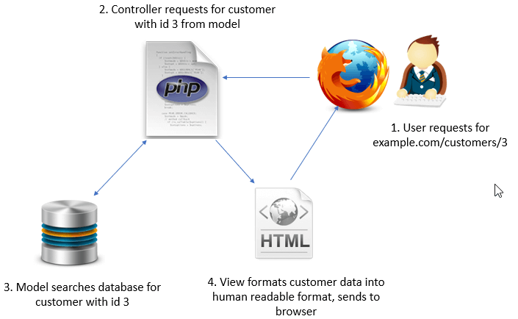

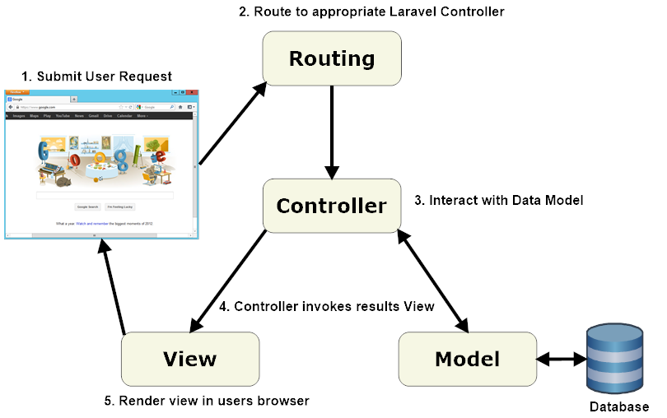

Oops provides some features

1. Class
2. Object
3. Inheritance
4. Polymorphism
5. Encapsulation
6. Abstract
7. What is class?

A class is a group of member and its member function

Or

A class is a blueprint of any object.

Or

A class is nothing whenever we can not create its object.

Syntax :

<?php

class classname

{

Create a member function

Statements;

}

//create an object of class

?>