What is OOPS?
Oops stands for object-oriented programming structured language.
Oops used in advanced php i.e php5 , php 7, and php 8
Oops used to make dynamic application in advanced php
Oops basically used for secured applications
Oops used to secured applications using
- Data visibility process
Public
Private
Protected

- Using access modifier or access specifier

Public
Private
Protected

Oops used to create architectures i.e called MVC
MVC support oops
MVC stands for model view and controller

Model=> model is used to create database or member function inside of your application.

View => view is provides to create all design | view | templates or GUI part of your application
Controller =>controller will create logic part of your applications.
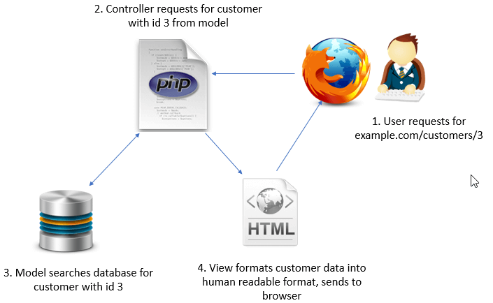

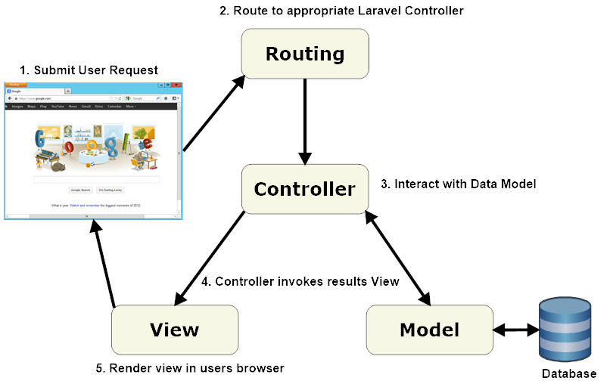

Oops provides some features
- Class
- Object
- Inheritance
- Polymorphism
- Encapsulation
- Abstract

- What is class?

A class is a group of member and its member function
Or
A class is a blueprint of any object.
Or
A class is nothing whenever we can not create its object.

Syntax :

<?php
class classname
{

Create a member function
Statements;

}
//create an object of class

?>

