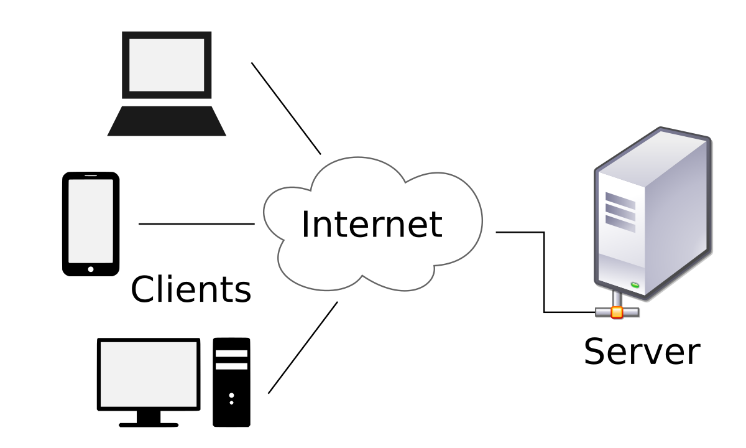

The client–server model is a distributed application structure that partitions tasks or workloads between the providers of a resource or service, called servers, and service requesters, called clients

