**CHAPTER-1.0**

**INTRODUCTION**

* 1. **Characteristics of existing system**
  2. **Overview of proposed system with advantages**
  3. **Scope**
  4. **INTRODUCTION**
  5. **Characteristics of existing system:**

Many organizations and institutions are using e-learning because it can be as effective as traditional training at a lower cost. Developing e-learning is more expensive than preparing classroom materials and training the trainers, especially if multimedia or highly interactive methods are used. However, delivery costs for e-learning (including costs of web servers and technical support) are considerably lower than those for classroom facilities, instructor time, participants’ travel and job time lost to attend classroom sessions. E-learning can offer effective instructional methods, such as practicing with associated feedback, combining collaboration activities with self-paced study, personalizing learning paths based on learners’ needs and using simulation and games. Further, all learners receive the same quality of instruction because there is no dependence on a specific instructor.

.

* **DISADVANTAGES:-**
* The design and development of a course by e-learning require more labour than actual courses.
* Teachers are required more effort, because they are going to receive different doubts from different students.
* It´s required a good instructional design. • Human contact between students and professors missing.
* E-learning changes the habitual form to work in a course. This system requires self-discipline, regulation of the time, etc from the students.
* Abandon, as in other modalities of distance education, can reach a high level.

**1.2Overview of proposed system with advantages:-**

E-Learning is the topic related to the virtualized distance learning by means of electronic communication mechanisms, specifically the internet. They are based in the use of approaches with diverse functionality (e-mail, web pages, forums, and so on) as a support of the process of teaching-learning. The cloud computing environment rises as a natural platform to provide support to e-learning systems and also for the implementation of data mining techniques that allow exploring enormous data bases generated from the formal process to extract the inherit knowledge, since it can be dynamically adapted by providing a scalable system for changes necessities along time.

.

* **ADVANTAGES:-**
* Student centered learning.
* Collaborative learning.
* Easy access to global resources.
* Experiential learning through multimedia presentations.
* Offer the opportunity to think about teaching in new ways.
* Instructor convenience.

**1.3Scope:-**

There is a huge scope of E-learning in India, especially for the Indian youths. E-learning has opened new avenues to education in India & has changed the dynamics of educational content. What seemed like a distant dream a few years back is India’s future today’s e-learning has surpassed challenges of reaching out to a varied audience, overcome the non-availability of adequately qualified teachers in rural India & making rich content available to an audience that was unreachable earlier. Today, with changing times, basic education is taught with a single computer in rural villages & has helped several children to get exposed to primary levels of education.

Many of the universities and colleges are conducting their course online and also certificated will be provided online. The e-learning scenario in India is still growing and at an experimental stage. India’s education policy has largely neglected the opportunity of benefiting from this technological revolution in education. E-learning is not only inexpensive, but also convenient. Yet there are huge digital divides which need to be bridged on an urgent basis. Indians however are more inclined to conventional methods of classroom training thus accepting e-learning is a major hindrance. Though, the corporate sector has imbibed e-learning in their business communication practices rather intelligently.

**Let’s look at some statistics made by the researchers:**-

1. E-learning is eco-friendly, according to a study by Britain's Open University, "eLearning courses consume 90% less energy on an average and produce 85% fewer CO emissions per student than classroom training".
2. 6 out of the top 10 outsourcing destinations are in India according to 2014 rankings released by Tholons (Tholons, 2014)
3. According to the 2014 Training Industry Report, more and more organizations are showing an **increasing focus on training**to close skill gaps, and activity. The report says that among the respondent organizations, 44% intend to purchase online learning tools and systems, 41% are looking into purchasing Learning Management Systems (LMSs), 37% plan on purchasing authoring tools/systems and 33% aim to purchase classroom tools and systems..
4. Revenue from the sale of eLearning reached $5.2 billion in 2011 and is expected to more than double to $11.5 billion by 2016.

ht 018. All

© Copyright 2018. A **CHAPTER-2.0**

**SYSTEM REQUIREMENTS SPECIFICATION**

* 1. **User characteristics**

**2.2 Functional requirements**

**2.3 Non functional requirements**

**2.0 Software Requirements Specification:-**

* 1. **User characteristics:-**
* **Admin:-**
* Admin will login to the site using his username and password
* Admin will view all registrations and logins of all clients and developers
* Admin can manage all categories and subcategories and can even add or modify a category
* Admin will approve all posts of clients before displaying them in the site
* Admin will manage all results of all the posts
* Admin will view all the feedbacks and complaints and reply if he feels.
* **User:-**
* User will register using his personal information like name, email, DOB, mobile no, gender etc.
* User will login using his username and password
* User will choose a particular category as per their requirements.
* User will view all post.
* User can give any feedbacks, comments or complaints to the site.
  1. **Functional Requirements:-**

A functional requirement document defines the functionality of the system or one of its subsystems. It so depends upon the type of software, expected users and the type of system where the software is used. A function is nothing but inputs, its behavior, and outputs. It can be a calculation, data manipulation, user interactions, or any other specific

Functionality which defines what function a system is likely to perform. The following are the key fields, which should be the part of functional requirement:-

1. Purpose of the document
2. Scope
3. Data integration
4. Security requirements
5. Performance
6. Certification requirement
7. Administrative functions

These above are the functional requirement. In this the Data Integrity is the process in which heterogeneous data is retrieved and combined as an incorporated form and structure. Data integration allows data types (such as data sets, documents and tables) to be merged by users, organizations and applications. Data integration is generally implemented in data warehouses through specialized software that holds large from internal and external

Resources. The confirmation is often, but not always, provided by some form of external review, education, assessment or in a specific organizations process of certification. There is a huge scope of E-learning in India, especially for the Indian youths. E-learning has opened new avenues to education in India & has changed the dynamics of educational content. What seemed like a distant dream a few years back is India’s future today’s e-learning has surpassed challenges of reaching out to a varied audience, overcome the non-availability of adequately qualified teachers in rural India & making rich content available to an audience that was unreachable earlier. Today, with changing times, basic education is taught with a single computer in rural villages & has helped several children to get exposed to primary levels of education.

* 1. **Non functional Requirements:-**

The definition for a non functional requirement is that it essentially specifies how the system should behave and it is a constraint upon the systems behavior. One could also think of non-functional requirements as quality attributes for of a system. Non functional requirements cover all the remaining requirements which are not covered by the functional requirements. Some typical non functional requirements are as follows:-

1. Performance – for example Response Time, Throughput, Utilization
2. Scalability
3. Capacity
4. Availability
5. Reliability
6. Recoverability
7. Maintainability
8. Serviceability
9. Security
10. Environmental

The importance of non functional requirements is therefore not to be trifled with. One way of ensuring that as few as possible non functional requirements are left out is to use non functional requirement groups, which will give you four of the main groups to use. Non functional requirements are often called quality attributes of a system. Other terms for non functional requirements are qualities, quality goals, and quality of service requirements, constraints, and non behavioral requirements. These above are the non functional requirements.

**CHAPTER-3.0**

**SYSTEM ANALYSIS MODELLING-USER BASED**

* 1. **Feasibility study of the new system**
  2. **User-based modeling**

**3.2.1 Use-case diagrams**

**3.0 System analysis and modeling- User based**

**3.1 Feasibility study of the new system**

A feasibility study assesses the operational, technical and economic merits of the proposed project.The feasibility study are a management-oriented activity. The objective of a feasibility study is to find out if an information of project can be done and to suggest possible alternative solutions.

* **Types of feasibility:**-

1. Technical feasibility
2. Economic feasibility
3. Operational feasibility
4. **Technical Feasibility:-**

It considers the technical requirements of the proposed project. The technical requirements are then compared to the technical capability of the organization. The systems project is considered technically feasible if the internal technical capability is sufficient to support the project requirements.

The analyst must find out whether current technical resources can be upgraded into a manner that fulfils the request under consideration. This is where the expertise of system analysts is beneficial, since using their own experience and their contact with vendors; they will be able to answer the question of technical feasibility.

The essential questions that help in testing the technical feasibility it includes the following:-

* Is the project feasible within the limits of current technology?
* Does the technology exist at all?
* Is it available within gives resource constraints?
* Manpower – programmers, testers & debuggers
* Software and hardware
* Are the current technical resources sufficient for the new system?
* Can they be upgraded to provide the level of technology necessary for the new system?
* Can the technology be easily applied to current problems?
* Does the technology have the capacity to handle the solution?
* Do we currently possess the necessary technology?

1. **Operational Feasibility:-**

Operational feasibility is dependent on human resources available for the project and involves projecting whether the system will be used if it is developed and implemented. To ensure success, desired operational outcomes must be imparted during design and development. These include design-dependent parameters such as reliability, maintainability, supportability, usability, sustainability, and affordability. it measures how well your company will be able to solve the problems and can take the advantage or opportunities that are presented during the course of the project

**3. Economic Feasibility:-**

. This assessment typically involves a cost/ benefits analysis. Economic analysis could also be referred to as cost/benefit analysis. It is the most frequently used method for evaluating the effectiveness of a new system. The economic feasibility study is more commonly called the cost benefit analysis.

Possible questions raised in economic analysis are:

* Estimated cost of hardware
* Estimated cost of hardware/software development
* Is the project possible, given the resource constraints?

Economic analysis is used for evaluating the effectiveness of the proposed system. The exact costs are not required to determine economic feasibility. It is only required to determine if it is feasible that the project costs will fall within the target budget or return on investment. A rough estimate of the project schedule is required to determine if it would be feasible to complete the system’s project within a required timeframe. The required timeframe would need to be set by the organization.

**3.2User-based modeling:-**

**3.2.1Use-case Diagrams:-**



Fig 3.2.1:- Use case Diagram

**CHAPTER-4.0**

**SYSTEM ANALYSIS AND DESIGN-DATA-BASED**

* 1. **Data modeling**

**4.1.1 Data dictionary**

**4.1.2 E-R diagram**

**4.2 Behavioral Modeling**

**4.2.1 Data flow diagram**

**4.2.1.1 Context Level**

**Diagram (Level 0)**

**4.2.1.2 DFD-Level 1**

**4.2.1.3 DFD-Level 2**

**4.0 System Analysis and Design- Data base:-**

**Table 4.1: Registration-User**

**4.1 Data modeling:-**

**4.1.1Data dictionary:-**

**Registration-Company**

|  |  |  |
| --- | --- | --- |
| Fieldname | Data type | Constraint |
| Cid | Varchar2 | Primary |
| Email-id | Varchar2 | Unique |
| Name | Char | Not Null |
| Company Name | Char | Not Null |
| Mobile no. | Number | Not Null |
| Address | Varchar2 | Not Null |
| Year | Number | Not Null |
| Certificate |  | Unique |

**Resume**

|  |  |  |
| --- | --- | --- |
| Fieldname | Data type | Constraint |
| Rid | Varchar2 | Primary |
| Uid | Varchar2 | Foreign |
| Name | Varchar2 | Not Null |
| Resume |  | Not Null |

**Post-Details**

|  |  |  |
| --- | --- | --- |
| Fieldname | Data type | Constraint |
| Pid | Varchar2 | Primary |
| Cid | Varchar2 | Foreign |
| Vacancy | Number | Not Null |
| Title | Varchar2 | - |
| Description | Varchar2 | - |
| Cat-id | Varchar2 | Foreign |
| Sid | Varchar2 | Foreign |
| Experience | Number | Not Null |
| Salary | Number | - |
| Address | Varchar2 | - |
| Company_Email-id | Varchar2 | Not Null |
| Company_Person | Varchar2 | Not Null |
| Company_Mob-no | Number | Not Null |

**History**

|  |  |  |
| --- | --- | --- |
| Fieldname | Data type | Constraint |
| Hid | Varchar2 | Primary |
| Cid | Varchar2 | Foreign |
| Uid | Varchar2 | Foreign |
| Pid | Varchar2 | Foreign |
| Re-id | Varchar2 | Foreign |

**Question**

|  |  |  |
| --- | --- | --- |
| Fieldname | Data type | Constraint |
| Qid | Varchar2 | Primary |
| Q-title | Varchar2 | Not Null |
| Q-Description | Varchar2 | - |

**Answer**

|  |  |  |
| --- | --- | --- |
| Fieldname | Data type | Constraint |
| Aid | Varchar2 | Primary |
| Qid | Varchar2 | Foreign |
| A-Description | Varchar2 | - |

**Category**

|  |  |  |
| --- | --- | --- |
| Fieldname | Data type | Constraint |
| Cat-id | Varchar2 | Primary |
| Cat-name | Varchar2 | Not Null |

**Sub-Category**

|  |  |  |
| --- | --- | --- |
| Fieldname | Data type | Constraint |
| Sid | Varchar2 | Primary |
| Cat-id | Varchar2 | Foreign |
| S-name | Varchar2 | Not Null |

**Feedback**

|  |  |  |
| --- | --- | --- |
| Fieldname | Data type | Constraint |
| Fid | Varchar2 | Primary |
| Cid | Vachar2 | Foreign |
| Uid | Vachar2 | Foreign |
| Reviews | Varchar2 | - |
| Date | Varchar2 | - |

**Result**

|  |  |  |
| --- | --- | --- |
| Fieldname | Data type | Constraint |
| Re-id | Varchar2 | Primary |
| Pid | Varchar2 | Foreign |
| Uid | Varchar2 | Foreign |
| Re-name | Varchar2 | Not Null |

**4.1.2 E-R (Entity Relationship) Diagram:-**

An entity-relationship diagram (ERD) is a data modeling technique that graphically illustrates an information system's entities and the relationships between those entities. An ERD is a conceptual and representational model of data used to represent the entity framework infrastructure.

**4.2 Behavioral modeling:-**

**4.2.1 Data flow diagram:-**

**4.2.1.1 Context Level Diagram (Level 0)**



**4.2.1.2 DFD level-1**

**4.2.1.3 DFD level-2**





**CHAPTER-5.0**

**SYSTEM DESIGN-UML**

* 1. **Sequence diagrams**
  2. **Activity diagrams**

**5.1 Sequence Diagram:-**

Sequence Diagrams are interaction diagrams that detail how operations are carried out. They capture the interaction between objects in the context of a collaboration. Sequence Diagrams are time focus and they show the order of the interaction visually by using the vertical axis of the diagram to represent time what messages are sent and when.

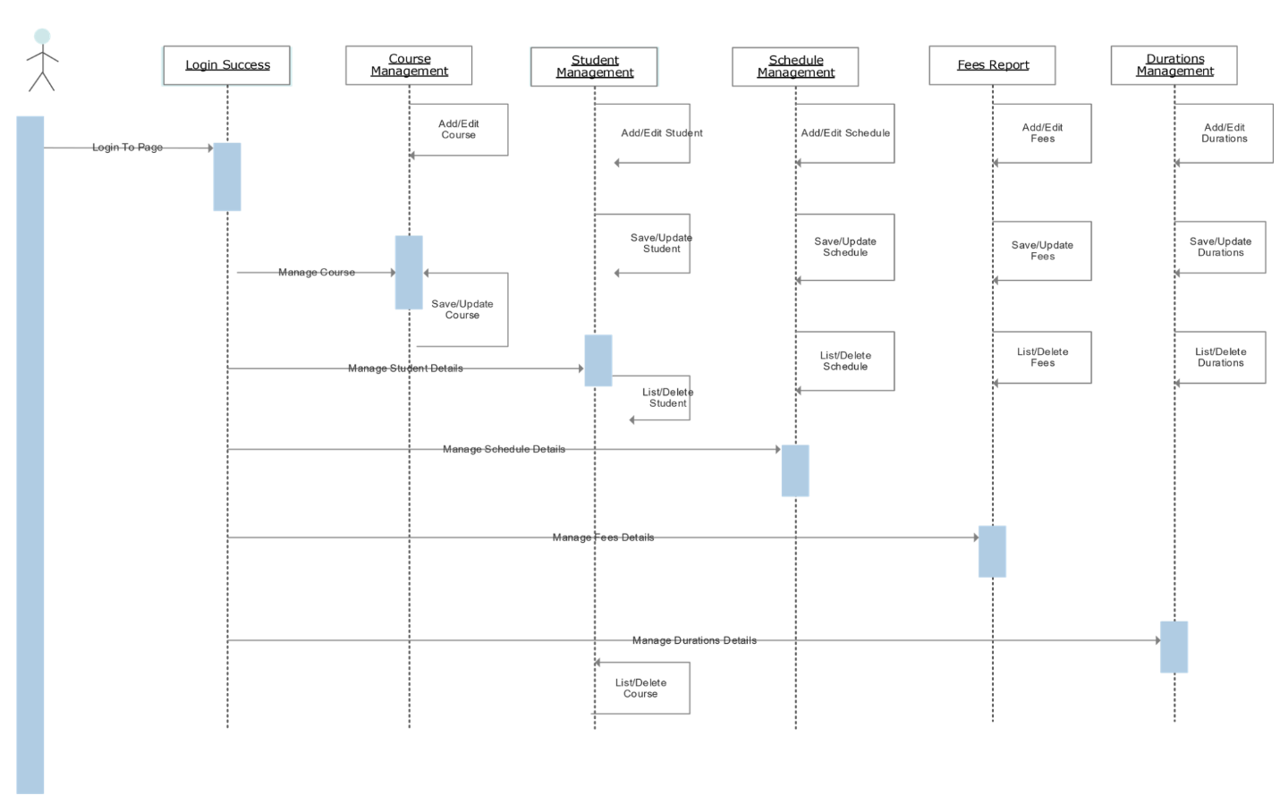

**5.3 Activity Diagram:-**

Activity diagram is another important diagram in UML to describe the dynamic aspects of the system. Activity diagram is basically a flowchart to represent the flow from one activity to another activity. The activity can be described as an operation of the system. The control flow is drawn from one operation to another.



**5.3Class Diagram:-**

Class Diagram in the Unified Modeling Language (UML) is a type of static structure diagram that describes the structure of a system by showing the systems classes, their attributes, operations (or methods), and the relationships among objects.Class Diagrams are the main building blocks of every object oriented methods.  
 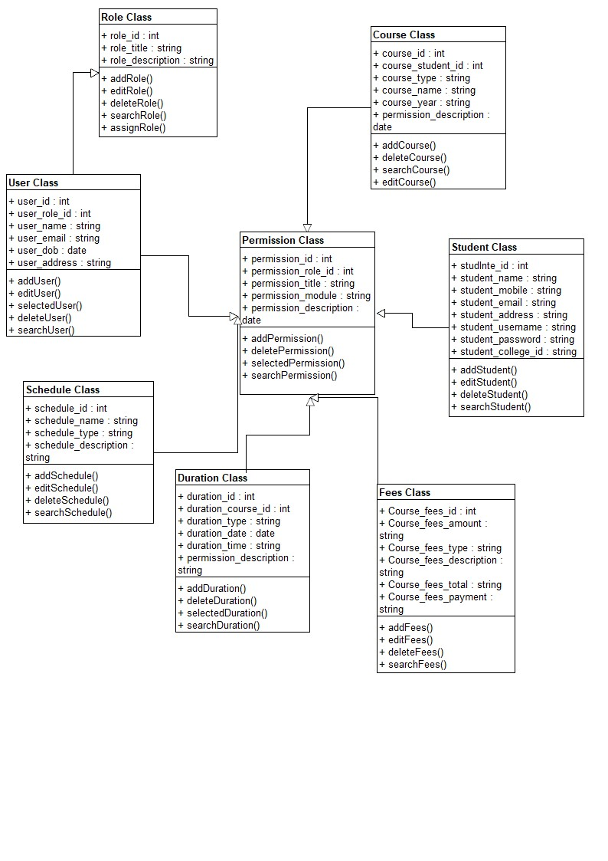

**CHAPTER-6.0**

**SYSTEM INTERFACE DESIGN**

* 1. **Input-Output forms design**
  2. **Graphical user interface design**

**6.1 Input-Output forms design:-**

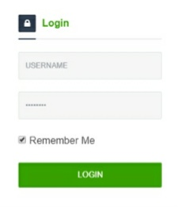

* 1. **Graphical user interface design:-**

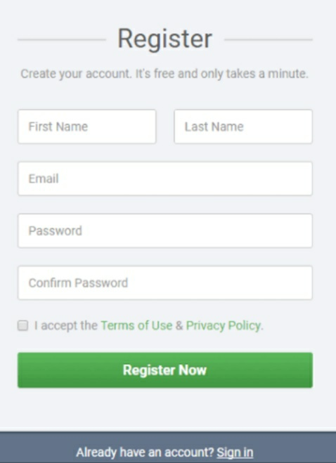

* **References:-**
  + Fundamental of Software Design Author, Publication
  + Beginner of Android (wei-meng lee)
* **Bibliography:-**