Changes

1. Link for sheet05 changes - <https://github.com/BrijeshKaria/JSAttendanceSystem/commit/8f7710d2dfeca610a8bc99281ce4d7976d102429#diff-98a7444632423bedb298e1d8d2d5fb93>
2. Add span style
   1. 
3. Add javascript
   1. 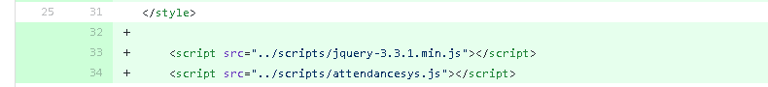
4. Update body onload
   1. 
5. Update table id
   1. 
6. Add Button to save changes
   1. 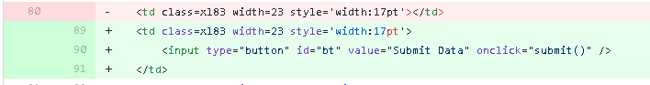
7. Find month td and set id
   1. 
8. Find <div contenteditable="" ></div> and replace it with <input id="Checkbox1" type="checkbox" value="A" onchange="updatecount(this)" /><span class="palabel"></span>