**Mineral Security in India’s Agriculture Sectors**

India’s agricultural sector—on which over 60% of the population depends directly or indirectly—relies heavily on the uninterrupted supply of mineral-based fertilizers. This dependency exposes a critical vulnerability: in 2023 alone, India imported over 18 million tonnes of key fertilizer minerals, with import reliance ranging from 50% to 100% across major inputs. The implications are twofold—a significant economic strain, reflected in the fertilizer subsidy bill reaching ₹2.25 lakh crore in FY2023–24, and a growing food security risk if global supply chains are disrupted (MoF, Union Budget 2024–25, Expenditure Statement; FAI, 2024).

India’s mineral security in agriculture is thus not merely a question of cost or logistics—it is deeply tied to agronomic productivity, ecological resilience, and the safeguarding of national food sovereignty. This security hinges on the consistent availability of mineral fertilizers and micronutrients that correct soil deficiencies, improve crop health, and enhance yields. However, for each of these minerals, India faces a distinct set of challenges spanning resource scarcity, technological gaps, import dependencies, and policy weaknesses. This paper discusses the mineral-specific value-chains, impediments and recommendations for phosphorus, potash, selenium, zinc, sulphur, and boron.

Fertilizer Demand vs Domestic Resource Availability 2024

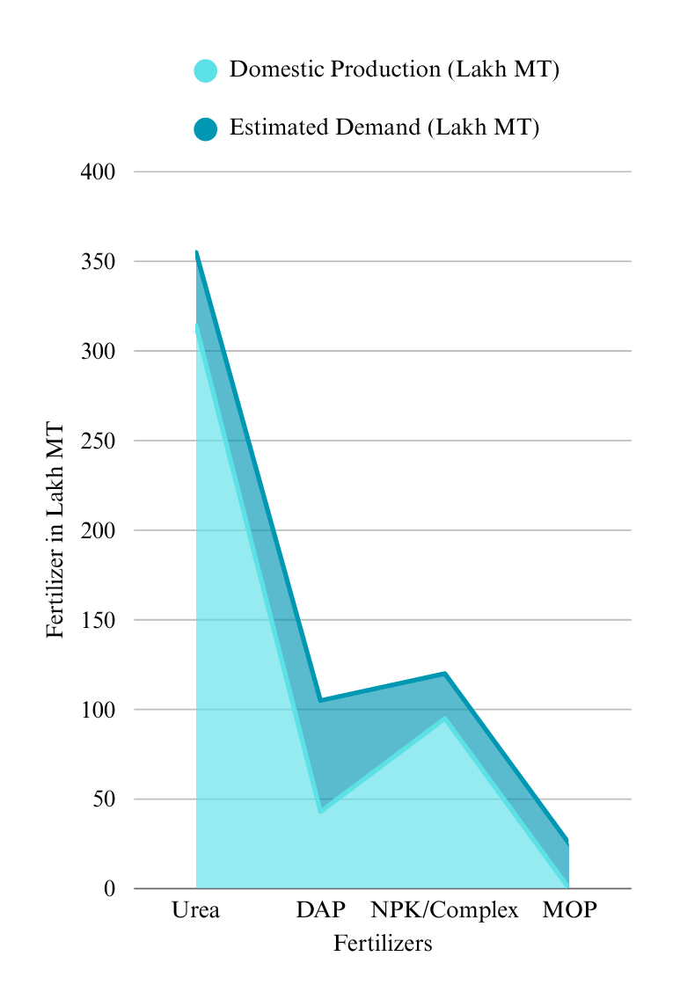

*Source : Fertilizer India*

**India’s Current Global Value Chains**

**Phosphorus (as Rock Phosphate and Phosphoric Acid)**

India is one of the world’s largest consumers of phosphate fertilizers but is heavily dependent on imports due to the limited quality and quantity of domestic rock phosphate reserves. In 2022–23, India imported approximately 9.8 million metric tonnes of rock phosphate and 2.8 million tonnes of phosphoric acid, mainly from Morocco, Jordan, Egypt, and Israel (Fertiliser Association of India, 2024). Domestic production, centered around states like Rajasthan, Madhya Pradesh, and Uttar Pradesh, contributed only around 1.4 million tonnes of low-grade rock phosphate, insufficient to meet the requirements of the 12.4 million tonnes demanded annually by the fertilizer sector (IBM Yearbook, 2024, Chapter 7, p.4).

Morocco has emerged as the single most important supplier due to its control over nearly 70 percent of global reserves. In a strategic move to mitigate long-term risk, India signed an MoU with Morocco’s OCP Group in January 2023 to jointly develop a fertilizer plant in India and secure 1.2 million tonnes of annual phosphoric acid supply under a long-term contract (MEA, 2023). However, access to Moroccan phosphate is influenced by global market volatility and price manipulation risks, given the country’s quasi-monopoly.

India is also exploring cooperation with Senegal and Togo, which together exported around 1.1 million tonnes of rock phosphate in 2023, primarily to European buyers (UN Comtrade, 2024). India’s diplomatic overtures toward Francophone West Africa, under the India-Africa Forum Summit mechanism, may ease access in the coming years.

**Potash (Potassium Chloride)**

Potash is another mineral where India is almost entirely import dependent. Annual domestic demand exceeds 4.5 million tonnes, with over 95 percent met through imports from Canada, Belarus, Israel, and Jordan. India signed a long-term supply contract with Canpotex, the Canadian potash consortium, in April 2023 to secure 1.5 million tonnes annually at a benchmark price of USD 422 per tonne (Ministry of Chemicals and Fertilizers, 2023). However, this relationship is increasingly fraught due to Canada’s pivot towards critical mineral alliances with the U.S. and EU, raising concerns about future prioritization.

India’s earlier reliance on Belarusian potash, nearly 20 percent of imports in 2020, has declined due to Western sanctions post-Ukraine war. This geopolitical bottleneck has left India exposed to higher prices and longer transit routes via the Suez Canal and Middle East.

While domestic production remains unviable due to geological constraints and deep-seated deposits, India is engaging with Israel Chemicals Ltd (ICL) and Jordan’s Arab Potash Company (APC) under G2G frameworks, including visits by ministerial delegations in late 2023. Yet, competition from European and East Asian buyers remains intense.

**Selenium**

Selenium is not produced as a primary mineral but is recovered as a byproduct from copper refining. India has minimal domestic production capacity; trace quantities of selenium are extracted from anode slimes in copper smelters operated by Hindustan Copper Ltd (HCL) and Hindalco. However, this is inadequate, with India importing roughly 220 tonnes annually, primarily from Japan, South Korea, and Germany (Volza, 2024).

Global recovery of selenium is concentrated in copper-refining countries with advanced recycling infrastructure, particularly Japan and South Korea. In 2022, India signed a technology collaboration agreement with JX Nippon Mining to explore selenium recovery from Indian copper smelters using Japanese leaching techniques (Ministry of Mines, 2022).

However, selenium exports are tightly controlled due to its strategic uses in electronics and solar industries. Moreover, India lacks participation in key multilateral forums that govern selenium trade standards. Current supply agreements are based on annual renewals, without the benefit of long-term security-of-supply contracts. This makes India highly susceptible to price fluctuations and export restrictions.

**Other Critical Minerals: Sulphur, Zinc, Boron**

* **Sulphur**: India imported over 4 million tonnes of elemental sulphur in 2023, used for sulphuric acid in phosphate fertilizer production (IBM Yearbook, 2024, Chapter 6, p.3). Imports originate mainly from Saudi Arabia and the UAE, which supply over 60 percent of India’s requirements. These are stable relationships underpinned by strong energy sector ties, but no mineral-specific MoUs exist, leaving supply vulnerable to shipping and energy market disruptions.
* **Zinc**: Domestic production of zinc is led by Hindustan Zinc Ltd, which meets over 80 percent of the country's needs. However, fertilizer-grade zinc, required in micro-nutrient form, is still partly imported, especially from South Korea and China. India has yet to establish preferential value-chain partnerships for micronutrient-grade zinc.
* **Boron**: India lacks boron reserves. In 2023, over 80 percent of boron imports came from Turkey and the United States. While Turkey’s Eti Maden is a major global supplier, India does not have a dedicated G2G agreement, unlike China, which has a long-term boric acid supply contract. This creates an asymmetry in access.

**Mineral-Specific Challenges for India’s Agricultural Sector**

**Phosphorus**

India’s phosphorus deficit is rooted in its limited endowment of high-grade rock phosphate. In 2023–24, India consumed approximately 8 million tonnes of phosphorus (as P₂O₅) for agricultural purposes, yet domestic rock phosphate production stood at only 3.2 million tonnes, much of it sub-grade with P₂O₅ content less than 17% (IBM Yearbook, 2024, Chapter 13, p.4).

Over 60% of the required phosphate rock or phosphoric acid is imported, mainly from Jordan, Morocco, Egypt, and Saudi Arabia. This gap leaves the domestic DAP and SSP industries exposed to global price fluctuations. Moreover, India’s beneficiation technologies remain outdated, with only a handful of integrated plants capable of treating low-grade phosphate ores. Despite the MoU signed with Morocco’s OCP Group in 2022 for assured supply of 1 million tonnes of phosphate derivatives annually, logistical and processing constraints have hindered domestic absorption (PIB, 2023).

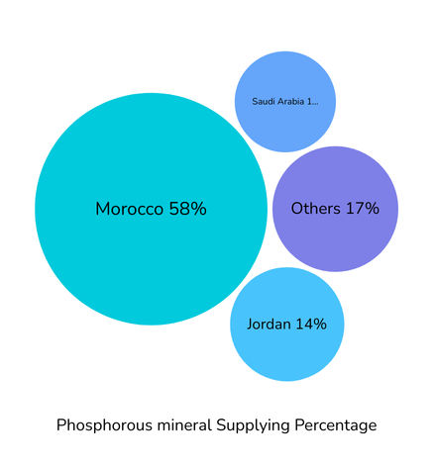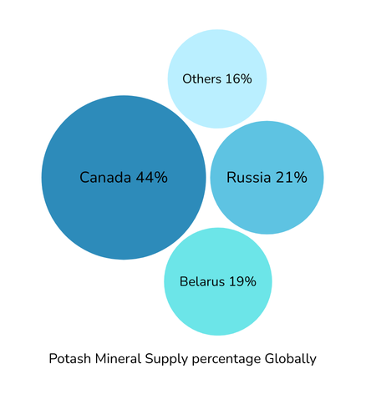

**Potash**

India imports 100% of its potash requirements due to the absence of economically viable potash reserves. In 2023, India imported 4.4 million tonnes of Muriate of Potash (MOP), with Canada (Nutrien), Russia (Uralkali), and Belarus (Belaruskali) being the top suppliers (FAI, 2024). These three countries accounted for more than 80% of India’s MOP imports. The geopolitical concentration of suppliers poses a persistent strategic risk. During the 2022 sanctions against Belarus, India’s potash procurement costs rose by nearly 80%, resulting in a ₹10,000 crore increase in fertilizer subsidy allocation (MoF, 2023). India’s exploration of potash from seawater and deep aquifers in Gujarat and Rajasthan is ongoing, but progress has been slow due to technical challenges and low concentrations (IBM Yearbook, 2024, Chapter 13, p.7). Additionally, India has no known reserves of sulphate of potash (SOP), critical for chloride-sensitive crops such as potato, tobacco, and citrus fruits**.**

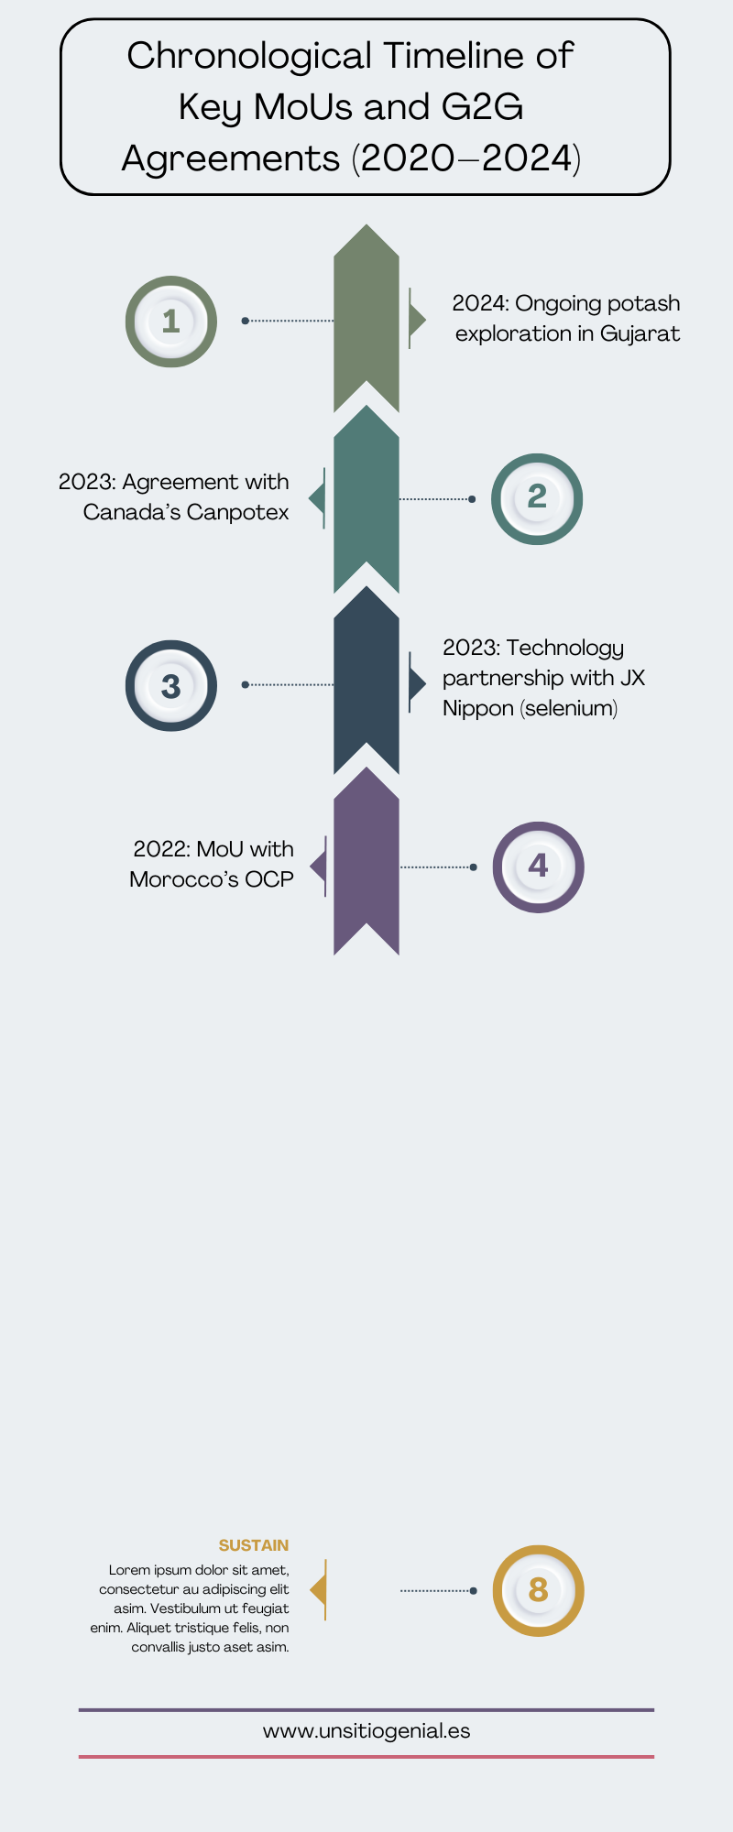

**Selenium**

Although required in trace quantities, selenium plays a growing role in Indian agriculture as a soil amendment and micronutrient for biofortified crops. India imported 516 tonnes of selenium in 2023, largely from Japan, South Korea, and Germany (WITS, 2024). Selenium is primarily recovered as a byproduct from copper refining and has limited global production centres, concentrated in East Asia and Europe. India currently lacks any selenium recovery infrastructure from domestic smelting operations, such as those at Hindustan Copper Ltd or Sterlite Industries. Furthermore, selenium’s use in agriculture remains under-researched domestically. The ICAR-Indian Institute of Soil Science has initiated pilot studies on selenium biofortification in lentils and maize, but there are no standards for selenium fertilizer blends under India’s Fertilizer Control Order (FCO) (ICAR-IISS, 2023).

**Zinc**

India is the third-largest consumer of zinc-based fertilizers, driven by increasing zinc deficiency in soils, particularly in rice- and maize-growing areas. In 2023, India consumed approximately 2.8 million tonnes of zinc sulphate, with about 45% met through imports from China, South Korea, and Australia (FAI, 2024). While Hindustan Zinc Ltd (HZL) is a global leader in zinc production, only a small fraction of its output is diverted to agriculture-grade products. Zinc sulphate monohydrate and heptahydrate production in India suffers from high costs due to inefficient recovery technologies and low product purity. The lack of integrated value chains between base metal producers and fertilizer manufacturers results in supply disruptions and underutilization of domestic capacity.

**Sulphur**

India imported approximately 5 million tonnes of elemental sulphur and sulphuric acid in 2023, sourced mainly from Saudi Arabia, the UAE, and Qatar, where sulphur is recovered as a byproduct of oil and gas refining (IBM Yearbook, 2024, Chapter 13, p.3). The usage of sulphur in Indian agriculture is rising due to soil acidification and the widespread adoption of sulphur-responsive crops like oilseeds and pulses. Despite this demand, domestic sulphur recovery remains inadequate, especially from private-sector oil refiners who lack incentives to refine sulphur to fertilizer-grade purity. The Fertilizer Control Order does not mandate sulphur content reporting in all NPK blends, leading to uneven adoption across states.

**Boron**

India’s boron requirement, though small in volume, is critical for crop quality, especially in fruits, vegetables, and sugarcane. India imported around 6.6 tonnes of boron compounds in 2023, mostly in the form of borax and boric acid from Turkey, Chile, and the United States (WITS, 2024). India lacks economically viable boron deposits, and attempts at extracting boron from fly ash and waste gypsum have shown limited success. Boron deficiency affects nearly 19% of India’s cultivated soils (ICAR-NBSS&LUP, 2023), and its erratic supply results in sub-optimal application by farmers. Moreover, no public-sector entity currently maintains buffer stocks of boron fertilizers, increasing price and availability volatility at the farmgate.

**Mineral-Wise Recommendations**

This section outlines tailored strategies to enhance India’s resilience across the fertilizer mineral value chain. For each mineral, the recommendations are divided into three domains: (1) strengthening supply chains, (2) identifying alternate chemistries or substitutes, and (3) deploying innovative technologies in discovery, processing, and downstream use.

**Phosphorus**

**Alternate Chemistries**  
Phosphorus solubilizing bacteria (PSB), such as *Bacillus megaterium* and *Pseudomonas fluorescens*, have demonstrated the ability to enhance phosphorus availability from fixed soil pools. Field trials in Punjab and Andhra Pradesh under the National Bio-fertilizer Mission have shown 15–20% yield gains with 30% reduced DAP use (ICAR-IISS, 2022). India should commercialize consortium-based biofertilizers combining PSB and mycorrhizal fungi.

**Technological Alternatives**  
Advanced beneficiation technologies such as flotation and calcination should be deployed at existing rock phosphate mines in Madhya Pradesh and Rajasthan. Phosphorus recovery from urban sewage sludge and agro-industrial waste (struvite crystallization) has proven effective in Germany and Japan and could be piloted in Indian urban municipalities (FAO, 2023).

**Strengthening Supply Chains**  
India must intensify bilateral partnerships with phosphorus-rich countries. The 2022 MoU with Morocco’s OCP Group to supply 1 million tonnes of phosphate annually should be expanded to include joint ventures in beneficiation and acidulation units in India. Jordan’s Arab Potash Company and Saudi Arabia’s Ma’aden should also be engaged for long-term rock phosphate supply under sovereign guarantees. Establishing strategic reserves of phosphate fertilizers is essential to insulate against global price shocks (PIB, 2023).

**Potash**

**Alternate Chemistries**  
Potassium-mobilizing biofertilizers (KMBs), particularly strains of *Frateuria aurantia*, have shown potential in maize and sugarcane cultivation in Tamil Nadu and Maharashtra. The ICAR-All India Coordinated Research Project on Biological Inputs reported a 25% improvement in potassium uptake (ICAR AICRP, 2023).

**Technological Alternatives**  
Extraction of potash from seawater brine and lake residues using solar evaporation, as practiced in China’s Qinghai Lake, should be explored in Gujarat and Tamil Nadu. Additionally, fluidized bed reactors for producing sulphate of potash (SOP) from polyhalite or kainite can be piloted in Indian fertilizer complexes.

**Strengthening Supply Chains**  
India must reduce its dependency on the Canada-Russia-Belarus triad by diversifying to alternative sources such as Laos and Chile, which together hold over 5% of global reserves. India should pursue offtake agreements with Compass Minerals (Chile) and deploy the Ministry of External Affairs’ Economic Diplomacy Division to negotiate port-to-port contracts. India’s deep-sea exploration of potash in the Rann of Kutch must be accelerated with technology from Israel and Australia.

**Selenium**

**Alternate Chemistries**  
While there is no known agronomic substitute for selenium, India should investigate nano-selenium formulations that enhance bioavailability. Studies from Brazil’s EMBRAPA have demonstrated nano-selenium uptake in soybean plants with 30% lower doses than conventional forms (EMBRAPA, 2022).

**Technological Alternatives**  
Selenium recovery from spent anode slimes and e-waste processing residue should be integrated into India’s circular economy strategy. The EU’s SELREC program is a useful model for creating decentralized selenium extraction units within existing metallurgy parks (EU SELREC Report, 2023).

**Strengthening Supply Chains**  
India should seek G2G agreements with Japan and South Korea for assured selenium supply recovered as a by-product from copper refining. Indian copper smelters, including Hindustan Copper Ltd, should be incentivized through Viability Gap Funding (VGF) to establish selenium recovery units.

**Zinc**

**Alternate Chemistries**  
Chelated zinc formulations (e.g., Zn-EDTA) are more effective at lower doses and reduce leaching losses. The Fertilizer Control Order (FCO) should prioritize these under the Micronutrient Subsidy Scheme (MoA&FW, 2023).

**Technological Alternatives**  
Hydrometallurgical zinc recovery from tailings and zinc-rich slags, as piloted in South Korea, could be adapted at Udaipur’s waste zinc stockpiles. Biochar-based zinc delivery mechanisms should also be trailed, building on successful trials by CSIR-IHBT (2022).

**Strengthening Supply Chains**  
India must mandate a minimum of 10% of Hindustan Zinc’s annual output be diverted to agriculture-grade zinc sulphate under public-private coordination. Joint ventures with global zinc fertilizer companies like Yara International or Mosaic could improve product formulation standards and access to high-efficiency coatings.

**Sulphur**

**Alternate Chemistries**  
Elemental sulphur is often underutilized due to poor bioavailability. Sulphur-oxidizing bacteria (SOB) inoculants such as *Thiobacillus thiooxidans* can convert elemental sulphur into plant-available forms, improving uptake by 20–30% (ICAR-CRIDA, 2023).

**Technological Alternatives**  
India must invest in sulphur recovery units (SRUs) at oil refineries, adopting double absorption and catalytic reduction technologies like those employed at Petronas’ RAPID refinery (Malaysia). Sulphur-enhanced compost using city waste is another route to sustainable sulphur supplementation.

**Strengthening Supply Chains**  
Sulphur procurement must be institutionalized through public-sector offtake agreements with refineries in Saudi Arabia, Qatar, and the UAE. The IOCL-RIL-ONGC consortium should also be mandated to upgrade sulphur recovery efficiency and offer consistent supply for fertilizer use.

**Towards Strategic Value Chain Diplomacy**

India’s agricultural mineral value chains remain highly import-dependent and exposed to geopolitical volatility. While MoUs with Morocco and Canada have helped partially secure phosphorus and potash, long-term bilateral frameworks remain underdeveloped for selenium, boron, and sulphur. A regional critical mineral security initiative, similar to the U.S.-led Minerals Security Partnership, should be considered. India could also align its fertilizer diplomacy with climate-resilient agriculture initiatives under G20 and Global Biofuel Alliance platforms. The current absence of a dedicated Fertilizer Mineral Security Mission hampers India’s ability to engage at scale and urgency with suppliers. A national strategy must now embed mineral-specific G2G frameworks into foreign policy, especially with Morocco, Israel, Canada, and Japan. This would support the dual objectives of food security and strategic autonomy in agriculture.