**Automobile Industry and Battery Applications**

The rapid shift toward electric vehicles (EVs) and next-generation battery technologies has made the automotive sector highly dependent on a secure, affordable supply of critical minerals—especially lithium, nickel, cobalt, graphite, and rare earth elements (REEs). These materials are essential for manufacturing high-performance batteries and electric drivetrains, directly impacting vehicle range, safety, and cost competitiveness.

For automakers and battery manufacturers, control over mineral supply chains and processing infrastructure is now a core strategic concern. Any disruption—whether from raw material shortages, processing bottlenecks, or geopolitical events—can halt production lines, drive up component costs, and threaten the industry's ability to meet regulatory emissions targets and consumer demand for EVs.

Geopolitical factors have become a major source of risk for automotive and battery manufacturers. Resource nationalism, export controls, and the concentration of refining capacity in a handful of countries—most notably China—translate into significant supply chain vulnerabilities. China’s dominance in the refining and processing of lithium, nickel, cobalt, graphite, and REEs has allowed it to impose export quotas, dual-license requirements, and outright bans that can suddenly curtail global supply and trigger price spikes of 20–30% in vital battery and magnet materials. These policies create acute strategic challenges for automakers and battery producers, forcing them to scramble for alternative sources, absorb higher costs, and face potential production delays that threaten profitability and market share.

This chapter analyzes the geopolitical dynamics surrounding each critical mineral relevant to this sector, highlights cross-cutting risks for the automotive and battery industry, and proposes actionable strategies for industry and policymakers to secure resilient, sustainable supply chains.

**Domestic Availability and India’s Current Value Chain  
  
Lithium**  
  
India recently discovered its first significant lithium reserves in Jammu and Kashmir’s Reasi district, marking a major milestone in its critical mineral strategy with inferred resources of 5.9 million tonnes in the Salal-Haimana area (PIB, 2024). Exploration continues in Rajasthan and Karnataka. Despite these discoveries, India remains import-dependent due to its underdeveloped lithium extraction infrastructure. In 2024, the auctioning process went unclaimed, prompting a re-auction in early 2025. Experts noted that the lack of detailed exploration reports was a key deterrent for potential bidders (Kumar, 2024). Detailed exploration is essential before initiating mining, especially to encourage private sector participation.

Preliminary AMD surveys in Karnataka’s Marlagalla-Allapatna area revealed approximately 1,600 tonnes of lithium resources in igneous rocks (Nadig, 2024). On August 2, 2023, Parliament passed a law allowing the government to auction and mine newly discovered lithium reserves. According to the Peterson Institute for International Economics (PIIE), this would position India as the sixth-largest holder of lithium resources—ahead of China. In February 2025, the Indian government launched the National Critical Mineral Mission, which includes tax relief measures like the elimination of import duties on non-ferrous metal scraps and critical mineral scraps, including cobalt powder and lithium-ion battery scraps (PIB, 2025).

From March 2023 to February 2024, India imported 54,402 lithium shipments from 3,139 exporters, reflecting 19% year-on-year growth (Volza, 2024). In February 2024 alone, 4,758 lithium shipments marked a 96% increase over the previous year. Through KABIL, India is exploring lithium in Argentina, with potential commercial production rights in five lithium brine blocks in Catamarca province (Guvvadi, 2024). India is also collaborating with Australia under the Critical Mineral Investment Partnership, involving three cobalt and two lithium projects, and has joined the US-led Minerals Security Partnership while pursuing opportunities in Chile and Bolivia.

**Cobalt**  
  
The Ministry of Mines classifies cobalt as both highly economically significant and at high supply risk. According to the Indian Bureau of Mines (IBM), India holds 44.91 million tonnes (ore) in reserves and resources, with 30.91 million tonnes located in Odisha alone (IBM Yearbook, 2024, Chapter 4, p. 2). Other identified reserves are in Singhbhum (Jharkhand), Kendujhar (Odisha), Jhunjhunu (Rajasthan), and the states of Nagaland and Madhya Pradesh. Despite these reserves, India has no primary cobalt production (IBM Yearbook, 2024, Chapter 4, p. 3).  
  
The rise of lithium-ion batteries has spurred a global surge in cobalt demand, reflected across various Indian industries. To meet domestic needs, public sector enterprise Hindustan Copper Ltd. (HCL) recovers cobalt from copper slags, but this remains limited. Consequently, India imports all its primary cobalt requirements. IBM reports that India’s main cobalt import partners include the US, Netherlands, Japan, Belgium, and Norway.  
  
These trade partners bring added value beyond supply. Countries like Japan and the US offer advanced technologies for refining and recycling cobalt, crucial for building a resilient and circular critical minerals supply chain. The recyclability of cobalt and access to processing infrastructure represent strategic advantages for long-term supply stability.  
  
The Netherlands exported $1.05 million worth of cobalt ore to India in 2023 (OEC Data, 2023) and is India’s fourth-largest investor. Bilateral trade between the two countries reached $27.582 billion in 2022–2023. The Hague Centre for Strategic Studies highlights the Netherlands’ strong R&D policies focused on circularity and sustainability in critical minerals—a model India could emulate. Along with Belgium, the Netherlands plays a key role in the global cobalt supply chain, backed by refining expertise and logistics infrastructure. Strengthening ties with the EU should be a priority in India’s critical minerals export and trade strategy.  
  
Japan, like India, has limited cobalt reserves and is heavily import-dependent. As a leader in electronics and automotive manufacturing, Japan relies on overseas cobalt supplies. In a strategic move to enhance domestic availability, Japan plans to begin deep-sea mining of cobalt and nickel in 2026 from a large deposit near the Ogasawara Islands, projected to meet its cobalt needs for the next 75 years (Aliyeva, 2024). India, in a similar push, has approved offshore mining for critical minerals to reduce external dependence and strengthen supply security.  
  
**Graphite**Graphite deposits have been reported across multiple Indian states, but economically significant reserves are concentrated in Chhattisgarh, Jharkhand, Odisha, and Tamil Nadu. According to the National Mineral Inventory (NMI), total reserves and resources as of 2020 stood at 211.62 million tonnes—with 8.56 million tonnes in the Reserves category and 203.6 million tonnes under Remaining Resources (IBM Yearbook, 2024, Chapter 14, p. 2). Of this, +40% fixed carbon resources total 2.91 million tonnes, while 10–40% fixed carbon resources stand at 43.98 million tonnes.

Arunachal Pradesh accounts for 36% of India’s graphite resources, followed by Jammu & Kashmir (29%), Jharkhand (9%), Odisha (9%), Madhya Pradesh (5%), and Tamil Nadu (4%). In terms of reserves, Tamil Nadu leads with 36%, followed by Odisha (33%) and Jharkhand (30%).

India’s graphite production in 2021 was 57,264 tonnes—a 61% increase over the previous year (IBM Yearbook, 2024, Chapter 14, p. 2). About 88% of this production came from three mines producing over 5,000 tonnes annually. Tamil Nadu was the top producer with 63% of total output, followed by Odisha. Key mining centres include Palamu district (Jharkhand); Nawapara and Balangir (Odisha); and Madurai and Sivagangai (Tamil Nadu). The Sarggipalli underground mine in Sambalpur, Odisha, operated by TP Mineral Industries, has yielded up to 40% fixed carbon. However, +40% fixed carbon graphite remains limited, highlighting the need for cost-effective beneficiation technologies for low-grade ore.

Disseminated deposits with 5–20% fixed carbon are found in Palamu (Jharkhand). Recent developments in silicon carbide graphite manufacturing aim to improve utilisation of lower-grade graphite, enabling smaller volumes with longer life cycles.

India imports graphite primarily from China, Madagascar, and Mozambique, with additional volumes from Germany and the US. Mozambique, a major natural graphite exporter, paused production at a large mine for four months in 2023 due to low prices caused by China’s overproduction of anodes, but operations resumed at a reduced rate. The US International Development Finance Corporation (USIDFC) provided a $150 million conditional loan to sustain operations (IEA 2024, p. 167).

In Madagascar, NextSource Materials, a Canadian company, owns the Molo Graphite Mine, one of the world’s largest and highest-grade graphite deposits. However, ongoing tensions between India and Canada—stemming from Canada’s pro-Khalistan posture—make future collaboration unlikely. India should therefore prioritise strengthening graphite supply ties with Madagascar. In 2023, Tanzania exported $4.61 million worth of graphite, with India as its second-largest destination ($101,000) (OEC Data, 2023).

**Nickel**  
  
In India, Hindustan Copper Ltd. (HCL) produces nickel sulphate as a by-product at its Ghatsila Copper Smelter in Jharkhand, where sulphide copper ore also contains trace quantities of nickel, gold, and cobalt (IBM Yearbook, 2024, Chapter 12, p. 3). HCL employs imported EMEW technology from Canada to recover LME-grade nickel from low-concentration spent electrolyte—an otherwise unfeasible process using conventional methods. HCL also uses an Acid Purification Unit (APU), also imported from Canada, which reduces liquid effluent and facilitates downstream nickel recovery. The company has an installed capacity of 390 metric tonnes to recover nickel sulphate.

Nicomet Industries Ltd., Goa, is another key domestic producer of nickel and its derivatives, with a reported annual capacity of 5,400 MTPA. Meanwhile, CSIR–National Metallurgical Laboratory (CSIR–NML) has developed India’s first holistic TRL-4 process for the extraction and separation of nickel from spent lithium batteries, expanding India’s potential for critical mineral recycling.

Despite these advancements, India’s nickel resource base—estimated at 189 million tonnes—remains underutilised due to economic, environmental, and technological constraints. India does not have a significant domestic nickel mining or processing industry, making it highly import-dependent. Imports are primarily used for the stainless steel industry, with the remainder allocated to the electronics and automotive sectors. HCL’s nickel recovery from copper refining waste is expected to moderately enhance domestic supply (IBM Yearbook, 2024, Chapter 12, p. 18).

India imports large volumes of nickel and nickel alloys, with major suppliers including China, Germany, and the United States. Indonesia has emerged as a dominant supplier of Nickel Pig Iron (NPI) and Class 1 nickel due to its significant processing capacities.

Between March 2023 and February 2024, India imported 55,206 shipments of nickel, reflecting a 6% growth over the previous year (Volza, 2024). Additionally, India imported $45.75 million worth of nickel waste and scrap totaling 4,223,010 kg, with key sources being Saudi Arabia, UAE, the US, Singapore, and Malaysia (World Integrated Trade Solutions, 2023).

**Rare Earth Elements**

In India, most REEs are found in monazite, a complex phosphate mineral present in beach and inland placer deposits. As of March 2021, monazite resource estimates stood at 12.73 million tonnes (IBM Yearbook, 2024b, Chapter 24, p. 2). These are located across the coastal regions of Kerala, Tamil Nadu, Odisha, Andhra Pradesh, Maharashtra, and Gujarat, and inland alluvium zones in Jharkhand, West Bengal, and Tamil Nadu. Key deposits include Chavara (Kerala), Manavalakurichi (Tamil Nadu), Bhimunipatnam (Andhra Pradesh), and Gopalpur (Odisha).

Indian Rare Earths Limited (IREL), under the Department of Atomic Energy, is the main public-sector enterprise overseeing mining and processing of beach sand minerals. In 2023, IREL announced plans to expand mining capacity by 400% within the next decade to support India’s clean energy transition. As global supply shocks increase, India will require a combination of domestic production expansion and strategic stockpiling to navigate the net-zero era. India currently imports heavy REEs, such as scandium and yttrium, primarily from China and the United States, with China dominating the global REE space.

In 2022, India imported REE compounds from China, Japan, Germany, South Korea, and the US (OEC, 2024). China’s 2010 export ban on REEs to Japan—triggered by tensions in the East China Sea—prompted Tokyo to launch a US$1.2 billion strategy to strengthen REE resilience, which included investments in efficient recycling technologies and domestic processing infrastructure (Terazawa, 2023). Since then, Japan has cut its dependence on China by 30% and halved its domestic REE consumption.

Given Japan’s advanced tech ecosystem and experience in REE circularity, India has an opportunity to deepen cooperation and reduce its reliance on Chinese imports. Japan has also launched deep-sea mining initiatives for REEs—an area where India currently lacks capacity. A strategic collaboration in this domain could provide India access to offshore resources and associated technologies.

South Korea and Germany, like Japan, have limited raw REE reserves and prioritize their domestic industries. However, their status as high-tech manufacturing economies makes them viable partners for India to advance processing technologies and build a domestic circular economy.

The United States holds major REE reserves, especially at the Mountain Pass mine in California. Strengthening US-India cooperation on critical minerals offers long-term benefits. However, growing US domestic demand for REEs—particularly for defense and advanced technology sectors—could limit export volumes. That said, US innovations in mining, processing, and recycling can help India develop its own REE value chain.

Different countries pose distinct opportunities and constraints: technology-rich countries often lack minerals, while resource-rich nations face hurdles in infrastructure and ESG compliance. Brazil, for instance, has significant REE potential but faces development barriers. India must strategically assess partners for technology transfer, sustainable sourcing, and secure supply chains.

**Mineral Specific Challenges**

**Lithium**

The lithium market, central to the automotive and battery industries, is experiencing significant volatility and regulatory complexity, with direct implications for electric vehicle (EV) supply chains and long-term industry planning. In February 2024, output at Australia’s Greenbushes—currently the world’s largest lithium mine—was reduced, and other major producers began reviewing their operations due to high operating costs (IEA, 2024, p. 124). As a result, production suspensions are becoming increasingly common, threatening the stability of lithium supply for battery manufacturers and automakers.

Since mid-2023, China has imposed stringent export controls on battery-grade lithium carbonate (Li₂CO₃) and lithium hydroxide (LiOH·H₂O) with purity of 99.5% or higher. Exporters must now secure both a license from the Ministry of Commerce (MOFCOM) and a technology license from the Ministry of Industry and Information Technology (MIIT). In late 2023, China expanded its list of restricted export technologies to include key cathode-precursor production processes, requiring additional licensing for overseas sales of critical lithium-processing equipment.

In February 2024, China raised export duties on semi-refined lithium carbonate (≤99.5% purity) from 5% to 10%. This policy discourages the export of minimally processed lithium and incentivizes domestic refiners to produce higher-purity compounds, further consolidating China’s control over the global lithium supply chain.

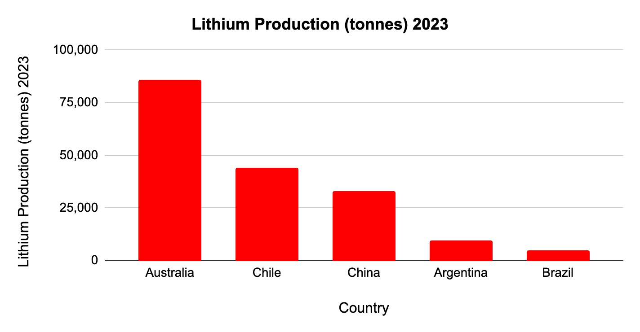

*Data source:* [*USGS Mineral Commodity Summary 2024.*](https://pubs.usgs.gov/periodicals/mcs2024/mcs2024-lithium.pdf)

The EV sector adds further pressure to pricing, as countries and companies with long-term offtake agreements face rising costs in domestic markets. Several integrated producers—including Australian hard rock miners at the lower end of the cost curve—are scaling back output (IEA, 2024, p. 124).   
  
According to S&P’s IRA data, new EV sales and battery chemistry are driving local raw material demand, with *metal requirements for EV batteries growing 28% annually*, spurred by IRS credits that boost local battery manufacturing. This, in turn, is expected to increase recycling capabilities as EVs reach end-of-life (S&P, 2023, p. 39).

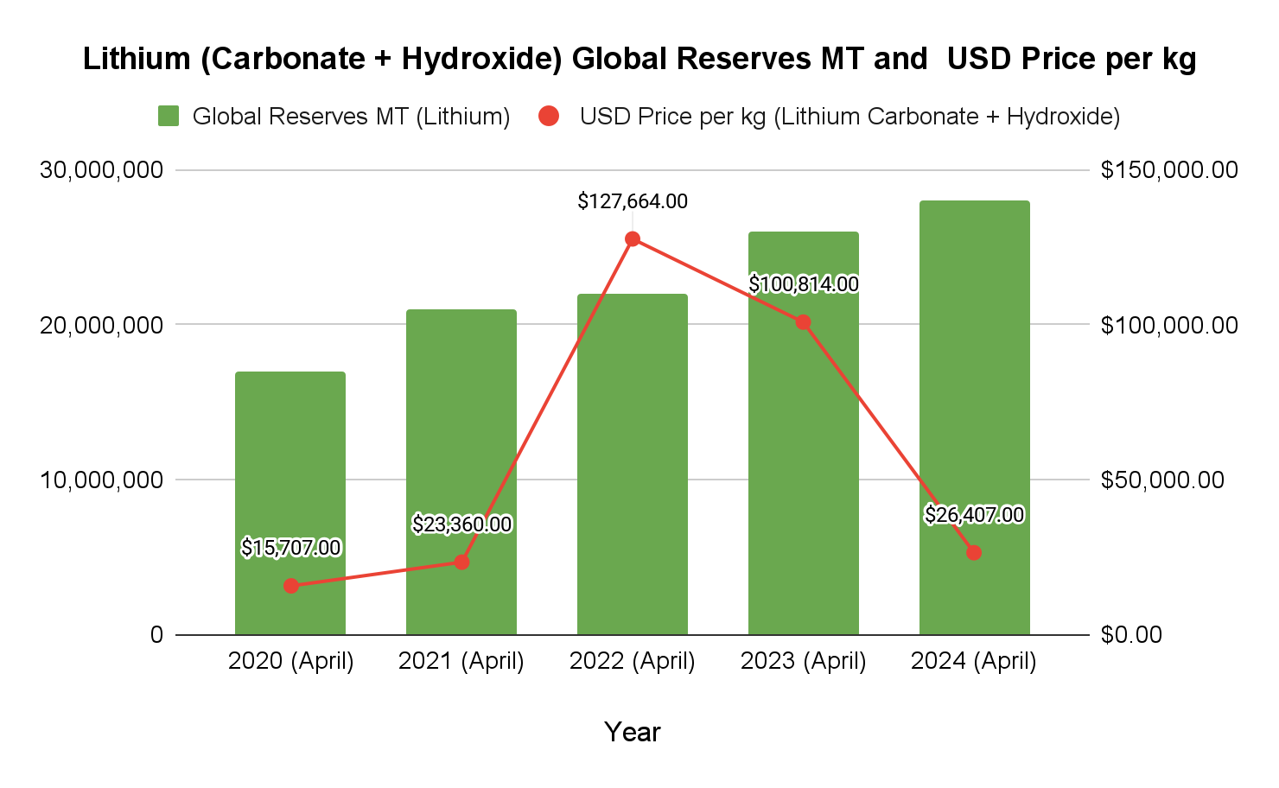

[*Data Source - Benchmark Minerals*](https://www.benchmarkminerals.com/lithium)

Resource nationalism is adding another layer of complexity. Countries like Chile and Bolivia have enacted stringent regulations on lithium mining and exports, restricting foreign access to their reserves. Bolivia, in particular, has nationalized its lithium industry, complicating foreign investment and contributing to upward pressure on global prices.

**Cobalt**

Cobalt’s long-term outlook is shaped by persistent oversupply and strategic maneuvering in the Democratic Republic of Congo (DRC), which dominates global production. Decades of overproduction have degraded ore quality and pushed up extraction costs, putting pressure on major mines like Glencore’s Mutanda, which now faces resource and investment constraints.   
  
While cobalt prices remain weak due to this glut, rising global demand from renewable energy and battery sectors is expected to gradually correct the market. However, supply growth is likely to be hampered by funding shortages, the entrenched DRC-China production monopoly, and Indonesia’s ongoing ban on cobalt exports.

China has exploited low prices by aggressively stockpiling cobalt, with MOFCOM now requiring export licenses for any shipment of cobalt sulfide, sulfate, or oxide concentrates with ≥99.5% purity. In 2023 alone, the Chinese government’s strategic reserves purchased 8,000 tonnes of cobalt, prompting the US to consider similar stockpiling measures. Further tightening the market, in January 2025, China’s Ministry of Industry and Information Technology (MIIT) added high-pressure acid leach (HPAL) and solvent extraction modules for cobalt-nickel mixed hydroxide precipitate (MHP) to its export control list, effectively blocking the export of these critical refining technologies without central approval.

The result is a volatile cobalt landscape: supply is constrained by regulatory barriers and monopolistic control, while demand is set to surge with the expansion of EV and battery manufacturing. For the automotive and battery industries, this means heightened supply chain risk, increased price volatility, and an urgent need to diversify sources and invest in recycling and alternative chemistries.

**Graphite**   
  
India’s graphite reserves are insufficient to meet its growing industrial demand, especially for high-purity graphite needed in lithium-ion batteries for EVs and electronics. Heavy reliance on Chinese graphite is a major strategic vulnerability. Since December 2023, China requires both export and technology licenses for graphite exports, including natural flake, purified flake, and spherical graphite. These licenses demand end-use declarations and environmental compliance. In October 2024, China further restricted exports by banning the transfer of graphite purification and spherical-graphite manufacturing technologies. This leaves India vulnerable to supply disruptions amid geopolitical tensions.

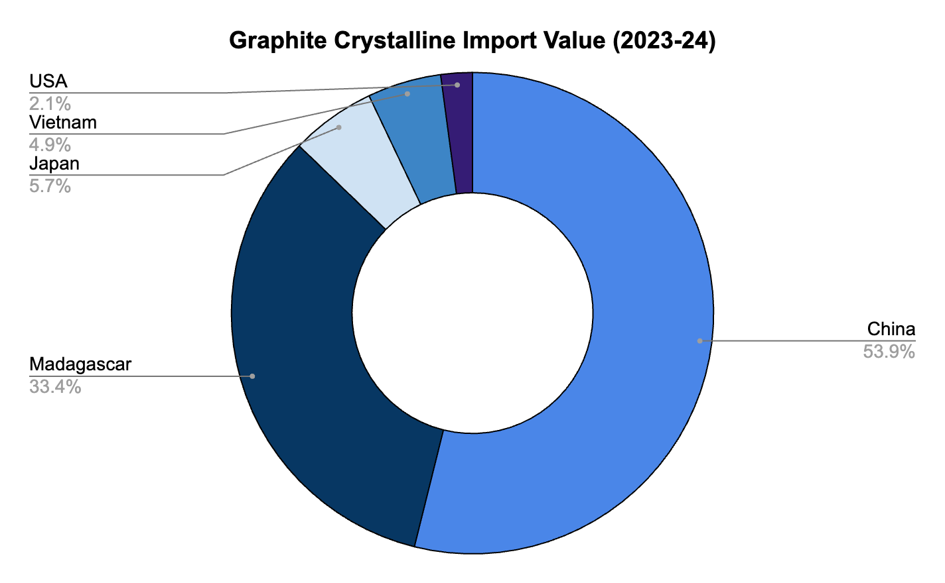

*Data Source - Ministry of Commerce (Export- Import Data Bank)*

At home, India faces gaps in investment and technology for graphite processing. High-purity graphite purification requires advanced facilities, which demand collaboration with technology providers, R&D investment, and policy support to attract private sector participation. Despite efforts to diversify mining, spherical graphite production remains highly concentrated in China, which accounts for 99% of the global market (IEA 2024, p. 167). New projects in Canada (Northern Graphite, Nouveau Monde), the US (Syrah Resources), and Europe (Talga Resources) are emerging but are not yet sufficient to reduce India’s dependence.

**Nickel**

The nickel industry faces several challenges ranging from extraction practices to capital-heavy processing as well as trade logistics. Laterite ore processing through high-pressure acid leaching (HPAL) is an energy-intensive process that creates challenges for sustainability practices. Additionally, the low cost of nickel leads to global producers halting and / or shutting down projects leading to uncertainty in long-term goals. The risk of closure and ‘development halts' is especially pronounced for projects with higher costs and lower margins, often located in regions beyond the current dominant producers’ (IEA, 2024, p. 136).   
  
The concentration of nickel production in Indonesia further heightens supply chain risks, as any policy shifts or export restrictions could disrupt global markets. Political instability in other key suppliers, such as the Philippines and Russia, compounds these vulnerabilities. Resource nationalism is also a growing factor: Indonesia, for example, has implemented policies to restrict raw ore exports and promote domestic refining and value-added processing. This geographic concentration increases the risk of supply disruptions, while price volatility on exchanges like the LME adds another layer of uncertainty for manufacturers and investors, complicating long-term planning. In countries like India, where domestic nickel production is limited, technological barriers—such as the lack of machinery to process laterite ores into battery-grade nickel—remain a significant technical and economic hurdle.

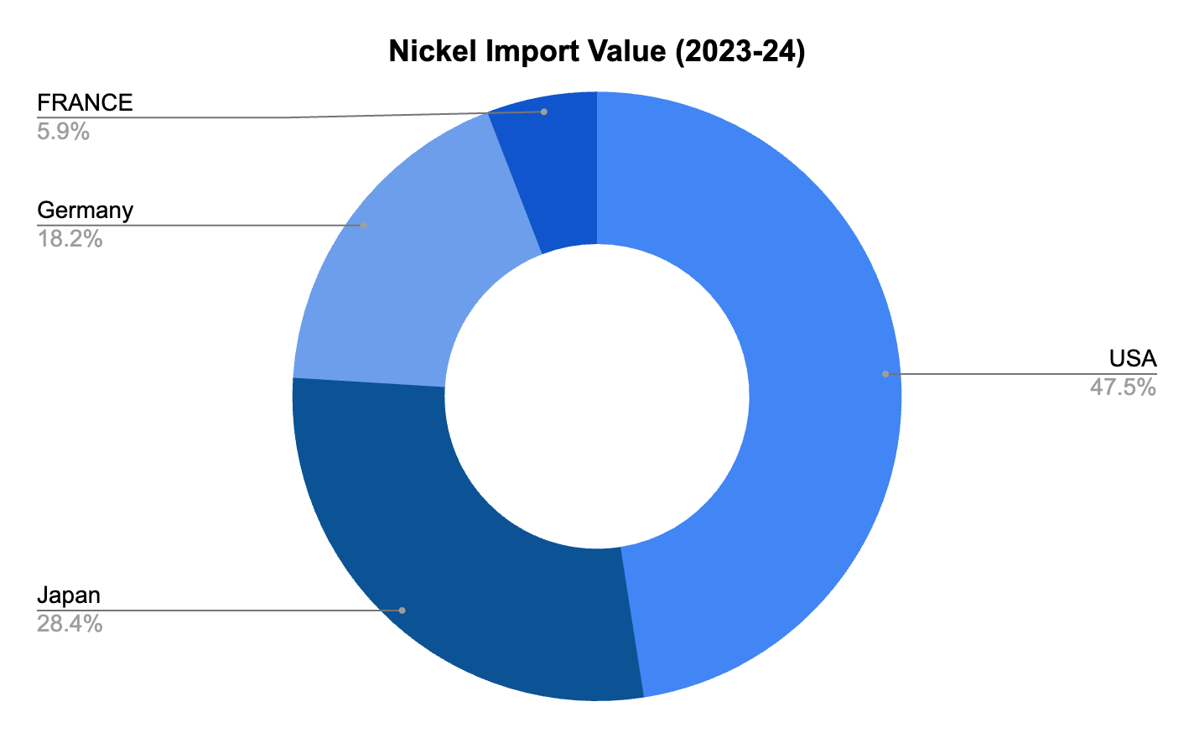

*Source - Ministry of Commerce (Export-Import Data Bank)*

There is an urgent need for technological and policy advancements to reduce the carbon footprint of nickel operations—addressing energy demand, sources of energy, and the mitigation of harmful emissions. Shallow, open-pit mining methods used in nickel extraction also raise ESG concerns, particularly due to large-scale deforestation.

In November 2023, MOFCOM mandated that any producer exporting more than 10,000 tonnes of nickel sulfate per month must obtain a non-automated, case-by-case export license through the Electronic Export-Control System. Alongside this, China added several battery-grade nickel precursor technologies—such as high-pressure acid leach (HPAL) modules and rotary kiln electric furnaces for nickel matte—to its Catalogue of Technologies Prohibited or Restricted from Export, requiring prior approval for overseas sales. Additionally, the National Development and Reform Commission (NDRC) offers preferential electricity tariffs and VAT rebates to nickel processors supplying Chinese battery-grade converters (e.g., producing NiSO₄ for CATL), indirectly curbing export volumes without formal export bans.

**Rare Earth Elements**  
  
On October 1, 2024, China imposed a ban on REE exports to the United States for manufacturing key semiconductors, escalating the ongoing tech war. The move responded directly to tightened U.S. restrictions on advanced chip exports to China, aimed at curbing its ability to develop advanced weapons and AI technologies. On April 4, 2025, China’s Ministry of Commerce formally banned exports of seven medium- and heavy REEs—samarium, gadolinium, terbium, dysprosium, lutetium, scandium, and yttrium—along with all related magnet products, ores, and compounds. This followed a 125% U.S. tariff on Chinese REE imports in March 2025. By tightening controls on REEs essential for permanent magnets, high-strength electronics, and defense systems, China aims to shield its technology base and strengthen its negotiating position in the broader U.S.-China trade dispute. With China accounting for over 70% of global REE output, the ban is expected to disrupt supply chains, raise costs, and slow India’s green energy efforts, including EV production and solar deployment.  
  
Though REEs are abundant in the Earth’s crust and often occur as by-products, processing remains the main barrier. Each mineral requires a distinct, high-cost extraction technology, discouraging domestic uptake. Existing PSUs frequently rely on foreign technology. Established refineries face added complications in meeting ESG standards due to the toxic waste generated during separation processes.

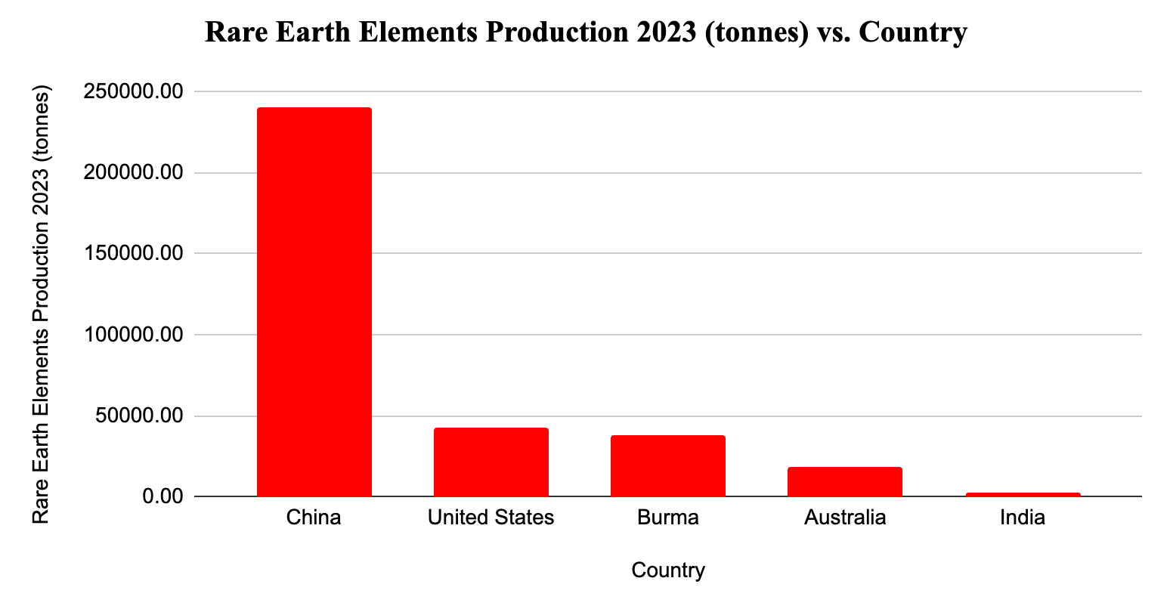

[*Data source - USGS Mineral Commodity Summary 2024*](https://pubs.usgs.gov/periodicals/mcs2024/mcs2024-rare-earths.pdf)

Supply chain disruptions extend beyond China’s resource dominance. The industry depends heavily on third-party logistics, especially intercontinental shipping, which creates bottlenecks and risks for modern industries. A lack of vertical integration—where most countries specialize in either mining or processing—worsens these vulnerabilities. This divide is further widened by significant technology gaps, making cross-border collaboration difficult. Despite raw material availability, countries like the U.S. and Australia struggle with refining due to historical dependence on external processors. REE magnets remain a strategic asset, offering energy savings that make them a valuable investment.

**Recommendations**

**Lithium**

*Exploring Alternative Chemistries*

Exploring alternative chemistries is essential to mitigate the supply chain vulnerabilities associated with conventional lithium-ion batteries. Sodium-ion batteries, now being mass-produced by China's CATL, offer a promising substitute due to sodium’s wider availability. Norway’s Morrow Batteries is another emerging player in the sector. The UK’s Faraday Institution is investing in solid-state battery research, including lithium-sulfur and lithium-air chemistries, which offer higher energy densities and eliminate the need for cobalt and nickel—minerals marked by geopolitical risks. In the US, companies such as Solid Power and QuantumScape, in partnership with BMW and Volkswagen, are advancing solid-state lithium battery development. Meanwhile, Australia’s CSIRO is exploring lithium-titanate and vanadium redox flow batteries to enhance energy storage systems. India should actively partner with these international players—such as the Faraday Institution, CSIRO, and Solid Power—to co-develop and co-fund next-generation chemistries like sodium-ion and lithium-sulfur. Establishing joint laboratories and formal technology collaboration agreements will allow India to pilot domestic deployments, diversify its energy storage ecosystem, and reduce reliance on critical minerals like cobalt and nickel.

*Diversifying Strategic Partnerships*

Engaging in strategic partnerships and joint ventures continues to be India’s most practical path to secure lithium supplies. As China imposes tariffs and cuts critical mineral exports, India must deepen ties with lithium-rich countries like Australia, Argentina, and Bolivia. While India has MoUs with Argentina and Chile, these must now evolve into long-term supply contracts involving capital investment or technical support in mining operations. Strengthening bilateral and multilateral platforms—such as the QUAD and BRICS—can provide India with additional leverage in negotiating sustainable lithium partnerships.

*Strengthening Recycling*

As global efforts intensify around end-of-life battery recycling, India must accelerate the development of its lithium recycling infrastructure by incentivising private sector participation and establishing dedicated recycling zones. Financial tools such as targeted subsidies and tax breaks can draw investment into recycling plants. Implementing extended producer responsibility (EPR) mandates will increase corporate accountability and spur investment in advanced recycling technologies, thereby decreasing reliance on imported lithium. The pace of lithium battery recycling has increased globally—in 2023, around 40 companies in Canada and the US, and 50 in Europe, either recycled or planned to recycle lithium batteries, often through partnerships between automakers and recyclers to secure a steady stream of battery-grade materials (S&P, 2023, p. 36).

*Battery Patent and Tech Collaboration with Japan*

According to the IEA’s report on Innovation in Batteries, international patenting activity for battery pack applications—particularly in the EV sector—has seen substantial growth. ‘Nine of the top 10 global applicants for battery patents are based in Asia; from 2014 to 2018, Japan produced 41 per cent of all Li-ion patenting activity, followed by Korea, Germany, the US, and China. By contrast, Japan’s leadership in battery patents has not translated into a large domestic electric car market’ (Guvvadi, 2024). This disconnect offers India a strategic opening to partner with Japan in the EV and battery manufacturing space. A collaboration that builds on Japan’s patent strength and India’s expanding EV market could include co-developing a battery production facility and jointly filing patents, strengthening India’s technological capacity while expanding Japan’s commercial footprint.  
  
  
**Cobalt**

*Alternate Chemistries*

Given cobalt’s critical role in EV and automotive battery chemistries, Tesla has led a global shift toward lithium-iron-phosphate (LFP) batteries, which eliminate cobalt entirely. In parallel, BYD has successfully commercialised LFP batteries in China, offering a more sustainable and scalable alternative. European initiatives like the ‘ReLieVe’ project focus on recovering cobalt from used batteries to create a circular economy, while also transitioning toward mass-scale LFP adoption.

India should co-invest in licensed LFP cathode manufacturing under the ₹1,000 crore Production-Linked Incentive (PLI) scheme. This would enable domestic cell manufacturers (e.g., Exide, Amara Raja) to adopt proven Blade-style battery designs and reduce cobalt dependency. At the same time, India can join European cobalt-recycling consortia like ReLieVe, which aims to process 50,000 t/y of end-of-life Li-ion batteries into new battery-grade salts by 2027. Allocating ₹500 crore toward a joint hydrometallurgical plant with European firms such as Eramet or Terrafame could provide a reliable feedstock of recovered cobalt for future cathode production while lessening reliance on DRC- and China-dominated supply chains.

*Developing Southeast Asian Partnerships*

Indonesia’s 2023 cobalt export ban has allowed the country to capture greater value from its resource base while inviting foreign collaboration—a strategic opening India must pursue. As ASEAN chair, Indonesia’s participation at the G7 Sapporo meeting underscored the region’s centrality in critical mineral development. Ongoing discussions between Indonesia and the US on the Minerals Security Partnership (MSP), of which India is a member, further highlight the importance of regional alignment.

Securing a cobalt agreement with Indonesia would strategically benefit India—restructuring regional trade flows while bolstering Southeast Asian supply chain cooperation. Indonesia’s new president, Prabowo Subianto, has temporarily stalled mining operations pending a broader policy review, but he has pledged continuity on core priorities: building a robust EV supply chain and deepening downstream processing. If these policies persist, Indonesia could emerge as a key long-term cobalt partner for India.

*Setting up a Strategic Stockpiling Commission*

China’s dominance over cobalt is reinforced by its international mining investments and a robust stockpiling strategy. As noted by Desai (2024), China intends to purchase up to 15,000 metric tons of cobalt metal from domestic producers in the coming months. This could cause future supply shocks and price volatility in global markets.

To mitigate such risks, India should establish a dedicated Strategic Reserves Administration for critical minerals—beginning with cobalt, lithium, and graphite. Similar to the country’s petroleum reserve model, this initiative could be integrated into the ‘National Critical Mission’ announced in the 2024 budget. With limited domestic mining capacity, India must regulate and reserve a portion of imported cobalt to stabilise prices and reduce vulnerability to geopolitical disruptions. Proactive stockpiling would also insulate domestic industry from future export restrictions by major suppliers like China.

*Tapping into Africa*

Africa holds roughly 30% of the world’s critical mineral reserves, with the Democratic Republic of Congo (DRC) historically dominating the cobalt sector. While Chinese investments in the DRC date back to the 1970s, growing political instability and declining ore quality have led China to expand its footprint into South Africa, Niger, Egypt, and Côte d’Ivoire.

Meanwhile, the US has signed critical minerals MoUs with Mongolia, the DRC, and Zambia for access to iron, tungsten, copper, and coal. India has inked similar MoUs with Zambia and Zimbabwe for mineral mapping and deposit modelling. However, India has lagged behind in strategic investments across Africa, particularly compared to Western and Chinese engagement. As competition for African resources intensifies, India must move swiftly to deepen bilateral ties, simplify trade procedures, and position itself as a reliable long-term partner.

Many resource-rich African countries are landlocked, making transport and logistics a persistent bottleneck. India could enhance its credibility by supporting logistical infrastructure and trade corridors that ease mineral exports. Such efforts, coupled with consistent diplomatic engagement, are key to securing long-term access to high-grade African cobalt.

**Graphite**

*Alternate Chemistries*

Amid surging demand, the graphite industry is undergoing significant innovation to overcome supply chain vulnerabilities. US-based NOVONIX is spearheading synthetic graphite production, while Canada’s Nouveau Monde Graphite (NMG) is building an all-electric mining operation to produce graphite sustainably—both efforts contributing to the diversification of global supply.

India should establish technology-transfer partnerships with NOVONIX by co-funding a ₹800 crore PLI slab for a 10,000 t/y synthetic graphite anode plant, leveraging NOVONIX’s licensed graphitization furnace technology. This would mirror NOVONIX’s Riverside facility in the US, which targets 20,000 t/y by 2025, and could support long-term offtake agreements with Indian EV OEMs such as Tata and Ola Electric. In parallel, through KABIL or relevant state mining corporations, India could sign an MoU with NMG to pilot an all-electric, carbon-neutral mining operation in Odisha or Jharkhand. The project could replicate NMG’s ABB-powered Matawinie mine—which operates a zero-emission fleet using hydropower—by committing ₹500 crore toward grid connectivity and electric fleet procurement to operationalise India’s first green mine by 2028.

*Tapping into South and Latin America*

India already has joint ventures across South America for lithium exploration. Brazil, with substantial graphite reserves, represents a natural extension of India’s presence in the region. Existing bilateral cooperation on sustainable fuels and a forthcoming tech partnership further strengthen the case for a graphite supply chain collaboration aligned with green transition goals.

Mexico also holds strategic promise. It exports 21% of its graphite output to the US (Benson & Denamiel, 2023), and its mining sector posted a trade surplus of USD 12.8 billion in 2022 (International Trade Association, 2023). A 2023 mining law nationalised Mexico’s critical minerals and granted exploration rights to the state—indicating a likely uptick in reserves. For Indian importers, this presents a timely opportunity to secure stable graphite supply chains from a mineral-rich, policy-backed partner.

*Norway as a potential partners*

Norway offers promise with significant flake graphite reserves in regions such as Senja Island, the Lofoten-Vesterålen islands, the Holandsfjorden area, and Bamble. Skaland Graphite is the country’s primary producer. According to the Geological Survey of Norway, most deposits are of the valuable “flake type.” India could collaborate with Norway to develop a robust logistical and trade framework, positioning the Nordic region as a stable supplier of high-grade graphite.

*Partnership with Key Technology Players*

India must also collaborate with Japan and South Korea—global leaders in battery and graphite processing technologies. Such partnerships could enable vital technology transfers and ensure India’s access to cutting-edge refining techniques for both natural and synthetic graphite. Notably, South Korea’s Posco International is securing supply from Tanzania through a US$40 million phased investment in Black Rock Mining, demonstrating how strategic investments are reshaping global graphite supply chains. India should pursue similar models to ensure secure and diversified graphite sourcing.

**Nickel**

*Alternate Chemistries*

To reduce reliance on nickel in electric vehicle (EV) and battery production, India can accelerate the shift toward lithium-iron-phosphate (LFP) batteries. China is leading this transition, with companies like BYD and Tesla widely adopting LFP chemistries due to their lower cost and improved safety profile. In Europe, the Horizon 2020-funded Battery ‘2030+’ project is advancing alternative formulations such as manganese-rich batteries, which reduce dependence on nickel and cobalt while maintaining high energy density.

In the US, innovation is being driven by startups like Sila Nanotechnologies and Nano One Materials, which are developing high-silicon anodes and manganese-based cathodes, respectively—technologies aimed at reducing nickel usage. Meanwhile, Indonesia, a top global nickel producer, is investing in nickel-cobalt-manganese (NCM) battery facilities while simultaneously exploring next-generation chemistries to hedge against resource bottlenecks.

Beyond batteries, nickel alternatives are also gaining ground in construction, transport, and industrial sectors. Materials such as aluminium, coated steels, plain chromium steels, and engineered plastics are replacing nickel-based stainless steels. Low-nickel duplex and ultra-chromium stainless steels are supplanting austenitic grades, while nickel-free specialty steels are increasingly used in power generation, petrochemical, and petroleum sectors. Additionally, titanium alloys and specialty plastics are substituting nickel alloys in corrosion-prone environments involving aggressive chemicals.

*Strengthening Bilateral Agreements*

India should strengthen ties with nickel-rich countries like Indonesia, the Philippines, and Australia through bilateral agreements. Leveraging forums such as the BRICS, G20, and ASEAN for multilateral cooperation on critical mineral supply chains would strengthen India’s nickel industry and take it forward.

Engaging and establishing strategic partnerships and joint ventures (similar to KABIL) with foreign companies would help secure long-term nickel supply agreements. Promoting regional cooperation in South Asia and with neighbouring countries for shared benefits and collective bargaining power in nickel supply and processing is a favourable move.

*Focus on Domestic Development*

Offering tax incentives and subsidies to attract foreign direct investment (FDI) into exploration and processing could be timely, especially as global nickel prices remain subdued. Public-private partnerships should be prioritised to develop infrastructure, adopt efficient extraction technologies, and establish domestic refining capabilities.

Simultaneously, export diversification—across raw ore, intermediate products, and processed nickel—would reduce vulnerability to international price swings and enhance India’s long-term competitiveness in the global nickel value chain.

**Rare Earth Elements**

*Alternate Chemistries*

Automakers such as BMW and Renault are pioneering the shift toward ferrite-based and induction motors, reducing dependency on rare earth elements (REEs). Simultaneously, advances in aluminum-cerium (Al-Ce) alloys are helping replace traditional REE applications in automotive and industrial sectors.

India should establish a public-private R&D consortium anchored by institutions like IIT Madras and CPRI to license ferrite motor designs from BMW and Renault. This effort could be supported by a dedicated ₹500 crore PLI scheme for a “Magnet-Free Motor” program, aiming to build 20 MW of induction/ferrite motor capacity by 2027. In parallel, the Ministry of Heavy Industries could partner with research centres such as DRDO’s Laboratory for Advanced Materials to co-develop Al-Ce alloy rotors, drawing on performance data published by BMW and Audi. A ₹300 crore “Lightweight Alloy Innovation” grant could accelerate bench-scale alloy casting and characterization, targeting at least one domestically produced Al-Ce rotor prototype by 2026.

These initiatives would not only reduce India’s reliance on REE-based magnets but also lower EV manufacturing costs and build long-term domestic expertise in magnet-free motor technologies and alternative alloys.

*Boosting Domestic Capabilities*

India’s REE sector faces key challenges in mining, processing, and material handling. Given the complex chemical nature of REEs and the presence of mildly radioactive by-products such as thorium, robust logistical and containment solutions are essential. Safe transport and storage require specialised infrastructure to prevent radiation leakage, moisture exposure, and material degradation—factors that, if mismanaged, can lead to environmental contamination and loss of material integrity.

India should explore technology collaborations with Japan, whose REE recycling roadmap emphasises innovative packaging techniques, such as inert gas-filled containers and vacuum-sealed systems, to maintain compound purity and safety. Such partnerships can help India develop protocols to safely manage REE compounds, while also learning from Japan’s broader strategy to reduce dependence on China and enhance domestic recyclability.

*Processing Opportunities in Central Asia*

Kazakhstan is emerging as a new frontier for REE processing. In June 2024, the government announced plans to declassify data on its rare-earth and rare-metal deposits and attract Western investment to develop these vast reserves (Bekmurzaev, 2024). Interest from the US, UK, and EU has accelerated Kazakhstan’s profile as a key REE partner.

Through its partnership with the US on critical minerals, India could leverage this alignment to collaborate with Kazakhstan under the C5+1 regional dialogue, which includes the US and five Central Asian nations. Kazakhstan could serve as both a model and a short-term alternative to China for REE processing. Technology cooperation with the country could help India fast-track its own capabilities while building a diversified regional network of REE partners.

*Stockpiling Strategies and Collaborating with Vietnam*

China’s imposition of export restrictions and aggressive stockpiling has heightened global supply volatility in critical minerals, including REEs. Strategic stockpiling is increasingly essential for hedging against such disruptions.

Vietnam, which holds the world’s second-largest reserves of rare earths (USGS, 2024, p. 145), has received support from the US to scale up its production. As the West seeks to diversify away from China, Vietnam is becoming central to emerging alternative supply chains.

India should pursue closer cooperation with Vietnam and other regional partners—such as the US, Japan, Australia, and ASEAN members—to develop a joint strategic stockpile mechanism. A coordinated reserve would enable countries to pool REE resources and offer mutual supply assurances during times of market stress, creating a resilient and balanced counterweight to China’s market control.

**Works Cited**

Aliyeva, A. (2024, June 21). ‘Japan Starts Mining Cobalt and Nickel in its Economic Zone in 2026.’ Azer News. DOI: https://www.azernews.az/region/227678.html

Benson, E. & Denamiel, T. (2023, October 23). ‘China’s New Graphite Restrictions.’ Center for Strategic and International Studies. DOI: https://www.csis.org/analysis/chinas-new-graphite-restrictions

Desai, P. (2024, May 24). ‘China state stockpiler aims to buy up to 15,000T of cobalt.’ *Reuters*. DOI: https://www.reuters.com/markets/commodities/china-state-stockpiler-aims-buy-up-15000-t-cobalt-sources-say-2024-05-23/

Geological Survey of Norway (NGU). (n.d.). DOI: https://www.ngu.no/en/geological-resources/graphite-norway

Gulley, A.L. (2022). One hundred years of cobalt production in the Democratic Republic of Congo. *Elsevier Science Direct* 79. DOI: https://www.sciencedirect.com/science/article/pii/S0301420722004500

Guvvadi, N. (2024). ‘Energy Transition and the Lithium Rush.’ Indian Council of World Affairs. DOI: https://www.icwa.in/show_content.php?lang=1&level=1&ls_id=10457&lid=6669#:~:text=The%20discovery%20of%205.9%20million,EVs)%20and%20electricity%20storage%20systems.

IEA. (2024). *Global Critical Minerals Outlook 2024.* The International Energy Agency. DOI: https://www.iea.org/reports/global-critical-minerals-outlook-2024

Ministry of Mines. (2024 [2022]). *Indian Minerals Yearbook: Cobalt, Part II Metals and Alloys*. Government of India, Ministry of Mines, Indian Bureau of Mines. February 2024.

Ministry of Mines. (2024 [2022]). *Indian Minerals Yearbook: Graphite*. Government of India, Ministry of Mines, Indian Bureau of Mines. February 2024.

Ministry of Mines. (2024 [2022]). *Indian Minerals Yearbook: Nickel*. Government of India, Ministry of Mines, Indian Bureau of Mines. February 2024.

International Nickel Study Group. (2024). DOI: https://insg.org/index.php/about-nickel/production-usage/

International Trade Administration. (2023). *Mexico - Country Commercial Guide: Mining and Minerals*. International Trade Administration. DOI: https://www.trade.gov/country-commercial-guides/mexico-mining-and-minerals

Kumar, N. (2024, October 17). ‘J&K 5.9 mn tonne lithium reserve to be re-explored after failed auction.’ *Business Standard*. DOI: https://www.business-standard.com/industry/news/j-k-s-5-9-mn-tonne-lithium-reserve-to-be-re-explored-after-failed-auction-124101700933_1.html

Nadig, Smruthi. (2024, February 5). ‘The Long Path to unlocking India’s lithium resources.’ *Mining Technology*. DOI: https://www.mining-technology.com/features/the-long-path-to-unlocking-indias-lithium-resources

Nickel Institute. (2024). *Nickel Magazine.* DOI: https://nickelinstitute.org/

OEC Data. (2023). ‘Cobalt Ore in Netherlands.’ Data from BACI, [HS6 REV. 1992 (1995-2023)](http://www.cepii.fr/CEPII/en/bdd_modele/presentation.asp?id=37). DOI: https://oec.world/en/profile/bilateral-product/cobalt-ore/reporter/nld

OEC Data. (2022)[A1] . ’Graphite in Tanzania.’. DOI: https://oec.world/en/profile/bilateral-product/graphite/reporter/tza#:~:text=Trade%20Balance&text=In%202022%2C%20Tanzania%20exported%20%243.83M%20in%20Graphite.,%2C%20and%20Germany%20(%2471).

PIB. (2025, February 1). Press release issued by the Ministry of Mines, GoI. Government of India: Press Information Bureau. DOI: https://pib.gov.in/PressReleasePage.aspx?PRID=2098653

PIB. (2024, August 5). ‘Deposits of Heavy Metals Required for Crucial Industries’. Press release by the Ministry of Mines, GoI. Government of India: Press Information Bureau. DOI: https://pib.gov.in/PressReleaseIframePage.aspx?PRID=2041804#:~:text=The per cent20details per cent20are per cent20as per cent20under,exist per cent20in per cent20Odisha per cent20and per cent20Jharkhand.

Reuters. (2024, December 19). ‘US Graphite miners ask Washington to impose 920% tariffs on Chinese rivals.’ *Reuters*. DOI: https://www.reuters.com/markets/commodities/us-graphite-miners-ask-washington-impose-920-tariff-chinese-rivals-2024-12-18/

S&P Global. (2023). ‘Inflation Reduction Act: Impact on North America Metals and minerals market.’ 2023.

Sanchez–Lopez, M.D. (2023). Geopolitics of the Li-ion battery value chain and the Lithium Triangle in South America. *Latin American Policy*, 14(1) Wiley online library. March 2023. DOI: https://doi.org/10.1111/lamp.12285

U.S. Geological Survey. (2024), *Mineral* C*ommodity Summaries 2024: USGS Publications Warehouse.* https://doi.org/10.3133/mcs2024.

United Nations Press. (2024, February 20). ‘DR Congo: Fighting threatens stability of entire region, envoy warns.’ *UN News Global Perspective Human Stories*. DOI: https://news.un.org/en/story/2024/02/1146782

Volza. (2024). ‘Natural Graphite Imports in India - Market Size & Demand based on Import Trade Data.’ Volza. DOI: https://www.volza.com/p/natural-graphite/import/import-in-india/

Volza. (2024). ‘Nickel Imports in India: Market Size and Demand based on Import Trade Data.’ Volza. DOI: https://www.volza.com/p/nickel/import/import-in-india/

Webster, J. (2025, January 22). ‘China’s lithium-ion battery exports: Why are US prices so low?’ Atlantic Council. DOI:<https://www.atlanticcouncil.org/blogs/energysource/chinas-lithium-ion-battery-exports-why-are-us-prices-so-low/#:~:text=Chinese%20Lithium%2Dion%20export%20price&text=Chinese%20exporters%20of%20lithium%2Dion,order%2C%20up%20from%207%20percent>.

World Integrated Trade Solutions. (2023). ‘India Waste and scrap, nickel imports by country in 2023.’ *World Integrated Trade Solutions.* DOI: https://wits.worldbank.org/trade/comtrade/en/country/IND/year/2023/tradeflow/Imports/partner/ALL/product/750300