**CSCI 1170: web development**

**group assignment (milestone 1)**

**TEAM MEMBERS:**

1. Brijesh Bharatbhai Varsani - B00882318
2. Gurrehmat Raj Singh
3. Jinyao Jiang
4. Aditya Rajil – B00881605
5. Md Ahnaf Monwar – B00879541

**Our Project topic:** Smartphone company website (it could be a website for a company that makes smartphones/tablets/etc.) (3rd topic from the given choices in instruction pdf)

**Our Company name and the logo:**

Name:- ***Finn_Digital***

Tag line:- Carry your Future with you.

Logo:- (we have created on our own using the software)

We are going to add this logo to the homepage of our website.

**Our approach towards the website:**

1st webpage will be the home page of our website where we will include

1. Header in which our logo and our slogan will be there with little bit decoration also we will include the navigation bar. Where we will try to set up the hovering drop-down menu. The header will also contain the search bar.
2. In the body will start with an image of the best offer we have. Followed by the devices in our company with their respective websites’ reference.
3. The footer will have all our contact information and the about us section. It will also have links to our accounts on our social media platforms.
4. We are still finalizing the background image according to the layout.
5. We might add self-created photos of our deals or offers on the home page but is not ready yet.

Other web pages will be for all the models our company is manufacturing.

**Web pages and some ids and classes we are going to use:**

1. Index.html (main page)
2. And each page for all models. (i.e., ZinnMultiFold , ZinnTransparent )
3. contactUs.html
4. aboutUs.html
5. class and ids for all images
6. #homepage_Footer
7. #homepage_body and many more such kinds of ids

**Text Content that we are going to include:**

1. In about us: Finn_Digital is focused on agreeing with nearby laws and guidelines just as applying a severe worldwide set of principles to all representatives. It accepts that moral administration isn't just an instrument for reacting to the quick changes in the worldwide business climate, yet additionally, a vehicle for building entrusts with its different partners including clients, investors, representatives, colleagues, and nearby networks. With a means to become one of the most moral organizations on the planet, Finn_Digital keeps on preparing its representatives and work observing frameworks, while rehearsing reasonable and straightforward corporate administration. (we can change as per the layout).

Also, probably we will include our team members’ details on this page only.

And our mission: Finn_Digital follows a straightforward business reasoning: to dedicate its ability and innovation to make better items and administrations that contribute to a superior worldwide society. To accomplish this, Finn_Digital sets a high worth on its kin and advances. (We may add more)

1. Specs for all mobile and accessories: battery info, Camara info, display info, processor info, charging info, sim card info, speaker info, all these information (of features) will be there for each model of our company.
2. Contact us: email option, WhatsApp option, Facebook, Instagram, Twitter option.

**Meta Description:**

1. Inside meta tag for the main page: Finn_Digital assists you with finding a wide scope of smart gadgets with state-of-the-art innovation including cell phones, headphones, and small accessories.

**Images we are going to use with their references:**

**(1)**

Reference:<https://www.royalvegascasino.com/blogrvc/images/uploads/www_royalvegas_com/2020/01/FlexiDisplayTech-EN2.jpg>

**(2)**

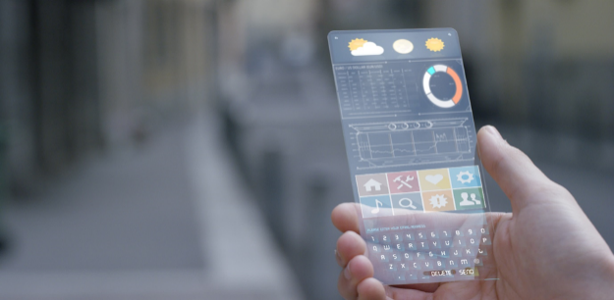

Reference: <https://cdn.mos.cms.futurecdn.net/X8ajP3firD9QzBCipfEtPk.jpg>

Reference: <https://s3.amazonaws.com/media.the-next-tech.com/wp-content/uploads/2020/02/19173343/future_phone.jpg>

**(3)**

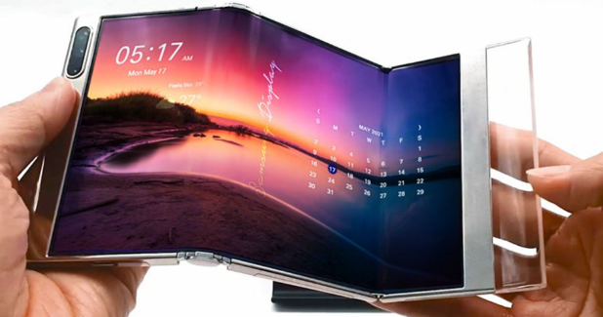

Reference: <https://assets.mspimages.in/wp-content/uploads/2021/05/Samsung-foldable-display.jpg>

**(4)**

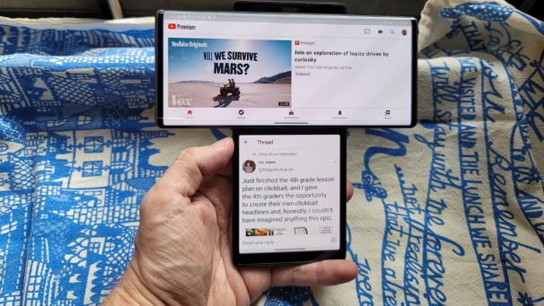

Reference: <https://i.pcmag.com/imagery/articles/029FMGY03n9UexuiJZZqKl7-8..1600376679.jpg>

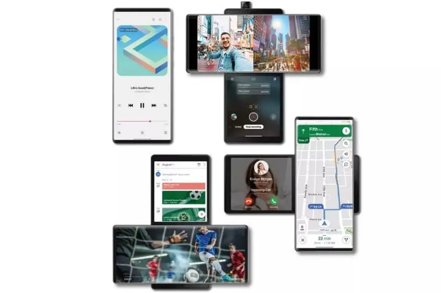

Reference: <https://paidfreedroid.com/wp-content/uploads/2020/09/LG-Wing-All-Iterations.jpg.webp>

**(5)**

Reference: <https://www.concept-phones.com/wp-content/uploads/2020/11/Samsung-surround-display-smartphone-concept-letsgodigital-snoreyn-3.jpg>

**(6)**

Reference: <https://i.pinimg.com/564x/ac/fc/4a/acfc4a58e29cfb14a2d5f700baea4983.jpg>

**(7)**

Reference: <http://www.fubiz.net/wp-content/uploads/2015/11/foldablesmartphone6.jpg>

**(8)**

Created this photo using the software.

**(9)**

Reference: <https://walyou.com/wp-content/uploads//2015/11/creative-Headphone-design-and-concept-21.jpg>

**(10)**

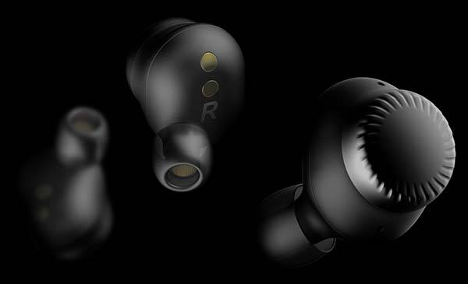

Reference: <http://gadgetsin.com/uploads/2018/02/concept_true_wireless_earbuds_with_two_dials_1.jpg>

**(11)**

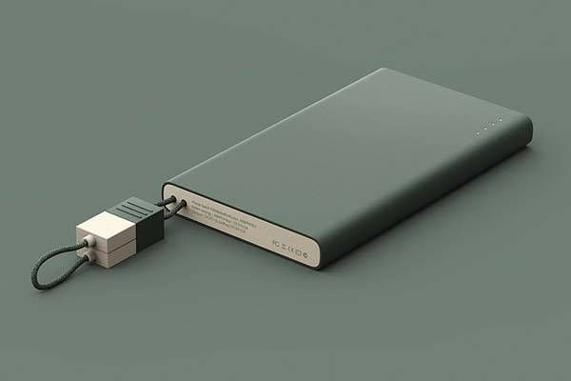

Reference: <https://i.pinimg.com/736x/03/85/d4/0385d4e19fe1dd623303160fa17b3f43.jpg>

**(12)** We will make a video by ourselves and will add in the accessories webpage but to be honest we haven’t made it yet. We are trying to make one.

**Team member’s role in milestone 1**

1. **In milestone 1:**

Brijesh Varsani: handled the word file work and created own photos and text content.

Gurrehmat Raj Singh: gathered photos and helped with the suggestions in our website planning

Ahnaf Monwar: also gathered photos and helped with the layout planning

Jinyao Jiang: gathered specs and also helped with the layout planning

Aditya Rajil: gathered specs and helped making notes of everything we discussed and giving suggestions.

**Team member’s role in our rest of the project:**

We are not going to divide any particular coding type(like one will handle CSS, one will handle JS. NOT LIKE THIS) that any individual has to do. Instead, we are going to distribute the webpages to every single member of our team. We together will make good home page. We also will collaboratively make one model webpage and will distribute the task to make the same web pages as we created for one model. After getting this thing done, we will work on referencing the web pages on the home page.