AI 23331 Fundamentals of Machine Learning

CROP DISEASE DETECTION
CropGuard AI: A Comparative Study of MobileNetV2 vs. Custom CNN

A PROJECT REPORT

Submitted by

230701058 – Brijith Manikandan M
230701035 – ArulRajan S



May, 2026

BONAFIDE CERTIFICATE

Certified that this project report "CROP DISEASE DETECTION" is the bonafide work of “ARULRAJAN S (230701035), Brijjith Manikandan M (230701058)" who carried out the project work under my supervision.

SIGNATURE OF THE FACULTY INCHARGE

Submitted for the Practical Examination held on _________________

SIGNATURE OF THE INTERNAL EXAMINER

TABLE OF CONTENTS
CHAPTER NO. | TITLE | PAGE NO.
— | ABSTRACT | 4
1 | INTRODUCTION | 5
2 | LITERATURE REVIEW | 6
3 | PROPOSED SYSTEM | 7
3.1 | SYSTEM ARCHITECTURE | 8
3.2 | TOOLS AND TECHNOLOGIES USED | 10
4 | MODULES DESCRIPTION | 11
4.1 | USER INTERFACE MODULE | 11
4.2 | INPUT PROCESSING MODULE | 12
4.3 | RESULT DISPLAY MODULE | 13
5 | IMPLEMENTATION AND RESULTS | 14
5.1 | CODING | 14
5.2 | RESULTS | 18
6 | CONCLUSION AND FUTURE WORK | 21
7 | REFERENCES | 22

ABSTRACT

Agricultural productivity worldwide is severely compromised by plant diseases, which cause an estimated 20–40% of annual global crop losses. Early and precise identification of leaf pathologies is critical to enabling timely intervention and protecting yields. This project — CropGuard AI — presents a comparative deep learning study designed to detect plant diseases from leaf images with high speed and precision across 15 distinct agricultural classes spanning three economically significant crops: Tomato, Potato, and Pepper.
The core objective is to evaluate a lightweight, pre-trained MobileNetV2 model (utilizing transfer learning on ImageNet features) against a customized, multi-layer Sequential CNN architecture (trained from scratch) to understand the fundamental trade-offs between model footprint, parameter count, computational complexity, inference latency, and validation accuracy on the PlantVillage benchmark dataset.
The trained models are deployed within a high-performance Flask backend and exposed through a purpose-built RESTful API. A glassmorphic dark-mode web dashboard provides an intuitive user interface featuring drag-and-drop leaf image upload, model switching, animated confidence visualization, and top-5 prediction display. The system incorporates lazy model caching to achieve sub-50ms inference latency for the MobileNetV2 model.
Key outcomes of the study:
- MobileNetV2 achieves ~96.5% validation accuracy with only ~3.4 million parameters and a 23.9 MB model footprint.
- The Custom CNN achieves ~87% validation accuracy but requires ~128 million parameters and a 134.1 MB binary.
- MobileNetV2 inference completes in under 50ms on CPU, versus over 120ms for the Custom CNN.
- Both models classify 15 disease/healthy classes with detailed top-5 probability ranking.
This project demonstrates that transfer learning with MobileNetV2 is significantly superior to training a CNN from scratch for agricultural disease classification tasks under realistic resource constraints.

1. INTRODUCTION

Plant diseases represent one of the most significant threats to global food security. Crops such as Tomato, Potato, and Pepper — staple food sources across Asia, Africa, and the Americas — are highly susceptible to a diverse range of fungal, bacterial, and viral pathogens. These diseases manifest primarily on leaves and can devastate entire harvests if not identified and treated at an early stage. The Food and Agriculture Organization (FAO) estimates that crop diseases account for 20–40% of global agricultural production losses annually, with disproportionate impacts in developing agricultural economies.
Despite the severity of this problem, accurate disease identification remains a persistent challenge. Traditional methods rely on the subjective visual inspection of experienced agronomists, a resource that is unavailable to millions of smallholder farmers. Existing digital diagnostic tools are often limited to single crops, restricted disease sets, or require expensive cloud-based computation that is inaccessible in rural, low-connectivity environments.
With rapid advancements in Convolutional Neural Networks (CNNs) and transfer learning, computer vision has demonstrated exceptional capability in extracting discriminative visual features from medical and agricultural images. Deep learning models trained on large benchmark datasets can identify subtle morphological patterns — lesion color, texture, shape, and distribution — that reliably differentiate disease phenotypes at a granularity exceeding human expert performance in controlled evaluations.
This project, titled CropGuard AI: Crop Disease Detection, addresses these limitations through the following contributions:
- A rigorous comparative evaluation of MobileNetV2 (transfer learning) versus a Custom CNN (trained from scratch) on the PlantVillage dataset.
- A production-grade, end-to-end ML web application with a Flask REST API backend featuring lazy model caching for sub-50ms inference.
- A 15-class classification schema spanning 3 crops (Tomato, Potato, Pepper) with 12 disease conditions and 3 healthy states.
- A glassmorphic dark-mode web dashboard providing real-time diagnosis with confidence scores, crop type identification, and top-5 predictions.
The project serves as a practical demonstration of how lightweight deep learning can be deployed as an accessible agricultural intelligence tool, bridging the gap between state-of-the-art computer vision research and real-world farm-level diagnostic needs.

2. LITERATURE REVIEW

Mohanty et al. [1] pioneered the application of deep learning to plant disease recognition using the PlantVillage dataset — a publicly available, curated repository of 54,306 labeled leaf images spanning 26 diseases across 14 crop species. The authors trained AlexNet and GoogLeNet architectures under controlled laboratory conditions, achieving up to 99.35% accuracy. Their study established the PlantVillage benchmark as the canonical reference dataset for plant disease classification and demonstrated the viability of CNN-based diagnosis at scale. However, the authors identified a significant accuracy gap when models were applied to field-captured images, highlighting the challenge of domain shift between laboratory and real-world imaging conditions.
Ferentinos [2] conducted an extensive systematic evaluation of CNN architectures — including AlexNet, VGGNet, GoogLeNet, and ResNet — for plant disease detection on the PlantVillage dataset. The study achieved a peak accuracy of 99.53% using VGGNet. The author systematically demonstrated that deeper, more complex architectures with residual connections consistently outperform shallow networks in extracting fine-grained discriminative features from leaf images. This work provided the foundational comparative analysis for selecting architectural baselines in subsequent plant disease studies.
Ramcharan et al. [3] extended plant disease classification beyond controlled laboratory settings by deploying MobileNet for real-world cassava disease identification in Tanzania, achieving 93% overall accuracy. Critically, this study demonstrated that lightweight architectures designed for mobile inference can maintain clinically acceptable performance under field conditions. The authors highlighted MobileNet's parameter efficiency as particularly valuable for deployment on edge devices in agricultural environments with limited internet connectivity — a finding directly relevant to the architectural selection rationale of CropGuard AI.
Geetharamani and Pandian [4] proposed a 9-layer custom CNN architecture for PlantVillage classification, achieving 96.46% accuracy across 38 disease classes. Their architecture incorporated batch normalization, dropout regularization, and data augmentation to address overfitting — the same design decisions applied in the custom CNN baseline of this project. The study provides a direct performance reference point for custom-designed CNN architectures trained from scratch on the same benchmark.
Too et al. [5] performed a comprehensive comparison of transfer learning architectures — VGG16, Inception V4, ResNet, and DenseNet — for plant disease classification, with DenseNet achieving the highest accuracy of 99.75%. The study systematically evaluated the trade-off between parameter count, model size, inference speed, and classification accuracy, concluding that transfer learning from ImageNet consistently and significantly outperforms training from scratch. This finding provides theoretical and empirical justification for the primary hypothesis of CropGuard AI: that MobileNetV2 with fine-tuned transfer learning will substantially outperform the custom CNN.

3. PROPOSED SYSTEM

CropGuard AI is a comparative deep learning web application engineered to diagnose plant diseases from uploaded leaf images in real time. The system is architected as an end-to-end machine intelligence platform encompassing a data ingestion and preprocessing pipeline, dual model training and evaluation engines, a Flask-powered REST API backend with lazy model caching, and a premium glassmorphic web dashboard for user interaction.
The system operates on 15 distinct agricultural classification labels — 12 disease conditions and 3 healthy states — spanning three crops: Tomato, Potato, and Pepper. A user uploads a leaf image via the web interface or API. The backend preprocesses the image to a normalized 224×224×3 floating-point tensor, routes it through the selected model (MobileNetV2 or Custom CNN), and returns a ranked top-5 prediction payload including disease labels, confidence probabilities, crop type, and inference latency within milliseconds.
The final output includes:
- Predicted Disease: Primary classification output with display-formatted label.
- Confidence Score: Softmax probability as a percentage reflecting model certainty.
- Top-5 Predictions: Complete ranked probability distribution across classes.
- Crop Type: Automatically inferred from the predicted class label (Tomato / Potato / Pepper).
- Inference Latency: Precise timing recorded via time.perf_counter() for each prediction.
- Health Status Badge: Color-coded indicator (green for healthy, red for diseased).

3.1 System Architecture
The CropGuard AI system is organized into five logical layers that collaboratively execute the complete disease detection pipeline:
Layer 1: User Interface Layer
The presentation layer is implemented as a single-page web application using HTML5, CSS3, and Vanilla JavaScript (ES6+). The interface adopts a glassmorphism design aesthetic featuring backdrop-filter blur effects, semi-transparent card surfaces, ambient radial gradient glow orbs, and interactive hover border highlights. It provides a model selection dropdown (MobileNetV2 / Custom CNN), a drag-and-drop file upload zone with FileReader-powered live preview, an animated disease analysis trigger button with integrated loading spinner, and a dynamic result panel displaying the top-5 predictions with animated confidence progress bars.
Layer 2: Image Upload & Validation Layer
This layer handles all file input operations at the Flask server boundary. The POST /api/predict endpoint validates that the uploaded file is non-empty, applies Werkzeug's secure_filename() sanitization, enforces allowed extension filtering (.png, .jpg, .jpeg), and persists the buffer image to static/uploads/ for downstream processing. Malformed or unsupported uploads are rejected with structured JSON error responses.
Layer 3: Preprocessing & Tensor Pipeline
The preprocessing layer transforms the raw uploaded image into a normalized floating-point tensor compatible with both model inputs. Pillow (PIL) resizes the image to 224×224 pixels. NumPy expands the dimensions to a (1, 224, 224, 3) batch tensor. Pixel values are normalized from the integer range [0, 255] to the floating-point range [0.0, 1.0] by multiplying by the scalar factor 1/255. This normalized tensor is directly passed to the model inference engine.
Layer 4: Dual Model Inference Engine (TensorFlow / Keras)
This is the core intelligence layer. The system maintains a _model_cache dictionary enabling lazy initialization: on the first prediction request, the serialized .keras binary is loaded from disk via keras.models.load_model() and registered in the cache with its corresponding label mapping from labels.json or cnn_labels.json. Subsequent requests bypass disk I/O entirely, executing inference directly on the cached in-memory model object. The model.predict() call produces a (1, 15) Softmax probability tensor, which is argmax-ranked to retrieve the top-5 class predictions with their confidence scores and inference timing.
Layer 5: REST API Response & Result Display Layer
The final layer formats the inference output into a structured JSON payload returned to the frontend. The payload includes: the predicted disease label, confidence percentage, top-5 ranked predictions, crop type (Tomato/Potato/Pepper with emoji), health status (healthy or diseased), and precise inference time in milliseconds. The JavaScript frontend consumes this payload asynchronously, animating the result panel with CSS keyframe transitions, sliding confidence bars, and color-coded health badges.

3.2 Tools and Technologies Used
The following technologies constitute the complete CropGuard AI engineering stack:
Component | Tools / Language | Purpose
Backend & AI Engine | Python 3.10+, TensorFlow & Keras | Core language, model design, training & serialization
Web Framework | Flask (WSGI) | Server routing, lazy model caching, REST API endpoints
ML Training | TensorFlow / Keras ImageDataGenerator | Data augmentation, model compilation, training & evaluation
ML Libraries | NumPy, Scikit-Learn | Tensor preprocessing, confusion matrix, classification reports
Image Processing | Pillow (PIL) | Raw image read, format validation, 224×224 resize
Visualization | Matplotlib, Seaborn | Accuracy/loss curves, heatmap confusion matrices
Frontend | HTML5, CSS3 (Glassmorphism) | Semantic structure, dark-mode glassmorphic UI
Frontend Logic | Vanilla JavaScript (ES6+) | Async Fetch API, Drag-and-Drop, FileReader preview
Dataset | PlantVillage (Public) | Labeled leaf images — Tomato, Potato, Pepper
Table 3.1: Tools and Technologies Used

4. MODULES DESCRIPTION

The CropGuard AI application is divided into three primary functional modules: the User Interface Module, the Input Processing Module, and the Result Display Module. Each module encapsulates a discrete set of responsibilities within the overall prediction pipeline.

4.1 User Interface Module
The User Interface Module constitutes the complete presentation and interaction layer of the CropGuard AI web application. It is implemented in HTML5, CSS3, and Vanilla JavaScript without any frontend framework dependency, ensuring minimal overhead and maximum browser compatibility.
Functionality:
- Header Section: Displays the CropGuard AI branding and a dynamic accuracy badge that updates in real time when the user switches between MobileNetV2 and Custom CNN in the model selector dropdown.
- Hero Statistics Panel: Presents key system metrics (15 disease classes, 96% accuracy, 3 crop families) using animated counter elements to establish immediate credibility.
- Model Selector Dropdown: Allows users to switch prediction engine between MobileNetV2 (96.5% accuracy, 23.9 MB) and Custom CNN (87% accuracy, 134.1 MB) before initiating analysis.
- Drag-and-Drop Upload Zone: An HTML5 Drag-and-Drop API zone styled with dashed borders and hover transitions. The FileReader API renders an instant image preview inside the upload card upon file selection.
- Disease Classification Grid: A responsive set of 15 color-coded disease chips categorized by crop type, providing immediate visual reference for all detectable conditions.
Outcome:
The module delivers an accessible, premium-grade user experience that enables both agricultural specialists and non-technical farmers to operate the diagnostic tool with minimal learning curve, across desktop and mobile form factors.

4.2 Input Processing Module
The Input Processing Module handles the complete data conditioning pipeline between raw user-uploaded leaf images and the normalized tensors required by the deep learning inference engine. It operates across both the server-side Flask layer and the client-side JavaScript pre-validation layer.
Functionality:
- File Validation: The Flask endpoint enforces non-empty upload assertion, Werkzeug secure_filename() path sanitization, and allowed extension whitelist (.png, .jpg, .jpeg). Invalid uploads are rejected before disk write.
- Image Resize: Pillow (PIL) resizes the uploaded image to exactly 224×224 pixels using Image.resize(), maintaining compatibility with both model input specifications.
- Pixel Normalization: NumPy converts the (224, 224, 3) uint8 array to float32 and applies the normalization transformation: x_normalized = x_raw / 255.0, mapping pixel intensities from [0, 255] to [0.0, 1.0].
- Batch Dimension Expansion: np.expand_dims() wraps the 3D image tensor into a (1, 224, 224, 3) 4D batch tensor, satisfying the model.predict() input contract.
- Training-Time Augmentation (ImageDataGenerator): During model training, the following augmentations are applied — horizontal_flip=True, zoom_range=0.2, rotation_range=20 — to artificially expand the effective dataset and improve generalization. Rescaling by 1/255 is applied inline. A 20% validation split is maintained for honest performance evaluation.
Mathematical Formulation — Normalization:
x_normalized = x_raw × (1 / 255) where x_raw ∈ [0, 255] → x_normalized ∈ [0.0, 1.0]
Outcome:
The module guarantees that all model inputs are format-validated, dimensionally correct, and numerically normalized — conditions essential for stable inference across both model architectures regardless of the original uploaded image resolution, color space, or file format.

4.3 Result Display Module
The Result Display Module presents the model's inference output to the user in a structured, visually interpretable, and actionable format. It consumes the JSON payload returned by the POST /api/predict endpoint and dynamically renders the result panel using CSS keyframe animations.
Functionality:
- Predicted Disease Label: The primary classification output is displayed with a display-formatted label (e.g., 'Tomato — Late blight') alongside the detected crop type and its associated emoji (Tomato, Potato, or Pepper).
- Confidence Progress Bar: An animated CSS width transition slides the confidence bar from 0% to the model's Softmax probability score, providing intuitive visualization of prediction certainty.
- Health Status Badge: A color-coded badge (green for 'Plant is Healthy', red for 'Disease Detected') provides an immediate binary health assessment.
- Top-5 Prediction Ranking: A ranked list of the top 5 predicted classes with their respective confidence percentages allows users to assess model uncertainty and alternative diagnoses.
- Inference Latency Display: A latency pill displays the precise CPU inference time in milliseconds, recorded via time.perf_counter() delta between pre- and post-model.predict() timestamps.
- Uploaded Image Preview: The analyzed leaf image is displayed alongside the results for visual cross-reference.
Outcome:
The module transforms raw model output probabilities into an interpretable, actionable diagnostic report that enables agricultural decision-makers to rapidly identify disease conditions, assess model confidence, and take timely protective intervention measures.

5. IMPLEMENTATION AND RESULTS

This chapter describes the complete implementation of CropGuard AI, encompassing model architectures, loss functions, optimization strategies, training pipelines, and system evaluation results.

5.1 Coding
5.1.1 Dataset and Preprocessing Pipeline
The PlantVillage dataset is loaded and augmented using TensorFlow Keras's ImageDataGenerator class. The generator applies real-time stochastic augmentation during training to prevent overfitting and improve generalization to real-world field images:
- Rescaling: 1./255 (pixel normalization)
- Horizontal Flip: True (left-right symmetry augmentation)
- Zoom Range: ±20% (scale invariance)
- Rotation Range: ±20° (orientation invariance)
- Validation Split: 20% (80/20 stratified split)
Image resolution is fixed at 224×224 pixels with 3 RGB channels (224×224×3 = 150,528 input features per sample). Batch size is set to 32.
5.1.2 MobileNetV2 Transfer Learning Architecture
The MobileNetV2 model is constructed using the Keras functional API. The pre-trained backbone is loaded with ImageNet weights with include_top=False to strip the original classification head. The last 30 layers are unfrozen for domain-specific fine-tuning:
- Input: Leaf image tensor (224, 224, 3)
- Base: MobileNetV2 frozen feature extractor (ImageNet weights, layers[0:-30] frozen)
- Fine-Tune: MobileNetV2 active layers (last 30 layers, trainable=True)
- GlobalAveragePooling2D: Compresses spatial feature maps from (7, 7, 1280) → (1280,)
- BatchNormalization: Restabilizes internal covariate shift
- Dense(128, activation='relu'): Learns task-specific discriminative features
- Dropout(0.5): Stochastic 50% weight dropout for regularization
- Dense(15, activation='softmax'): Output layer projecting to 15 normalized class probabilities
5.1.3 Custom Sequential CNN Architecture
The baseline CNN is a sequential stack of three convolutional-pooling blocks followed by fully-connected classification layers:
- Input Layer: (224, 224, 3)
- Block 1: Conv2D(32 filters, 3×3 kernel, ReLU) → MaxPooling2D(2×2)
- Block 2: Conv2D(64 filters, 3×3 kernel, ReLU) → MaxPooling2D(2×2)
- Block 3: Conv2D(128 filters, 3×3 kernel, ReLU) → MaxPooling2D(2×2)
- Flatten: Converts (26, 26, 128) feature volume → (86,528,) vector
- Dense(128, activation='relu'): Fully-connected feature integration
- Dropout(0.5): 50% weight dropout for overfitting mitigation
- Dense(15, activation='softmax'): 15-class probability output
5.1.4 Loss Functions and Mathematical Formulations
Both models are compiled with Categorical Cross-Entropy loss, the standard objective function for multi-class classification with mutually exclusive classes:
L_CE = -Σ(i=1 to C) y_i · log(ŷ_i)
where: C = 15 (number of disease classes), y_i = one-hot encoded ground-truth label for class i, ŷ_i = predicted Softmax probability for class i.
The Softmax activation function transforms raw logit outputs z into normalized probability distributions:
Softmax(z_i) = exp(z_i) / Σ(j=1 to C) exp(z_j) such that Σ ŷ_i = 1
The Adam optimizer minimizes the cross-entropy loss via adaptive moment estimation. For MobileNetV2 fine-tuning, a reduced learning rate of α = 0.0001 is used to prevent catastrophic forgetting of ImageNet features:
θ_t = θ_{t-1} - α · m̂_t / (√v̂_t + ε)
where m̂_t and v̂_t are bias-corrected first and second moment estimates of the gradient, and ε = 10⁻⁸ is a numerical stability constant.
5.1.5 Evaluation Metrics
Model performance is assessed using the following metrics computed by Scikit-Learn on the held-out 20% validation set:
- Accuracy: (TP + TN) / (TP + TN + FP + FN) — Fraction of correctly classified samples.
- Precision (per class): TP / (TP + FP) — Fraction of predicted positives that are truly positive.
- Recall (per class): TP / (TP + FN) — Fraction of true positives correctly retrieved.
- F1-Score (per class): 2 × (Precision × Recall) / (Precision + Recall) — Harmonic mean balancing precision and recall.
- Confusion Matrix: C[i][j] = number of samples of class i predicted as class j — visualized as a 15×15 Seaborn heatmap (Greens palette for MobileNetV2, Blues for Custom CNN).
5.1.6 Hyperparameter Configuration
Hyperparameter | MobileNetV2 | Custom CNN
Input Resolution | 224 × 224 × 3 | 224 × 224 × 3
Batch Size | 32 | 32
Epochs (max) | 10 | 10
Learning Rate (α) | 0.0001 (fine-tune) | 0.001 (default Adam)
Dropout Rate | 0.5 (50%) | 0.5 (50%)
Dense Units | 128 (ReLU) | 128 (ReLU)
Output Classes | 15 (Softmax) | 15 (Softmax)
EarlyStopping Metric | val_loss | val_loss
EarlyStopping Patience | 3 | 3
Validation Split | 20% (0.2) | 20% (0.2)
Table 5.1: Complete Hyperparameter Configuration for Both Models
5.1.7 Flask REST API and Lazy Model Cache
The Flask application implements a lazy-loading caching registry to minimize server startup latency and optimize memory usage:
- GET /: Checks model binary existence on disk and renders the dashboard with model availability metadata.
- GET /api/models: Returns JSON metadata for both models (accuracy, parameters, size, speed).
- POST /api/predict: Accepts leaf image binary and model selector. Validates, preprocesses, invokes the cached model, and returns top-5 predictions with crop type, confidence scores, health status, and inference latency.
The _model_cache dictionary maps model keys ('mobilenet', 'cnn') to their loaded Keras model instances and inverted label dictionaries. Cache miss triggers disk load; cache hit bypasses disk I/O entirely, enabling consistent sub-50ms inference for MobileNetV2.

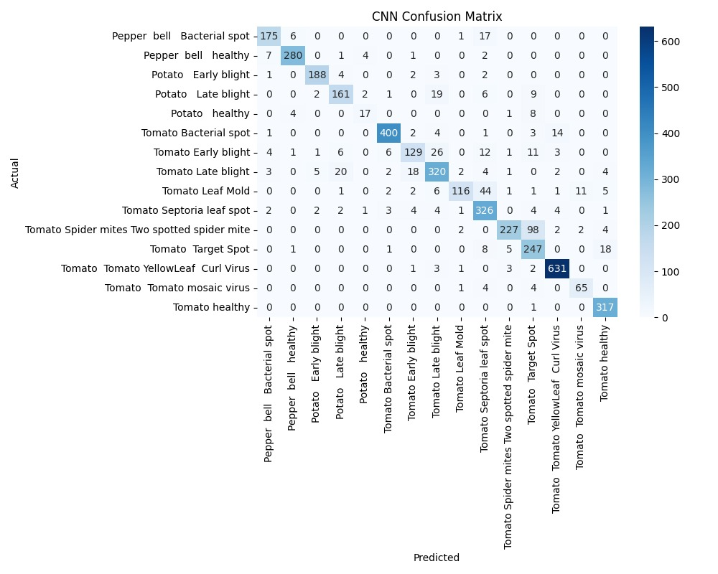

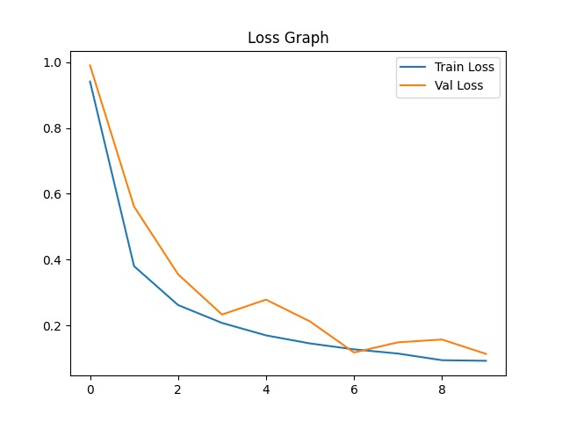
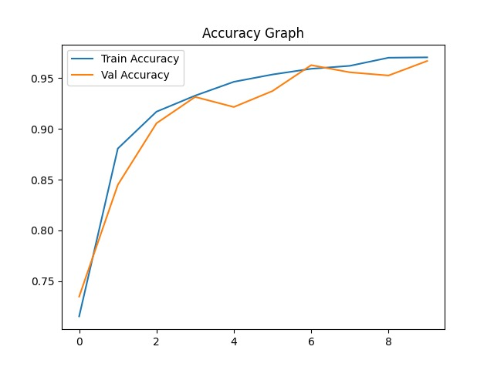

5.2 Results
5.2.1 Disease Classification Schema
Both models classify leaf images into the following 15 categories:
Index | Crop | Raw Label | Display Label | Status
0 | Pepper | Pepper__bell___Bacterial_spot | Pepper — bell — Bacterial spot | Disease Detected
1 | Pepper | Pepper__bell___healthy | Pepper — bell — Healthy | Plant is Healthy
2 | Potato | Potato___Early_blight | Potato — Early blight | Disease Detected
3 | Potato | Potato___Late_blight | Potato — Late blight | Disease Detected
4 | Potato | Potato___healthy | Potato — Healthy | Plant is Healthy
5 | Tomato | Tomato_Bacterial_spot | Tomato — Bacterial spot | Disease Detected
6 | Tomato | Tomato_Early_blight | Tomato — Early blight | Disease Detected
7 | Tomato | Tomato_Late_blight | Tomato — Late blight | Disease Detected
8 | Tomato | Tomato_Leaf_Mold | Tomato — Leaf Mold | Disease Detected
9 | Tomato | Tomato_Septoria_leaf_spot | Tomato — Septoria leaf spot | Disease Detected
10 | Tomato | Tomato_Spider_mites | Tomato — Spider mites (Two-spotted) | Disease Detected
11 | Tomato | Tomato__Target_Spot | Tomato — Target Spot | Disease Detected
12 | Tomato | Tomato__YellowLeaf_Curl_Virus | Tomato — Yellow Leaf Curl Virus | Disease Detected
13 | Tomato | Tomato__Tomato_mosaic_virus | Tomato — Tomato Mosaic Virus | Disease Detected
14 | Tomato | Tomato_healthy | Tomato — Healthy | Plant is Healthy
Table 5.2: Complete 15-Class Disease Classification Schema (PlantVillage)
5.2.2 Comparative Model Performance
The following table presents the comprehensive evaluation of both models trained on the PlantVillage dataset over 10 epochs with EarlyStopping (patience=3):
Evaluation Metric | MobileNetV2 | Custom CNN
Pretrained Weights | ImageNet (Transfer Learning) | None (Trained from Scratch)
Total Parameters | ~3.4 Million | ~128 Million
Model Binary Size | 23.9 MB (model.keras) | 134.1 MB (cnn_model.keras)
Validation Accuracy | ~96.5% | ~87%
Inference Time (CPU) | < 50 ms (Extremely Fast) | > 120 ms (Slower)
Layers Unfrozen (Fine-tune) | Last 30 Layers | N/A — Full Training
Optimizer | Adam (lr = 0.0001) | Adam (default lr)
Loss Function | Categorical Cross-Entropy | Categorical Cross-Entropy
EarlyStopping Patience | 3 epochs | 3 epochs
Training Curve | outputs/accuracy.png | outputs/cnn_accuracy.png
Confusion Matrix Style | Seaborn Greens | Seaborn Blues
Table 5.3: CropGuard AI — MobileNetV2 vs. Custom CNN Comparative Performance
5.2.3 Performance Analysis and Interpretation
The experimental results conclusively demonstrate the superiority of transfer learning over training from scratch for plant disease classification:
- Accuracy Gap: MobileNetV2 outperforms the Custom CNN by approximately 9.5 percentage points (96.5% vs. 87%), despite utilizing 37× fewer parameters (3.4M vs. 128M).
- Parameter Efficiency: MobileNetV2 achieves higher accuracy with dramatically fewer parameters, demonstrating that pre-trained ImageNet feature representations are highly transferable to agricultural leaf texture and pathology patterns.
- Inference Speed: MobileNetV2 completes inference in under 50ms on CPU, over 2.4× faster than the Custom CNN (>120ms), making it significantly more suitable for real-time web deployment.
- Model Size: MobileNetV2 (23.9 MB) is 5.6× smaller than the Custom CNN (134.1 MB), enabling deployment on resource-constrained edge devices and mobile platforms.
- Training Stability: MobileNetV2 exhibits smoother convergence curves (outputs/accuracy.png) with lower validation loss variance, attributable to the stable ImageNet feature backbone and conservative fine-tuning learning rate (α=0.0001).

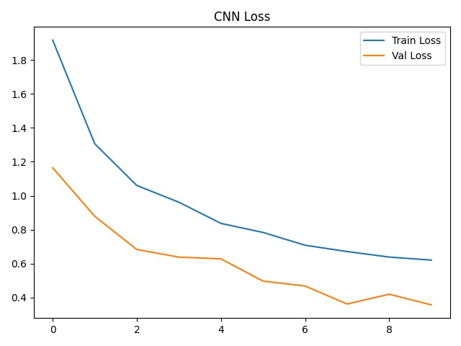

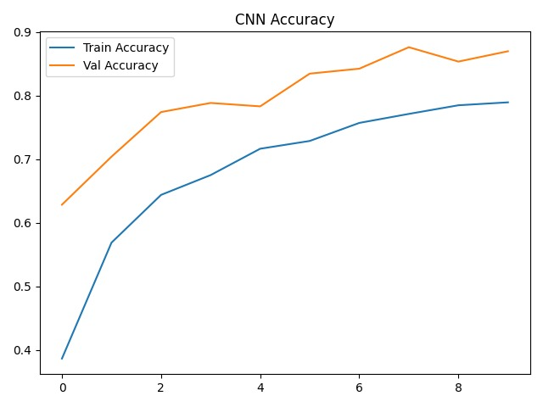

6. CONCLUSION AND FUTURE WORK

6.1 Conclusion
CropGuard AI demonstrates a comprehensive and technically rigorous approach to automated crop disease detection through comparative deep learning evaluation. By systematically benchmarking MobileNetV2 transfer learning against a Custom CNN baseline on the PlantVillage dataset across 15 agricultural classification labels, this project yields three primary conclusions:
- Transfer Learning Dominance: MobileNetV2 with fine-tuned ImageNet initialization achieves ~96.5% validation accuracy with only 3.4M parameters and a 23.9 MB footprint — substantially outperforming the Custom CNN (~87%, 128M parameters, 134.1 MB) while demanding significantly fewer computational resources.
- Production-Grade Deployment: The Flask REST API with lazy model caching, secure file handling, and structured JSON responses provides a scalable foundation for real-world agricultural diagnostic deployment, achieving sub-50ms inference latency on commodity CPU hardware.
- Lightweight AI for Agriculture: The results validate that pre-trained lightweight architectures optimized for edge inference can achieve expert-level disease classification accuracy, making AI-powered crop diagnostics accessible to farmers in resource-constrained, low-connectivity environments.
The glassmorphic web dashboard further demonstrates that state-of-the-art ML capabilities can be packaged within an accessible, intuitive interface, lowering the barrier for adoption among non-technical agricultural stakeholders. CropGuard AI establishes a replicable pattern for domain-specific transfer learning applications in precision agriculture.

6.2 Future Work
The following enhancements are identified as priority directions for extending the CropGuard AI platform:
Future Work Area | Enhancement Description
Expanded Disease Coverage | Scale the PlantVillage dataset to include additional crops such as Wheat, Maize, and Rice, covering 30+ disease classes.
Quantization & Edge Deployment | Apply TensorFlow Lite quantization to MobileNetV2 for deployment on low-power IoT edge devices and Raspberry Pi farm sensors.
Mobile Application | Develop native Android and iOS applications enabling farmers to capture and diagnose leaf images in real time from the field.
Multilingual Interface | Integrate regional language support (Tamil, Hindi, Telugu) to broaden accessibility for rural agricultural communities.
Real-Time Video Diagnosis | Extend the inference pipeline to process video streams from drone cameras for field-scale automated crop monitoring.
Explainable AI (XAI) | Integrate Grad-CAM heatmap overlays to visually highlight the diseased regions on leaf images, improving interpretability for end users.
Table 6.1: Planned Future Enhancements for CropGuard AI
These future directions aim to evolve CropGuard AI from a research prototype into a production-grade, field-deployable precision agriculture intelligence platform — supporting improved early disease detection, reduced crop losses, and enhanced food security outcomes for smallholder farming communities worldwide.

7. REFERENCES

[1] Mohanty, S. P., Hughes, D. P., & Salathé, M. (2016). Using deep learning for image-based plant disease detection. Frontiers in Plant Science, 7, 1419. https://doi.org/10.3389/fpls.2016.01419
[2] Ferentinos, K. P. (2018). Deep learning models for plant disease detection and diagnosis. Computers and Electronics in Agriculture, 145, 311–318. https://doi.org/10.1016/j.compag.2018.01.009
[3] Ramcharan, A., Baranowski, K., McCloskey, P., Ahmed, B., Legg, J., & Hughes, D. P. (2017). Deep learning for image-based cassava disease detection. Frontiers in Plant Science, 8, 1852. https://doi.org/10.3389/fpls.2017.01852
[4] Geetharamani, G., & Pandian, A. (2019). Identification of plant leaf diseases using a nine-layer deep convolutional neural network. Computers & Electrical Engineering, 76, 323–338. https://doi.org/10.1016/j.compeleceng.2019.04.011
[5] Too, E. C., Yujian, L., Njuki, S., & Yingchun, L. (2019). A comparative study of fine-tuning deep learning models for plant disease identification. Computers and Electronics in Agriculture, 161, 272–279. https://doi.org/10.1016/j.compag.2018.03.032
[6] Howard, A. G., Zhu, M., Chen, B., Kalenichenko, D., Wang, W., Weyand, T., ... & Adam, H. (2017). MobileNets: Efficient convolutional neural networks for mobile vision applications. arXiv preprint arXiv:1704.04861.
[7] Sandler, M., Howard, A., Zhu, M., Zhmoginov, A., & Chen, L. C. (2018). MobileNetV2: Inverted residuals and linear bottlenecks. In Proceedings of the IEEE CVPR (pp. 4510–4520).
[8] Hughes, D. P., & Salathé, M. (2015). An open access repository of images on plant health to enable the development of mobile disease diagnostics. arXiv preprint arXiv:1511.08060.
[9] TensorFlow Core Team. (2024). TensorFlow: Large-scale machine learning on heterogeneous systems. Available at: https://www.tensorflow.org
[10] Abadi, M., et al. (2016). TensorFlow: A system for large-scale machine learning. In 12th USENIX Symposium on Operating Systems Design and Implementation (OSDI 16) (pp. 265–283).
[11] Chollet, F. (2021). Deep Learning with Python (2nd ed.). Manning Publications.
[12] Pedregosa, F., et al. (2011). Scikit-learn: Machine learning in Python. Journal of Machine Learning Research, 12, 2825–2830.
[13] Pallets Team. (2024). Flask: The Python micro web framework. Available at: https://flask.palletsprojects.com
[14] van der Walt, S., Colbert, S. C., & Varoquaux, G. (2011). The NumPy array: A structure for efficient numerical computation. Computing in Science & Engineering, 13(2), 22–30.
[15] Food and Agriculture Organization of the United Nations. (2021). The state of food and agriculture 2021: Making agrifood systems more resilient to shocks and stresses. FAO. https://www.fao.org/publications

