Phase 2:
Excel
Employee ID | Name | Department
101 | Alice | Sales
102 | Bob | HR
103 | Charlie | IT
VLOOKUP:
VLOOKUP searches for a value in the first column of a table and returns a value from another column in the same row.
VLOOKUP(lookup_value, table_array, col_index_num, [range_lookup])
lookup_value: What you want to find.
table_array: The table where you search.
col_index_num: The column number to return. (1 = first column of table)
range_lookup: TRUE = approximate match, FALSE = exact match.
- Goal: Find the Department of Employee ID 102.
- Formula:=VLOOKUP(102, A2:C4, 3, FALSE)
XLOOKUP:
XLOOKUP can search anywhere in a table (not just first column) and return a value from left or right.
XLOOKUP(lookup_value, lookup_array, return_array, [if_not_found], [match_mode], [search_mode])
• lookup_value: Value to search.
• lookup_array: Column/row to search in.
• return_array: Column/row to return value from.
• if_not_found: Optional, value if not found.
• match_mode: Exact or approximate match.
• search_mode: Optional, search top→bottom or bottom→top.
- Goal: Find Name of Employee ID 103.
- Formula:
=XLOOKUP(103, A2:A4, B2:B4, "Not Found")

Advantages of XLOOKUP over VLOOKUP:
- Works left or right.
- Can return custom “not found” message.
- Easier syntax; no need for column index number.
INDEX + MATCH better than VLOOKUP/XLOOKUP

Goal: Find the Department of Employee ID 102.
Step 1 – Find row number of Employee ID 102 using MATCH:
=MATCH(102, A2:A4, 0)
- Result: 2 (Employee ID 102 is in the 2nd row of the range)
Step 2 – Get Department using INDEX:
=INDEX(C2:C4, MATCH(102, A2:A4, 0))

Purpose
- INDEX → Returns a value from a specific row and column in a range.
- MATCH → Finds the position of a value in a range.
- Combined: MATCH tells INDEX which row (or column) to return, allowing flexible lookups left or right

Pivot Tables & Pivot Charts

1️⃣ Purpose
- Pivot Table: Quickly summarizes large datasets—totals, averages, counts, and trends.
- Pivot Chart: Visualizes pivot table data in charts—bar, line, column, pie, etc.

2️⃣ How Pivot Tables Work
Imagine this sales data:
Date | Product | Region | Sales
01-Jan | Pen | East | 100
01-Jan | Pencil | West | 50
02-Jan | Pen | East | 200
02-Jan | Pencil | West | 70
Goal: Find total sales by Product.
Steps:
- Select data → Insert → Pivot Table
- Drag Product to Rows
- Drag Sales to Values → It automatically sums the sales
Result:
Product | Sum of Sales
Pen | 300
Pencil | 120

3️⃣ Pivot Chart
- Select the pivot table → Insert → Pivot Chart → choose chart type (Bar, Column, Pie)
- Example: Column chart showing total sales per product
- Makes data easy to visualize trends and comparisons

4️⃣ Key Features
- Drag & drop fields to rows, columns, values, filters
- Summarize by sum, average, count, max, min
- Filter data using Slicers for interactivity
- Pivot Charts update automatically when Pivot Table changes

✅ Tip for Candidates
- Use Pivot Tables for quick reporting
- Use Pivot Charts to present results visually

SQL
- Create a database named training
CREATE DATABASE training;
USE training;
- Create a table sales
CREATE TABLE Sales (
OrderID INT PRIMARY KEY,
ProductName VARCHAR(50),
Category VARCHAR(50),
Quantity INT,
Price DECIMAL(10,2),
Sales INT,
City VARCHAR(50),
OrderDate DATE
);
3)Insert Data into the tables
INSERT INTO Sales (OrderID, ProductName, Category, Quantity, Price, Sales, City, OrderDate)
VALUES
(1, 'Laptop', 'Electronics', 5, 50000, 250000, 'Chennai', '2026-01-01'),
(2, 'Mobile', 'Electronics', 10, 15000, 150000, 'Mumbai', '2026-01-02'),
(3, 'Chair', 'Furniture', 20, 2000, 40000, 'Bangalore', '2026-01-03'),
(4, 'Desk', 'Furniture', 15, 5000, 75000, 'Chennai', '2026-01-04'),
(5, 'Headphones', 'Electronics', 50, 2000, 100000, 'Mumbai', '2026-01-05');
Task: to insert onw more row to the table:
INSERT INTO Sales (OrderID, ProductName, Category, Quantity, Price, Sales, City, OrderDate)
VALUES
(6, 'Tablet', 'Electronics', 8, 20000, 160000, 'Delhi', '2026-01-06');
If you are adding values for every column in order, you can skip column names:
Alternative (shorter way
INSERT INTO Sales
VALUES (7, 'Mouse', 'Accessories', 30, 800, 24000, 'Chennai', '2026-01-07');
To delete data from a row
DELETE FROM Sales
WHERE OrderID = 5;
to permanently remove rows
all rows will change
UPDATE Sales
SET Sales = 0;
5)UPDATE — To CHANGE existing data
UPDATE Sales
SET Sales = 300000
WHERE OrderID = 1;

4)Write a query to display the entire table
SELECT * FROM Sales;
5)to display only the top 4 row?
SELECT * FROM Sales limit 4;
6)to display only 2 columns
SELECT Price,Sales
FROM Sales;

7)to calculate total sales:
SELECT SUM(Sales)
FROM Sales limit 1;
8)Now change the column name to meaningful name
SELECT SUM(Sales) as totalSales
FROM Sales limit 1;
9) calculate sales based on city
SELECT city,SUM(Sales) as totalSales
FROM Sales group by city;

Learn the following thing before coming to next session:
COUNT(*),COUNT(column), COUNT(DISTINCT City),JOIN IN SQL

PHASE 3
Selecting other table of another database // best practise
SELECT * FROM Factory.employees;
Syntax= db name . table name
Addition in select statement
SELECT name ,age,age+10 FROM Factory.employees;
Note:DB follow PEMDAS rule
Showing data without repeating
Select distinct gender from Factory.employees;
Like statement
Select * from Factory.employees where first_name LIKE ‘%er%’
Note:if we add% in prefix then it means some letter will come before and if it in suffix then it means somethins will come after .and is mostly useful for date as just specify year…
SQL Nested Queries
A nested query (or subquery) is a SQL query written inside another query to solve complex data problems. The inner query executes first and passes its result to the main query.
Types of Nested Queries in SQL
There are two primary types of nested queries in SQL:

1. Independent Nested Queries
In an independent nested query, the execution of the inner query is independent of the outer query. The inner query runs first and its result is used directly by the outer query. Operators like IN, NOT IN, ANY and ALL are commonly used with independent nested query.
2. Correlated Nested Queries
In correlated nested queries, the inner query depends on the outer query for its execution. For each row processed by the outer query, the inner query is executed. This means the inner query references columns from the outer query. The EXISTS keyword is often used with correlated queries
STUDENT Table

STUDENT Table
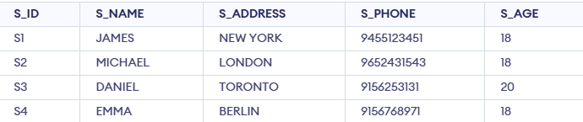
COURSE Table
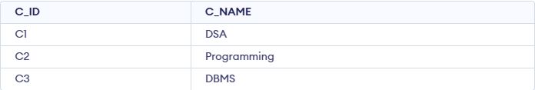
STUDENT_COURSE Table
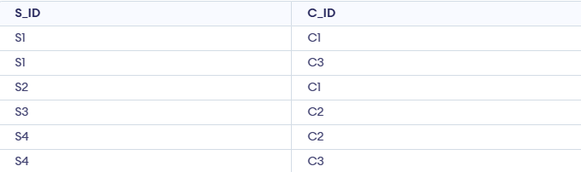

Example 1: Using IN

Question: query retrieves the IDs of the courses named 'DSA' or 'DBMS' from the COURSE table.
SELECT C_ID FROM COURSE WHERE C_NAME IN ('DSA', 'DBMS');
Question: query retrieves the student IDs associated with those courses from the STUDENT_COURSE table.
SELECT S_ID FROM STUDENT_COURSE
WHERE C_ID IN (
SELECT C_ID FROM COURSE WHERE C_NAME IN ('DSA', 'DBMS')
);
Question: Retrieve student names who enrolled in ‘DSA’ or ‘DBMS’:
SELECT S_NAME FROM STUDENT
WHERE S_ID IN (
SELECT S_ID FROM STUDENT_COURSE
WHERE C_ID IN (
SELECT C_ID FROM COURSE WHERE C_NAME IN ('DSA', 'DBMS')
)
);
Explanation:

The innermost query fetches course IDs of ‘DSA’ and ‘DBMS’.
The middle query finds student IDs enrolled in those courses.
The outer query retrieves names of those students.

Example 2: Using EXISTS
Qusetion:find the names of students who are enrolled in the course with C_ID = 'C1':
SELECT S_NAME FROM STUDENT S
WHERE EXISTS (
SELECT 1 FROM STUDENT_COURSE SC
WHERE S.S_ID = SC.S_ID AND SC.C_ID = 'C1'
);
Explanation: For each student, the inner query checks if they are enrolled in C1. If yes, that student’s name is returned.
Homework:
NOT IN OPERATOR
Retrieve student IDs not enrolled in ‘DSA’ or ‘DBMS’
ANY OPERATOR
Retrieve student names whose age is greater than at least one student from
ALL OPERATOR
Retrieve student names whose age is greater than all students from Delhi

