- Create branch feature-login.
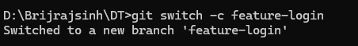

- Switch to it.


- Add a file login.html.

- Commit the changes.
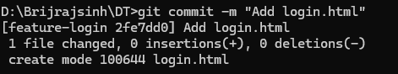
- Display all branches.


- Create branch feature-contact.

- Add contact.html. and commit changes.
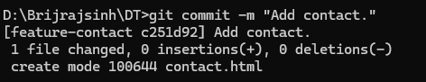

- Switch to main branch.
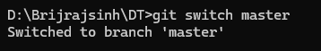

- Merge feature branch.
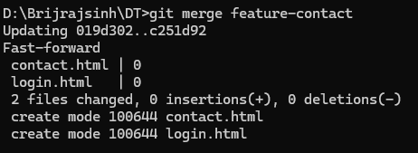

- Verify merged content.
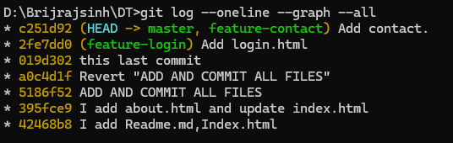

- Create branch feature-ui.

- Attempt merge.


- Resolve conflict manually.
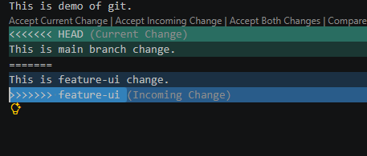

- Complete merge