1 Verify Git installation.

2 Configure username and email.

3 Create a folder GitLab.

4 Initialize it as a Git repository.

5 Check repository status.

6 Create a file README.md and add basic project information

7 Create files: index.html, style.css, script.js

8 Stage all files and commit the changes.

9 View commit history.

10 Modify index.html.

11 Create about.html.

12 Check repository status.

13 Stage only one file.

14 Compare status before and after staging
\

15 Modify style.css.
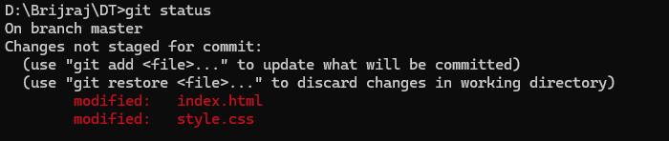

16 Restore original version.
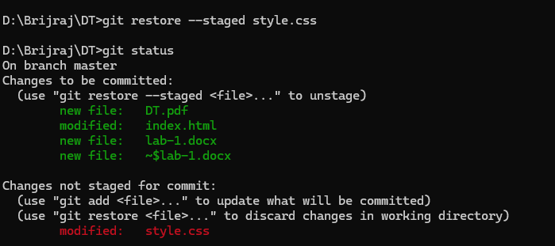

17 Create and commit another change.
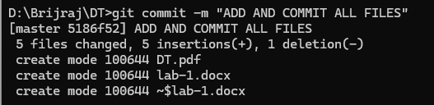

18 Undo the latest commit while keeping changes.
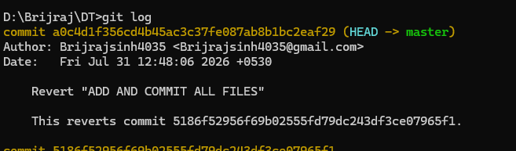

19 Undo the latest commit permanently.
