**CS Math Society**

**Equation Solver**

# **Team members**

Omar Adel Abdel Hamid Ahmed Brikaa - 20206043

Ali Esmat Ahmed Orfi - 20206123

Mostafa Hesham Ragab Allam - 20206126

# **Submitted to**

Dr. Eng. Mostafa Reda A. El Tantawi

# **Project Description**

This tool calculates the roots of the quadratic equations using the general formula. The tool also works with linear equations. The user inputs the coefficients of and the constant. It is planned to use the tool for cubic equations as well as quadratic equations.

# **Using the tool**

**Step 1:** Open **index.html**, if it doesn't open in a web-browser choose "open with" and your preferred browser



**Step 2:** The tool will open in a web-browser, choose **equation solver**.

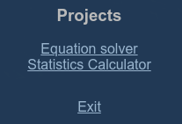

**Step 3:** Enter the coefficients of and the constant in the empty text boxes. You can leave the text box empty if the desired value is zero.

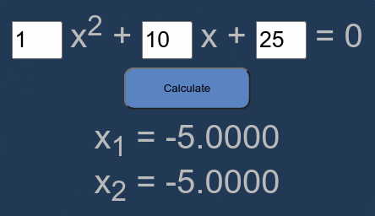

# **Pseudocode**

0. start (calculate button)

1. int a, b, c

2. string x1, x2

3. if textbox_a is empty

3.1 x1 = -c / b, x2 = N/A

3.2 exit

4. if textbox_b is empty

4.1 b = 0

5. if b ^ 2 - 4ac < 0

5.1 x1 = -b / 2a + (sqrt(-(b ^ 2 - 4ac)) / 2a)i

5.2 x2 = -b / 2a - (sqrt(-(b ^ 2 - 4ac)) / 2a)i

5.3 exit

6. x1 = (-b + sqrt(b ^ 2 - 4ac)) / 2a

7. x2 = (-b - sqrt(b ^ 2 - 4ac)) / 2a

8. exit