**CS Math Society**

**Statistics Calculator**

# **Team members**

Omar Adel Abdel Hamid Ahmed Brikaa - 20206043

Ali Esmat Ahmed Orfi - 20206123

Mostafa Hesham Ragab Allam - 20206126

Ahmed Wael Nagy Wanas - 20206008

# **Submitted to**

Dr. Eng. Mostafa Reda A. El Tantawi

# **Project Description**

This tool sorts an array and does different statistical calculations on the array.

# **Using the tool**

**Step 1:** Open **index.html**, if it doesn't open in a web-browser choose "open with" and your preferred browser



**Step 2:** The project will open in a web-browser, choose **Min Max Sort**.



**Step 3:** Enter the values of the array separated by a space and click **sort**.

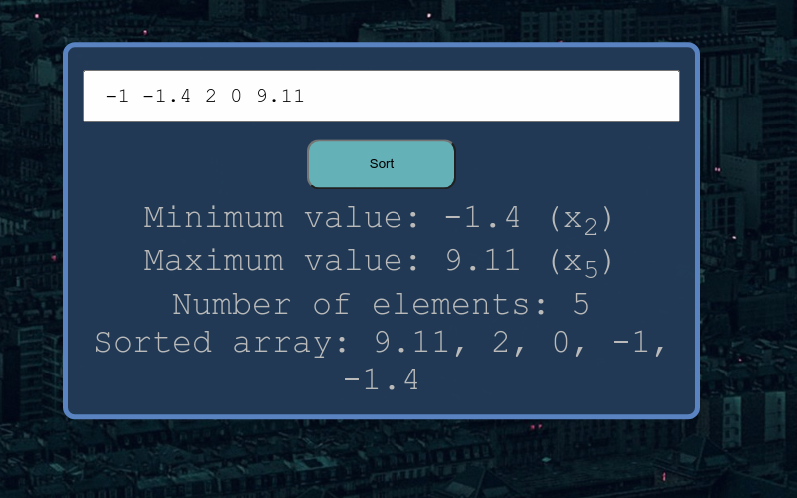

# **Pseudocode**

0. Start

1. array inputs = []

2. for i = 0, i < 5, i++

2.1 input inputs[i]

3. If array.length == 0

3.1 exit

4. inputs.sort(desc)

5. print inputs

5. if inputs.count(inputs[0]) == 5

5.1 output minimum = maximum

5.2 exit

6. maximum = inputs[0], minimum = inputs[4]

7. print minimum

8. for i in inputs

8.1 if inputs[i] == maximum

8.1.1 print inputs[i] + " is maximum"

8.2 if inputs[i] == minimum

8.2.1 print inputs[i] + " is minimum"

9. exit