**CS Math Society**

**Quadratic Formula Calculator**

# **Team members**

Omar Adel Abdel Hamid Ahmed Brikaa - 20206043

Ali Esmat Ahmed Orfi - 20206123

Mostafa Hesham Ragab Allam - 20206126

# **Submitted to**

Dr. Eng. Mostafa Reda A. El Tantawi

# **Project Description**

This tool calculates the roots of the quadratic equations using the general formula. The tool also works with linear equations. The user inputs the coefficients of $x^{2}, x$ and the constant.

# **Using the tool**

**Step 1:** Open **index.html**, if it doesn't open in a web-browser choose "open with" and your preferred browser



**Step 2:** The tool will open in a web-browser, click **start**.



**Step 3:** Enter the coefficients of $x^{2}, x$ and the constant in the empty text boxes. You can leave the text box empty if the desired value is zero.

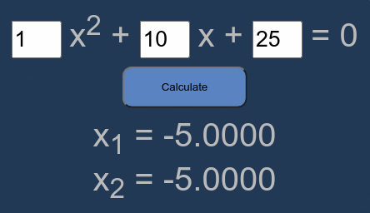

# **Pseudocode**

0. start (calculate button)

1. int a, b, c

2. string x1, x2

3. if textbox_a is empty

3.1 x1 = -c / b, x2 = N/A

3.2 exit

4. if textbox_b is empty

4.1 b = 0

5. if b ^ 2 - 4ac < 0

5.1 x1 = -b / 2a + (sqrt(-(b ^ 2 - 4ac)) / 2a)i

5.2 x2 = -b / 2a - (sqrt(-(b ^ 2 - 4ac)) / 2a)i

5.3 exit

6. x1 = (-b + sqrt(b ^ 2 - 4ac)) / 2a

7. x2 = (-b - sqrt(b ^ 2 - 4ac)) / 2a

8. exit