Genetic Algorithm’s and Their Use in Randomised Game states. | Abstract  Genetic algorithms are an iterative artificial intelligence (AI) optimisation technique designed to have each agent’s actions based upon the actions of a previous selection of agents. These algorithms are designed to mimic the behaviour of evolutionary principles and natural genetic operations such as reproduction, crossover and mutation. Genetic Algorithms have the benefits of being naturally parallel in their execution leading to increased efficiency. Genetic algorithms have several key steps involved in their execution, each of which is crucial for the algorithm to properly function. These are; the population generation of AI agents, the attempts of these agents to complete a task, the evaluation of those agents in terms of their fitness for purpose and the creation of the next generation. The full process of this will be explained within this report. Genetic algorithms such as Smart Rockets (Thorpe, 2016) and Box Car 2D (Boxcar2d.com, 2018) have the same basic premise. This premise is; each member of each generation has the same start state. This means that for every member of the generation must face the same generated or designed trials. The purpose of this report is to determine the ability of a traditional genetic algorithm to handle a random game state. The way this shall be tested is through the creation of a genetic algorithm which is designed to attempt to play through a simplified version of the game Frogger,(found at: https://github.com/Brackeys/Frogger-Replica) a game known for its need to avoid obstacles to reach a goal.  David Hesketh S1437170  Artificial Intelligence, Module Leader; David Moffat

- Introduction
3.1 Glossary of Terms
Certain terms will be used over the course of this report which can have multiple meanings in the English language. The use of these terms will be defined to ensure full comprehension of this report.
Population – A collection of AI agents who’s genes act as the basis of the genes for the next generation of AI agents.
Fitness – A function used to determine the successfulness of the agent in its attempted task.
DNA – A class used to hold a collection of attributes with the intent of filling the genes of the related AI agent and its child.
Genes – An array of integers, each of which corresponds to an action to be taken by the AI agent.
3.2 Genetic Algorithms Explained
A genetic algorithm is an artificial intelligence technique inspired by Charles Darwin’s Theory of Evolution. This is the theory that an organism will adapt to its environment based on a “Survival of the Fittest” ideal. It posits, in simple terms, that those best suited to their environment will be most likely to breed and as such pass on their ability survive to offspring which then would have greater ability to survive and as such be more likely to breed. This cycle is where the work behind the genetic algorithm begins.
Breaking this down piece by piece is the best way to fully understand the process behind the genetic algorithm which itself is broken into five phases (Mallawaarachchi, 2017). These five phases are; Initial Population, Fitness Function, Selection, Crossover and Mutation. To understand a general genetic algorithm each of these phases will be explained.
Initial Population: This is the first phase of any genetic algorithm and, as the name would imply, a population is generated. Each member of this population holds a DNA object, which in turn holds a collection of genes. The agents within this population, having no previous generation or gene pool to draw from have randomised genes. Each of the members of this population effectively act as a potential solution to the problem the algorithm is designed to solve.
Fitness Function: The fitness function is integral to the creation of the algorithm. The evaluation of this is what is used to determine how successfully the member of the population has solved the provided problem. Fitness functions can have incredibly simple operators such as, the closer the agent is to the goal at time of evaluation, the higher their fitness. However, this does not have to be the case. The fitness function can have more complicated operators, for example; the agent who most closely followed a predetermined path could have the highest fitness level. They can also combine simple operators to allow more complex behaviour, an example of this would be; The base fitness increases as the agent gets closer to a goal. However, if the agent stops moving for more than two ticks its fitness is reduced by five percent and if the it reaches the goal its fitness is multiplied by three. Truly the fitness function can be as simple or complicated as the developer wishes to make it. The fitness function determines the success of a member of the population by making it more likely to be selected in the next phase of the algorithm.
Selection: This is the phase of the algorithm which determines which of the members of the current population will be allowed to breed and pass on their genes into the next generation. As previously mentioned, this is based on the fitness function of the chosen agent. The selection itself can take place in a variety of ways. All are aimed at ensuring that those with a higher fitness score are more likely to be chosen as parents than those who have a lower fitness score. Selection can be done manually by programming it so the top tier of the population is selected for the crossover process to increase the likelihood for success of each subsequent generation. This does not however follow nature because while those who have the very best fitness for their environment may be the most likely to reproduce, they are often not the only ones. To more closely mimic the natural process, often, a mating pool is created, and each member of the population is added to this pool a number of times based upon their fitness value. The parents are then chosen at random from the pool, this way those with a higher fitness function are more likely to be chosen, however they are not the only ones to be
Crossover: The crossover phase is the process of taking a selection of genes from the two parents and combining them to create the genes for a member of the next generation’s population. This can be done in a massive variety of ways entirely up to the programmer of the algorithm. The crossover can take the first half of the genes from parent A and the second half from parent B, it can take a random number of genes from each parent, it can take one from parent A and the remainder from parent B. This is another instance, like the fitness function, where a limit to the number of ways in which the programmer can manipulate the crossover of the genes is varied to the point where it is almost personal to them how it is done.
Mutation: Once the new population has been generated and their genes have been filled by the previous population they undergo a process known as mutation. Mutation in a genetic algorithm is a way to ensure that the algorithm itself does not get stuck in a specific series of genes. An array of genes is looped through and each one has a low random chance to, instead of remaining from the parent, become a completely random gene. For example; if each gene has the potential of being a number between one and five and the array of genes has a size of ten. It is possible that, due to the parents, the genes of the child have the first three elements being one and the remaining seven being two. After being subject to mutation, the genes have the potential to be different. Mutation rate has to be carefully considered. If this rate is too high then each population has a chance of being totally random, if the mutation rate is too low then there is a chance of the algorithm running into a loop of the same genes with a relatively high but lower than one hundred percent fitness (The Coding Train, 2016). Typically, a low (non-zero) mutation chance allows children to inherit from parents while reducing the chance of a loop of the same genes. Once the mutation process has taken place, the new population is generated.
Once the next generation is created it acts as a new set of potential solutions to the desired problem and the process starts again, looping until an end point determined by the developer.
- Problem
  - Frogger
Every genetic algorithm is designed to determine or optimise a solution to a specific problem. This project has been undertaken in order to attempt to play a simplified version of the arcade game Frogger in order to showcase the ability of a genetic algorithm to play or fail to play a game in which the game state may be constantly changing.
  - Explain Chosen Solution
An algorithm will be developed to determine a solution to the problem of Frogger, using a traditional Genetic Algorithm format. The reason for this is genetic algorithms traditionally create a self-optimising solution to a problem. With the ideal being each new generation being slightly more successful than the last.
- Code Example
  - Development Description
The development of this algorithm was done in the Unity Game Development Environment in the C# programming language. Originally the project was going to be developed in NetLogo using the provided Frogger model. However, the transfer from an object-oriented paradigm to the heavily abstracted principles contained within the netlogo language proved to be overly complex for the given time frame within which the development solution also had to be researched and fully understood. Throughout the research phase of this project a variety of possible development solutions presented themselves. These were traditional genetic algorithms, an algorithm that combined a genetic algorithm with sensory input, and an algorithm which combined a genetic algorithm with a classifier system. The chosen result was that of a traditional genetic described as traditional as the only influence on an agent’s behaviour is the ability of its previous generation to survive and the possibility of mutation. The reason behind this was a simple one, to be able to properly research, understand and document the successes and failings of this versatile technique, other techniques could not be combined with it as this may have skewed the results and caused successes or failures based on the additional feature as opposed to the genetic algorithm.
  - Code Description
The algorithm has been developed in the same way as the stages in which it was described in this report, developing from the initial population generation up to the mutation of the next generation. A step-by-step overview of the execution of the code will be done to ensure readers fully grasp the concepts and development of this algorithm.
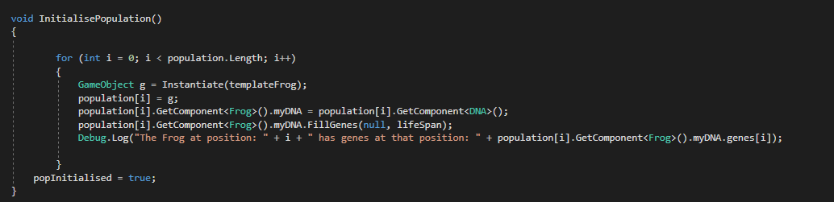Fig 1. The initial population generation function
The population object in this Genetic Algorithm is an array of GameObjects 200 long each of which holds a 2D Rigidbody, a DNA script, a Frog script, a 2D Circle Collider, a sprite renderer and a Transform. Upon start of the algorithm a tick count is set to 0, this is to ensure that the agents do not attempt to act past their lifespan. And the population is initialised. Within this function the population is generated and instantiated. Then the agents execute their genes one at a time. The genes themselves are a 15 long array of integers.
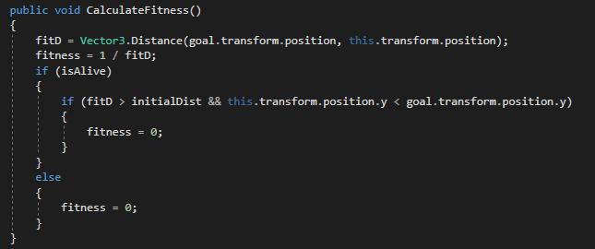
Fig 2. Fitness evaluation function
The evaluation of the fitness of the agent occurs each frame. The base fitness function has an inverse linear correlation with the distance between the agent and the its goal. As a preventative measure should the agent die they are removed from the potential gene pool, and should the agent move below the limits of the screen they are also removed from the gene pool. There is also a multiplier of 10 applied to the fitness of an individual should it successfully reach the goal.

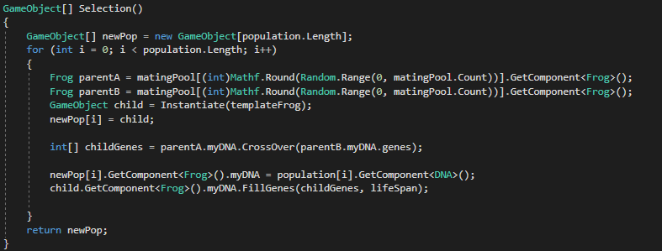Fig 3. Selection Function
Fig 4. Mating Pool Generation
The selection function is used to determine which of the agents should be used as parents. And generate a new population from them. A mating pool is generated with each agent being added a number of times equal to their fitness level multiplied by 100. This way, those with the highest fitness are added much more times than those with a lower fitness, making them more likely to breed. The selection function returns a new population based upon the parents within this mating pool.

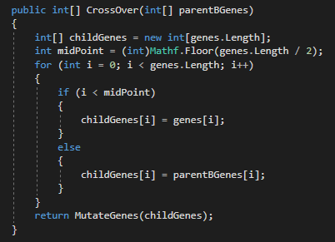
Fig 5. Crossover Function
The crossover function takes place in the DNA object assigned to each agent. It takes in the genes of the second parent for crossover. The crossover chooses the midpoint of the gene array and then subsequently has all of the genes prior to that point be inherited from the parent A and the remainder inherited from the provided genes from parent B. The mutation function is then called.
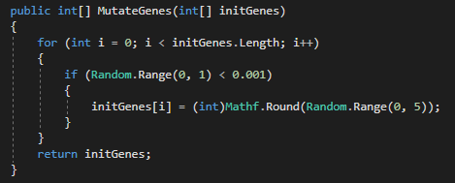
Fig 6. Mutation Function
The mutation function is rather simple in terms of its use. The function takes in a set of genes and for each gene it generates a random number. Using a 0.1% likelihood of mutation has a chance of generating a random action as opposed to the current action within the given gene. Once this mutation has occurred for each gene in each member of the new population, that population is produced and the cycle continues.
  - Other Options
Sensory Input – Allowing the agent to receive visual input was considered. Initially this seemed a favourable solution, the reason for this being that as an agent saw a threat it would allow it to react and avoid the threat or wait for it to pass. This however comes with the issue of influencing the behaviour of the agent over its genes. This, while more effective in the playing of Frogger, would have skewed the results of the tests of the algorithm to a positive bias. For this reason, the use of sensory input was discounted as an option. However, the use of a sensory input should be considered for future problems of a similar nature if there is not the specific constraint of using a different AI technique.
Learning Classifier System (LCS) – The suggestion of combining a genetic algorithm with a LCS was considered over the course of this project as well. A LCS is a rule-based machine learning system which combines discovery with learning. The consideration was to use the genetic algorithm to select from rule sets to generate new rule sets, treating the classifiers of the algorithm as the population for the genetic algorithm. This the contextual relationship between certain values and a prediction, typically taking the form of an {IF:THEN} expression. For example, a classifier relating to vehicles may have the prediction {IF ‘has engine’ AND ‘only 2 wheels’ THEN ‘Motorbike’}. The Genetic Algorithm is used to select parent classifiers in an attempt to optimise these classifiers. This was decided against due to the complexity of the classifier system versus the time constraints of this project. However, had the project had a longer development cycle this method would have been more fully explored.
- Evaluation of the algorithm
5.1 Was it successful/unsuccessful
In terms of the development project this algorithm was very successful, it effectively showcases the merits and failings of the traditional genetic algorithm format used in programs such as Smart Rockets and Box Car 2D. However due to the iterative nature of Genetic algorithms and the randomness of the start state. The algorithm itself was not allowed to build upon previous knowledge as that knowledge had become irrelevant by the time the next generation had come around. This meant that each generation may as well have had random genes as their genes were based on information for obstacles that no longer existed.
5.2 Improvements
The algorithm itself was by no means perfect. As such there are a variety of ways that, had time constraints been less severe and had research occurred on these improvements earlier in development time, it could have been improved. For example, if the project was being done over a Learning Classifier System (LCS) with emphasis on the genetic algorithmic component would have been developed. If the LCS had been researched earlier and more thoroughly it is likely It would have proven to be a more effective demonstration of genetic algorithmic principles whilst also successfully navigating a random environment. This is because if generating a sequence of actions, the algorithm would generate a ruleset for the agent to follow.
Within the algorithm that was developed improvements that could be considered include; a larger population, this would allow more variance in the initial population which can allow a greater variety of moves. This was not feasible simply due to the amount of time it took to allow the number of agents to execute their moves providing them with one frame per gene meant that allowing them to run individually through the level took a total of 3000 frames. Also, had the algorithm been developed following this report the population would have executed their actions in unison, this would have had two effects; firstly this would have made the population more likely to survive as once the agents had stopped moving they became more likely to be hit by an obstacle and secondly, it would have allowed larger populations as the entire population would only take 15 frames to complete.

- References
The Coding Train. (2016). 9.3: Genetic Algorithm: Shakespeare Monkey Example - The Nature of Code. [Online Video]. 30 July 2016. Available from: https://www.youtube.com/watch?v=nrKjSeoc7fc&index=3&list=PLRqwX-V7Uu6bJM3VgzjNV5YxVxUwzALHV. [Accessed: 10 April 2018].
Thorpe, J. (2016). SmartRockets. [online] Blprnt.com. Available at: http://www.blprnt.com/smartrockets/ [Accessed 9 Apr. 2018].
Boxcar2d.com. (2018). BoxCar2D. [online] Available at: http://boxcar2d.com/ [Accessed 9 Apr. 2018].
Mallawaarachchi, V. (2017). Introduction to Genetic Algorithms — Including Example Code. [online] Towards Data Science. Available at: https://towardsdatascience.com/introduction-to-genetic-algorithms-including-example-code-e396e98d8bf3 [Accessed 10 Apr. 2018].
Brackeys. (2017). Frogger-Replica. [online] Github. Available At: https://github.com/Brackeys/Frogger-Replica [Accessed 30 Mar. 2018]

