CTQA Windows Installation Guide

Author: Reece Walsh

Project Website: <https://github.com/brikwerk/ctqa>

1. Please download a compatible release distribution from [here](https://github.com/Brikwerk/ctqa/releases)

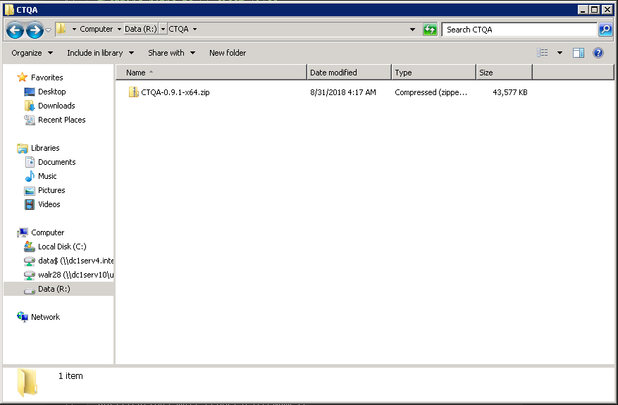

1. Extract the executable to a sensible location. Please keep in mind that the windows distribution of CTQA will create extra files and folders.

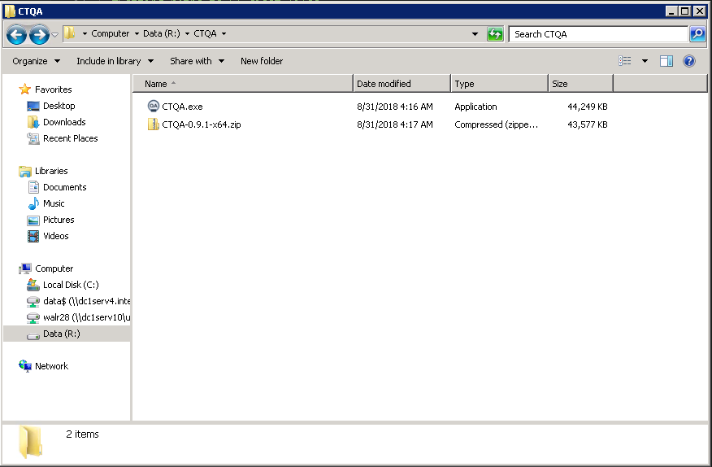

1. Run the executable. It's recommended to agree/follow the first run setup.

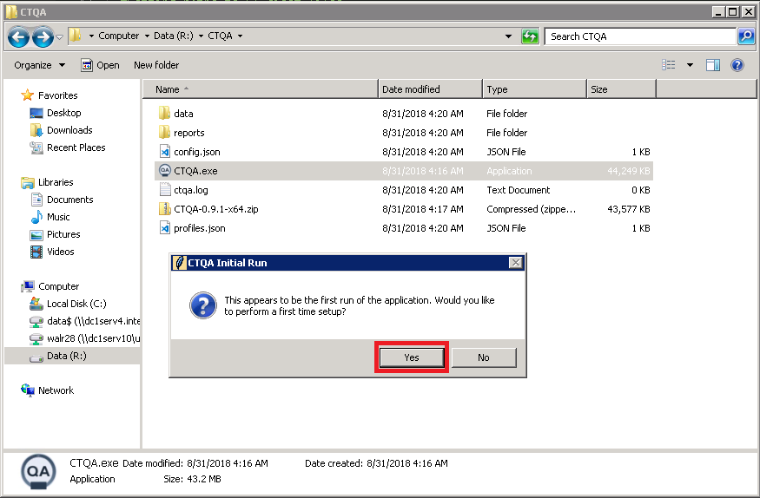

1. Press OK when the prompt comes up and fill in the configuration values with appropriate values. For this guide, the TEST source will be used for configuration.

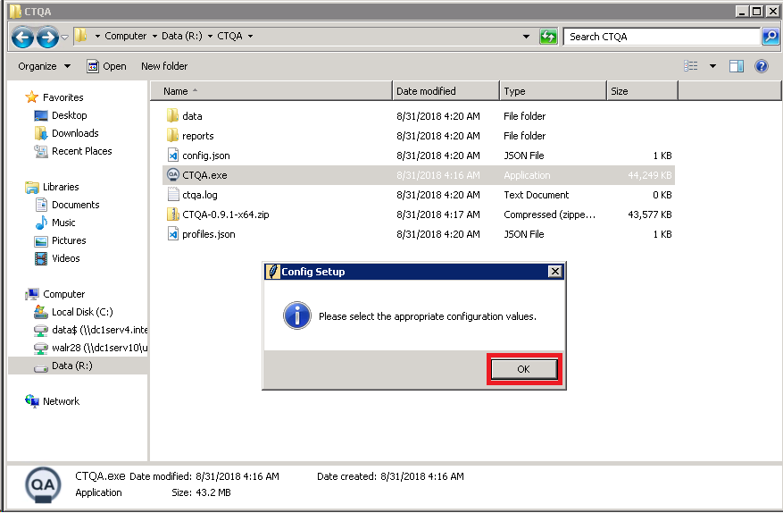

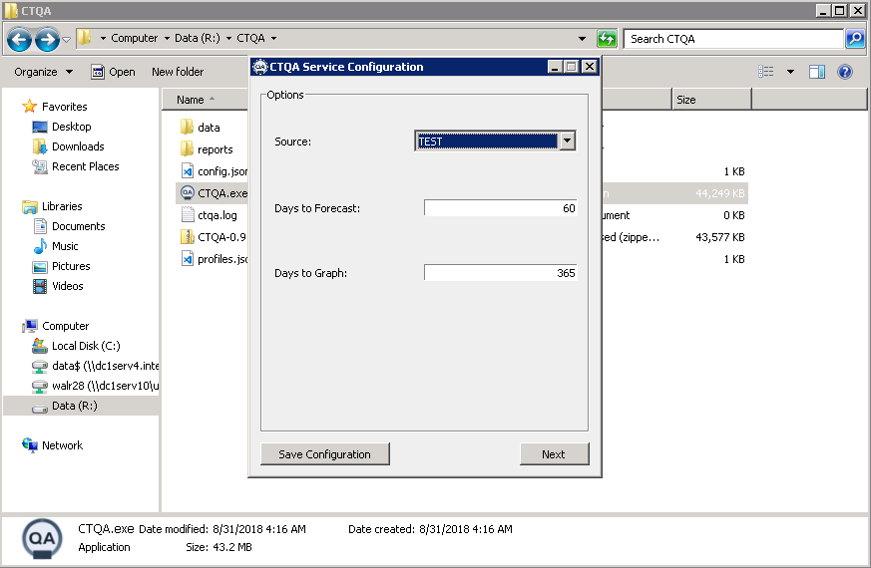

1. Click “Save Configuration” and click “Next”

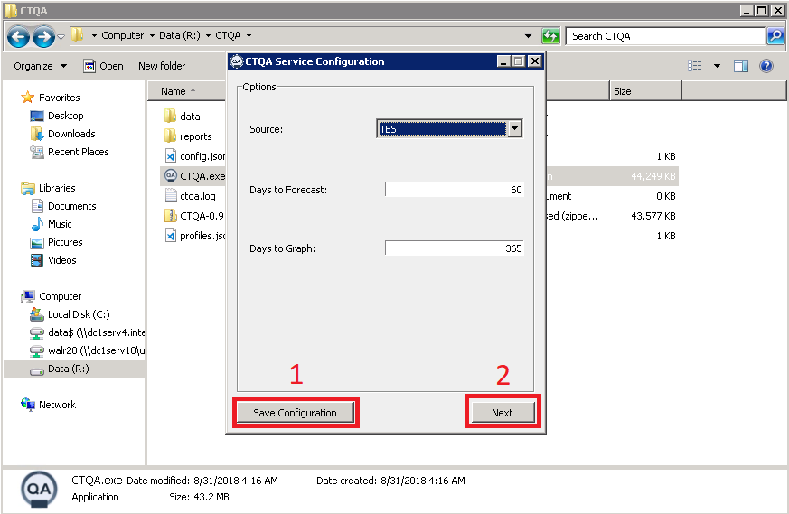

1. Click “OK” on the next prompt

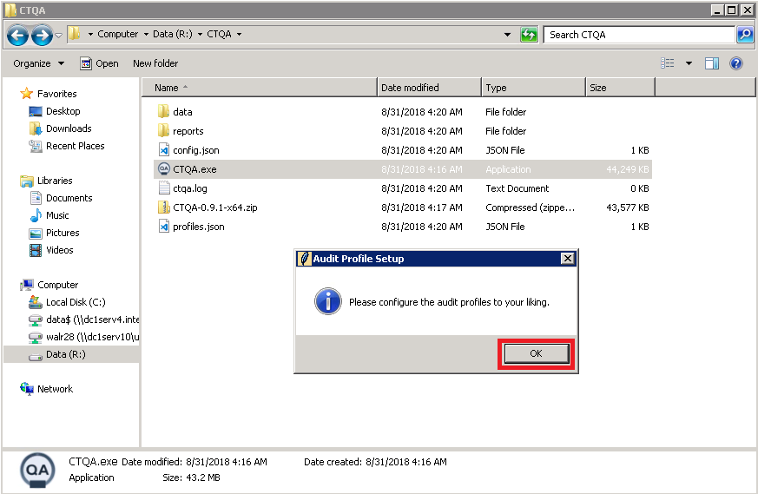

1. The audit profile window will open. If you know what the StationName, Manufacturer, ManufacturerModel, and Institution tags are going to be in the DICOM header for the machine, you can (A) manually fill out a profile. If your image source is already populated, however, CTQA can automatically populate the audit profile (B) list with all machines present on the server. Choose one of the two options and click “Next” when done.

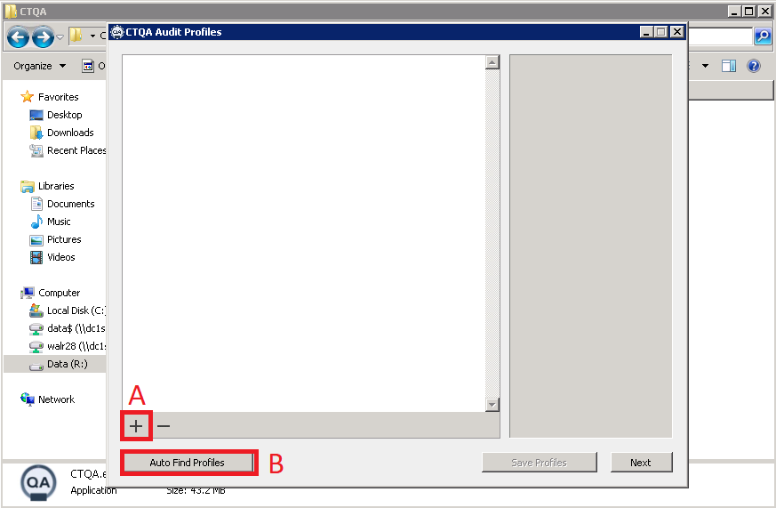

1. If you proceed with auto find profiles (Option B), click “Yes” on the Image Download prompt and click “Next” when the profiles have appeared.
2. If you proceed with manually adding profiles, enter the necessary values from the DICOM header that were mentioned above. Click “Save Profiles” once done and click “Next”.
3. The main user interface for CTQA should open up.

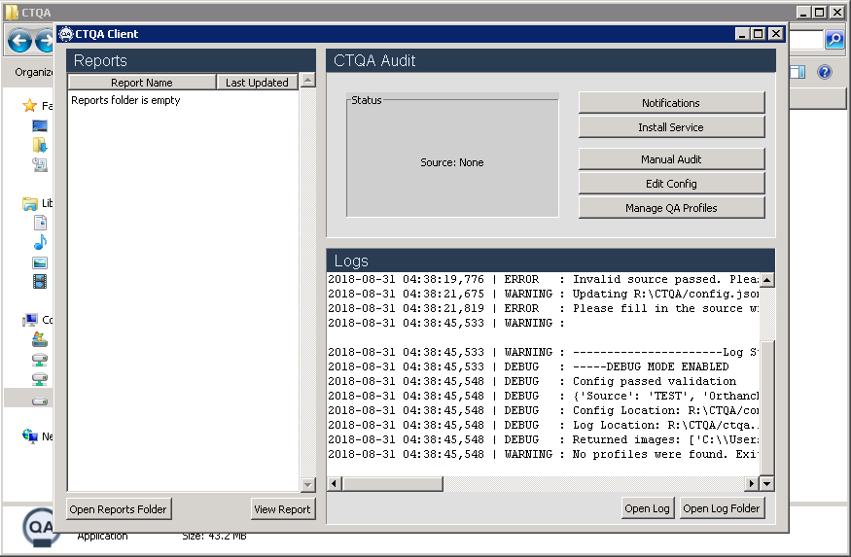

1. If you do not wish to setup email notifications, skip steps 12-14
2. Click the “Notifications” button.

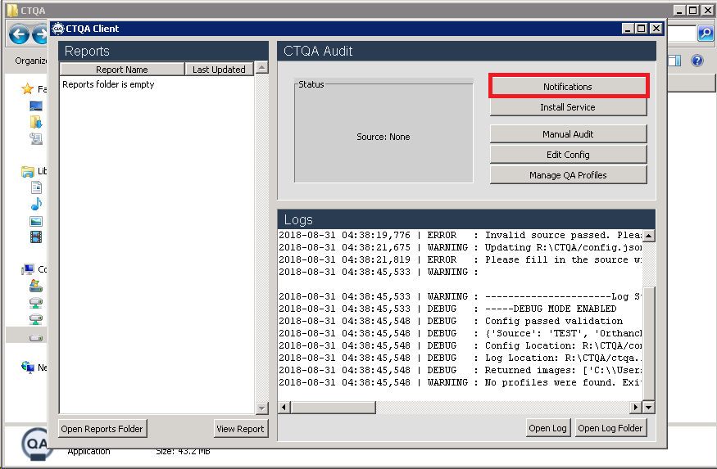

1. Enter your email address, email address password, and which email you would like to receive the notifications on. Change the protocol, if your email server is using something different.

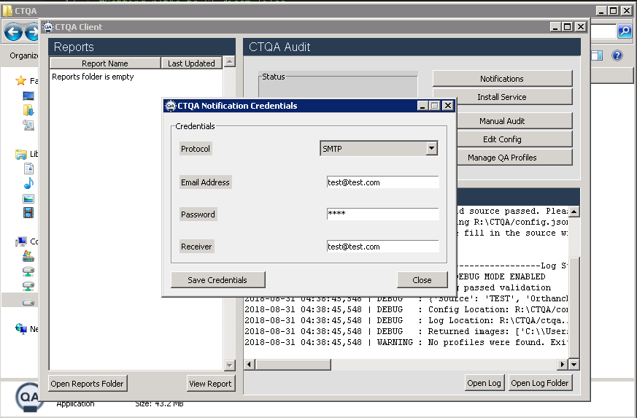

1. Click the “Save Credentials” button and click “Close”
2. Once you're finished with setting up, press the "Manual Audit" button and follow the log to make sure everything is correct. The manual audit should go through all new images and record the results. New reports should appear in the reports pane. If you setup email notifications, ensure you received an email with the report attached.

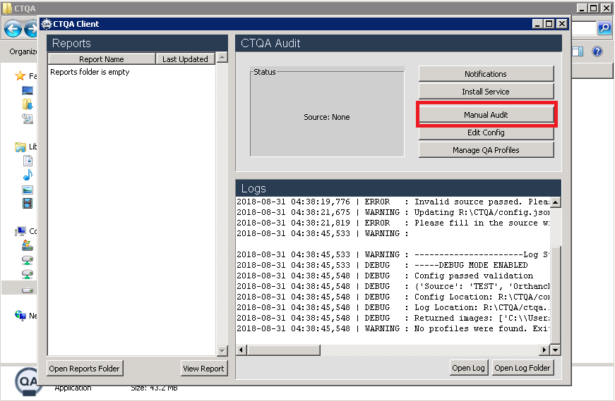

1. If all goes well with the manual audit (data/reports generated), click the "Install Service" button. This will install the CTQA audit functionality as a scheduled task (Windows) or Chron job (Linux/Mac). **PLEASE NOTE:** Attempting to install CTQA twice will result in a crash. Uninstallation must be done through the Task Scheduler, as of v0.9.1

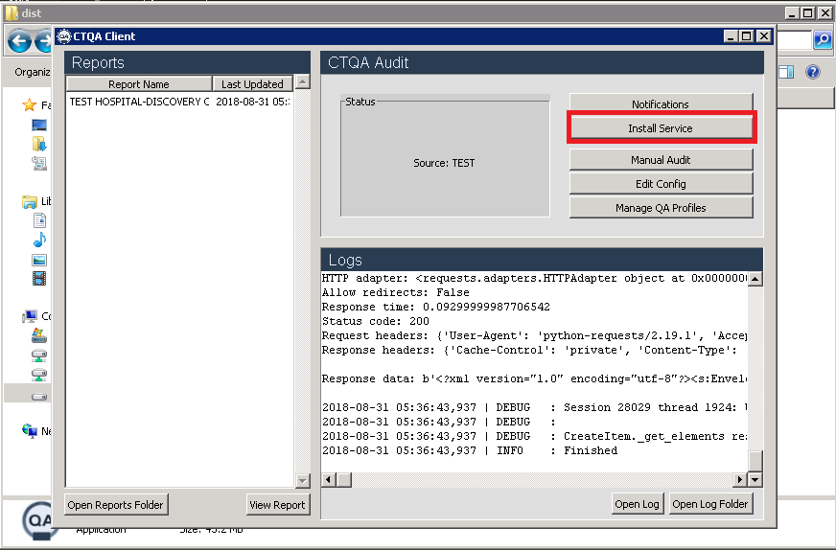

1. You will be prompted for administrative access as CTQA installs itself. Please agree to this prompt to continue.

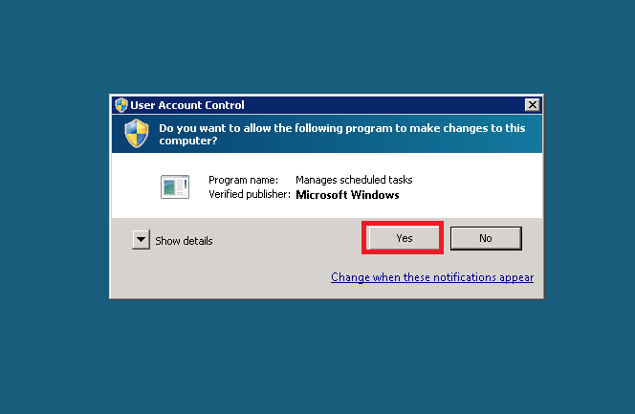

1. To ensure that CTQA was installed by open the start menu, searching for Task Scheduler and opening it.

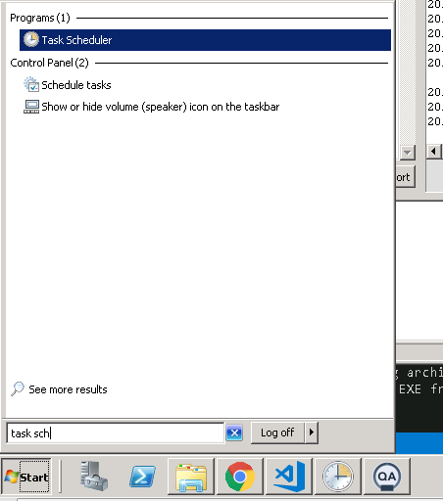

1. Click “Task Scheduler Library” and look for CTQA under the list of tasks. If it’s present, then you’ve successfully installed the software.

