Online Banking System (online-banking) SQL Injection Vulnerability Report

1. Vulnerability Overview
The auth_login.php file under the path online-banking-master/online-banking/site/dist/ of the online-banking project has an SQL injection vulnerability, which poses a threat to user data security.
The vulnerable code snippet in the file is as follows:
if(isset($_REQUEST['btn_submit']))
{ $username = $_REQUEST["txt_username"];
$password = $_REQUEST["txt_password"];
$query = "SELECT username, password FROM tbl_account WHERE username = '$username' AND password='$password' ";
This code directly concatenates the user-input username and password parameters into the SQL statement without using prepared statements. As a result, attackers can construct malicious inputs to tamper with the SQL query logic, thereby achieving login bypass or data theft.
At the URL http://localhost/online-banking/site/dist/auth_login.php, an attacker only needs to enter ' OR 1=1 -- + in the username field and any random content in the password field to successfully login.
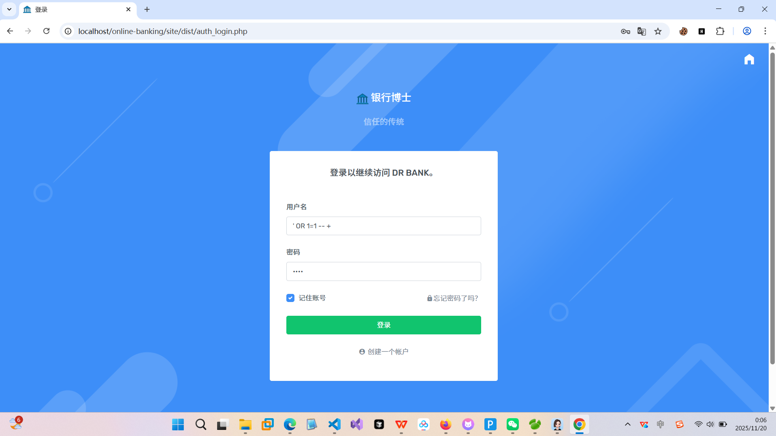
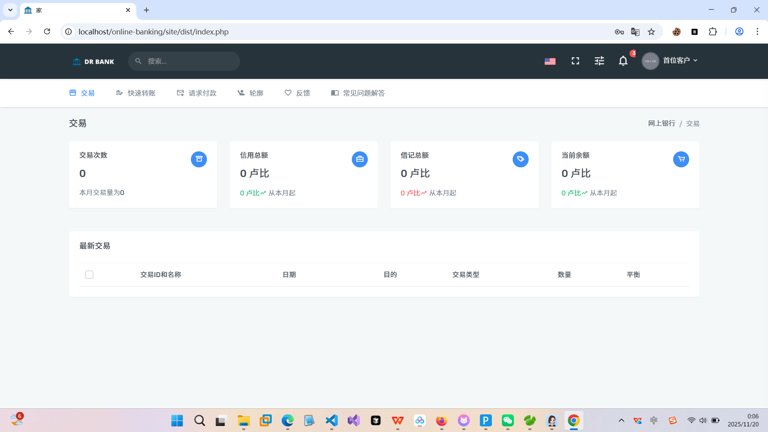

After logging in via this method, the attacker can normally use all functions of the logged-in user.

- Environment Setup and Vulnerability Reproduction

2.1 Obtain the Source Code
The source code of the project can be obtained from the GitHub repository: https://github.com/RashminDungrani/online-banking?tab=readme-ov-file#screenshots
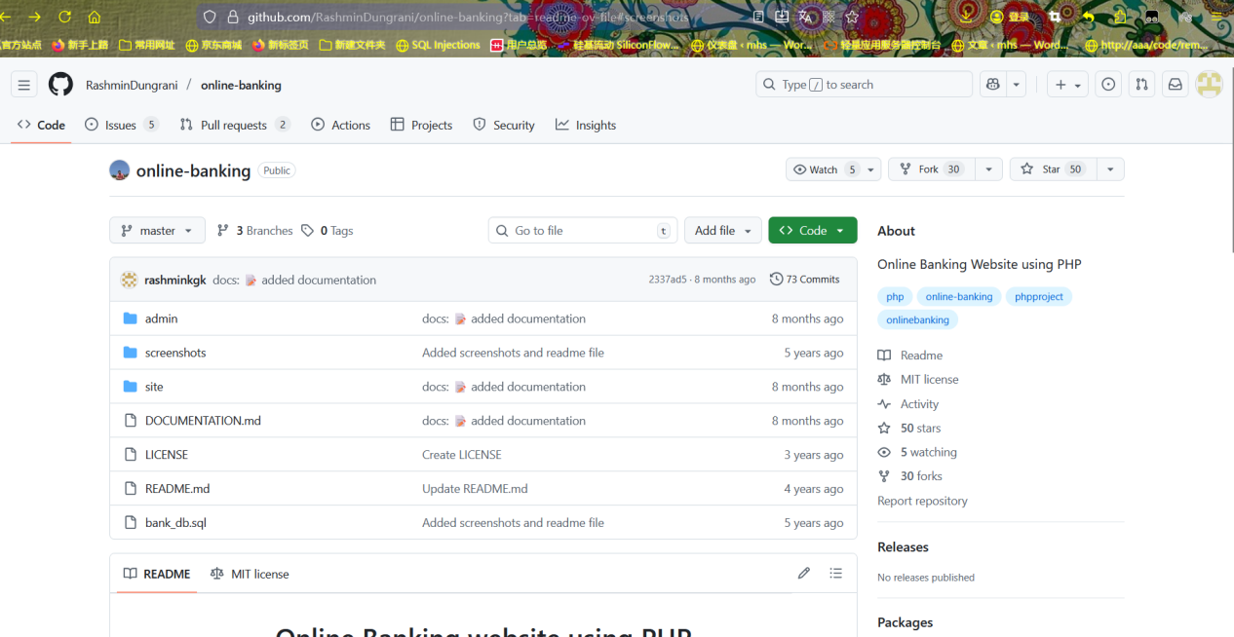2.2 Extract and Place the Source Code File
After downloading the compressed file, extract it. The extracted files are as follows:
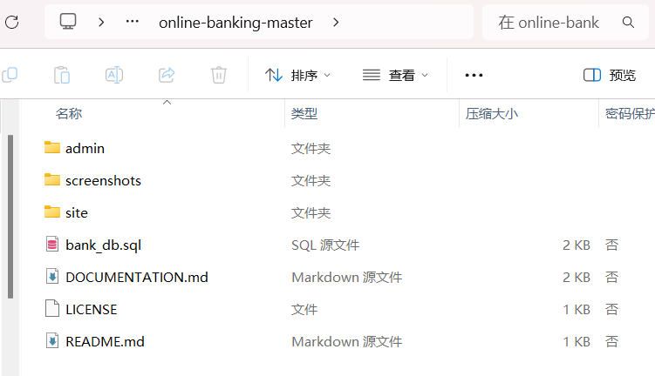
Place the extracted folder named online-backing-master into the www folder in the root directory of phpstudy_pro.
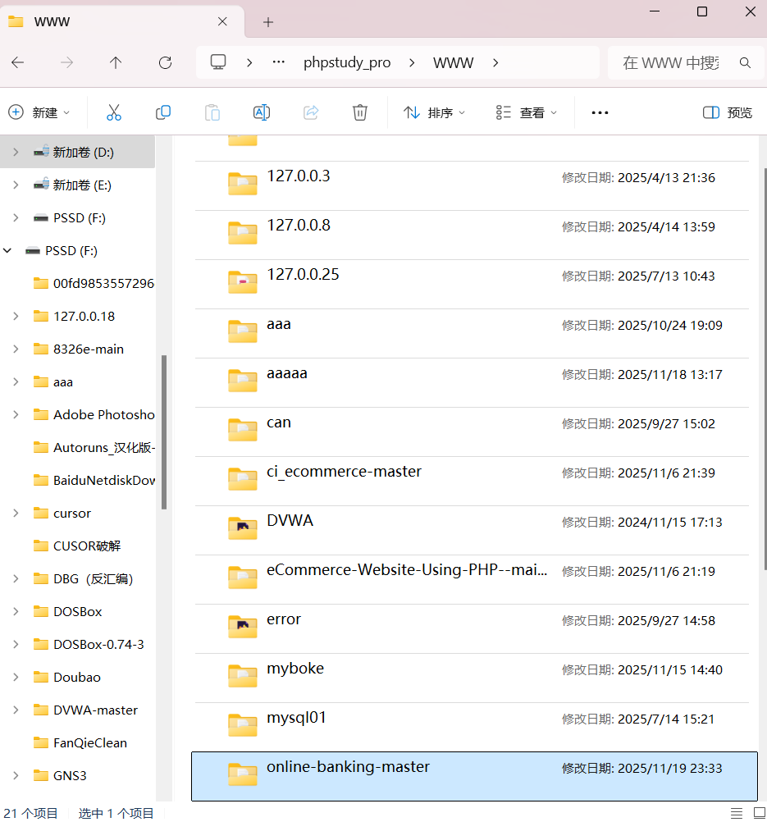

Open the current folder and rename the internal folder from online-banking-master to online-banking.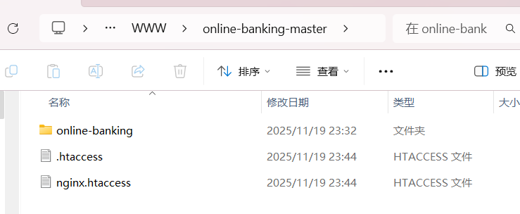
2.3Then, open MySQL and create a database named bank_db, and import the bank_db.sql fileinto the created database.
2.4Next, open site/dist/connect.php and admin/dist/connect.php to modify the configuration files.
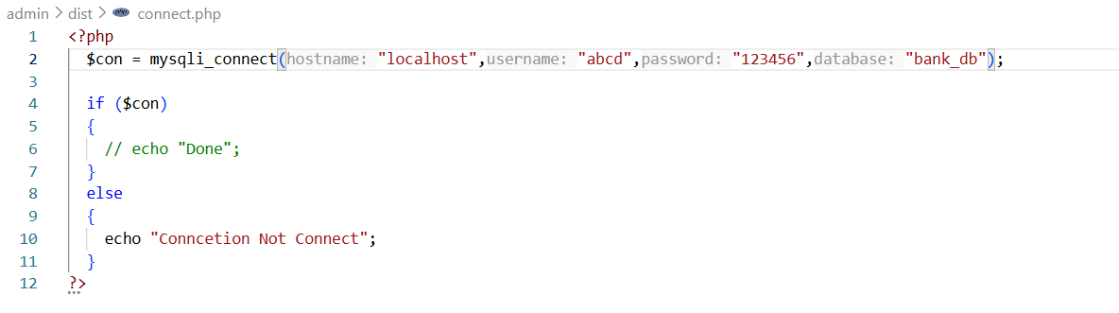
2.4 Create and Configure the Website
In xp.cn, create a new website named localhost, select port 80, and set the root directory to D:/phpstudy_pro/WWW/online-banking-master.
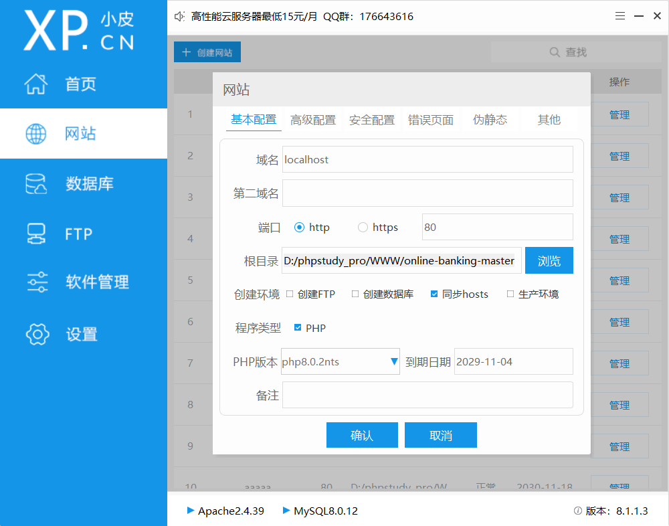
2.5 Reproduce the Vulnerability
Start the Apache service and MySQL service, then open the website via the URL http://localhost/online-banking/site/dist/auth_login.php.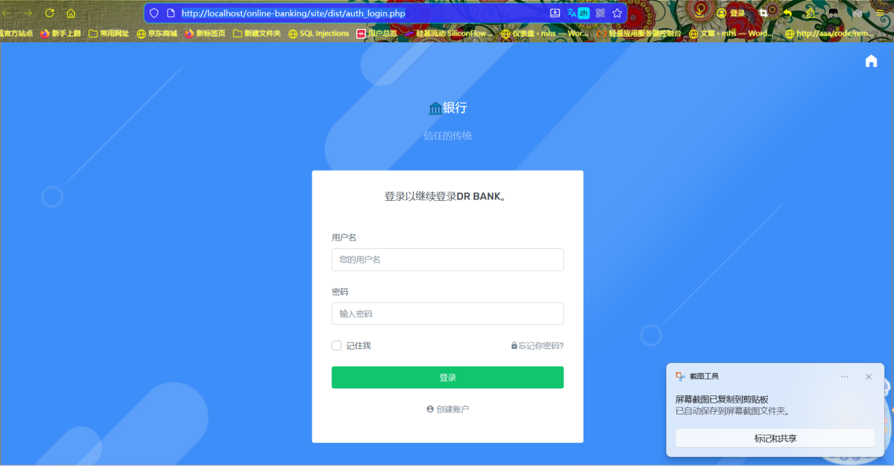
The correct username and password are customer1 and Password1 respectively. However, if you enter ' OR 1=1 -- + in the username field and any random content in the password field, you can still log in successfully.
Click the "Login" button. The system will not verify the correctness of the password and will directly redirect to the functional page after the user logs in (such as the account query or fund transfer page), which proves that the login bypass is successful. After logging in, you can normally use all functions of the logged-in user, which further proves that the vulnerability can lead to the illegal acquisition of user permissions.
Conclusion: The website contains an SQL vulnerability.

