  - SafeReach Backend Development Plan
  - Professional backend architecture blueprint
MOHAMED ASMATHULLA G¹

Planning-only deliverable
This document recommends the future backend design for SafeReach. It does not create backend source code, API files, Dockerfiles, Kubernetes manifests, or database migrations.

I. ARCHITECTURE

SafeReach should start as a modular Flask backend with clear domain modules, production-ready security, and a deployment path that supports both practical near-term hosting and long-term autoscaling. The frontend remains hosted separately, while the backend exposes versioned REST APIs and real-time channels for tracking, alerts, and notifications.

Layer | Recommendation | Purpose
Frontend | Existing Next.js app in frontend/, hosted on Vercel | User interface for admin, teacher, parent, and future mobile integrations.
Backend | Python Flask with Flask-RESTX or Flask-Smorest, Gunicorn, modular packages | REST APIs, authentication, RBAC, business logic, tracking, notifications, reports.
Primary database | MongoDB cluster | Main editable operational data store for schools, users, students, attendance, alerts, and tracking.
Immutable backup/audit store | Separate MongoDB cluster or database with append-only credentials and WORM-style controls | Admin-proof audit copy and recovery support. Application users cannot edit or delete data here.
Cache and queues | Redis using Docker volume-backed persistence where required | Session/token support, rate limits, background jobs, notification queues, and hot dashboard data.
Future relational option | Neon PostgreSQL | Future reporting, billing, analytics, or relational workloads when needed.
Real-time | Socket.IO or Flask-SocketIO behind a compatible worker setup | Live bus/student tracking, geofence alerts, emergency notifications.
Deployment | Render for current backend hosting; Kubernetes for container orchestration/autoscaling design | Practical launch path plus future high-availability scaling plan.

Recommended architecture pattern
Use a modular monolith first, not microservices. This gives professional structure without operational overload. Plan microservices later for notifications, analytics, tracking ingestion, and reporting only after traffic justifies the split.

II. FOLDER STRUCTURE

The future backend should live in a new backend/ folder. The structure below is intentionally module-based so Flask remains maintainable as SafeReach grows.

backend/
app/
__init__.py # Flask app factory
config/ # environment settings and secrets loading
extensions/ # db, redis, jwt, socket, mail, metrics
common/ # validators, errors, pagination, decorators
auth/ # login, refresh tokens, password reset, RBAC
schools/ # school and tenant management
users/ # admin, teacher, parent, student user accounts
students/ # student profile and guardian links
academics/ # class, section, attendance, leave
tracking/ # GPS events, geofences, route status
alerts/ # emergency alerts and escalation workflows
notifications/ # SMS, WhatsApp, email, push queues
reports/ # reports, exports, analytics APIs
audit/ # immutable audit writes and activity logs
files/ # uploads, profiles, documents
health/ # health checks, metrics, readiness probes
tests/
requirements.txt
gunicorn.conf.py
.env.example

Folder / Module | Responsibility
config | Loads .env settings for MongoDB, immutable backup DB, Redis, JWT secrets, notification keys, Render, and observability tools.
common | Shared validation, exception handling, pagination, search/filter helpers, response formatting, and decorators.
auth | Login, JWT access tokens, refresh tokens, bcrypt password hashing, RBAC, session revocation.
tracking | Student GPS event intake, geofencing, route status, WebSocket broadcasting, and alert triggers.
audit | Append-only activity log and immutable backup writes for every sensitive create/update/delete action.
health | Health check APIs, readiness checks, system metrics, and dependency status.

III. ENVIRONMENT CONFIGURATION

Use .env for local development and platform secrets for Render, Kubernetes, GitHub Actions, and production. Do not commit real secrets.

Variable Group | Examples | Notes
App runtime | FLASK_ENV, APP_ENV, API_VERSION, CORS_ORIGINS | Separate local, staging, and production values.
MongoDB primary | MONGO_PRIMARY_URI, MONGO_PRIMARY_DB | Editable operational database.
MongoDB immutable backup | MONGO_AUDIT_URI, MONGO_AUDIT_DB | Use credentials that can insert only. No update/delete permissions.
Redis | REDIS_URL, REDIS_CACHE_TTL, REDIS_QUEUE_DB | Cache, rate limiting, queues, sessions, and scheduler locks.
Auth | JWT_SECRET, JWT_REFRESH_SECRET, ACCESS_TOKEN_TTL, REFRESH_TOKEN_TTL | Rotate secrets and isolate staging/production.
Notifications | SMS_API_KEY, WHATSAPP_TOKEN, SMTP_HOST, FIREBASE_CREDENTIALS | Use provider-specific secure storage.
Observability | PROMETHEUS_ENABLED, ELK_ENDPOINT, SENTRY_DSN | Optional per environment.

IV. DATABASE PLAN

MongoDB is the primary database for SafeReach. Use document collections for domain records and time-series or event collections for high-volume tracking and audit data. Use indexes aggressively for tenant, role, search, date, route, and geofence queries.

Collection Area | Recommended Collections | Notes
Tenant and school | schools, branches, academic_years | Supports multi-tenant school architecture. Always include school_id/tenant_id.
Users and roles | users, roles, permissions, sessions, refresh_tokens | RBAC and session revocation. Store password hashes only.
Students and guardians | students, parents, guardian_links, student_documents | Parent-child links, profile data, medical/safety metadata.
Academics | classes, sections, attendance, leave_requests, events | Attendance and leave are query-heavy; index by school_id, date, class_id, section_id.
Tracking | student_locations, route_events, geofence_events | Use time-series/event design; consider TTL on raw telemetry if retention policy allows.
Alerts and notifications | alerts, notification_jobs, notification_status | Queue-based delivery and retry tracking.
Reports and analytics | report_jobs, report_exports, dashboard_snapshots | Use background jobs for heavy reports.
Audit and immutable backup | audit_events, immutable_record_snapshots | Append-only mirror of sensitive writes. No app role should update/delete.

4.1 Immutable Backup and Audit Store

- Write every important create/update/delete operation to the primary MongoDB and also append a snapshot/event into the immutable backup database.
- Use separate credentials for immutable storage that allow insert only. Deny update, delete, drop, and collection modification permissions.
- Protect the immutable store outside the app: separate cluster/account if possible, restricted network access, object-lock snapshots, backup retention, and operational alerts for any permission changes.
- Admins may view audit reports through controlled APIs, but no admin user should receive credentials capable of editing immutable data.
- For MongoDB sharding/large scale, shard high-volume collections by tenant_id and time window, not by randomly distributed fields that break school-level reporting.

4.2 Future Neon PostgreSQL Use

Neon PostgreSQL should remain a future option for relational analytics, billing, payment records, compliance report exports, or BI workloads. It should not replace MongoDB for the initial operational backend unless the data model changes substantially.

V. AUTHENTICATION, RBAC, AND SECURITY

Area | Recommendation
Authentication | Email/password login with bcrypt hashing; optional OTP/2FA for admins and high-risk actions.
Access tokens | Short-lived JWT access token with role, tenant_id, user_id, and permission claims.
Refresh tokens | Longer-lived rotating refresh tokens stored hashed in MongoDB or Redis with device/session metadata.
RBAC | Roles: Super Admin, School Admin, Teacher, Parent, Student, Transport Staff, Support/Auditor. Use permission checks at route and service levels.
Session management | Support logout, revoke all sessions, refresh token rotation, device tracking, and suspicious login alerts.
Validation | Use Pydantic, Marshmallow, or Flask-Smorest schemas for every request and response contract.
Exception handling | Central error handler with safe public messages and internal structured logs.
Rate limiting | Use Redis-backed limits for login, OTP, alerts, tracking ingestion, and notification APIs.
Data encryption | TLS everywhere, encrypted secrets, encrypted backups, and field-level encryption for sensitive medical or emergency fields where needed.
Compliance | Implement consent, retention, export/delete workflows, audit reports, and privacy-by-design for GDPR/CCPA. Treat HIPAA as a consideration for medical fields, not a claim unless formal compliance work is completed.

VI. MODULES AND API PLAN

Expose APIs under /api/v1. Keep controllers thin, services responsible for business logic, repositories responsible for data access, and audit writes centralized.

Module | Primary APIs | Important Behaviors
School Management | schools, branches, academic years, settings | Multi-tenant configuration, school profile, active year, timezone, policies.
User Management | admins, teachers, parents, students, roles | Invite users, activate/deactivate, role assignment, profile updates.
Student Management | student profiles, guardians, documents, safety metadata | Enrollment, profile, guardian linking, medical/safety notes.
Class and Section | classes, sections, teacher assignment | Academic structure and timetable support.
Attendance and Leave | mark attendance, attendance history, leave requests | Teacher workflows, parent visibility, reports.
Tracking and Geofencing | location ingest, route status, geofence rules/events | GPS events, geofence entry/exit, route progress, live dashboard feeds.
Emergency Alerts | create alert, escalate, resolve, audit | Priority workflows, notification fan-out, incident timeline.
Notifications | SMS, WhatsApp, email, push | Provider abstraction, queue, retry, status tracking, templates.
Reports and Analytics | dashboard stats, exports, audit compliance reports | Background generation, filters, pagination, role-based output.
Files and Profiles | profile images, documents, exports | Size/type validation, private storage, signed URLs, virus scanning future.
Health and Metrics | healthz, readyz, metrics | Render/Kubernetes health checks, dependency status, Prometheus metrics.

6.1 API Standards

- Use /api/v1 as the initial API version and document all endpoints with OpenAPI/Swagger.
- Use consistent pagination: page, limit, sort, search, and filters with maximum limit controls.
- Return stable JSON envelopes with data, meta, and error fields.
- Log every sensitive action to activity logs and immutable audit events.
- Use idempotency keys for alert creation, notification jobs, file uploads, and payment-related future APIs.

VII. INTEGRATIONS AND REAL-TIME SYSTEMS

Integration | Recommended Approach | Project Use
Firebase Cloud Messaging | Use for mobile and web push notifications. | Parent, teacher, admin alert delivery.
SMS provider | Abstract provider behind a notification service. | Emergency alerts, OTP, attendance reminders.
WhatsApp Business API | Use approved templates and queue delivery. | Parent emergency and school updates.
Email | SMTP or transactional provider with templates. | Invites, reports, account recovery, summaries.
Google Maps / GPS | Future integration for geocoding, route display, maps, and geofence visualization. | Student tracking and route dashboards.
Payments | Future module such as Stripe/Razorpay depending on market. | Fees, subscriptions, transport billing.
AI | Future analytics assistant, anomaly detection, report summaries. | Safety insights, admin summaries, risk alerts.
Socket.IO / WebSocket | Authenticated real-time channels with school and role rooms. | Live tracking, alerts, dashboard updates.

VIII. DEPLOYMENT, DOCKER, AND KUBERNETES

Render is the current backend deployment target. Kubernetes is the professional autoscaling/container orchestration design for later production scale. This gives a practical launch path while preserving a market-ready cloud architecture.

Concern | Recommendation
Docker | Containerize Flask with Gunicorn. Keep production image slim and run as non-root user.
Docker Compose | Local stack with backend, MongoDB dev instance, Redis, optional ELK/Prometheus/Grafana services.
Render | Deploy backend web service from GitHub. Configure environment variables and health check path.
Vercel | Keep frontend deployed separately from frontend/. Configure API base URL per environment.
Kubernetes Deployment | Use backend Deployment with replica count 2, rolling updates, readiness/liveness probes.
ReplicaSet | Managed by Deployment; desired replicas 2 initially. Scale via HPA.
Services and Ingress | ClusterIP service for backend, Ingress controller for external routing, TLS termination.
ConfigMaps and Secrets | ConfigMaps for non-sensitive config; Secrets for DB URIs, JWT keys, provider tokens.
Horizontal Pod Autoscaling | Scale by CPU, memory, and optionally custom request latency/queue metrics.
Load balancing and HA | Use platform load balancer, multiple replicas, health checks, and dependency redundancy.

8.1 GitHub Actions CI/CD

- Run linting, unit tests, integration tests, API contract tests, and build checks on pull requests.
- Run SonarQube quality checks and fail the pipeline for critical quality/security issues.
- Build Docker images and push to registry for production deployments.
- Deploy to Render for current production backend; keep Kubernetes deployment workflow as a future environment path.
- Use environment-scoped secrets, never plain secrets in workflow files.

IX. MONITORING, LOGGING, AND QUALITY TOOLS

Tool | Role in SafeReach
Prometheus | Collect backend metrics, API latency, request counts, error rates, queue length, Redis/Mongo health.
Grafana | Dashboards for production health, notification delays, tracking ingestion, alert volume, user activity.
ELK Stack | Centralized logs with search for API requests, exceptions, audit events, background jobs, and security events.
SonarQube | Code quality, maintainability, security hotspots, and technical debt tracking.
Sentry or equivalent | Optional application error monitoring with stack traces and release tracking.
Health APIs | /healthz for liveness, /readyz for dependencies, /metrics for Prometheus.

X. TESTING STRATEGY

Test Type | Coverage
Unit testing | Services, validators, password hashing, token creation, RBAC checks, geofence calculations.
Integration testing | MongoDB, Redis, auth flow, audit mirror writes, notification queue writes.
API testing | Role-based endpoint access, pagination, validation errors, OpenAPI contract behavior.
Load testing | Login, dashboard APIs, tracking event ingestion, notification fan-out, report generation.
Security testing | JWT tampering, rate limiting, password policy, unauthorized tenant access, file upload validation.
Recovery testing | Primary DB restore, immutable backup verification, Redis restart, queue retry behavior.

XI. ROADMAP

Phase | Goal | Deliverables
Phase 1: Foundation | Create backend skeleton and core configuration. | Flask app factory, env config, Mongo/Redis connections, health APIs, auth base, OpenAPI docs.
Phase 2: Core school platform | Build operational school modules. | Schools, users, students, parents, teachers, classes, sections, attendance, leave.
Phase 3: Safety and tracking | Launch safety-critical workflows. | GPS tracking, geofencing, emergency alerts, notification queues, activity logs.
Phase 4: Reporting and observability | Make the app production-operable. | Dashboards, reports, analytics, Prometheus/Grafana, ELK, audit reports.
Phase 5: Scale and future integrations | Prepare for market expansion. | Kubernetes, HPA, Neon future analytics, payments, AI, Google Maps/GPS enhancements, microservices planning.

XII. PRODUCTION READINESS CHECKLIST

- All API endpoints have authentication, authorization, validation, pagination, and documented error responses.
- Primary MongoDB and immutable backup database have tested write paths and recovery procedures.
- No app/admin credential can update or delete immutable backup data.
- JWT refresh token rotation and revocation are tested.
- Redis-backed rate limiting protects login, OTP, alert, and notification endpoints.
- Docker image builds reproducibly and runs with Gunicorn in production mode.
- GitHub Actions runs tests, quality checks, and deployment steps safely.
- Render health check is configured; Kubernetes readiness/liveness probes are documented for future scale.
- Prometheus, Grafana, ELK, and SonarQube are integrated before production launch.
- Backup, restore, disaster recovery, and audit compliance reports are tested before live school data is onboarded.

XIII. TOPIC COVERAGE APPENDIX

The original topic list is covered through the sections above. Related topics are grouped into practical implementation areas so the future backend can be built in phases rather than as disconnected features.

Topic Group | Covered Topics
Architecture and structure | Project architecture design, backend folder structure, API versioning, future microservices, API gateway, service discovery.
Data and storage | MongoDB, immutable backup database, Neon future plan, schema design, indexing, query optimization, clustering, replication, sharding, recovery.
Identity and access | Authentication, JWT, refresh tokens, bcrypt, RBAC, sessions, profile management.
School modules | School, user, student, parent, teacher, class, section, attendance, leave, event management.
Safety and notifications | Tracking, geofencing, emergency alerts, SMS, WhatsApp, email, Firebase push, notification queues.
Operations | Validation, errors, logs, audit trail, reports, analytics, monitoring, Prometheus, Grafana, ELK.
DevOps and scale | Docker, Docker Compose, GitHub Actions, Render, Vercel, Kubernetes, replicas, services, ingress, HPA, HA, DR.
Quality | Unit, integration, API, load, security tests, SonarQube, production readiness.

XIV. DETAILED DATA, PERMISSIONS, AND SECURITY ADDENDUM

This addendum expands the backend plan with database structure, ER-style diagrams, role-permission API mapping, Main Admin authority, frontend data replacement strategy, terms and data-use policy planning, exception handling, and security controls. It is still a planning document only; no backend code or database migration files are created.

Design principle
SafeReach should avoid duplicate manual data in the frontend. Demo arrays should be replaced with authenticated API calls that read from MongoDB through role-aware backend services. Sensitive writes must be mirrored into the immutable audit/backup database.

14.1 ER-Style Database Diagrams

MongoDB is document-oriented, so these diagrams show logical entities and references rather than SQL foreign keys. Use ObjectId references and denormalized snapshots only where they improve performance or audit stability.

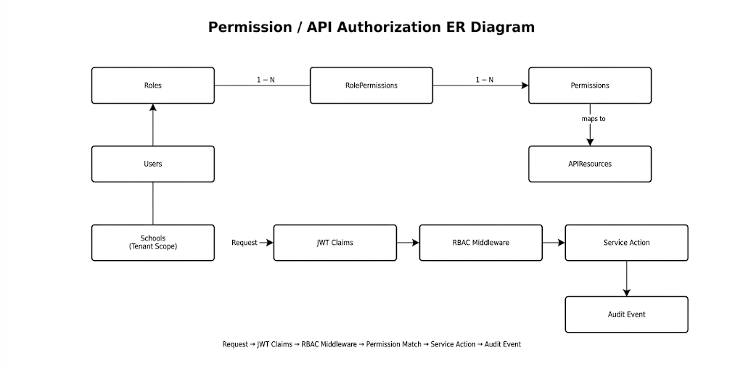

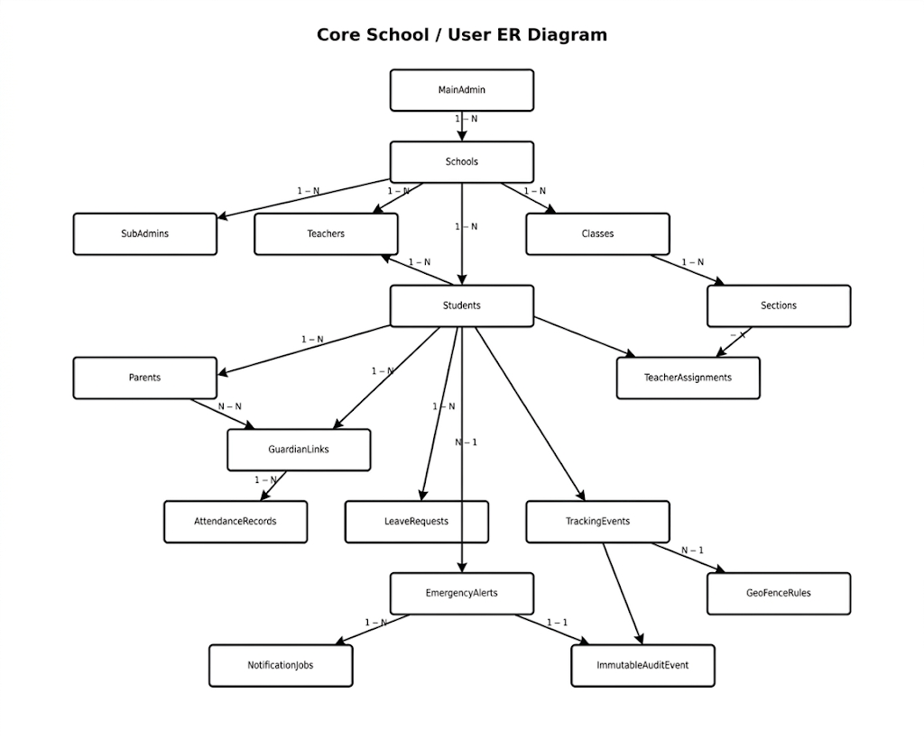

14.2 Recommended MongoDB Collection Structure

Collection | Key Fields | Purpose / Format
schools | school_id, name, address, timezone, status, settings | Tenant root for each school. Every operational record should include school_id for isolation and indexing.
users | user_id, school_id, role_id, email, password_hash, status, profile, last_login_at | Single identity collection for Main Admin, Sub Admin, teachers, parents, students, and staff.
roles | role_id, name, scope, description, is_system_role | Defines Main Admin, Sub Admin, Teacher, Parent, Student, Transport Staff, Auditor.
permissions | permission_key, module, action, method, url_pattern, description | Canonical API permission registry such as app.admin.student.add.
role_permissions | role_id, permission_key, allowed, conditions, created_by | Connects roles to API rules and optional constraints such as same school only.
students | student_id, school_id, admission_no, name, class_id, section_id, parent_ids, medical_safety | Student profile, enrollment, safety metadata, active status.
parents | parent_id, user_id, school_id, contact, verification_status | Parent-specific profile and notification preferences.
guardian_links | student_id, parent_id, relationship, primary_contact, pickup_allowed | Many-to-many bridge between parents/guardians and students.
teachers | teacher_id, user_id, school_id, employee_no, subjects, status | Teacher profile and staff metadata.
classes | class_id, school_id, name, grade_level, academic_year_id | Class-level structure.
sections | section_id, class_id, school_id, name, capacity, room_no | Section/classroom-level grouping.
teacher_assignments | teacher_id, class_id, section_id, subject, academic_year_id | Bridge collection for teacher-to-section assignment.
attendance_records | student_id, class_id, section_id, date, status, marked_by, source | Daily attendance. Unique index by student_id + date.
leave_requests | student_id, parent_id, date_range, reason, status, reviewed_by | Parent leave request and school approval workflow.
tracking_events | student_id, route_id, gps, speed, accuracy, event_time, source | High-volume GPS/time-series style events. Index by student_id and event_time.
geofence_rules | school_id, name, polygon_or_radius, active_hours, action | Geofence definitions for school, bus routes, pickup zones.
geofence_events | student_id, geofence_id, event_type, event_time, gps | Entry/exit events generated by tracking service.
emergency_alerts | alert_id, school_id, student_id, type, severity, status, created_by | Emergency alert lifecycle and escalation state.
notification_jobs | job_id, channel, recipient, template, payload, status, retry_count | Queue-backed SMS, WhatsApp, email, and push notifications.
activity_logs | actor_id, action, resource_type, resource_id, ip, user_agent, created_at | Human-readable activity log for dashboard and audit review.
immutable_audit_events | event_id, source_collection, operation, before, after, actor, hash, created_at | Append-only mirror in immutable backup DB. No update/delete permissions.

14.3 Collection Format Examples

Document Type | Example Fields / JSON Shape | Indexes
students | { school_id, admission_no, full_name, class_id, section_id, parent_ids[], status, medical_safety } | school_id + admission_no unique; school_id + class_id + section_id; status
attendance_records | { school_id, student_id, date, status: present|absent|late, marked_by, remarks } | student_id + date unique; school_id + date + section_id
tracking_events | { school_id, student_id, route_id, gps: {lat,lng}, speed, accuracy, event_time } | student_id + event_time desc; route_id + event_time; school_id + event_time
role_permissions | { role_id, permission_key, allowed, conditions: {scope: school|global|own_child} } | role_id + permission_key unique; permission_key
immutable_audit_events | { event_id, operation, actor, before_hash, after_hash, payload, created_at } | event_id unique; actor.user_id + created_at; source_collection + resource_id

14.4 Role, Permission, API, and URL Matrix

Create a permission registry that connects roles to exact API methods and URL patterns. Permission keys should follow a predictable namespace such as app.admin.student.add. The RBAC middleware checks JWT role claims against this registry before controller logic runs.

Permission Key | Method | URL Pattern | Main Admin | Sub Admin | Teacher | Parent | Student
app.admin.school.create | POST | /api/v1/admin/schools | Allow | Deny | Deny | Deny | Deny
app.admin.school.update | PATCH | /api/v1/admin/schools/{school_id} | Allow | Deny | Deny | Deny | Deny
app.admin.subadmin.add | POST | /api/v1/admin/sub-admins | Allow | Deny | Deny | Deny | Deny
app.admin.subadmin.monitor | GET | /api/v1/admin/sub-admins/activity | Allow | Deny | Deny | Deny | Deny
app.admin.user.manage | POST/PATCH/DELETE | /api/v1/admin/users/{user_id} | Allow | Scoped | Deny | Deny | Deny
app.admin.student.add | POST | /api/v1/admin/students | Allow | Scoped | Deny | Deny | Deny
app.admin.student.edit | PATCH | /api/v1/admin/students/{student_id} | Allow | Scoped | Deny | Deny | Deny
app.admin.student.delete | DELETE | /api/v1/admin/students/{student_id} | Allow | Scoped | Deny | Deny | Deny
app.admin.teacher.add | POST | /api/v1/admin/teachers | Allow | Scoped | Deny | Deny | Deny
app.teacher.attendance.mark | POST | /api/v1/teacher/attendance | Allow | Scoped | Allow assigned | Deny | Deny
app.teacher.report.create | POST | /api/v1/teacher/reports | Allow | Scoped | Allow assigned | Deny | Deny
app.parent.child.view | GET | /api/v1/parent/students | Allow | Scoped | Deny | Own child | Deny
app.parent.leave.create | POST | /api/v1/parent/leave-requests | Allow | Scoped | Deny | Own child | Deny
app.student.profile.view | GET | /api/v1/student/profile | Allow | Scoped | Deny | Deny | Own profile
app.alert.emergency.create | POST | /api/v1/alerts/emergency | Allow | Scoped | Allow assigned | Own child limited | Deny
app.audit.report.view | GET | /api/v1/admin/audit-reports | Allow | Read only | Deny | Deny | Deny

Scoped permission meaning
Scoped means the user may perform the action only within their assigned school, class, section, student relationship, or explicit assignment. Main Admin has global authority across schools and roles, except immutable audit data remains non-editable even for Main Admin.

14.5 Main Admin Role Plan

Capability | Main Admin Permission | Audit Requirement
Monitor sub admins | View sub-admin list, login history, activity logs, permission changes, school assignments. | Every view/export and permission change should create an activity log entry.
Manage sub admins | Create, edit, deactivate, reset password, assign school scope, assign permission templates. | Write before/after snapshots to immutable audit store.
Monitor teachers | View teacher profiles, assigned classes, attendance marking activity, incident/report submissions. | Log sensitive profile and assignment changes.
Monitor students | View student profiles, attendance, leave, safety status, alerts, tracking status. | Medical/safety fields require stricter access logs.
Monitor parents | View parent accounts, linked students, notification status, leave requests. | Parent contact and verification updates must be audited.
Edit/add/delete operational records | Allowed across school scope or global scope depending on deployment model. | Deletes should be soft-delete in primary DB and append immutable delete event.
Immutable audit access | Read audit reports only; no edit/delete/drop access. | Immutable database credentials must not be available to Main Admin UI.

14.6 Frontend Dynamic Data Replacement Plan

The current frontend contains demo/default data arrays. The backend should replace those arrays through authenticated API calls so dashboards show real database records and avoid duplicate manual entry.

Frontend Area | Current Demo Data To Replace | Backend API Plan
Role selection/login | Hardcoded demo credentials and role cards. | Keep demo only for development; production uses /api/v1/auth/login and role-based redirect from JWT claims.
Admin dashboard | Static stats, transit map, alerts. | GET /api/v1/admin/dashboard/summary, /alerts, /tracking/live.
Admin students | Static student directory and profile. | GET/POST/PATCH/DELETE /api/v1/admin/students with search, filters, pagination.
Admin teachers | Static staff directory/profile. | GET/POST/PATCH /api/v1/admin/teachers and /teacher-assignments.
Teacher dashboard | Static class snapshot and messages. | GET /api/v1/teacher/dashboard, /teacher/students, /teacher/messages.
Teacher attendance | Static attendance table. | GET /api/v1/teacher/attendance?date=; POST /api/v1/teacher/attendance.
Parent dashboard | Static child tracking, billing, notifications. | GET /api/v1/parent/dashboard, /parent/students, /parent/notifications.
Reports pages | Static report cards and charts. | GET /api/v1/reports with role-aware filters and export jobs.

- Use one source of truth: backend MongoDB data. Avoid manually duplicating the same student, teacher, parent, attendance, or alert data in multiple frontend files.
- Use SWR/React Query or Next.js data-fetching patterns later so frontend data refreshes predictably without hardcoded arrays.
- Every API should return only records permitted by the logged-in role and tenant/school scope.

14.7 Terms, Conditions, and Data Use Plan

Policy Area | Plan For SafeReach
Terms of service | Define acceptable use, school responsibility, account rules, emergency alert limitations, parent/teacher obligations, and prohibited misuse.
Privacy policy | Explain collected data: names, contact info, student profiles, attendance, location/tracking events, alerts, messages, logs, device info.
Purpose of data use | Use data only for student safety, school operations, attendance, communication, emergency response, reporting, and compliance.
Consent and notice | Schools must obtain parent/guardian consent for student tracking, emergency contacts, notifications, and profile data.
Location data | State when tracking is active, retention period, who can view it, and how location history is protected.
Data retention | Define retention for attendance, tracking, alerts, audit logs, reports, and deleted accounts. Use soft-delete plus immutable audit logs.
User rights | Support data access/export, correction, deletion request where legally allowed, and consent withdrawal workflows.
Third-party processors | List notification, email, SMS, WhatsApp, Firebase, hosting, logging, and analytics vendors.
Security disclosure | Explain encryption, access control, audit trail, backups, and incident response at a user-friendly level.
Compliance note | Design for GDPR/CCPA-style privacy. Treat HIPAA as a consideration for medical fields, not as a legal claim unless formally certified.

14.8 Exception Handling Plan

Error Class | HTTP Status | Response Strategy | Log / Audit Strategy
ValidationError | 400 | Return field-level errors with machine-readable codes. | Log at info/debug; no alert unless repeated.
AuthenticationError | 401 | Return invalid/expired token message without sensitive detail. | Track failed login count and IP/device metadata.
AuthorizationError | 403 | Return forbidden with permission key if safe. | Audit denied sensitive access attempts.
NotFoundError | 404 | Return resource not found without exposing cross-tenant existence. | Log route/resource identifier.
ConflictError | 409 | Return duplicate admission number, email, or already-processed request. | Log conflict and request id.
RateLimitError | 429 | Return retry_after and generic throttling message. | Track in Redis and security logs.
ProviderIntegrationError | 502/503 | Return notification/map/email provider temporarily unavailable. | Log provider response and queue retry.
DatabaseError | 500/503 | Return safe generic service error. | Log full internal stack; trigger alert if repeated.
ImmutableAuditWriteError | 500/503 | Fail closed for sensitive writes if audit mirror cannot be written. | Critical alert; block operation until audit path recovers or safe queue is enabled.

- Use a global Flask error handler that converts exceptions into a consistent JSON envelope: { error: { code, message, details, request_id } }.
- Every request should carry a request_id/correlation_id for logs, API responses, audit events, and support investigation.
- Never expose stack traces, database connection strings, JWT secrets, or provider tokens in production responses.

14.9 Data Security Methods

Security Layer | Method
Transport security | HTTPS/TLS for all frontend-backend and backend-provider traffic.
Password security | bcrypt with strong cost factor; never store plain passwords.
Token security | Short-lived access JWTs, rotating refresh tokens, hashed refresh token storage, device/session revocation.
Database access | Least-privilege MongoDB users for app, read-only analytics, insert-only immutable audit writer, and no UI access to backup credentials.
Field protection | Encrypt highly sensitive fields such as medical notes, emergency contacts, and high-risk student safety metadata where required.
Location protection | Restrict GPS data by role; limit retention; aggregate old tracking data; audit every sensitive location access.
File upload security | Validate file type/size, private storage, signed URLs, malware scanning in future production.
Secrets management | Render secrets now; Kubernetes Secrets later; no secrets in GitHub or frontend bundles.
Audit integrity | Hash audit payloads, store before/after snapshots, include actor and request metadata, verify immutable backup consistency.
Backups | Encrypted snapshots, restore drills, retention policy, immutable audit database, disaster recovery runbooks.

No-edit backup rule
The immutable backup database must be architected so nobody using the SafeReach app, including Main Admin, can edit or delete its records. Protection must be enforced by database credentials, network access, backup policies, and operational controls, not only by frontend buttons.

14.10 Additional Acceptance Criteria For Backend Build

- Main Admin can monitor Sub Admin, Teacher, Student, and Parent activity through dashboard APIs.
- Role-permission registry exists and maps permission keys to methods and URL patterns.
- All frontend demo/static data has a planned backend API replacement path.
- Sensitive primary database writes also create immutable audit events.
- Terms/privacy/data-use policies are published before real school/student data is collected.
- Global exception handling returns safe JSON errors and logs request_id for support.
- Data security controls are enforced by backend, database credentials, and infrastructure, not only UI rules.

