THE FILES INSIDE THE IMG FOLDER ARE WHAT YOU WILL HAVE TO ADD THE PROPER LOCATION PATH IN THE CODE. SAVE EVERYTHING IN DESKTOP AND RUN.

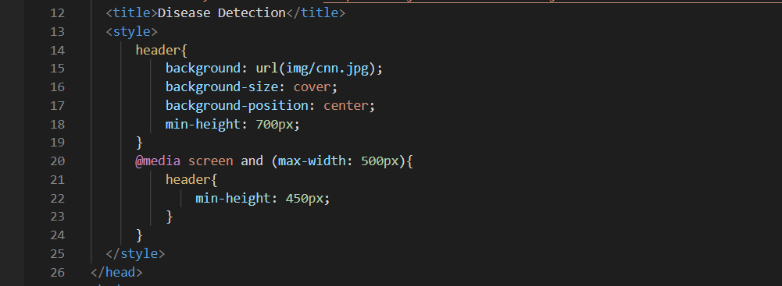

IN “background: url();” upload the path of “cnn” after saving it.

IT IS THE SAME FOR ALL THREE WORKFILES(proj, proj1, proj2).

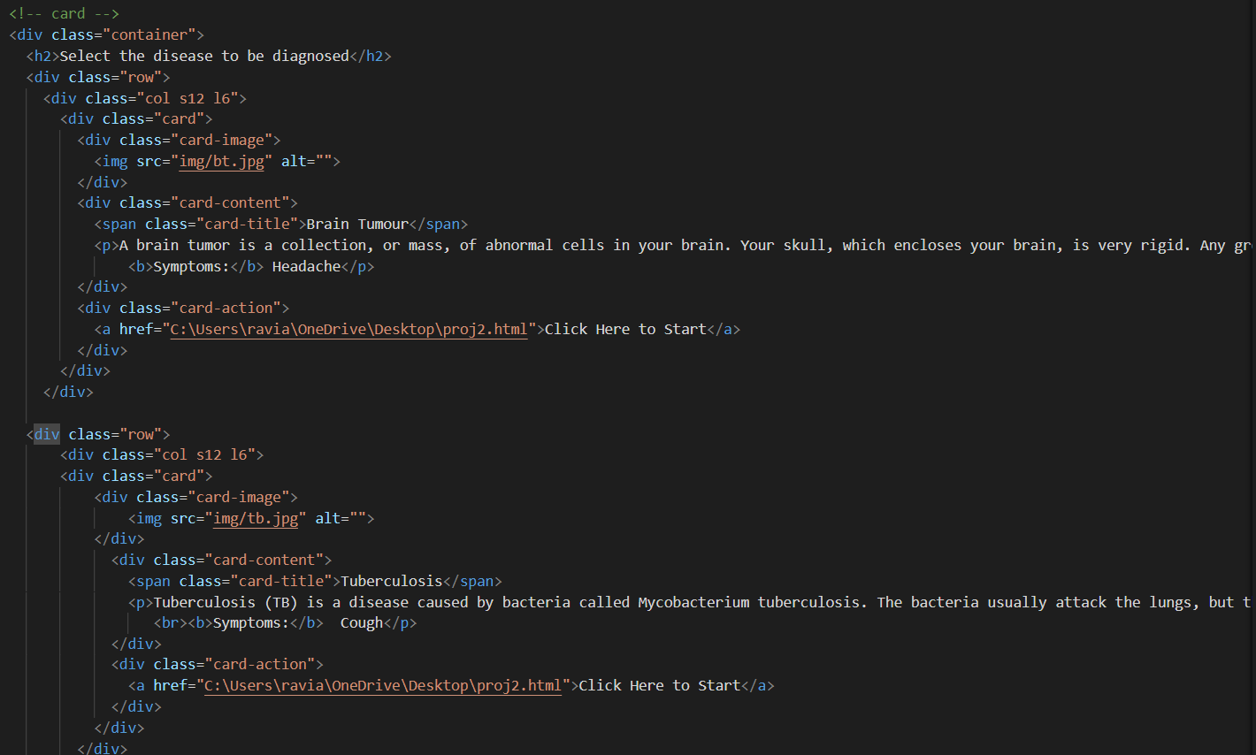

IN proj2 FILE, IN <img> TAG USE THE”bt” PICTURE, SAVE IT PROPERLY AND ADD ITS PATH. DO THE SAME FOR “img/tb.jpg” AS WELL.

IN ANCHOR TAG <a> SAVE proj2 IN DESKTOP AND ADD ITS PATH TOO.

I DID THIS USING VISUAL STUDIO CODE. IF POSSIBLE DOWNLOAD THAT SO THERE WONT BE MUCH COMPLICATIONS WHEN YOURE WORKING IN YOUR LAPTOP.