**PROJECT REPORT**

Project 1 is about the “Time Series Visualization”. A primary goal of data visualization is to communicate information clearly and efficiently via statistical graphics, plots and information graphics. Numerical data may be encoded using dots, lines, or bars, to visually communicate a quantitative message. Effective visualization helps users analyze and reason about data and evidence. It makes complex data more accessible, understandable and usable. Users may have particular analytical tasks, such as making comparisons or understanding causality, and the design principle of the graphic (i.e., showing comparisons or showing causality) follows the task. Tables are generally used where users will look up a specific measurement, while charts of various types are used to show patterns or relationships in the data for one or more variables.

In the project, the unemployment rates of the US states from 1978 to 2015 have been visualized. D3 library has been used. Data has been collected from the BLS website. Users are allowed to select a state and display its unemployment rate in the graph. Users are also allowed to select more than one state to compare the unemployment of two states. Graph labels are available and easy to use.

**GRAPH LABELS:**

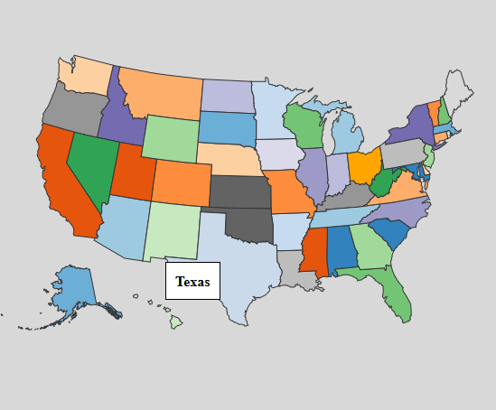

**SELECTION OF ALL 50 STATES:**

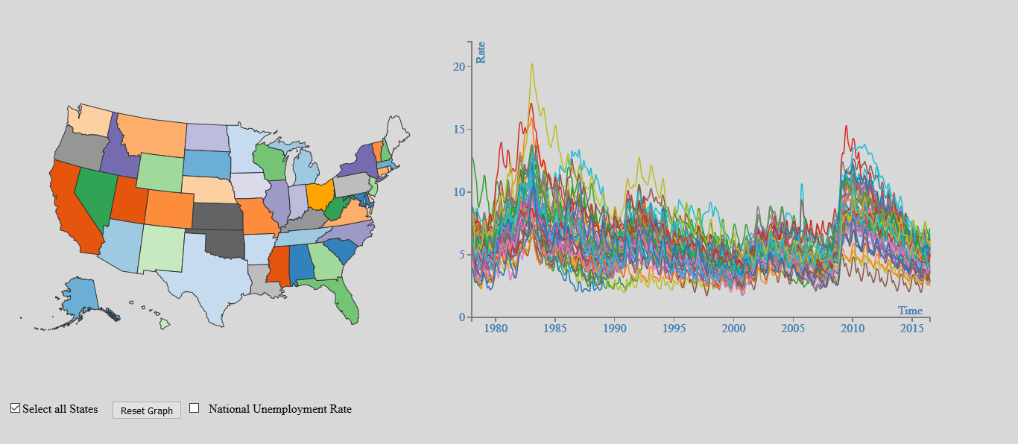

The selection of all 50 states is enabled through a check box and the unemployment rate is displayed on the graph. The tool tips are used to know the name of the state whenever we hover a graph line.

**THE RESET, SELECT ALL STATES AND NATIONAL UNEMPLOYMENT RATE:**



The National employment rate of the United States of America has been included in this project which contains the aggregate data of every state.

Comparison of two or more states and comparison of one state with national unemployment has been enabled in the graph.

**ACKNOWLEDGEMENT**

This project is a part of project 1 which is given to the students of visualization and visual analytics class.