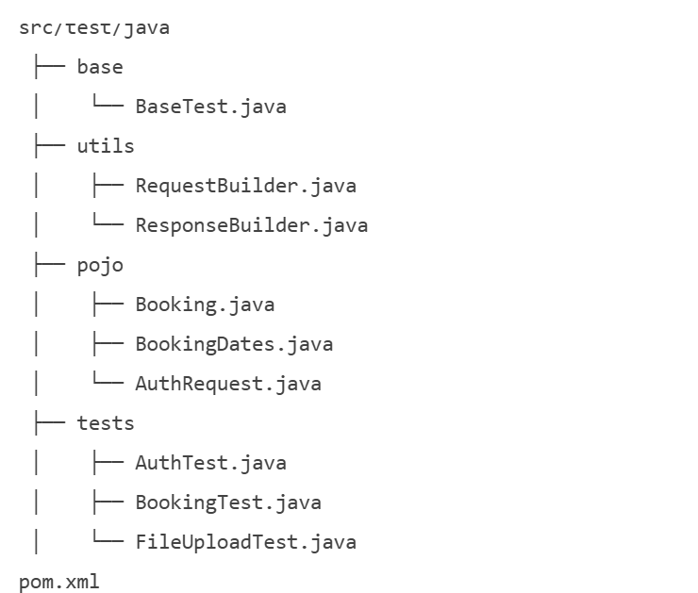

{
"firstname": "John",
"lastname": "Doe",
"totalprice": 1000,
"depositpaid": true,
"bookingdates": {
"checkin": "2024-01-01",
"checkout": "2024-01-10"
},
"additionalneeds": "Breakfast"
}

