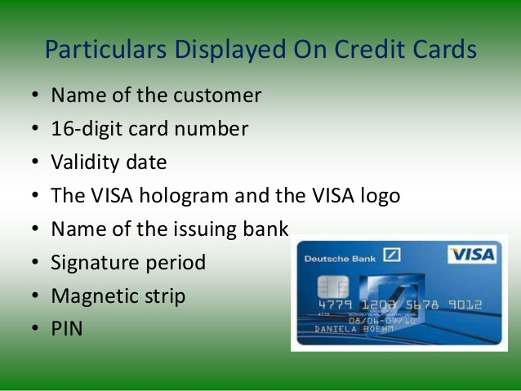

**KYC means** “Know Your Customer”. It is a process by which **banks** obtain information about the identity and address of the customers. This process helps to ensure that **banks**' services are not misused. The **KYC** procedure is to be completed by the **banks** while opening accounts and also periodically update the same.