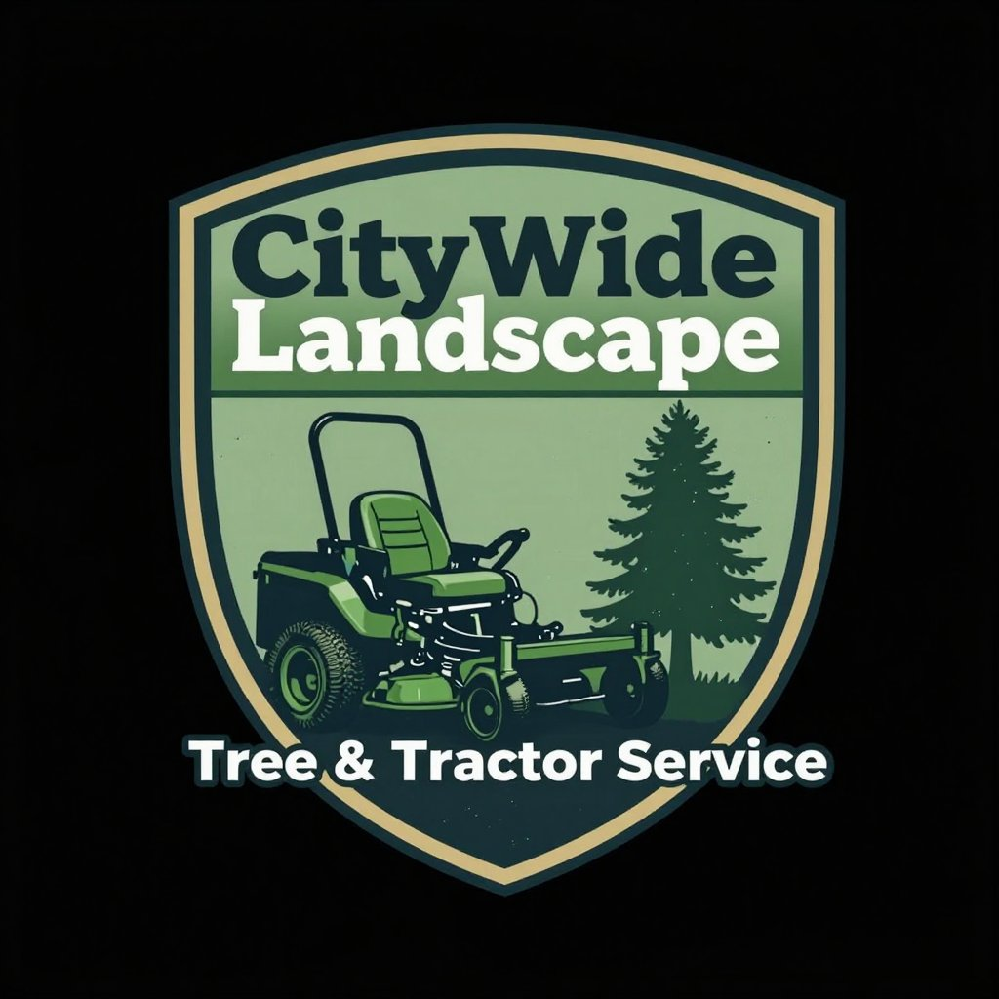 | Website Project Questionnaire  Axly's Customs · axly.com · Mike

Thanks for reaching out! Please fill out as much as you can — the more detail you provide, the better your site will turn out. Don't worry if you don't have every answer yet; we'll work through the gaps together. This should take about 10–15 minutes. Type directly in this document and email it back when done.
1. About Your Business

Business name:

What do you do? (Describe your business like you'd explain it to a neighbor)

Where are you located?
City, State, ZIP:

Street address (for website footer):

How long have you been in business?

Who are your typical customers?
e.g. homeowners, local families, tourists, businesses

What sets you apart from competitors? Why do customers choose you?

2. Contact & Hours

Primary phone number (the one you want on the website):

Email address for contact form inquiries:

Business hours:
Monday: |  |  | Tuesday:
Wednesday: |  |  | Thursday:
Friday: |  |  | Saturday:
Sunday:

3. Your Website Goals

What's the #1 thing you want visitors to do on your site?
☐ Call us ☐ Fill out a form ☐ Book an appointment ☐ Visit our location
Do you want to accept online bookings?
☐ Yes — I already use a tool: ☐ Yes — help me find one ☐ No, phone/email is fine
Booking tool name (if applicable):

Anything else the website should help with?

4. Pages & Content

Which pages do you need? (check all that apply)
☐ Home | ☐ About Us / Our Story
☐ Services | ☐ Menu (restaurants/cafes)
☐ Gallery / Portfolio | ☐ Testimonials / Reviews
☐ FAQ | ☐ Contact
☐ Other: ___________________________

Do you have written content ready?
☐ Yes — I can provide it ☐ Partially — need help with some ☐ No — need help writing it
5. Branding & Style

Do you have a logo?
☐ Yes — I can send the file ☐ I have one but needs work ☐ No — I need one created
Do you have brand colors? (hex codes or describe them)

How would you describe the vibe you want for your website?
e.g. clean & professional, warm & welcoming, bold & modern, rustic & homey

Any websites you really like the look of? (paste links — any industry)

Any websites you strongly dislike? What bothers you about them?

6. Photos & Online Presence

Do you have photos to use?
☐ Professional photos ready ☐ Good phone photos ☐ Partial — need more ☐ None
Tip: Real photos of your work and team always outperform stock images.

Do you have a Google Business Profile?
☐ Yes ☐ No ☐ Not sure
Google Business link or name (for referencing reviews):

Social media links to include on the site:
Facebook:

Instagram:

Yelp:

Other:

7. Domain & Existing Website

Do you have a domain name already?
☐ Yes ☐ No — I need one
Domain name:

Registered with (GoDaddy, Namecheap, etc.):

Do you have an existing website?
☐ Yes ☐ No
URL (if yes):

If yes — what do you want to keep? What do you want to change?

8. Competitors

Who are your main local competitors? (names or websites)

Is there a competitor's site you think is really good?

Is there a competitor's site you think is terrible? What's wrong with it?

9. Project Logistics

What's your timeline?
☐ ASAP (within 2 weeks) ☐ Within a month ☐ 1–2 months ☐ No hard deadline

Primary contact for approvals and feedback:
Name:

Email:

Best way to reach you (phone/text/email):

Anything else I should know before we get started?

Thanks for taking the time to fill this out! I'll review your answers and follow up within 1 business day.
Mike · Axly's Customs · axly.com

