1. bne的opcode是1100011，SB指令都是1100011，下表的SB指令opcode都要改

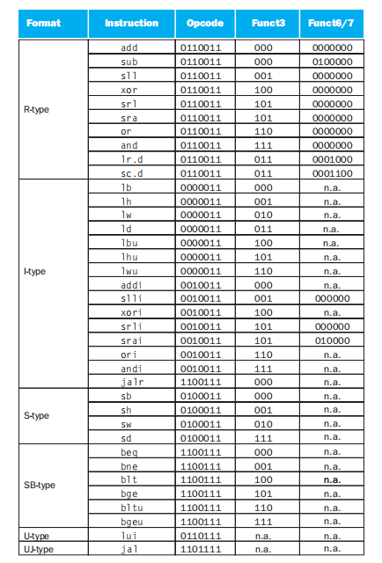

1. P278 错误

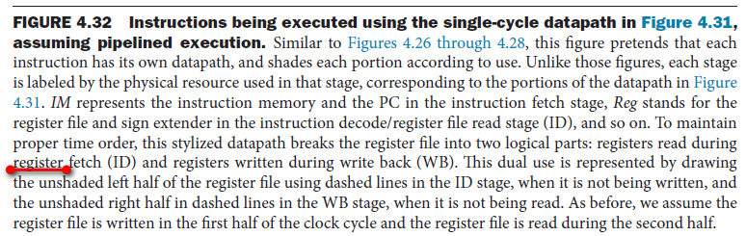

FIGURE 4.32 Instructions being executed using the single-cycle datapath in Figure 4.31,… assuming pipelined execution.parts: registers read during register fetch (ID) and registers written during write back (WB).

Register改成 instruction

1. P309 错误

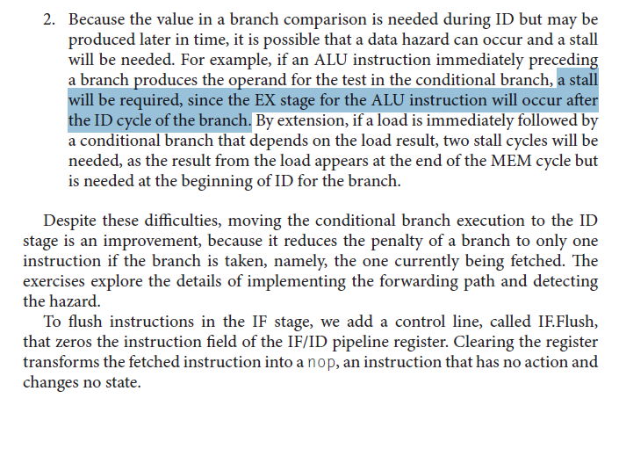

a stall will be required, since the EX stage for the ALU instruction will occur after the ID cycle of the branch. ==》a stall will be required, since the MEM stage for the ALU instruction will occur after the ID cycle of the branch.

1. P313 错误

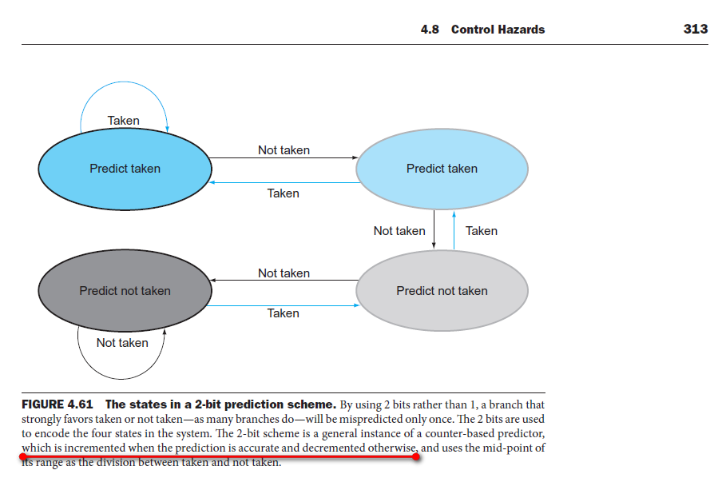

上面红线画出的话有错

1. P316 错误

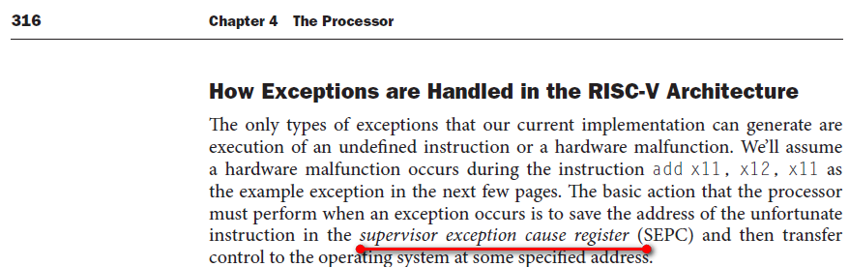

上面红线画出的话有错，正确的是Supervisor Exception Program Counter。