指路98回忆帖：[计算机学院《计组》回忆 - CC98论坛](https://www.cc98.org/topic/5114223)

以下是能找到的几个题：

1. Suppose you executed the code below on a version of the pipeline CPU that does not handle hazards. All registers are initialized to zero. Mem(1)=0xaa,Mem(9)=0xbb. The Branch takes place depending on the result of comparison in the stage of memory access.

main: addi x0,x0,0x0

addi x1,x0,0x1

addi x2,x0,0x1

addi x3,x0,0x1

addi x4,x0,0x1

lw x20,0x8(x1)

andi x4,x20,0x2

ori x3,x4,0x8

and x5,x6,x7

sw x7,0x1(x0)

xor x8,x3,x2

addi x9,x1,0x7

lw x9,0x1(x0)

and x10,x4,x3

beq x9,x8,loop1

addi x17,x8,0x2

add x11,x2,x4

loop1: addi x13,x13, 1

andi x15,x8,0x1

or x28,x9,x3

add x16,x10,x10

……………………

After the instructions running, the content of register x3 is ( ),

X4 is ( ),x8 is ( ),x17 is ( ),x13 is ( ).

2. Pipeline CPU Design

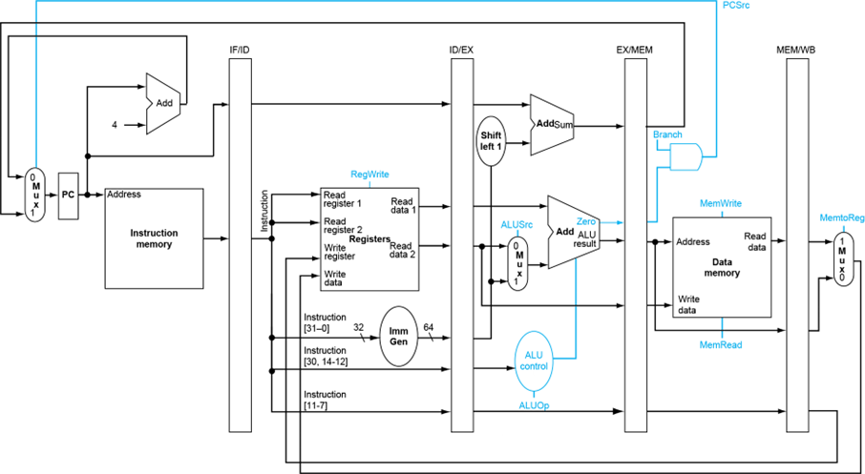

1) Assume that a1 is initialized to AA and a2 is initialized to CC. Suppose you executed the code below on a version of the pipeline CPU without solving data hazards. Now please adopt a measure of software(add nop) to make the pipeling run correctly.

xori a1, a2, 10

add a3, a1, a2

addi t1, a1, 15

sub t2, a3, a2

2) After you modify the code, please draw the corresponding instruction for each level of pipeline under the fourth clock.

IF ID EX MEM WB

3) Now please adopt the measure of forwarding to deal with the data harzard. You have to draw the datapath for the forwarding.

4) Suppose that the cycle time of this pipeline without forwarding is 200 ps. Suppose also that adding forwarding hardware will reduce the number of NOPs from 0.5*n to 0.04*n, but increase the cycle time to 210 ps. What is the speed up of this new pipeline compared to the one without forwarding?

答案：

1. 

2.

